**ARCHITECTURE OF THE OCDS OPEN SOURCE CENTRAL UNIT FOR NETWORKING DIGITAL PUBLIC PROCUREMENT SYSTEM**

Ver. 4.0 (18.02.2020)

Contract reference: C36346/520/38928  
Deliverable 6: Final version of Open Source OCDS-based architecture for electronic public procurement platform

List of abbreviations

|  |  |
| --- | --- |
| AC | Awarded Contract |
| API | Application Programming Interface |
| BPE | Business Process Engine |
| CA | Contracting Authority |
| CAN | Contract Award Notice |
| CDU | Central database unit |
| CN | Contract Notice |
| CPV | Common Procurement Vocabulary |
| CQRS | Command-query responsibility segregation |
| CRUD | Create, Read, Update, and Delete |
| DA | Direct Award |
| DB | Database |
| DbC | Design by contract |
| DTO | Data Transfer Objects |
| EC | European Commission |
| EDA | Exploratory Data Analysis |
| EI | Expenditure Item |
| EO | Economic Operator |
| EV | Evaluation |
| FA | Framework Agreement |
| FS | Funding Source |
| ISO | International Organization for Standardization |
| NEPPs | National Electronic Procurement Platform |
| OCDS | Open Contracting Data Standard |
| PE | Procuring Entity |
| PIN | Prior Information Notice |
| PN | Periodic Notice |
| PS | Pre-selection |
| SOA | Service Oriented Architecture |
| UNCITRAL | The United Nations Commission on International Trade Law |
| UI | User Interface |

Table of contents

1. Introduction 8

1.1. Procurement methods covered 9

1.1.1. Single-stage competitive procedure 9

1.1.2. Single-stage non-competitive procedure 10

1.1.3. Multi-stage competitive procedures 11

1.1.4. Multi-stage repetitive procedures 12

1.2. General approach 16

1.2.1. Multi-platform networking model 16

1.2.2. eProcurement.Systems API 18

2. Design and development principles 18

2.1 Architectural approach 18

2.1.1 Service-oriented architecture 18

2.1.2 Event-driven architecture 18

2.1.3 CQRS architecture style: command-query separation 19

2.1.4 Design by Contract: contract programming approach 20

2.2 Used Patterns 21

2.2.1 Materialized View pattern 21

2.2.2 Event Sourcing pattern 23

3. Hi-level eProcurement solution architecture 25

3.1 Building blocks 26

3.1.1 NEPPs 26

3.1.2 Central Unit 26

3.2 Architecture diagram 28

4 Data Standard 28

4.1 Open Contracting Data Standard 1.1+ 28

4.1.1 OCDS structure 28

4.1.2 Building blocks 29

4.1.3 Procurement Process Stages 31

4.1.4 Data Transfer Approach 34

4.1.4.1 Record Package 34

4.1.4.2 Record 36

4.1.4.3 Linked releases 36

4.1.4.4 Release Package 36

4.1.5 Definitions 37

4.1.6 Codelists 61

4.1.7 Classifiers 75

4.1.8 International standards 76

4.1.9 Registers 77

4.2 Procurement Process Stages 79

4.2.1 Groups of the general data-models 79

4.2.1.1 Budgeting 79

4.2.1.2 ‘Multi-stage process’ concept 86

4.2.1.3 Planning 111

4.2.1.4 Tendering 122

4.2.1.5 Awarding 131

4.2.1.6 Contracting 135

4.2.1.7 User Actions 141

4.2.2 Data models mind-map 156

5 Components’ management 158

5.1 eBudget 159

5.1.1 Methods 159

5.1.2 Related entities 165

5.1.3 Functional relationship 165

5.2 ePlanning 165

5.2.1 Methods 166

5.2.2 Related entities 168

5.2.3 Functional relationship 168

5.3 eAccess 168

5.3.1 Methods 169

5.3.2 Related entities 176

5.3.3 Functional relationship 176

5.4 eClarification 176

5.4.1 Methods 177

5.4.2 Related entities 182

5.4.3 Functional relationship 182

5.5 eSubmission 183

5.5.1 Methods 183

5.5.2 Related entities 193

5.5.3 Functional relationship 193

5.6 eQualification 193

5.6.1 Methods 193

5.6.2 Related entities 198

5.6.3 Functional relationship 198

5.7 eAuction 198

5.7.1 Methods 198

5.7.2 Related entities 203

5.7.3 Functional relationship 204

5.8 eAwarding 204

5.8.1 Methods 204

5.8.2 Related entities 210

5.8.3 Functional relationship 211

5.9 eContracting 211

5.9.1 Methods 211

5.9.2 Related entities 219

5.9.3 Functional relationship 220

5.10 eNotice 220

5.10.1 Methods 220

5.10.2 Related entities 237

5.10.3 Functional relationship 239

6 Business Process Engine 240

6.1 Architecture 240

6.2 Components 241

6.3 Environment 242

6.3.1 Chronograph 242

6.3.2 Feed Point 243

6.3.3 Master data Service 243

6.3.4 Document Service 244

Requirements 244

Components 244

Methods 244

6.4 External Environment (integrations) 249

6.5 Sequence diagrams 249

7 Public API 283

7.1 CQRS approach 283

7.2 Command API 284

7.2.1 Request example 284

7.2.2 Response examples 285

7.2.3 Activities 285

7.2.3.1 Budgeting 285

7.2.3.2 Planning 286

7.2.3.3 Announcement 287

7.2.3.4 Clarification 288

7.2.3.5 Submission 289

7.2.3.6 Awarding 290

7.2.3.7 Contracting 292

7.2.4 Query API 293

7.2.4.1 AccessPoint 293

7.2.4.2 Flow Description 294

8 Folder structure 296

# Introduction

The current document describes the solution architecture for the OCDS Open Source Central Unit of an electronic public procurement system.

This document provides the description of the software architecture of the system, including:

* technologies to be used to implement the required functionalities;
* structure of the information system identifying each of the subsystems;
* references to software architecture standards and models;
* description of the interactions amongst the different subsystems.

This document cannot be read as a standalone description of an eProcurement system. It rather provides a general approach towards an OCDS based architecture, which shall be complemented by an actual definition document (technical documentation) reflecting how this architecture was developed and implemented in a specific context. Such document will be adapted to specific user needs and specific tasks and activities that are not described in this architecture document.

This system architecture follows an end-to-end approach towards digital public procurement. Therefore, it covers the complete public procurement life cycle, from budgeting and planning to contract management. The architectural implementation of the public pgetrocurement process is provided in the Business Process Engine section.

The document is structured as follows: firstly, an overview of the architecture approach and the system key features and development principles is described, including a high level solution architecture of all system components. Secondly, the Data Model to be implemented following OCDS is detailed, along with building blocks, definition of data components and codelists. Thirdly, the document describes the Business Process Engine, which is the logical layer responsible for managing and executing the business processes. Fourthly, the public API that provides an access point to the system for external users and systems is defined. Lastly, the coverage section provides a complete overview of all the procurement methods that are covered under this eProcurement system architecture.

## Procurement methods covered

This section provides a complete overview of all the procurement methods that covered under this eProcurement system architecture. A general overview of the workflows is provided within this section. The complete BPMN for the procurement methods prescribed shall be accessed through the links indicated in the following subsections.

* Single-stage competitive procedures (parallel and sequential)
  + Small value procedure (simplified open tender)
  + Micro value procedure based on electronic reverse auction
  + EU GPA Open Tender
  + Price Quotation without eCatalogue
* Single-stage non-competitive procedures
  + Negotiated procedures
  + Direct awards
* Multi-stage competitive procedures
  + Restricted Tender
  + Design Contest
  + Competitive Dialog
* Multi-stage repetitive competitive procedures
  + Framework Agreement / Multiple suppliers with direct call offs
  + Framework Agreement / Multiple suppliers with mini-competitions for call-offs
  + Framework Agreement / Multiple suppliers with mini-competitions
  + Dynamic Purchasing System

### Single-stage competitive procedure

* Small value procedure (simplified open tender)
* EU GPA Open Tender
* Price Quotation without eCatalogue

|  |
| --- |
| "procurementMethod": "open" "procurementMethodDetails": "microValue", "smallValue", "rfq", "openTender" |

##### Sequential Type

The procurement process is carried out in the following sequence:

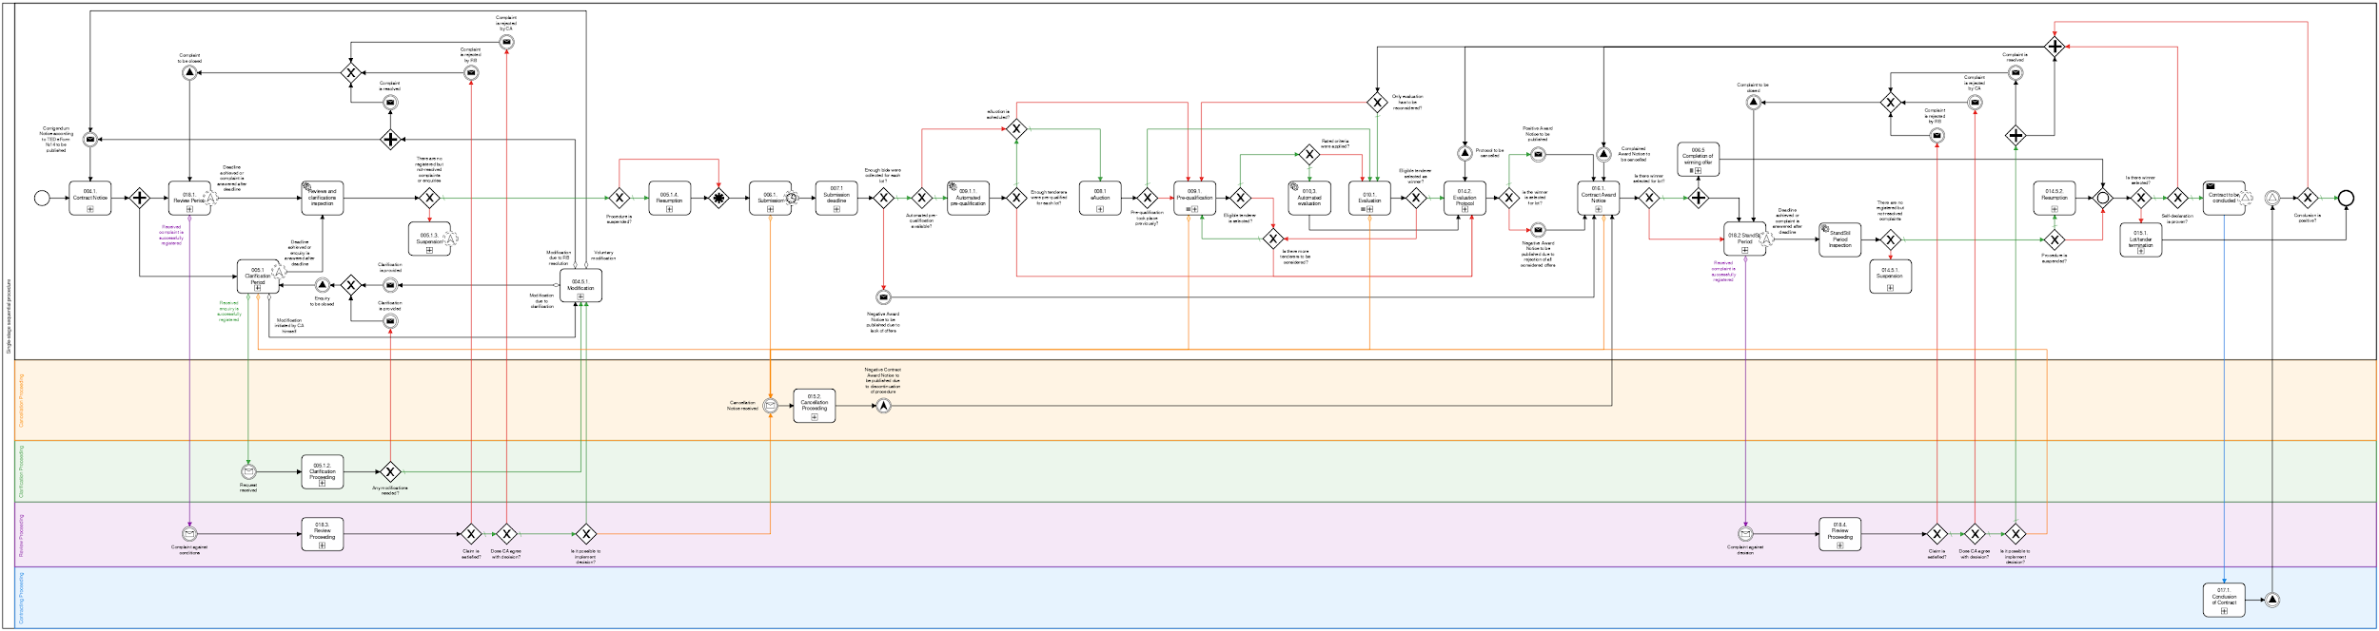*Business Process Diagram (go to* [*http://bit.ly/2J13Vf6*](http://bit.ly/2J13Vf6)*)*

##### Parallel Type

The procurement process is carried out in the following sequence:

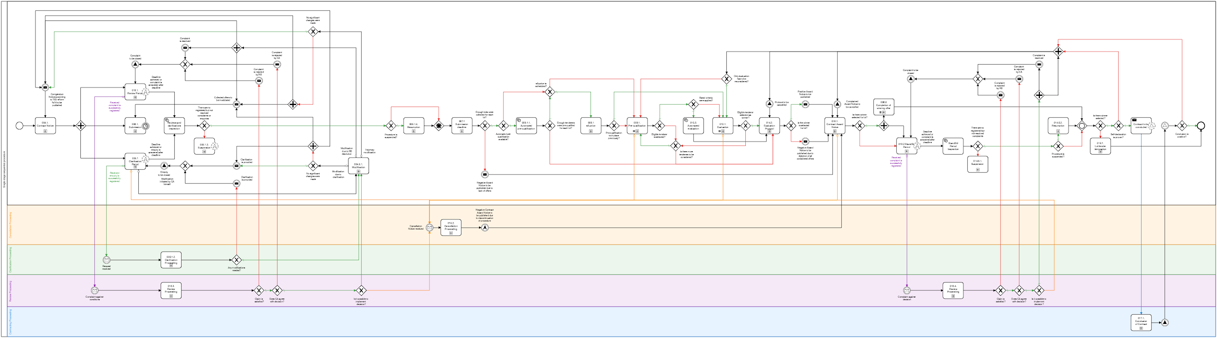

*Business Process Diagram (go to* [*http://bit.ly/2Y5Hclj*](http://bit.ly/2Y5Hclj)*)*

### Single-stage non-competitive procedure

* Negotiated procedures
* Direct awards

|  |
| --- |
| “procurementMethod”: "selective" “procurementMethodDetails”: "negotiatedProcedure", "directAward" |

The procurement process is carried out in the following sequence:

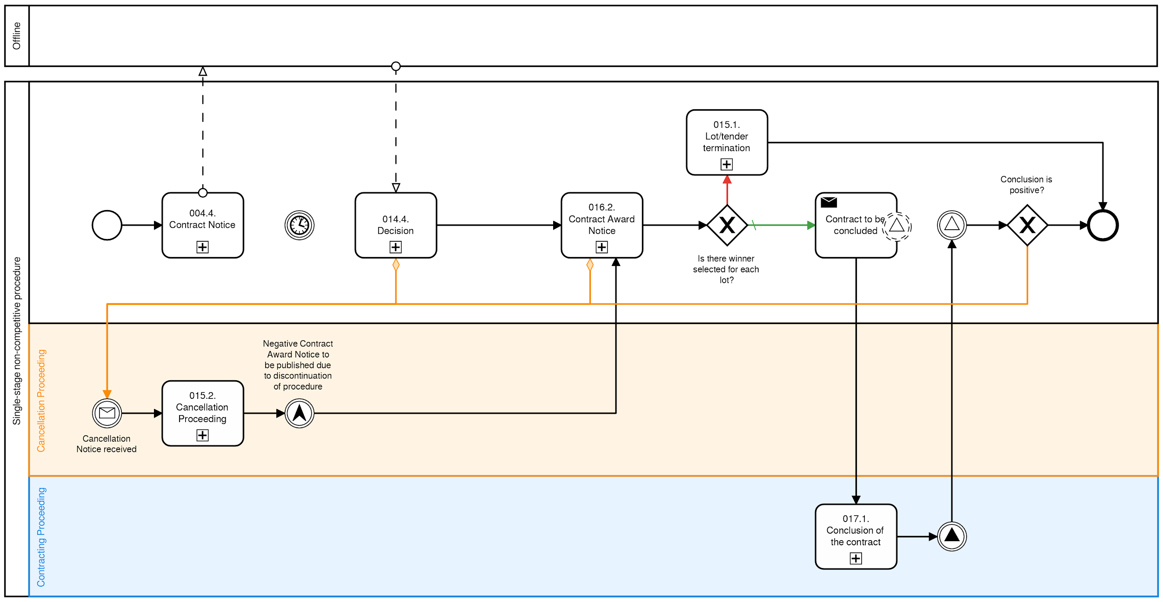

*Business Process Diagram (go to* [*http://bit.ly/2ZWVwOR*](http://bit.ly/2ZWVwOR)*)*

### Multi-stage competitive procedures

* Restricted Tender
* Design Contest
* Competitive Dialog

|  |
| --- |
| "procurementMethod": "open" "procurementMethodDetails": "restrictedTender", "designContest", "competitiveDialog" |

The procurement process is carried out in the following sequence:

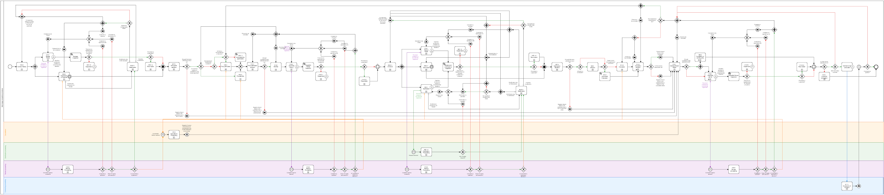

*Business Process Diagram (go to* [*http://bit.ly/2ZZqJB9*](http://bit.ly/2ZZqJB9)*)*

### Multi-stage repetitive procedures

Multi-stage repetitive procedure - Framework agreements set out the general terms under which specific purchases (“call offs”) can be made under the agreement. The purpose of using a framework is to enable contracting authorities to award individual contracts without going through a full EU procurement process each time.

|  |
| --- |
| "procurementMethod": "open" "procurementMethodDetails": "frameworkAgreement", "dynamicPurchasingSystem" |

The procurement process is splitted into (at least) two stages:

1. Framework establishment
2. Framework execution

##### Establishment

Part for isolated establishment (focused only on selection of participants for FA execution) is carried out in the following sequence:

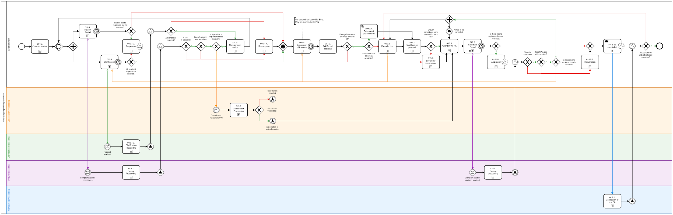

*Business Process Diagram (go to* [*https://bit.ly/2Vz3afM*](https://bit.ly/2Vz3afM)*)*

##### Execution

A framework agreement may be established with one provider (“single sulier frameworks”) or with more than one (“multiple suppliers frameworks”). Therefore there are four combinations of process available:

* Framework Agreement / Single supplier with direct call-offs
* Framework Agreement / Multiple suppliers with direct call offs
* Framework Agreement / Multiple suppliers with mini-competitions for call-offs
* Framework Agreement / Multiple suppliers with second-stage competitions

As shown above, where the framework is a multiple suppliers framework, the contracting authority has several options when awarding call off contracts:

* Where the terms of the framework are sufficiently precise to cover the particular call off, the contract may be awarded without reopening competition (i.e. a “direct call off”).
* Where the terms laid down in the framework are not precise enough or complete for the particular call off, a further competition (i.e. a “mini competition”) should be held with all those suppliers within the frameworks capable of meeting the particular need.
* In addition, there is a third option of calling off a contract via a combination of both direct award and mini-competition routes.

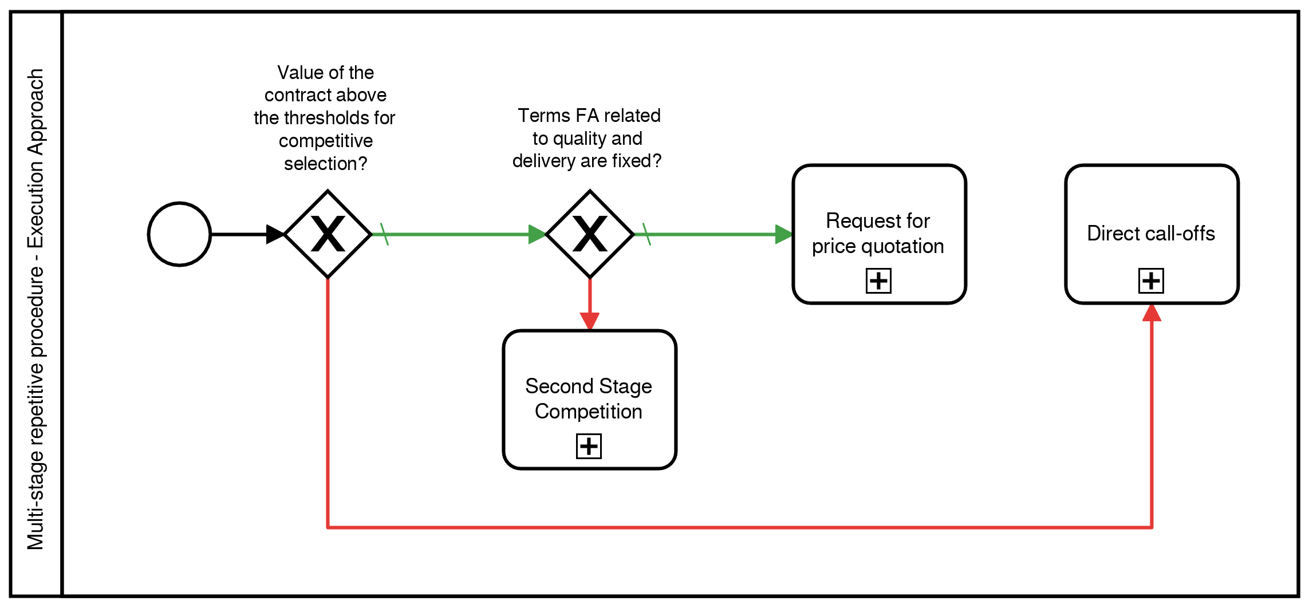*Business Process Diagram (go to* [*http://bit.ly/2Gqbloo*](http://bit.ly/2Gqbloo)*)*

Therefore, depending on CAs strategy as well as the value of the purchase from FA, execution part is carried out in accordance to one of the following sequences

Direct award

As set out above, where the terms of the framework are sufficiently precise to cover the particular call off, a direct call off may be made. If the framework agreement sets out all the terms governing the provision of the works, services and/or supplies concerned and all the objective conditions that are required to make a decision for award of the specific contract, then awarding the contract without reopening competition amongst the parties to the framework agreement is possible. In this instance, the choice of provider must be based on the objective criteria laid out in the procurement docs.

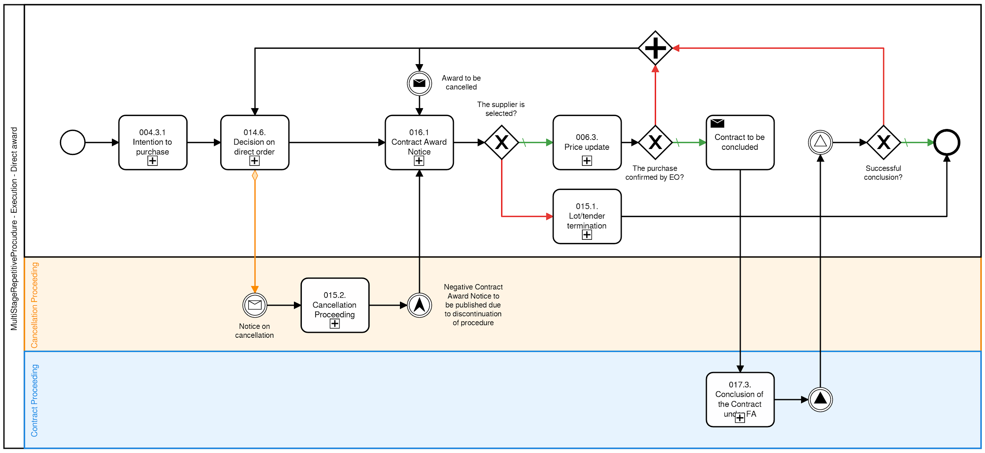

*Business Process Diagram (go to* [*http://bit.ly/2UotAiY*](http://bit.ly/2UotAiY)*)*

Request for Price Quotation

Where the terms laid down in the framework agreement are not precise or complete enough for the particular call off, a mini competition should be held with all those suppliers within the framework arrangements capable of meeting the particular need. This does not mean that basic terms can be renegotiated or that the specification used in setting up the framework can be substantively changed. Basic terms can be refined or supplemented to reflect particular circumstances that apply to the call off where these were not and could not be provided for when the framework agreement was established.

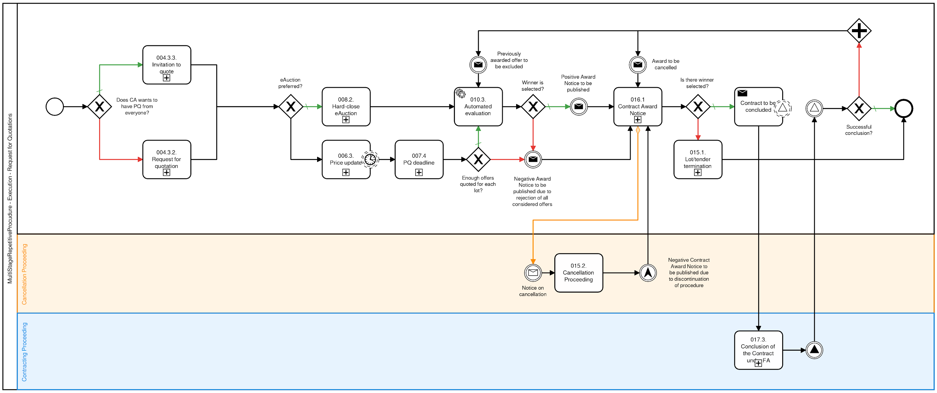*Business Process Diagram (go to* [*http://bit.ly/2XuJFFP*](http://bit.ly/2XuJFFP)*)*

Second-stage competition

Combination of direct award and mini-competition can be can be used provided that:

* the procurement documents state that this route may be used
* the framework sets out all the necessary terms governing provision of the work/supply/service being procured
* objective criteria are set out in the procurement documents for the framework agreement and are applied to determine whether a particular call off is directly awarded or goes on to a mini- competition
* the procurement documents specify which terms may be subject to the reopening of competition. The guidance gives this example.

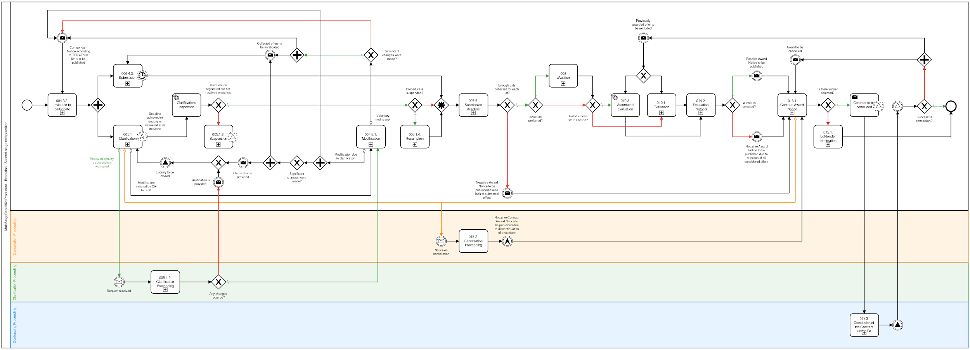*Business Process Diagram (go to* [*http://bit.ly/2Vf988A*](http://bit.ly/2Vf988A)*)*

## General approach

To ensure the attainment of the objectives set for the IT System, the following principles shall be considered while designing, developing and implementing the Architecture of the OCDS open source central unit of the electronic public procurement system.

### Multi-platform networking model

Any system based on this architecture will consists of a CDU that communicates in real time with several NEPPs and external information systems (eGov services) that ensure complete digitization of public procurement procedures. CDU consolidates and distributes all data entered and generated by NEPPs, and performs all transactions, processes and functionalities of the lifecycle and the NEPPs are serve as a user-interface - frolm registration of user account, through UI for all transactions processes and functionalities of lifecycle, up to ability of end-users to use needed eGov Services.

##### *End-to-end public procurement processes*

The functionalities of the system based on this architecture from CDU perspective will cover the entire procurement process, from procurement planning to billing and public procurement payments. Online tools will make the system easier for all end-users and will generate process improvements and significant benefits.

##### *Interoperability with eGov Services*

This architecture designed to ensure interoperability with existing and future eGovernment services and local national public registers. This approach guarantees a modern and advanced eProcurement system with comprehensive functionalities, but without presenting huge risk or expense since eGovernment services have already been significantly developed in most countries.

##### *Open source, open data and open contracting data standards.*

This architecture designed for a stack of open-source technologies to foster transparency and accountability of public procurement by incorporating open data concept and Advanced Open Contracting Data Standards. Openness of data shall help building citizens’ and economic operators’ trust in the Government, in efficiency of public procurement management and discourage any corrupt practices.

##### *Split-level architecture*

Involves independent design of systems’ components in compliance with interface standards between levels, which facilitates future incorporation of new services, evolution of the different functionalities and, in general, scalability of the system.

##### *Reliable data*

Any data shall be entered into the system through authorised and authenticated channels only.

##### *Extensibility*

Possibility to expand and supplement the system based on this Architecture with new functions or improve the existing ones.

##### *Additional features*

The following key features are applied for the development of the architecture of an Open Source Central Unit. These ensure that the architecture can be reusable in other context and implementing different technologies while guaranteeing the interoperability with other systems and being compliant with main standard regulations in public procurement.

|  |  |  |  |
| --- | --- | --- | --- |
|  |  |  |  |
| Based on United Nations Commission on International Trade Law on Public Procurement (UNCITRAL) (2011) | Complies with the European legislation on Public Procurement (e.g. 2004/17/EC, 2004/18/EC and their amendments) | Interoperable with existing official resources constituting the EU Single Market of Public Procurement | Maximum standardization of data according to international and EU standards: ISO, OCDS, EDI, CEN, etc |
|  |  |  |  |
| Fully open-sourced stack of frameworks of multi-paradigmatic development tools and databases services, | Complete independence from the hardware platforms and/or structures of data-centers or virtual clouds | Business-processes and workflows that are configured from independent parameterized blocks | Reconfigurable in attend to the needs of CAs in a flexible, efficient and customised manner for local or international level |

### eProcurement.Systems API

The eProcurement.Systems API is the only interface to Central Business Process Engine that is core unit of eProcurement.Systems infrastructure. The eProcurement.Systems API is a CQRS interface that provides programmatic access to BPE of the systems. It provides predictable URLs for accessing resources, and uses built-in HTTP features to receive commands and return responses. This makes it easy to communicate with.

The API accepts JSON or form-encoded content in requests. It returns JSON content in all of its responses, including errors. Only the UTF-8 character encoding is supported for both requests and responses.

# Design and development principles

This section describes the design and development methodologies followed for the architecture definition of the OCDS Open Source Central Unit of the electronic public procurement system. The general approach on design of architecture for the eProcurement system involves the Service Oriented Architecture (SOA) and Exploratory Data Analysis (EDA) architecture. These two approaches combined provide a richer, more robust model by leveraging previously unknown causal relationships in order to build a new event pattern. This new business intelligence pattern triggers further automated processing that adds exponential value to the enterprise by injecting value-added information into the recognized pattern which could not have been previously achieved.

## Architectural approach

Event-driven SOA that combines the intelligence and proactiveness of EDA with the organizational capabilities found in service offerings.

### Service-oriented architecture

SOA is a style of software design where services are provided to the other components by application components, through a communication protocol over a network. The basic principles of service-oriented architecture are independent of vendors, products and technologies. A service is a discrete unit of functionality that can be accessed remotely and acted upon and updated independently, such as retrieving a credit card statement online.

### Event-driven architecture

EDA, is a software architecture pattern promoting the production, detection, consumption of, and reaction to events. From a formal perspective, what is produced, published, propagated, detected or consumed is a (typically asynchronous) message called the event notification, and not the event itself, which is the state change that triggered the message emission. Events do not travel, they just occur. However, the term event is often used metonymically to denote the notification message itself, which may lead to some confusion. Building systems around an event-driven architecture simplifies horizontal scalability in distributed computing models and makes them more resilient to failure. This is because an application state can be copied across multiple parallel snapshots for high-availability. New events can be initiated anywhere, but more importantly propagated across the network of data stores updating each as they arrive. Adding extra nodes becomes easier as well as you can simply take a copy of the application state, feed it a stream of events and run with it. Event-driven architecture can complement SOA because services can be activated by triggers fired on incoming events. This paradigm is particularly useful whenever the sink does not provide any self-contained executive

### CQRS architecture style: command-query separation

In traditional architectures, the same data model is used to query and update a database. That's simple and works well for basic CRUD operations. In more complex applications, however, this approach can become unwieldy. For example, on the read side, the application may perform many different queries, returning data transfer objects (Data Transfer Objects or DTOs) with different shapes.

Object mapping can become complicated. On the write side, the model may implement complex validation and business logic. As a result, you can end up with an overly complex model that does too much. Another potential problem is that read and write workloads are often asymmetrical, with very different performance and scale requirements.

Command and Query Responsibility Segregation (CQRS) is an architecture which addresses these problems by separating reads and writes into separate models, using commands to update data, and queries to read data.

* Commands should be task based, rather than data centric. Commands may be placed on a queue for asynchronous processing, rather than being processed synchronously.
* Queries never modify the database. A query returns a DTO that does not encapsulate any knowledge.

Compared to the single data model used in CRUD-based systems, the use of separate query and update models for the data in CQRS-based systems simplifies design and implementation.

|  |
| --- |
| Figure 1. General scheme for CQRS-approach |

For greater isolation, the read and the write data could be physically separated. In that case, the read database can use its own data schema that is optimized for queries.

For example, it can store a materialized view of the data, in order to avoid complex joins or mappings. It might even use a different type of data store. If separate read and write databases are used, they must be kept in sync. Typically this is accomplished by having the write model publish an event whenever it updates the DB.

### Design by Contract: contract programming approach

Design by contract (DbC), also known as contract programming, programming by contract and design-by-contract programming, is an approach for designing software prescribes that software designers should define formal, precise and verifiable interface specifications for software components, which extend the ordinary definition of abstract data types with preconditions, postconditions and invariants. These specifications are referred to as "contracts", in accordance with a conceptual metaphor with the conditions and obligations of business contracts.

The DbC approach assumes all client components that invoke an operation on a server component will meet the preconditions specified as required for that operation. Where this assumption is considered too risky (as in multi-channel client-server or distributed computing) the opposite "defensive design" approach is taken, meaning that a server component tests (before or while processing a client's request) that all relevant preconditions hold true, and replies with a suitable error message if not.

## Used Patterns

### Materialized View pattern

Materialized views (MV) are used to generate pre-populated views of the data in one or more data stores when the data isn't ideally formatted for required query operations. This can help support efficient querying and data extraction, and improve application performance.

##### *Context and problem*

When storing data, the priority for developers and data administrators is often focused on how the data is stored, as opposed to how it's read. The chosen storage format is usually closely related to the format of the data, requirements for managing data size and data integrity, and the kind of store in use. For example, when using NoSQL document store, the data is often represented as a series of aggregates, each containing all of the information for that entity. However, this can have a negative effect on queries. When a query only needs a subset of the data from some entities, such as a summary of orders for several customers without all of the order details, it must extract all of the data for the relevant entities in order to obtain the required information.

##### *Solution*

To support efficient querying, a common solution is to generate, in advance, a view that materializes the data in a format suited to the required results set. The MV pattern describes generating pre populated views of data in environments where the source data isn't in a suitable format for querying, where generating a suitable query is difficult, or where query performance is poor due to the nature of the data or the data store. These MVs, which only contain data required by a query, allow applications to quickly obtain the information they need. In addition to joining tables or combining data entities, MVs can include the current values of calculated columns or data items, the results of combining values or executing transformations on the data items, and values specified as part of the query. A MV can even be optimized for just a single query. A key point is that a MV and the data it contains is completely disposable because it can be entirely rebuilt from the source data stores.

|  |
| --- |
| Figure 2a. General scheme of “Materialized View” pattern |

A materialized view is never updated directly by an application, and so it's a specialized cache.

When the source data for the view changes, the view must be updated to include the new information. You can schedule this to happen automatically, or when the system detects a change to the original data. In some cases it might be necessary to regenerate the view manually. The figure shows an example of how the Materialized View pattern might be used.

##### *How it works*

The following figure shows an example of using the Materialized View pattern to generate a summary of sales. Data in the Order, OrderItem, and Customer tables in separate partitions in an Azure storage account are combined to generate a view containing the total sales value for each product in the Electronics category, along with a count of the number of customers who made purchases of each item.

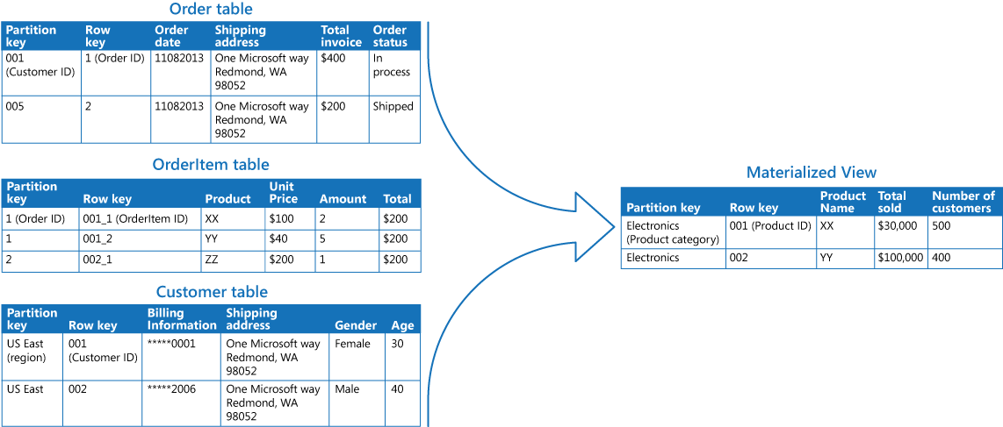

Figure 2b. Tables and materialized view

### Event Sourcing pattern

Instead of storing just the current state of the data in a domain, Event Sourcing uses an append-only store to record the full series of actions taken on that data. The store acts as the system of record and can be used to materialize the domain objects. This can simplify tasks in complex domains, by avoiding the need to synchronize the data model and the business domain, while improving performance, scalability, and responsiveness. It can also provide consistency for transactional data, and maintain full audit trails and history that can enable compensating actions.

##### *Context and problem*

Most applications work with data, and the typical approach is for the application to maintain the current state of the data by updating it as users work with it. For example, in the traditional Create, Read, Update, and Delete (CRUD) model a typical data process is to read data from the store, make some modifications to it, and update the current state of the data with the new values—often by using transactions that lock the data. The CRUD approach has some limitations:

* CRUD systems perform update operations directly against a data store, which can slow down performance and responsiveness, and limit scalability, due to the processing overhead it requires.
* In a collaborative domain with many concurrent users, data update conflicts are more likely because the update operations take place on a single item of data.
* Unless there's an additional auditing mechanism that records the details of each operation in a separate log, history is lost.

##### *Solution*

The Event Sourcing pattern defines an approach to handling operations on data that's driven by a sequence of events, each of which is recorded in an append-only store. Application code sends a series of events that imperatively describe each action that has occurred on the data to the event store, where they're persisted. Each event represents a set of changes to the data. The events are persisted in an event store that acts as the system of record (the authoritative data source) about the current state of the data. The event store typically publishes these events so that consumers can be notified and can handle them if needed. Consumers could, for example, initiate tasks that apply the operations in the events to other systems, or perform any other associated action that's required to complete the operation. Notice that the application code that generates the events is decoupled from the systems that subscribe to the events.

Typical uses of the events published by the event store are to maintain materialized views of entities as actions in the application change them, and for integration with external systems. For example, a system can maintain a materialized view of all customer orders that's used to populate parts of the UI. As the application adds new orders, adds or removes items on the order, and adds shipping information, the events that describe these changes can be handled and used to update the materialized view.

In addition, at any point it's possible for applications to read the history of events, and use it to materialize the current state of an entity by playing back and consuming all the events related to that entity. This can occur on demand to materialize a domain object when handling a request, or through a scheduled task so that the state of the entity can be stored as a materialized view to support the presentation layer.

The figure №3 below shows an overview of the pattern, including some of the options for using the event stream such as creating a materialized view, integrating events with external applications and systems, and replaying events to create projections of the current state of specific entities.

The Event Sourcing pattern provides the following advantages:

* Events are immutable and can be stored using an append-only operation. The user interface, workflow, or process that initiated an event can continue, and tasks that handle the events can run in the background.
* Events are simple objects that describe some action that occurred, together with any associated data required to describe the action represented by the event. Events don't directly update a data store. They're simply recorded for handling at the appropriate time.
* Events typically have meaning for a domain expert, whereas object-relational impedance mismatch can make complex database tables hard to understand. Tables are artificial constructs that represent the current state of the system, not the events that occurred.
* Event sourcing can help prevent concurrent updates from causing conflicts because it avoids the requirement to directly update objects in the data store.
* The append-only storage of events provides an audit trail that can be used to monitor actions taken against a data store, regenerate the current state as materialized views or projections by replaying the events at any time, and assist in testing and debugging the system. In addition, the requirement to use compensating events to cancel changes provides a history of changes that were reversed, which wouldn't be the case if the model simply stored the current state.
* The event store raises events, and tasks perform operations in response to those events. This decoupling of the tasks from the events provides flexibility and extensibility. Tasks know about the type of event and the event data, but not about the operation that triggered the event. In addition, multiple tasks can handle each event. This enables easy integration with other services and systems that only listen for new events raised by the event store.

|  |
| --- |
| Figure 3. General scheme of “Event sourcing” pattern |

# Hi-level eProcurement solution architecture

## Building blocks

The system consists of following set of components and environments:

### NEPPs

The front-end platforms are web platforms that implement eProcurement system features and provide access for CAs and EOs. The NEPPs interact with the CDU via the API and provides suppliers with temporary credentials to access the auction module hosted on the central unit.

### Central Unit

* *Business Process Engine* - core systems component responsible for execution of commands received and processes inside the system
* *CDB* - central database, which contains information related to each contracting process
* *Chronograph* - component that controls the time and operates as a scheduler
* *Transport agent -* middleware responsible for transferring data (requests and responses) between the System and third-party services and systems
* *Form Service -* service that allows NEPPs to get actual needed field-set together with existing related information and reference data within one single request to build UI-Form for producing specific type of data-entity by end-user on its side.
* *Auth Service -* self-contained service for securely transmitting information between parties as a JSON object. This information can be verified and trusted because it is digitally signed.
* *Operation Service* - self-contained service responsible for identification of the commands between the CDU (BPE) and the NEPPs.
* *Feed Point -* platform to organize real-time communication between parties (including NEPPs) for transfering a personalized data as a closed feed,
* Public Point - component that displays CDB records in read-only mode. Only information allowed for publication by the current legislation is displayed.

##### *Document Service*

Component responsible for registering, uploading, archiving, organising and control of access to all documents (files), enabling long-term preservation of them in digital format and ensuring that they can be easily retrieved without conversions. Service also provides basic document management functionality for receipt, dispatch, storage and retrieval of documents. Component consist of following:

* *Document Repository Management System* - server managing the access to the file repository. It controls the access to the files and reads the files from the repository. Requires Internet Connection.
* *Document Repository* - storage of the files attached to the tender notices, offers, and complaints. Does not require Internet Connection.

##### *Master Data Service*

Component is responsible for providing a Data Management, both master and meta. Therefore consumers (such as NEPPs) are able to use centralized dictionary, identification, classification and other kinds of data needed to fulfill data-layer of procurement process according to the data models used (see bellow).

##### *eAuction environment*

* *Front-end Auction Servers* - cluster of the front-end servers for the eAuction module, which serves eAuction users: displaying individual user’s page; retrieving the current status of the auction from the CDB server, etc.Requires Internet Connection.
* *Auction Public Server* - front-end eAuction server, installed for the observers. It displays the web page for read-only users, so that everybody can watch how an eAuction is running. Current status of the auction is received from the DB auction server. It does not allow making bids.Requires Internet Connection.
* *Back-end Auction Server* - back-end eAuction server. It receives bids uploaded through the front-end auction servers, saves them in the auction DB, and executes the logic of the eAuction module. During the auction, it keeps track of the time allocated to each bidder and it determines the sorting order of the bidders at the end of each round according to the award criteria. Does not require Internet Connection.
* *Auction DB Management Server* - back-end server, which provides correlation between the back-end auction server and the auction DB.Does not require an Internet Connection.
* *Auction DB* - auction database, which contains information about the auctions in progress and bids provided by every participant.Does not require an Internet Connection.

##### *Web portal*

Website that presents procurement information in compliance with legislation, from the CDB through the Portal’s Public. Contains general information pages as well. Requires Internet Connection. Web portal is described in the functional document “EBRD_MTender_Technical Specifications_v16.0.docx”, in section 4.1.

## Architecture diagram

|  |
| --- |
|   Figure 4. High-level diagram of the systems’ architecture |

# Data Standard

## Open Contracting Data Standard 1.1+

Data standard is modelled along the Open Contracting Standard[1] with extensions in areas that were not covered by it. OCDS is an open data standard for publication of structured information on all stages of a contracting process. The Open Contracting Data Standard is maintained using JSON Schema. The main sections and common objects used in the schema are introduced in the getting started section.

### OCDS structure

The OCDS provides a detailed specification of the fields and data structures to use when publishing open data about contracting processes. The OCDS concept of a release can be broadly equated to the concept of a ‘notice’ UNCITRAL regulations.

The core OCDS schema is designed to support global interoperability, and to include a common core of data fields required by a wide range of use cases. The OCDS schema can be extended with definitions for new data structures to meet the needs of particular publishers.

A typical OCDS release consists of Package, Release and one or more Sections. This documentation includes Package and Release within this Structure subheading. Sections, such as Tender, Award and Contract are explained within the Sections sub-heading. Objects are explained within the Building Blocks and Extensions Building Blocks.

### Building blocks

Building blocks are OCDS data structures that are smaller than most sections and are coherent blocks of data in their own right. It should be possible to read a building blocks data in isolation and for it to make sense. Where blocks have other building blocks nested within them the documentation shows how those are structured and then provides an example of the data that describes the building blocks together.

The majority of OCDS data is held within a release structure. One or more releases can be published within a release package. Releases are made up of a number of sections, including the following.

#### 

Parties

Each of the parties (organizations or other participants) referenced in a release must be included in the parties section: information on the parties who are involved in the contracting process and their roles, e.g. buyer, procuring entity, supplier etc. Organization references elsewhere in the schema are used to refer back to this entries in this list.

Planning

The planning section is used to describe the financial background to a contracting process. This include details of the budget from which funds are drawn or related budget-projects for this contracting process.

Budget

This section contains information about the budget line and/or associated projects, through which this contracting process is funded. It used to cross-reference to more detailed information held using a Budget Data Package (Expenditure Item and/or Budget Project) or where no linked Budget Data Package is available, to provide enough information to allow cross-reference with another published source of budget and project information.

Tender

The tender section includes details of the announcement that an organization intends to source some particular goods, works or services, and to establish one or more contract(s) for these.

Bids

The bid section is used to publish summary statistics and individual bid information. Where information is provided on individual bids, these statistics should match those that can be calculated from the bid details array and an array of bids, providing information on the bidders, and where applicable, bid status, bid values and related documents. The extent to which this information can be disclosed varies from jurisdiction to jurisdiction.

Prequalification

Data regarding prequalification process - limiting the number of qualified bidders by reviewing each bidder's qualifications against a set of criteria.

Awards

An award for the given procurement. There may be more than one award per contracting process e.g. because the contract is split amongst different providers, or because it is a standing offer.

Contract

The contract section is used to provide details of contracts that have been entered into. Every contract needs to have a related award, linked via the awardID property. This is because supplier information is contained within the ‘award’. The framework contract details below help illustrate the reasons for this.

|  |
| --- |
| Extending the standard  The OCDS release schema can be extended with definitions for new fields and data structures to meet the needs of particular communities of data publishers. This document also provides key information on using an extended release schema for the UNCITRAL. |

### Procurement Process Stages

Depending on the type of procedure (tender.procurementMethodDetails) different stages can be used. In general, there are 4 main stages of the procurement process, from which the competitive phase of the purchasing process can consist (in different combinations and / or sequences):

##### *Pre-selection*

This is a period during which interested parties can clarify any details of object of future procurement with CA and with respond to an initial contract notice are submits a short statement of information about the organization according to instructions or a questionnaire. These form the basis of a qualification submission that such parties must make to demonstrate their ability to implement the project. CA selects several candidates to be invited to the next stage. This stage relates specifically to the selection of competent tenderers, prior to the issue of invitations to tender with a main purpose to select those potential suppliers, whose qualifications and experience would minimise the risk of non-performance.

##### *Pre-selection Stage (PS) data-model*

The *pre-selection* of participants of future stages usually the first active stage of multi-stage procedures (restricted tender or any other). Therefore, the core of data-model of the pre-selection stage is the contractNotice and described as Release Package.

Since the stage is active (meaning that there are user actions form CA and EOs expected) in its process there are data describing its course and result generated by Users Actions. Such data are described by objects complementing the initial data model of the stage (see description below).

##### *Pre-Qualification*

During ‘Pre-qualification’ stage all invited (pre-selected) parties can also clarify any additional details of object of future procurement with CA and with respond to an invitation are submits a technical offer according to instructions or a questionnaire. These form the basis of a pre-qualification submission that such parties must make to demonstrate benefits and superiorities of theirs offers. CA selects several candidates to be invited to the next stage.

The pre-qualification process itself consists of the examination and evaluation of the technical part of received offers according to specifications and requirements as defined in the tender documentation, analyse their benefit and determine their superiority. Pre-qualification is the basis for the subsequent selection of the offer that provides the best value for money for the CA.

##### *Pre-qualification Stage (PQ) data-model*

|  |  |
| --- | --- |
| Note that pre-qualification of participants of future stages may goes either the first (and even include functionality of PS) or one of the subsequent stages of a multi-stage tender as stand-alone stage |  |

In case of PQ is a first active stage of multi-stage tender, the core of data-model of such ‘PQ’ is equal to PS data-model described above.

If PQ used in a Procurement Process as subsequent stage, an extension to initial data-model is used to describe a list of invited (usually - pre-selected) participants. This model extension is equal to model of definition of disclosed bids described below. All included ‘bids’ will be indicated with initial status ‘invited’ that means that this is a “drafts” of future possible technical bids, based on the results of previous stage (in case of PQ usually it’s a PS). Also all tenderers who passed previous stage and invited to participate in PQ will be included in a ‘parties’ section of definition of such PQ as ‘tenderers’. Since the stage is active (meaning that there are user actions form CA and EOs expected) in its process there are data describing its course and result generated by Users Actions. Such data are described by objects complementing the initial data model of the stage (see description below).

Given that the process of selection of qualified suppliers at the PQ in repetitive procedures (FA, DPS) leads to the obligation to Contract Award Notices, the data-model of this stage is also could be expanded with one more section - ‘contracts’ that includes auto-generated CANs. This model extension is equal to model of definition of Contract Award Notices described below.

##### *Evaluation*

During ‘Evaluation’ stage all invited (pre-selected and/or pre-qualified) parties can also clarify any additional details of object of future procurement with CA and with respond to an invitation are submits a financial offer according to instructions or a questionnaire. CA selects several candidates to be invited to the next stage. Financial evaluation of the proposals involves consideration the offers with the financial and commercial requirements stipulated in the tender documentation. It is also important to identify whether they are within the available budget for the project.

##### Evaluation Stage (EV) data-model

|  |  |
| --- | --- |
| Note that Evaluation stage may go either the first (and include one or both previous steps: PS and PQ) or one of the subsequent stages of a multi-stage tender as stand-alone stage. |  |

In case of EV is a first active stage of multi-stage tender, the core of data-model of such pre-qualification stage is equal to cnPreselectionStage data-model described above. If EV used in a Procurement Process as subsequent stage, an extension to initial data-model is used to describe a list of invited (usually - pre-qualified) participants. This model extension is equal to model of definition of disclosed bids described below. All included ‘bids’ will be indicated with initial status ‘invited’ that means that this is a “drafts” of future possible financial bids, based on the results of previous stage (in case of EV usually it’s a PQ). Also all tenderers who passed previous stage and invited to participate in EV will be included in a ‘parties’ section of definition of such EV as ‘tenderers’.

Since the stage is active (meaning that there are user actions form CA and EOs expected) in its process there are data describing its course and result generated by Users Actions. Such data are described by objects complementing the initial data model of the stage (see description below).

Given that the process of selecting a winner at the EV leads to the obligation to Contract Award Notices, the data-model of this stage is also expanded with one more section - ‘contracts’ that includes auto-generated CANs. This model extension is equal to model of definition of Contract Award Notices described below.

### Data Transfer Approach

Data-releases must be published within a release package, which can contain one or more releases. The release package, modelled on the Data Package protocol, provides metadata about the release(s) it contains, the publisher, and data licensing information.

The following points describe some information about the releases and records:

* Releases are immutable, records are updated over the life of the contracting processes.
* Releases are point in time updates, records show the most up to date information.
* A single contracting process can have many releases but must have only one record.
* Records either store a history of changes **or** links to individual releases.
* The OCID remains consistent across all releases and records whilst the release ID changes with each release.
* The value of persistent releases for spotting red flags.
* Releases can **repeat or update** information from previous releases.
* Release tags help to identify what stage of the contracting process a release is about

#### 4.1.4.1 Record Package

The Record Package contains a list of records along with publishing metadata. The records pull together all the releases under a single OCID and compile them into the latest version of the information along with the history of any data changes.

|  |  |
| --- | --- |
| **Record Package Schema on** [**GitHub/Open-Contracting**](https://github.com/open-contracting/standard/blob/1.1-dev/standard/schema/record-package-schema.json#L118) |  |

Schema

|  |  |  |  |
| --- | --- | --- | --- |
| **uri** |  | string | auto-generated |
| The URI of this package that identifies it uniquely in the world | | | |
| **version** |  | string | auto-generated |
| The version of the OCDS schema used in this package | | | |
| **extensions** | array | string | auto-generated |
| An array of OCDS extensions used in this package | | | |
| **publisher** | object |  | auto-generated |
| Information to uniquely identify the publisher of this package  See Publisher | | | |
| **license** |  | string (uri),null | auto-generated |
| A link to the license that applies to the data in this data package. | | | |
| **publicationPolicy** |  | string (uri),null | auto-generated |
| A link to a document describing the publishers publication policy. | | | |
| **publishedDate** |  | string (date-time) | auto-generated |
| The date that this package was published. | | | |
| **packages** | array | string (uri) | auto-generated |
| A list of URIs of all the release packages that were used to create this record package | | | |
| **records** | array | object | auto-generated |
| The records for this data package | | | |

#### 4.1.4.2 Record

The record (Release Package) schema describes the container document for publishing releases.

Schema

|  |  |  |  |
| --- | --- | --- | --- |
| **ocid** |  | string | auto-generated |
| A unique identifier that identifies the unique part of multi-stage Open Contracting Process. | | | |
| **releases** | array | string (uri),null | auto-generated |
| A list of objects that identify the release associated with this OCID. The releases are sorted into date order in the array, from oldest to newest. | | | |
| **compiledRelease** | array | object | auto-generated |
| This is the latest version of all the contracting data, provided as an array of releases | | | |
| **versionedRelease** |  | string (uri),null | auto-generated |
| This contains the history of the data with all versions of the information and the release they came from | | | |

#### 4.1.4.3 Linked releases

Information to uniquely identify the release

Schema

|  |  |  |  |
| --- | --- | --- | --- |
| **url** |  | string (uri),null | auto-generated |
| The URL of the release which contains the URL of the package | | | |
| **date** |  | string (date-time),null | auto-generated |
| The date this information was first released, or published. | | | |
| **tag** | enum | string | auto-generated |
| One value from the releaseTag codelist. Tags may be used to filter release and to understand the kind of information that a release might contain. The tag should match the tag in the release. This provides additional context when reviewing a record to see what types of releases are included for this ocid. | | | |

#### 4.1.4.4 Release Package

All information about a current stage of specific part of contracting process is described with release.

|  |  |
| --- | --- |
| **Release Package Schema on** [**GitHub/Open-Contracting**](https://github.com/open-contracting/standard/blob/1.1-dev/standard/schema/release-package-schema.json) |  |

Schema

|  |  |  |  |
| --- | --- | --- | --- |
| **ocid** |  | string | auto-generated |
| A unique identifier that identifies the unique part of multi-stage Open Contracting Process. | | | |
| **id** |  | string | auto-generated |
| An identifier for this particular released information | | | |
| **date** |  | string | auto-generated |
| The date this information was first released, or published. | | | |
| **tag** | array | string | auto-generated |
| One or more values from the releaseTag codelist. Used to understand the kind of that a release might contain. | | | |
| **initiationType** |  | string | auto-generated |
| String specifying the type of initiation process used for this contract, taken from the initiationType codelist. | | | |
| **parties** | array | object | auto-generated |
| Information on the Organizations who are involved in the process and their roles.  See Organization | | | |
| **buyer** |  | object | auto-generated |
| The buyer is the entity whose budget will be used to purchase the goods.  See Organization reference | | | |
| **planning** |  | object | optional |
| Information from the planning phase of the contracting process.  See Planning | | | |
| **tender** |  | object | optional |
| The activities undertaken in order to enter into a contract.  See Tender | | | |
| **bids** | array | object | auto-generated |
| The bid section is used to publish summary statistics, and where applicable, individual bid information.  See Bids | | | |
| **awards** | array | object | auto-generated |
| Information from the award phase of the contracting process.  See Award | | | |
| **contracts** | array | object | auto-generated |
| Information from the contract creation phase of the procurement process.  See Contracts | | | |
| **relatedProcesses** | array | object | auto-generated |
| A link to a related contracting process in OCDS and the type of relationship  See RelatedProcess | | | |
| **hasPreviousNotice** |  | boolean | optional |
| True/False field whether this release represents a notice that is connected to a previous notice | | | |
| **buyerInternalReferenceId** |  | string, null | optional |
| The buyer's internal reference identifier is an EU specific field. | | | |
| **purposeOfNotice** |  | object | optional |
| Details about the purpose of this notice release  See PurposeOfNotice | | | |
| **relatedNotice** | array | object | optional |
| Information that connects a notice with a related notice for the contracting process.  See RelatedNotice | | | |

### Definitions

For more information about entitities definitions, you can find the extended version of this section in the latest version of the document *Definitions.xlsx*.

From eProcurementSystem.MD:

##### AcceleratedProcedure

|  |  |  |  |
| --- | --- | --- | --- |
| **isAcceleratedProcedure** |  | boolean | default:false |
| A True/False field to indicate whether an accelerated procedure has been used for this procurement | | | |
| **acceleratedProcedureJustification** |  | string, null |  |
| Justification for using an accelerated procedure | | | |

##### Address

|  |  |  |  |
| --- | --- | --- | --- |
| **streetAddress** |  | string |  |
| The street address. For example, 1600 Amphitheatre Pkwy. | | | |
| **postalCode** |  | string, null |  |
| The postal code. For example, 94043.. | | | |
| **addressDetails** |  | object |  |
| See AddressDetails | | | |

##### AddressDetails

|  |  |  |  |
| --- | --- | --- | --- |
| **country** |  | object |  |
| Classification of the country according to one of available schemes  See Classification | | | |
| **locality** |  | object |  |
| Classification of the locality according to one of available schemes  See Classification | | | |
| **region** |  | object |  |
| Classification of the region according to one of available schemes  See Classification | | | |

##### Amendment

|  |  |  |  |
| --- | --- | --- | --- |
| **date** |  | string, date-time | auto-generated |
| The date of this amendment. | | | |
| **rationale** |  | string, null |  |
| An explanation for the amendment | | | |
| **id** |  | string, null | auto-generated |
| An identifier for this amendment: often the amendment number | | | |
| **description** |  | string, null |  |
| A free text, or semi-structured, description of the changes made in this amendment. | | | |
| **amendsReleaseID** |  | string, null | auto-generated |
| Provide the values for this contracting process before the amendment was made. | | | |
| **releaseID** |  | string, null | auto-generated |
| Provide the values for this contracting process after the amendment was made. | | | |
| **type** |  | string, null | auto-generated |
| A type for this amendment taken from a Amendment types codelist | | | |
| **status** |  | string, null | auto-generated |
| A status for this amendment taken from a Amendment statuses codelist | | | |
| **relatesTo** |  | string, null | auto-generated |
| This ‘amendment’ can be specifically related to one of the lots. Where this is a case, this attribute to be filled as a ‘lot’ | | | |
| **relatedItem** |  | string, null | auto-generated |
| Where ‘relatesTo:lot’ for this ‘amendment’ a unique id of the related lot shall be reflected by this attribute | | | |

##### Award

|  |  |  |  |
| --- | --- | --- | --- |
| **id** |  | string, date-time | auto-generated |
| The identifier for this award | | | |
| **suppliers** | array | object | auto-generated |
| See OrganizationReference | | | |
| **documents** | array | object |  |
| All documents and attachments related to the award, including any notices.  See Document | | | |
| **value** |  | string, null | auto-generated |
| The total value of this award  See Value | | | |
| **items** | array | object | auto-generated |
| The goods and services awarded in this award, broken into line items  See Item | | | |
| **status** |  | string, null | auto-generated |
| The current status of the award drawn from the AwardStatuses codelist | | | |
| **statusDetails** |  | string, date-time | auto-generated |
| Additional details of an award status according to AwardStatusDetails codelist | | | |
| **date** |  | string, null | auto-generated |
| The date of the contract award. This is usually the date on which a decision to award was made. | | | |
| **relatedLots** | array | string, null | auto-generated |
| If this award relates to one or more specific lots, provide the identifier(s) of the related lot(s) here. | | | |
| **relatedBid** |  | string, null | auto-generated |
| The identifier of the bid related to this award | | | |
| **requirementResponces** | array | object | auto-generated |
| See RequirementResponse | | | |
| **weightedValue** |  | object | auto-generated |
| Total weighted value for this award calculated with a scoring function applied  See Value | | | |

##### BankAccount

|  |  |  |  |
| --- | --- | --- | --- |
| **description** |  | string |  |
| Any free text description related to the Bank Account | | | |
| **bankName** |  | string |  |
| The legal name of the bank | | | |
| **address** |  | object |  |
| Bank address described as standard ‘address’ object  See Address | | | |
| **identifier** |  | object |  |
| The main identifier of the Bank according to one of available Banks schemes  See Identifier | | | |
| **accountIdentification** | array | object |  |
| The settlement account according to one of available bank account identification schemes  See Classification | | | |
| **additionalAccountIdentifiers** | array | object |  |
| Additional identifiers of bank account (e.g. fiscal code of the bank if applicable)  See Identifier | | | |

##### 

##### Bid

|  |  |  |  |
| --- | --- | --- | --- |
| **id** |  | string, null | auto-generated |
| A local identifier for this bid | | | |
| **date** |  | string, date-time | auto-generated |
| The date when this bid was received. | | | |
| **status** |  | string, null | auto-generated |
| The status of the bid, drawn from the bidStatus codelist | | | |
| **statusDetails** |  | string, null | auto-generated |
| The status details of the bid, drawn from the bidStatusDetails codelist | | | |
| **tenderers** | array | object |  |
| See OrganizationReference | | | |
| **value** |  | object |  |
| The total value of the bid  See Value | | | |
| **documents** | array | object, null |  |
| All documents and attachments related to the bid and its evaluation.  See Document | | | |
| **relatedLots** | array | string |  |
| If this bid relates to one or more specific lots, provide the identifier(s) of the related lot(s) here. | | | |
| **requirementResponses** | array, null | string |  |
| A set of responses by EO against the requirements applied by PE for eligibility check and evaluation  See RequirementResponse | | | |

##### BidStatistic

|  |  |  |  |
| --- | --- | --- | --- |
| **id** | array | string, null | auto-generated |
| An internal identifier for this statistical item. | | | |
| **measure** |  | string, null | auto-generated |
| An item from the bidStatistics codelist for the statistic reported in value. | | | |
| **date** |  | string, date-time | auto-generated |
| The date when this statistic was last updated. This is often the closing date of the tender process. | | | |
| **value** |  | number,null | auto-generated |
| The value for the measure in question. Total counts should be provided as an integer. | | | |
| **notes** |  | string, null | auto-generated |
| Any notes required to understand or interpret the given statistic. | | | |
| **relatedLot** |  | string, null | auto-generated |
| If this statistic relates to bids on a particular lot, provide the lot identifier here. | | | |

##### BudgetSource

|  |  |  |  |
| --- | --- | --- | --- |
| **budgetBreakdownID** |  | string |  |
| ID of part of initial defined budget using BudgetBreakdown.id as a link | | | |
| **amount** |  | number |  |
| The amount of available fundings | | | |

##### 

##### Budget

|  |  |  |  |
| --- | --- | --- | --- |
| **id** |  | string |  |
| An identifier for the budget | | | |
| **description** |  | string |  |
| A short free text description of the budget | | | |
| **project** |  | string |  |
| The name of the project that through which this contracting process is funded (if applicable) | | | |
| **projectID** |  | string |  |
| An external identifier for the project that this contracting process forms part of, or is funded via (if applicable). | | | |
| **uri** |  | string |  |
| A URI pointing directly to a machine-readable record about the budget | | | |
| **europeanUnionFunding** |  | object |  |
| Details where a procurement has partial or full financing from a European funded project  See EuropeanUnionFunding | | | |
| **isEuropeanUnionFunded** |  | boolean |  |
| A True or False field to indicate whether this procurement is related to a project and/or programme financed by EU funds. | | | |
| **budgetAllocation** | array | object |  |
| Structured information about allocation of fundings under this concluded contract  See BudgetAllocation | | | |
| **budgetSource** | array | object |  |
| Set of sources of fundings defined for this concluded contract  See BudgetSource | | | |
| **sourceEntity** |  | object |  |
| Reference the organization providing the budget  See OrganizationReference | | | |
| **verified** |  | boolean |  |
| A True or False field to indicate whether this funds are verified by authorized entity (Treasury) | | | |
| **verificationDetails** |  | string |  |
| The rationale for the verification provided in free text. | | | |
| **amount** |  | object |  |
| Object described the sum of the available funds under this EI  See Value | | | |
| **budgetBreakdown** | array | object |  |
| Detailed budget breakdown to be expressed, covering multiple budget sources and multiple periods  See BudgetBreakdown | | | |

##### BudgetBreakdown

|  |  |  |  |
| --- | --- | --- | --- |
| **id** |  | string |  |
| An identifier for this particular budget entry (equal to OCID of used FS) | | | |
| **description** |  | string, null |  |
| A short free text description of this budget entry. | | | |
| **amount** |  | object |  |
| The value of the budget line item.  See Value | | | |
| **uri** |  | string |  |
| A URI pointing directly to a machine-readable information about this budget entry. | | | |
| **sourceParty** |  | object |  |
| Reference the organization providing the funds under this budget-line  See OrganizationReference | | | |
| **period** |  | object |  |
| The period covered by this budget entry.  See Period | | | |

##### BudgetAllocation

|  |  |  |  |
| --- | --- | --- | --- |
| **budgetBreakdownID** |  | string |  |
| ID of part of initial defined budget using BudgetBreakdown.id as a link | | | |
| **period** |  | object |  |
| The period on which specific budget is allocated  See Period | | | |
| **relatedItem** |  | string |  |
| Identifier of specific item on which allocated budget is related | | | |
| **amount** |  | number |  |
| The amount of available fundings | | | |

##### BusinessFunction

|  |  |  |  |
| --- | --- | --- | --- |
| **id** |  | string |  |
| ID for this function | | | |
| **type** |  | string,url |  |
| This field is used to indicate the code of function according to the BusinessFunctions codelist | | | |
| **jobTitle** |  | string,null |  |
| Job title name | | | |
| **period** |  | object |  |
| Period of occupation of this business function  See Period | | | |
| **documents** |  | string,url |  |
| See Document | | | |

##### Classification

|  |  |  |  |
| --- | --- | --- | --- |
| **scheme** |  | string,url |  |
| This field is used to indicate the scheme/codelist from which the classification is drawn | | | |
| **id** |  | string,null |  |
| The classification code drawn from the selected scheme. | | | |
| **description** |  | string,null |  |
| A textual description or title for the code. | | | |
| **uri** |  | string,url |  |
| A URI to identify the code | | | |

##### Coefficient

|  |  |  |  |
| --- | --- | --- | --- |
| **id** |  | string |  |
| The identifier of this coefficient | | | |
| **value** |  | number, boolean, string, integer |  |
| Requirement value for this coefficient | | | |
| **coefficient** |  | number |  |
| The value of the coefficient | | | |

##### 

##### ContactPoint

|  |  |  |  |
| --- | --- | --- | --- |
| **name** |  | string |  |
| The name of the contact person, department, or contact point, for correspondence relating to this process | | | |
| **email** |  | string |  |
| The e-mail address of the contact point/person | | | |
| **telephone** |  | string,null |  |
| The telephone number of the contact point/person. This should include the international dialling code | | | |
| **url** |  | string,null |  |
| A web address for the contact point/person | | | |

##### ConfirmationRequest

|  |  |  |  |
| --- | --- | --- | --- |
| **id** |  | string |  |
| The identifier for this request | | | |
| **title** |  | string,null |  |
| Request title | | | |
| **description** |  | string,null |  |
| Request description | | | |
| **source** |  | string,null |  |
| Source of response to the requirements specified in the criterion as one of the available types, | | | |
| **relatesTo** |  | string,null |  |
| The schema element on which this request is related | | | |
| **relatedItem** |  | string,null |  |
| The id of related element | | | |
| **requestGroups** | array | object |  |
| A group of actors related to this request.  See RequestGroup | | | |
| **type** | enum | string |  |
| The way or confirmation according to RequestType codelist | | | |

##### ConfirmationResponse

|  |  |  |  |
| --- | --- | --- | --- |
| **id** |  | string |  |
| The identifier for this confirmation response | | | |
| **value** |  | object | |
| See ConfirmationResponseValue | | | |
| **request** |  | string |  |
| The id and of the request on which the response is applicable to | | | |

##### ConfirmationResponseValue

|  |  |  |  |
| --- | --- | --- | --- |
| **name** |  | string |  |
| The name of Entity whose representative did this conformation | | | |
| **id** |  | string | |
| The identifier of Entity whose representative did this conformation | | | |
| **date** |  | string |  |
| The date than this confirmation has been done | | | |
| **relatedPerson** |  | object | |
| Reference to the person who did this confirmation  See PersoneReference | | | |
| **verification** |  | object |  |
| The type and the body of confirmation substance  See Verification | | | |

##### Contract

|  |  |  |  |
| --- | --- | --- | --- |
| **id** |  | string | auto-generated |
| The identifier for this contract | | | |
| **awardID** |  |  | auto-generated |
| The award.id against which this contract is being issued. | | | |
| **extendsContractID** |  | string,null | auto-generated |
| If this contract extends or amends a previously issued contract, then the contract.id provided here. | | | |
| **title** |  | string,null |  |
| Contract title | | | |
| **description** |  | string,null |  |
| Contract description | | | |
| **status** | enum | string,null | auto-generated |
| The current status of the contract. Drawn from the contractStatus codelist | | | |
| **statusDetails** |  | string | auto-generated |
| The details of the status of the contract specified with contract statusDetails codelist | | | |
| **agreedMetrics** | array | object | auto-generated |
| Any target metrics set out as part of the contract or its terms  See Metric | | | |
| **period** |  | object |  |
| The start and end date for the contract.  See Period | | | |
| **value** |  | object | auto-generated |
| The total value of this contract.  See Value | | | |
| **confirmationRequests** | array | object | auto-generated |
| The set of confirmations required under this contract  See ConfirmationRequest | | | |
| **confirmationResponses** | array | object |  |
| The set of responses of requested confirmations  See ConfirmationResponse | | | |
| **documents** | array | object |  |
| All documents and attachments related to the contract, including any notices.  See Document | | | |
| **implementation** | array | object |  |
| See Implementation | | | |
| **relatedProcesses** | array | object | auto-generated |
| Details of the related process can be provided here.  See RelatedProcess | | | |
| **milestones** | array | object |  |
| A list of milestones associated with the finalisation of this contract.  See Milestone | | | |
| **amendments** | array | object |  |
| See Amendment | | | |
| **date** |  | date | auto-generated |
| Date when this contract was issued | | | |

##### Conversion

|  |  |  |  |
| --- | --- | --- | --- |
| **id** |  | string |  |
| The identifier for this conversion | | | |
| **description** |  | string,null |  |
| Conversion description | | | |
| **rationale** |  | string |  |
| The rationale provided in free text | | | |
| **coefficients** |  | array |  |
| A set of coefficients applicable within this conversion for each value available under related requirement  See Coefficient | | | |
| **relatesTo** |  | enum |  |
| The schema element that the conversion relates to | | | |
| **relatedItem** |  | string |  |
| The id of related element | | | |

##### Criterion

|  |  |  |  |
| --- | --- | --- | --- |
| **id** |  | string |  |
| The identifier for this criterion | | | |
| **title** |  | string,null |  |
| Criterion title | | | |
| **description** |  | string,null |  |
| Criterion description | | | |
| **source** |  | string,null |  |
| Source of response to the requirements specified in the criterion as one of available types | | | |
| **relatesTo** |  | string,null |  |
| The schema element that the criterion judges, evaluates or assesses. E.g. criterion may be defined against items or bidders | | | |
| **relatedItem** |  | string,null |  |
| The id of related element | | | |
| **requirementGroups** | array | object |  |
| A list of requirement groups for this Criterion  See RequirementGroup | | | |

##### Details

|  |  |  |  |
| --- | --- | --- | --- |
| **typeOfBuyer** |  | string |  |
| The type of buyer taken from the EU's specified list [typeOfBuyer] | | | |
| **mainGeneralActivity** |  | string |  |
| The main general activity of the buyer taken from the EU's specified list mainGeneralActivity codelist | | | |
| **mainSectoralActivity** |  | string |  |
| The activity of the buyer taken from the mainSectoralActivity codelist | | | |
| **isACentralPurchasingBody** |  | boolean |  |
| A true/false field to indicate whether the organization is a central purchasing body | | | |
| **scale** |  | string |  |
| For commercial organization's, is this a micro, Small or Medium or large entity according to the Scale codelist | | | |
| **gpaProfile** |  | object |  |
| See GpaProfile | | | |
| **bankAccounts** | array | object |  |
| See BankAccount | | | |
| **legalForm** |  | object |  |
| Classification of the organization according to Classifier of organizational and legal forms of entities of Moldova (MD-CFOJ)  See Classification | | | |
| **mainEconomicActivity** | array | object |  |
| Identifier of the registered activity according to Classification of the types of economic activity (MD-CTEA)  See Classification | | | |
| **permits** | array | object |  |
| Information about permits and licenses issued for the organization  See Permit | | | |
| **typeOfSupplier** |  | string |  |
| Classification of the supplier according to typeOfSupplier codelist | | | |

##### Document

|  |  |  |  |
| --- | --- | --- | --- |
| **id** |  | string |  |
| A local, unique identifier for this document. | | | |
| **documentType** |  | string |  |
| A classification of the document described taken from the documentType codelist. | | | |
| **title** |  | string,null |  |
| The document title. | | | |
| **description** |  | string,null |  |
| A short description of the document. | | | |
| **url** |  | string,url |  |
| A direct link to the document or attachment. | | | |
| **datePublished** |  | string,date-time |  |
| The date on which the document was first published. | | | |
| **dateModified** |  | string,date-time |  |
| Date that the document was last modified | | | |
| **format** |  | string,null |  |
| The format of the document taken from the IANA Media Types code list. | | | |
| **language** |  | string,null |  |
| Specifies the language of the linked document using either two-digit ISO 639-1 | | | |
| **relatedLots** | array | string,null |  |
| If this document relates to a particular lot, provide the identifier(s) of the related lot(s) here. | | | |

##### EconimicActivityReference

|  |  |  |  |
| --- | --- | --- | --- |
| **id** |  | string |  |
| The identifier of specific economic activity described for EO | | | |
| **description** |  | string |  |
| Human readable description of related activity | | | |

##### ElectronicWorkflows

|  |  |  |  |
| --- | --- | --- | --- |
| **useOrdering** |  | boolean |  |
| A True/False field to indicate if electronic ordering will be used. Required by the EU | | | |
| **usePayment** |  | boolean |  |
| A field to indicate whether the Dynamic Purchasing System may be used by buyers outside the notice. | | | |
| **acceptInvoicing** |  | boolean |  |
| A True/False field to indicate if electronic invoicing will be accepted. Required by the EU | | | |

##### ElectronicAuctions

|  |  |  |  |
| --- | --- | --- | --- |
| **statistics** |  | object | auto-generated |
| Aggregate statistics about the auctions related to this specific contracting process | | | |
| **details** |  | array |  |
| An array, providing information for each auction scheduled under this specific contracting process  See ElectronicAuctionDetails | | | |

##### ElectronicAuctionDetails

|  |  |  |  |
| --- | --- | --- | --- |
| **id** |  | string | auto-generated |
| A unique identifier for the auction | | | |
| **relatedLot** |  | string |  |
| If this auction relates to a specific lot, this field contains the lot identifier | | | |
| **electronicAuctionModalities** |  | array |  |
| The set of specific attributes and values of this auction  See ElectronicAuctionModality | | | |
| **auctionPeriod** |  | object |  |
| Auction period for specific electronic auction | | | |
| **electronicAuctionProgress** |  | array |  |
| The array describes set of parts of the auction (rounds) and users action (moves) under this parts  See ElectronisAuctionRound | | | |
| **electronicAuctionResult** |  | array |  |
| The array describes a result of specific electronic auction  See ElectronicAuctionResult | | | |

##### ElectronicAuctionModality

|  |  |  |  |
| --- | --- | --- | --- |
| **eligibleMinimumDifference** |  | object |  |
| The minimal step available for the specific electronic auction  See Value | | | |
| **url** |  | string | auto-generated |
| The url of this auction for viewers | | | |

##### ElectronicAuctionResult

|  |  |  |  |
| --- | --- | --- | --- |
| **relatedBid** |  | string |  |
| The id of tenderers’ bid | | | |
| **value** |  | object | auto-generated |
| The value for final tenderers’ offer submitted under auction  See Value | | | |

##### ElectronicAuctionRound

|  |  |  |  |
| --- | --- | --- | --- |
| **id** |  | string |  |
| The minimal step available for the specific electronic auction | | | |
| **period** |  | object | auto-generated |
| See Period | | | |
| **breakdown** |  | object |  |
| The minimal step available for the specific electronic auction  See ElectronicAuctionRoundDetails | | | |

##### 

##### ElectronicAuctionRoundDetails

|  |  |  |  |
| --- | --- | --- | --- |
| **relatedBid** |  | string | auto-generated |
| The id of tenderers’ bid | | | |
| **status** |  | object | auto-generated |
| The status of tenderers’ action (move) under specific part of auction (round) from auction moves codelist | | | |
| **date** |  | date |  |
| The minimal step available for the specific electronic auction | | | |
| **value** |  | object |  |
| The minimal step available for the specific electronic auction  See Value | | | |

##### EuropeanUnionFunding

|  |  |  |  |
| --- | --- | --- | --- |
| **projectIdentifier** |  | string,null |  |
| National identifier of the EU project providing partial or full funding | | | |
| **projectName** |  | string,null |  |
| Name or other national identification of the project providing full or partial funding. | | | |
| **uri** |  | string(url),string |  |
| Uri of the project providing full or partial funding. | | | |

##### Enquiry

|  |  |  |  |
| --- | --- | --- | --- |
| **id** |  | string | auto-generated |
| A unique identifier for the enquiry. | | | |
| **date** |  | string | auto-generated |
| The date the enquiry was received or processed. | | | |
| **author** |  | object |  |
| See OrganizationReference | | | |
| **title** |  | string |  |
| The subject line of the question. | | | |
| **description** |  | string |  |
| The body of the question. | | | |
| **answer** |  | string |  |
| The answer to this question, when available. | | | |
| **dateAnswered** |  | string,date-time | auto-generated |
| The date the answer to the question was provided. | | | |
| **relatedItem** |  | string |  |
| If this question relates to a specific line-item, this field contains the line-item identifier. | | | |
| **relatedLot** |  | string |  |
| Where lots are used, if this question relates to a specific lot, this field contains the lot identifier. | | | |

##### GPA Profile

|  |  |  |  |
| --- | --- | --- | --- |
| **gpaAnnex** |  | object |  |
| Classification of Entity according to e-GPA scheme  See Classification | | | |
| **gpaOrganizationType** |  | object |  |
| Classification of Entity according to GPA Types of Organization  See Classification | | | |
| **gpaThreshold** | array | object |  |
| See GPAThreshold | | | |

##### GPAThreshold

|  |  |  |  |
| --- | --- | --- | --- |
| **mainProcurementCatogory** |  | string |  |
| The primary category describing the main object of this tender from the procurementCategory codelist. | | | |
| **value** |  | object |  |
| See Value | | | |

##### Implementation

|  |  |  |  |
| --- | --- | --- | --- |
| **transactions** | array | object |  |
| A list of the spending transactions made (or planned) against this contract  See Transaction | | | |
| **milestones** | array | object |  |
| As milestones are completed, milestone completions should be documented.  See Milestone | | | |
| **documents** | array | object |  |
| Documents and reports that are part of the implementation phase e.g. audit and evaluation reports.  See Document | | | |

##### Identifier

The identifier block provides a way to identify the legal entities involved in a contracting process.

|  |  |
| --- | --- |
| **Looking to find an organisation identifier? Go to** [**http://org-id.guide**](http://org-id.guide/) |  |

|  |  |  |  |
| --- | --- | --- | --- |
| **scheme** |  | string,null |  |
| Organization identifiers should be drawn from an existing organization identifier list. The scheme field is used to indicate the list or register from which the identifier is drawn. This value should be drawn from the Organization Identifier Scheme codelist. | | | |
| **id** |  | string,null |  |
| The identifier of the organization in the selected scheme. | | | |
| **legalName** |  | string,null |  |
| The legally registered name of the organization. | | | |
| **uri** |  | string(uri),null |  |
| A URI to identify the organization | | | |

##### Item

|  |  |  |  |
| --- | --- | --- | --- |
| **id** |  | string |  |
| A local identifier to reference and merge the items by. Must be unique within a given array of items. | | | |
| **internalId** |  | string |  |
| The identifier used for sequence of items | | | |
| **description** |  | string,null |  |
| A description of the goods, services to be provided. | | | |
| **classification** |  | object |  |
| The primary classification for the item. See the [itemClassificationScheme]  See Classification | | | |
| **additionalClassifications** | array | object |  |
| An array of additional classifications for the item. See the [itemClassificationScheme]  See Classification | | | |
| **quantity** |  | number,null |  |
| The number of units required | | | |
| **unit** |  | object |  |
| A description of the unit in which the supplies, services or works are provided (e.g. hours, kilograms) and the unit-price.  See Unit | | | |
| **relatedLot** |  | string,null |  |
| If this item belongs to a lot, provide the identifier of the related lot here. | | | |
| **deliveryAddress** |  | object |  |
| See Address | | | |

##### JointProcurement

|  |  |  |  |
| --- | --- | --- | --- |
| **isJointProcurement** |  | boolean |  |
| A True/False field to indicate if this is a joint procurement or not. Required by the EU | | | |
| **country** |  | string,null |  |
| ISO Country Code of the country where the law applies. Use ISO Alpha-2 country codes. | | | |

##### LegalProcedure

|  |  |  |  |
| --- | --- | --- | --- |
| **id** |  | string,null |  |
| Legal identifier(s) of any review procedure(s) initiated. Required by the EU | | | |
| **title** |  | string,null |  |
| Title(s) of any legal proceedings(s) initiated. | | | |
| **uri** |  | string(url),null |  |
| Legal Proceedings uri | | | |

##### Lot

|  |  |  |  |
| --- | --- | --- | --- |
| **id** |  | string |  |
| A local identifier for this lot, such as a lot number. | | | |
| **internalId** |  | string |  |
| The identifier used for sequence of lots | | | |
| **title** |  | string |  |
| A title for this lot. | | | |
| **description** |  | string |  |
| A description of this lot. | | | |
| **status** |  |  |  |
| The current status of the process related to this lot based on the tenderStatus codelist | | | |
| **statusDeails** |  | string |  |
| The current detailed status of the process related to this lot based on the tenderStatusDetails codelist | | | |
| **value** |  | float |  |
| The maximum estimated value of this lot.  See Value | | | |
| **hasOptions** |  | boolean |  |
| A True/False field to indicate if lot options will be accepted | | | |
| **hasVariants** |  | boolean |  |
| A True/False field to indicate if lot variants will be accepted. | | | |
| **hasRenewals** |  | boolean |  |
| A True/False field to indicate whether contract renewals are allowed. | | | |
| **recurrentProcurement.isRecurrent** | | boolean |  |
| A True/False field to indicate whether this is a recurrent procurement | | | |
| **contractPeriod** |  | object |  |
| The period over which the contract is estimated or required to be active for this lot  See Period | | | |
| **placeOfPerformance** | | object |  |
| The address and further description of the place where the contract will be performed  See PlaceOfPerformance | | | |

##### Metric

|  |  |  |  |
| --- | --- | --- | --- |
| **id** |  | string |  |
| An identifier for this metric | | | |
| **title** |  | string |  |
| The title of this metric | | | |
| **description** |  | string |  |
| A short description of the metric. This may include short details of measurement methods | | | |
| **observations** | array | object |  |
| An array of target or actual values for this metric  See Observation | | | |

##### Milestone

|  |  |  |  |
| --- | --- | --- | --- |
| **id** |  | string |  |
| A local identifier for this milestone, unique within this block. | | | |
| **title** |  | string |  |
| Milestone title | | | |
| **type** |  | string |  |
| The type of milestone, drawn from an extended milestoneType codelist | | | |
| **description** |  | string |  |
| A description of the milestone | | | |
| **code** |  | string |  |
| Milestone codes can be used to track specific events that take place for a particular kind of contracting process. | | | |
| **dueDate** |  | string, date-time |  |
| The date the milestone is due | | | |
| **dateMet** |  | string, date-time |  |
| The date on which the milestone was met | | | |
| **dateModified** |  | string, date-time |  |
| A description of the milestone | | | |
| **status** |  | string |  |
| The status that was realized on the date provided in dateModified, drawn from the milestoneStatus codelist | | | |
| **documents** | array | object |  |
| List of documents associated with this milestone  See Document | | | |
| **relatedLots** | array | string |  |
| If this milestone relates to a particular lot, provide the identifier(s) of the related lot(s) here. | | | |
| **relatedParties** | array | object |  |
| Parties that have a relationship with the milestone  See OrganizationRef  erence | | | |
| **additionalInformation** |  | string |  |
| Additional information about the milestone | | | |

##### Observation

|  |  |  |  |
| --- | --- | --- | --- |
| **id** |  | string |  |
| A local identifier for this specific observation. | | | |
| **period** |  | object |  |
| The period over which this observation is measured  See Period | | | |
| **value** |  | object |  |
| For financial metrics, the value of this forecast, target or actual observation  see Value | | | |
| **measure** |  | string |  |
| For non-financial metrics, the measure of this forecast, target or actual observation. Free text or numerical values. | | | |
| **unit** |  | object |  |
| Unit of measure for this observation  See Unit | | | |
| **notes** |  | string |  |
| Any notes on this observation. This may include clarifying information. | | | |

##### Organization

|  |  |  |  |
| --- | --- | --- | --- |
| **name** |  | string |  |
| Common Entity name |  |  |  |
| **id** |  | string |  |
| The ID used for cross-referencing to this party from other sections of the release. | | | |
| **identifier** |  | object |  |
| The primary identifier for this organization. Identifiers that uniquely pick out a legal entity should be preferred.  See Identifier | | | |
| **additionalIdentifiers** | array | object |  |
| A list of additional / supplemental identifiers for the organization  See Identifier | | | |
| **address** |  | object |  |
| See Address | | | |
| **contactPoint** |  | object |  |
| See contactPoint | | | |
| **roles** | array | string |  |
| The party's role(s) in the contracting process. Role(s) should be taken from the [partyRole codelist] | | | |
| **details** |  | string, date-time |  |
| Additional classification information about parties.  See Details | | | |
| **buyerProfile** |  | string, uri |  |
| For buyer organisations only: the url of the organization's buyer profile. Specified by the EU | | | |
| **persones** | array, null | object |  |
| Individuals who represent this legal entity in this specific contracting process.  See Persone | | | |

##### OrganizationReference

|  |  |  |  |
| --- | --- | --- | --- |
| **name** |  | string |  |
| Common Entity name |  |  |  |
| **id** |  | string |  |
| The ID used for cross-referencing to this party from other sections of the release. | | | |
| **identifier** |  | object |  |
| The primary identifier for this organization. Identifiers that uniquely pick out a legal entity should be preferred.  See Identifier | | | |
| **additionalIdentifiers** | array | object |  |
| A list of additional / supplemental identifiers for the organization  See Identifier | | | |
| **address** |  | object |  |
| See Address | | | |
| **contactPoint** |  | object |  |
| See contactPoint | | | |

##### Period

|  |  |  |  |
| --- | --- | --- | --- |
| **startDate** |  | string, date-time |  |
| The start date for the period |  |  |  |
| **endDate** |  | string, date-time |  |
| The end date for the period. Has to be later than ‘startDate’ (at least one day) | | | |
| **durationInDays** |  | integer |  |
| The maximum duration of this period in days. | | | |

##### Permit

|  |  |  |  |
| --- | --- | --- | --- |
| **scheme** |  | string |  |
| Identifier that uniquely pick out a legal registry consists needed details. By default here - MD-SRL | | | |
| **id** |  | string |  |
| Identifier of permit/license in selected scheme | | | |
| **description** |  | string |  |
| The human readable name of permit/license in selected scheme | | | |
| **permitDetails** |  | object |  |
| Details about permit/license  See PermitDetails | | | |
| **uri** |  | string |  |
| A URI to identify the permit/license | | | |

##### PermitDetails

|  |  |  |  |
| --- | --- | --- | --- |
| **issuedBy** |  | object |  |
| Entity who issued this permit/license  See OrganizationReference | | | |
| **validityPeriod** |  | string |  |
| Period of validity of this permit/license.  See Period | | | |
| **issuedThought** |  | string |  |
| Reference to an activity (described in 'mainEconomicActivities') which is covered by this permit/license  See EconomicActivityReference | | | |

##### Persone

|  |  |  |  |
| --- | --- | --- | --- |
| **title** |  | string |  |
| Title of the person (e.g. Mr, Mrs. Ms) |  |  |  |
| **name** |  | string |  |
| Full name of the person | | | |
| **identifier** |  | object |  |
| Person’s identifier  See Identifier | | | |
| **businessFunction** | array | object |  |
| The list of functions of this person for specific organization  See BusinessFunction | | | |

##### PersoneReference

|  |  |  |  |
| --- | --- | --- | --- |
| **id** |  | string |  |
| Person’s identifier |  |  |  |
| **name** |  | string |  |
| Full name of the person | | | |

##### PlaceOfPerformance

|  |  |  |  |
| --- | --- | --- | --- |
| **address** |  | object |  |
| See Address | | | |
| **description** |  | string |  |
| Further description of the place of performance of the contract. | | | |

##### Planning

|  |  |  |  |
| --- | --- | --- | --- |
| **budget** |  | object |  |
| Information about the budget line, and associated projects, through which this procurement is funded.  See Budget | | | |
| **rationale** |  | string |  |
| The rationale for the procurement provided in free text. More details can be provided in an attached document | | | |
| **documents** |  | string |  |
| A list of documents related to the planning process.  See Document | | | |
| **implementation** |  | object |  |
| See Implementation | | | |
| **milestones** | array | object |  |
| Any milestones related to this planning  See Milestone | | | |

##### Unit

|  |  |  |  |
| --- | --- | --- | --- |
| **name** |  | string |  |
| Name of the unit | | | |
| **id** |  | string |  |
| The identifier from the codelist referenced in the scheme property | | | |
| **scheme** |  | string |  |
| The list from which units of measure identifiers are taken. | | | |
| **value** |  | object |  |
| The monetary value of a single unit.  See Value | | | |

##### RelatedProcess

|  |  |  |  |
| --- | --- | --- | --- |
| **identifier** |  | string |  |
| The OCID of the related process |  |  |  |
| **uri** |  | string, uri |  |
| A URI pointing to an OCDS release or record for the related process. This should be a machine-readable release or record package containing the relevant ocid | | | |
| **id** |  | string |  |
| A local identifier for this relationship, unique within this array | | | |
| **relationship** |  | string |  |
| Specify the type of relationship using the [related process codelist] | | | |
| **title** |  | string |  |
| The title of the related process, where possible this field should match the tender/title field in the related process | | | |
| **scheme** |  | string |  |
| The identification scheme used by this cross-reference - “ocid” | | | |

##### Requirement

|  |  |  |  |
| --- | --- | --- | --- |
| **id** |  | string |  |
| The identifier for this requirement | | | |
| **title** |  | string |  |
| Requirement title | | | |
| **description** |  | string |  |
| Requirement description | | | |
| **dataType** |  | string |  |
| "string", "date-time", "number", "integer | | | |
| **expectedValue** |  | string, boolean, number, integer |  |
| Requirement description | | | |
| **minValue** |  | according to dataType |  |
| Used to state the lower bound of the requirement when the response must be within a certain range | | | |
| **maxValue** |  | according to dataType |  |
| Used to state the upper bound of the requirement when the response must be within a certain range | | | |
| **period** |  | according to dataType |  |
| A requirement response provides the value for the requirement and may provide the period to which it applies  See Period | | | |

##### RequirementGroup

|  |  |  |  |
| --- | --- | --- | --- |
| **id** |  | string |  |
| The identifier for this requirement group | | | |
| **description** |  | string |  |
| Requirement group description. | | | |
| **requirements** | array | object |  |
| A list of requirements which must all be satisfied for the requirement group to be met  See Requirement | | | |

##### RequirementResponse

|  |  |  |  |
| --- | --- | --- | --- |
| **id** |  | string |  |
| The identifier for this requirement response | | | |
| **title** |  | string |  |
| Requirement response title | | | |
| **description** |  | string, null |  |
| Requirement response description | | | |
| **value** |  | according to requirement.dataType | |
| Requirement response value. The value must be of the type defined in the requirement.dataType field | | | |
| **requirement** |  | object |  |
| The id and title of the requirement which the response is applicable to  See RequirementReference | | | |
| **relatedTenderer** |  | object |  |
| Reference the entry in the parties section for the tenderer the response relates to  See OrganizationReference | | | |
| **period** |  | object, null |  |
| The period which the requirement response is applicable to  See Period | | | |
| **responder** |  | object |  |
| The object for the specific person from the responding Organization  See Persone | | | |

##### RequirementReference

|  |  |  |  |
| --- | --- | --- | --- |
| **id** |  | string |  |
| The id of the requirement which the response is applicable to | | | |
| **title** |  | string |  |
| The title of the requirement which the response is applicable to | | | |

##### RequestGroup

|  |  |  |  |
| --- | --- | --- | --- |
| **id** |  | string |  |
| The identifier for this request group | | | |
| **description** |  | string |  |
| Request group description. | | | |
| **requirements** | array | object |  |
| A list requests which must all be satisfied for the requirement group to be met  See Request | | | |

##### Request

|  |  |  |  |
| --- | --- | --- | --- |
| **id** |  | string |  |
| The identifier for this request | | | |
| **title** |  | string |  |
| Request title | | | |
| **description** |  | string |  |
| Request description | | | |

##### Transaction

|  |  |  |  |
| --- | --- | --- | --- |
| **id** |  | string |  |
| A unique identifier for this transaction. | | | |
| **source** |  | string(url), null |  |
| Used to point either to a corresponding Fiscal Data Package or machine-readable source | | | |
| **date** |  | string(date-time), null |  |
| The date of the transaction | | | |
| **value** |  | object |  |
| The value of the transaction.  See Value | | | |
| **executionPeriod** |  | object |  |
| Period during which this transaction should be executed then related contract milestone is achieved  See Period | | | |
| **uri** |  | string(url), null |  |
| A URI pointing directly to a machine-readable record about this spending transaction. | | | |
| **payer** |  | object |  |
| The organization from which the funds in this transaction originate  See OrganizationReference | | | |
| **payee** |  | object |  |
| The organization which receives the funds in this transaction  See OrganizationReference | | | |
| **budgetSource** | array | object |  |
| See BudgetSource | | | |
| **type** |  | string |  |
| The type of payment, specified with one of the values from transactopnTypes codelist | | | |
| **relatedContractMilestone** |  | string |  |
| The identifier of the milestone of contract on which this transaction is relates on | | | |

##### ReviewProceedings

|  |  |  |  |
| --- | --- | --- | --- |
| **buyerProcedureReview** |  | boolean |  |
| A True/False field to indicate if an economic operator applied to the buyer for a review of the procedure. | | | |
| **reviewBodyChallenge** |  | boolean |  |
| True/False to indicate if an economic operator or another party challenged the procedure before a review body. | | | |
| **legalProcedures** | array | object |  |
| Identifier(s) of any review procedure(s) initiated. Required by the EU  See LegalProcedure | | | |

##### Value

|  |  |  |  |
| --- | --- | --- | --- |
| **amount** |  | number |  |
| Amount as a number. It should be considered that this field describes amount excluding VAT everywhere except contracts. For contracts this field describes total amount (including all taxes) | | | |
| **currency** | enum | string |  |
| The currency for each amount should always be specified using the uppercase 3-letter currency code from ISO4217. | | | |
| **valueAddedTaxIncluded** |  | boolean |  |
| True/False value indicates whether this value includes taxes or not. Applicable on the contracting stage | | | |
| **amountNet** |  | number |  |
| Amount excluding VAT. Applicable on the contracting stage | | | |

##### Verification

|  |  |  |  |
| --- | --- | --- | --- |
| **type** | enum | string |  |
|  | | | |
| **value** |  | string |  |
|  | | | |

### Codelists

For more information about entitities definitions, you can find the extended version of this section in the latest version of the document *Codelists.xlsx*.

Copied from eProcurementSystem.MD:

##### Release Tag

A contracting process may result in a number of releases of information over time. These should be tagged to indicate the stage of the contracting process they relate to.

|  |  |
| --- | --- |
| **planning** | A contracting process is proposed and/or in the planning stage. Information in the tender section describes the proposed process and description of subject.. |
| **planningUpdate** | Details of a proposed contracting process are being updated. |
| **tender** | Providing information about a new tender (call for proposals) process. |
| **tenderAmendment** | An amendment to an existing tender release. |
| **tenderUpdate** | An update to an existing tender release. |
| **tenderCancellation** | The cancellation of an existing tender. |
| **award** | Providing information about the award of a contract. |
| **awardUpdate** | An update to an existing award release. |
| **awardCancellation** | Providing information about the cancellation of an award. |
| **contract** | Providing information about a contract that has been/will be entered into. |
| **contractUpdate** | Providing information about updates to a contract. |
| **contractAmendment** | An amendment to an existing contract release. |
| **implementation** | Providing new information on the implementation of a contracting process. |
| **implementationUpdate** | Updating information provided about the implementation of a contract |
| **contractTermination** | Providing information at the end of a contracting process. |
| **compiled** | Used in compiled records, which have merged together multiple releases to provide a snapshot view of the contract, and a version history. |

##### Initiation Type

Contracting processes may be formed under a number of different processes. Currently, only ‘tender’ is supported in this codelist. Future versions of the standard may support other Initiation Types.

|  |  |
| --- | --- |
| **tender** | An open competitive bidding or tendering to form contracts. |

##### Tender Status

The tender.status field is used to indicate the current status of a tender process.

|  |  |
| --- | --- |
| **planning** | A future contracting process is being considered |
| **planned** | A contracting process is scheduled, but is not yet taking place |
| **active** | A tender process is currently taking place |
| **cancelled** | The tender process has been cancelled. |
| **unsuccessful** | The tender process was unsuccessful. |
| **complete** | The tender process is complete. |
| **withdrawn** | No further information on this process is available under this ocid. |

##### 

##### Tender Status Details

The tender.statusDetails field is used to indicate the current state of a tender process.

|  |  |
| --- | --- |
| **active.preselection** |  |
| **active.preselected** |  |
| **active.pre-qualification** |  |
| **active.pre-qualified** |  |
| **active.clarification** |  |
| **active.tendering** |  |
| **active.evaluation** |  |
| **active.evaluated** |  |
| **active.execution** |  |
| **active.suspended** |  |
| **complete.empty** |  |

##### Fundings Statuses and its details

###### Expenditure Item Status

The tender.status field is used for EIs to indicate the current status of specific item

|  |  |
| --- | --- |
| **planning** |  |
| **active** |  |
| **compete** |  |
| **cancelled** |  |

###### Expenditure Item Status Details

The tender.statusDetails field is used for EIs t to indicate the current state of specific item.

|  |  |
| --- | --- |
| **blocked** |  |

###### Funding Source Status

The tender.status field is used for FSs to indicate the current status of specific item

|  |  |
| --- | --- |
| **planning** | source announced for future use |
| **planned** | source announced and sent for external approve (treasury) |
| **active** | source announced and in use |
| **unsuccessful** | source received from validator (treasury) with negative answer |
| **complete** | source is spent or budget period expired |
| **cancelled** | source cancelled |

###### Funding Source Status Details

The tender.statusDetails field is used for FSs t to indicate the current state of specific item.

|  |  |
| --- | --- |
| **blocked** | used together with ‘active’ status: budget period expired but there are still contracting process in ‘active’ status which use funding from this source |

##### Procurement Methods

The procurement method is the procedure used to purchase the relevant works, goods or services.

|  |  |
| --- | --- |
| **open** | All interested suppliers may submit a tender. |
| **selective** | Only qualified suppliers are invited to submit a tender. |
| **limited** | The procuring entity contacts a number of suppliers of its choice. |
| **direct** | The contract is awarded to a single supplier without competition. |

##### Procurement Methods Details

Additional detail on the procurement method used.

|  |  |
| --- | --- |
| **microValue** | Micro Value Tender |
| **openTender** | Open Tender |
| **restrictedTender** | Restricted Tender |
| **frameworkAgreement** | Framework Agreement |
| **smallValue** | Small Value Tender |
| **directAward** | Direct Award Contract |
| **negotiation** | Negotiation Procedure |

##### Procurement Category

The codelist is used to indicate the primary focus of a contracting process.

|  |  |
| --- | --- |
| **goods** | The primary subject of this procurement involves goods or supplies. |
| **works** | The primary subject of this procurement involves construction, repair, rehabilitation, demolition, restoration or maintenance of some asset |
| **services** | The primary subject of this procurement involves professional services of some form, generally contracted for on the basis of measurable outputs |

##### Extended Procurement Category

The codelist is used to provide additional detail about the focus of a contracting process.

|  |  |
| --- | --- |
| **goods** | This procurement involves physical or electronic goods or supplies |
| **works** | This procurement involves construction, repair, rehabilitation, demolition, restoration or maintenance of some asset or infrastructure. |
| **services** | This procurement involves professional services of some form, generally contracted for on the basis of measurable outputs or deliverables. |
| **consultingServices** | This procurement involves services provided on a consultancy basis. |

##### Award Criteria

The codelist describes the basis on which contract awards will be made.

|  |  |
| --- | --- |
| **priceOnly** | The award will be made to the qualified bid with the lowest price. |
| **costOnly** | The award will be made to the qualified bid with the lowest overall cost. |
| **qualityOnly** | The award will be made to the qualified bid with the highest quality against some assessment method. |
| **ratedCriteria** | The award will be made to the qualified bid with the highest score against a set of weighted criteria such as price, cost and quality. |

##### Award Criteria Details

The codelist for award criteria processing format

|  |  |
| --- | --- |
| **manual** | the awarding will be approached manually |
| **automated** | the awarding will be approached automatically based on ‘awardCriteria’ and set of relevant requirementResponses received from the tenderers against `requirements` applied by PE |

##### Submission Method

The codelist is used to identify the mechanism through which a submission may be made.

|  |  |
| --- | --- |
| **electronicSubmission** | Bids will be received through an electronic procurement platform. |
| **electronicAuction** | Bids will be received through an electronic auction platform. |
| **written** | Bids will be received via written documents, delivered as hard copies |
| **inPerson** | Bids will only be received if they are hand delivered. |

##### Related Process

The related process block is used at the release level to point backwards to prior processes and at the contract level to point onward to sub-contracts, renewal or replacement processes. Codelist determines the kind of relationship that is being described.

|  |  |
| --- | --- |
| **framework** | Framework agreement procedure first stage. |
| **planning** | This contracting process follows on from the related planning process. |
| **parent** | This contracting process may result in a sub-contract of the related process. |
| **prior** | This contracting process is the renewal of the related prior process. |
| **unsuccessfulProcess** | This contracting process follows on from a previous unsuccessful process. |
| **subContract** | The related process may result in a sub-contract of this contract. |
| **replacementProcess** | The related process may result in the replacement of this contract. |
| **renewalProcess** | The related process may result in the renewal of this contract. |
| **x_fundingSource** |  |
| **x_expenditureItem** |  |
| **x_planned** |  |
| **x_preselection** |  |
| **x_prequalification** |  |
| **x_evaluation** |  |
| **x_contracting** |  |
| **x_directContracting** |  |
| **x_execution** |  |

##### Legal Basis

|  |  |
| --- | --- |
| **DIRECTIVE_2014_23_EU** |  |
| **DIRECTIVE_2014_24_EU** |  |
| **DIRECTIVE_2014_25_EU** |  |
| **DIRECTIVE_2009_81_EC** |  |
| **REGULATION_966_2012** |  |
| **NATIONAL_PROCUREMENT_LAW** |  |

##### Submission Method Rationale

|  |  |
| --- | --- |
| **TOOLS_DEVICES_FILE_FORMATS_UNAVAILABLE** |  |
| **IPR_ISSUES** |  |
| **REQUIRES_SPECIALISED_EQUIPMENT** |  |
| **PHYSICAL_MODEL** |  |
| **SENSITIVE_INFORMATION** |  |

##### Submission Languages

|  |  |
| --- | --- |
| **en** |  |
| **ro** |  |
| **ru** |  |

##### Award Status

An award move through multiple statuses. Releases over time may update the status of an ‘award’.

|  |  |
| --- | --- |
| **pending** | This award has been proposed, but is not yet in force. |
| **active** | Bid under this award has been selected, and decision in force |
| **cancelled** | This award has been cancelled. |
| **unsuccessful** | Bid under this award has been disqualified and decision in force |

##### Country

|  |  |
| --- | --- |
| **ISO-ALPHA2** | Country Codes - ISO 3166 |

##### Region

|  |  |
| --- | --- |
| **ISO-ALPHA2** | Subdivisions Codes - ISO 3166 |
| **MD-CUATM** | Classifier of administrative-territorial units (MD) |

##### Locality

|  |  |
| --- | --- |
| **MD-CUATM** | Classifier of administrative-territorial units (MD) |
| **OTHER** | Free definition In case UN/LOCODE is not applicable |

##### Banks schemes

|  |  |
| --- | --- |
| **MD-BNM** | State register of licensed banks (MD) |

##### Bank account identification schemes

|  |  |
| --- | --- |
| **MD-IBAN** | International Bank Account Number (MD) |

##### Award Status Details

An award move through multiple states (disclosed as ‘statusDetails’). Releases over time may update the ‘statusDetails’ of an award.

|  |  |
| --- | --- |
| **active** | award will go to ‘active’ status |
| **cancelled** |  |
| **unsuccessful** | award will go to ‘unsuccessful’ status |
| **consideration** | award is under consideration |
| **empty** |  |

##### Bid Status

Bid move through multiple statuses. Releases over time may update the ‘status’ of an ‘bid’.

|  |  |
| --- | --- |
| **invited** | A bid has been invited from the listed tenderer(s). |
| **pending** | A bid has been submitted but not yet evaluated. |
| **valid** | The submitted bid met the qualification requirements. |
| **disqualified** | The submitted bid did not meet the qualification requirements |
| **withdrawn** | The submitted bid was withdrawn by the tenderer or because of terms. |

##### Bid Status Details

|  |  |
| --- | --- |
| **valid** |  |
| **disqualified** |  |

##### Bid Statistics

###### Bids

|  |  |
| --- | --- |
| **requests** | The total number of unique requests to participate received |
| **bids** | The total number of unique bids received. |
| **validBids** | The total number of unique bids received that were considered valid against. |

###### Bidders

|  |  |
| --- | --- |
| **bidders** | The total number of unique organizations submitting bids |
| **qualifiedBidders** | The total number of unique organizations passing the qualification stage |
| **disqualifiedBidders** | The total number of unique organizations that did not pass the qualification stage |

###### EU

|  |  |
| --- | --- |
| **electronicBids** | The number of bids received by electronic means. |
| **smeBids** | The number of bids received from Small and Medium Sized Enterprises |
| **foreignBids** | The number of bids received from bidders from outside the country |
| **foreignBidsFromEU** | The number of bids received from bidders from outside the country, but based in EU |
| **tendersAbnormallyLow** | The number of tenders excluded because they were abnormally low. |

##### Item Classification Scheme

|  |  |
| --- | --- |
| **CPV** | General codes of Common Procurement Vocabulary |
| **CPVS** | Supplementary codes of Common Procurement Vocabulary |

##### Criterion and Request Sources

|  |  |
| --- | --- |
| **tenderer** | Criterion on request came from the tenderer |
| **buyer** | Criterion on request came from the buyer |
| **procuringEntity** | Criterion on request came from the Procuring Entity |

##### Criterion Relations

|  |  |
| --- | --- |
| **item** |  |
| **tenderer** |  |
| **lot** |  |

##### Confirmation Request Relations

|  |  |
| --- | --- |
| **document** | This confirmation request is related to specific document |
| **amendment** | This confirmation request is related to specific amendment |

##### Contract Award Notice Statuses

|  |  |
| --- | --- |
| **pending** | This CAN has been issued and related awarded contract is expected |
| **active** | This CAN has been issued and related awarded contract is concluded |
| **cancelled** | This CAN has been cancelled before conclusion of related awarded contract |
| **unsuccessful** |  |

##### Contract Award Notice StatusDetails

|  |  |
| --- | --- |
| **contractProject** | The preparation of related awarded contract is in progress |

##### Contract Statuses

|  |  |
| --- | --- |
| **pending** | This contract has been proposed, but is not yet in force. |
| **active** | This contract has been signed by all the parties, and is now legally in force. |
| **cancelled** | This contract has been cancelled prior to being signed. |
| **terminated** | This contract was signed and in force, and has now come to a close. |

##### Contract Status Details

|  |  |
| --- | --- |
| **contractProject** | This contract has been issued as a draft and needs to be prepared by CA |
| **issued** | This contract has been fully prepared by CA and ready for approvement by CA |
| **approvement** | This contract is under approvement by CA |
| **approved** | This contract has been signed by CA and moved for signing by EO |
| **signed** | This contract has been signed by both, CA and EO |
| **verification** | This contract has been sent for verification to the State Treasury |
| **verified** | This contract has been verified by State Treasury |
| **clarification** | This contract has been returned by State Treasury with clarification request |
| **rejected** | This contract has been rejected by State Treasury |
| **cancellation** | This contract has been set for cancellation (termination before signed by Supplier) |
| **termination** | This contract has been set for termination |
| **complete** | This contract has been terminated as completed |
| **unsuccessful** | This contract has been terminated as unsuccessful |

##### Conversion Relations

|  |  |
| --- | --- |
| **requirement** | Where conversion is related to the specific requirement |

##### Document Type

###### Planning

|  |  |
| --- | --- |
| **procurementPlan** | Documentation that sets out the basis for this particular contracting process. |
| **riskProvisions** | Documents covering how risks will be managed as part of this process. |

###### Tender

|  |  |
| --- | --- |
| **tenderNotice** | The formal notice that gives details of a tender. |
| **biddingDocuments** | Documentation for potential suppliers, describing the goals of the contract |
| **technicalSpecifications** | Detailed technical information about goods or services to be provided. |
| **evaluationCriteria** | Documentation on how bids will be evaluated. |
| **evaluationReports** | Documents on the evaluation of the bids and the application of the evaluation criteria, |
| **contractDraft** | A draft or pro-forma copy of the contract. |
| **eligibilityCriteria** | Detailed documents about the eligibility of bidders. |
| **clarifications** | Documentation that provides replies to issues raised. |
| **shortlistedFirms** | Documentation providing information on shortlisted firms. |
| **contractArrangements** | Documentation of the arrangements for ending the contract(s). |
| **complaints** | Documentation of any complaints received, or decisions in response. |
| **billOfQuantity** | Itemized information on materials, parts and labour, terms and conditions for provision. |
| **contractGuarantees** | Documentation of guarantees relating to a contracting process or contract. |
| **conflictOfInterest** | Documentation of conflicts of interest declared or uncovered. |
| **illustration** | Images intended to provide supporting information. |
| **cancellationDetails** | Documentation of reasons for cancellation of a process, award or contract. |

###### Bid

|  |  |
| --- | --- |
| **illustration** | Images intended to provide supporting information. |
| **submissionDocuments** | Documentation submitted by a bidder as part of their proposal. |
| **x_commercialOffer** | Сommercial part of the offer |
| **x_qualificationDocuments** | Qualification documents |
| **x_eligibilityDocuments** | Eligibility documents |
| **x_technicalDocuments** | Technical document of the offer |

###### Award

|  |  |
| --- | --- |
| **awardNotice** | The formal notice that gives details of the contract award. |
| **contractDraft** | A draft or pro-forma copy of the contract. |
| **contractArrangements** | Documentation of the arrangements for ending the contract(s). |
| **contractSchedule** | Any document which contains additional terms. |
| **winningBid** | Documents of the winning bid |
| **complaints** | Documents of any complaints received, or decisions in response to complaints. |
| **conflictOfInterest** | Documents of conflicts of interest declared or uncovered. |
| **cancellationDetails** | Documents of reasons for cancellation of a process, award or specific contract. |

###### Contract

|  |  |
| --- | --- |
| **contractNotice** | The formal notice that gives details of a contract being signed and valid to start implementation. |
| **contractSigned** | A copy of the signed contract. Consider providing both machine-readable and a separate document entry for scanned-signed pages where this is required. |
| **contractArrangements** | Documentation of the arrangements for ending the contract(s). |
| **contractSchedule** | Any document which contains additional terms or |
| **contractAnnexe** | Copies of annexes and other supporting documentation related to the contract. |
| **contractGuarantees** | Documentation of guarantees relating to a contracting process or contract. |
| **subContract** | Documentation detailing subcontracts and/or providing a copy of subcontracts |
| **contractSummary** | Documentation providing an overview of the key terms and sections of the contract. Commonly used for large and complex contracts. |
| **conflictOfInterest** | Documentation of conflicts of interest declared or uncovered. |
| **illustration** | Images intended to provide supporting information. |
| **cancellationDetails** | Documentation the arrangements, or reasons, for cancellation of a contract |

###### Implementation

|  |  |
| --- | --- |
| **conflictOfInterest** | Documentation of conflicts of interest declared or uncovered. |
| **illustration** | Images intended to provide supporting information. |
| **cancellationDetails** | Documents of reasons for cancellation of a process, award or contract. |

###### Business Function

|  |  |
| --- | --- |
| **regulatoryDocument** | Documents which confirm specific business function or activity |

##### Form Service Parameters

The following list describes Form Service params used

###### ‘lang’ codes

|  |  |
| --- | --- |
| **EN** | English |
| **RU** | Russian |
| **RO** | Romanian |

###### ‘country’ codes

|  |  |
| --- | --- |
| **MD** | Republic of Moldova |

###### ‘form’ codes

|  |  |
| --- | --- |
| **EI** | Expenditure Item |
| **UPDATE-EI** | Update of existing EI |
| **FS** | Funding Source |
| **UPDATE-FS** | Update of existing FS |
| **PN** | Planning Notice |
| **UPDATE-PN** | Update of existing PN |
| **PIN** | Prior Information Notice |
| **UPDATE-PIN** | Update of existing PIN |
| **CN** | Contract Notice |
| **UPDATE-CN** | Update of existing CN |
| **BID** | Bid |
| **UPDATE-BID** | Update of existing bid |
| **ENQUIRY** | Enquiry |
| **ANSWER** | Answer for specific enquiry |
| **AWARD** | Award |
| **UPDATE-AC** | Update of automatically prepared draft of future contract |
| **CANCELLATION-TENDER** | Cancellation of contracting process |
| **CANCELLATION-LOT** | Cancellation of specific lot of contracting process |

###### ‘funder’ codelist

|  |  |
| --- | --- |
| **BUYER** |  |
| **STATE** |  |
| **DONOR** |  |

###### ‘payer’ codelist

|  |  |
| --- | --- |
| **BUYER** |  |
| **THIRDPARTY** |  |
| **FUNDER** |  |

###### ‘procuringEntity’ codelist

|  |  |
| --- | --- |
| **BUYER** |  |
| **THIRDPARTY** |  |

###### ‘responsibleContactPerson’ codelist

|  |  |
| --- | --- |
| **BUYER** |  |
| **THIRDPARTY** |  |

###### ‘pmd’ codelist

|  |  |
| --- | --- |
| **MV** | Micro Value Procedure |
| **SV** | Small Value Procedure |
| **OT** | Open Tender Procedure |
| **DA** | Direct Award |
| **OP** | Other Procedure |
| **NP** | Negotiation Procedure |

##### Milestone Type

|  |  |
| --- | --- |
| **preProcurement** | For events during the planning or pre-procurement phase of a process |
| **approval** | For events such as the sign-off of a contract or project. |
| **engagement** | For engagement milestones, such as a public hearing. |
| **assessment** | For assessment and adjudication milestones |
| **delivery** | For delivery milestones |
| **reporting** | For reporting milestones, such as when key reports should be provided. |
| **financing** | For events such as planned payments, or equity transfers |

##### Milestone Status

|  |  |
| --- | --- |
| **scheduled** | This milestone has been scheduled |
| **met** | This milestone has been achieved. |
| **notMet** | This milestone had not been met at the date it was last reviewed |
| **partiallyMet** | This milestone was judged to have been partially met at the date it was last reviewed |

##### typeOfBuyer

|  |  |
| --- | --- |
| **BODY_PUBLIC** | Body governed by public law |
| **EU_INSTITUTION** | European institution/agency or international organisation |
| **MINISTRY** | Ministry or any other national or federal authority, including their regional or local subdivisions |
| **NATIONAL_AGENCY** | National or federal agency/office |
| **REGIONAL_AGENCY** | Regional or local agency/office |
| **REGIONAL_AUTHORITY** | Regional or local authority |

##### mainGeneralActivity

|  |  |
| --- | --- |
| **DEFENCE** |  |
| **ECONOMIC_AND_FINANCIAL_AFFAIRS** |  |
| **EDUCATION** |  |
| **ENVIRONMENT** |  |
| **GENERAL_PUBLIC_SERVICES** |  |
| **HEALTH** |  |
| **HOUSING_AND_COMMUNITY_AMENITIES** |  |
| **PUBLIC_ORDER_AND_SAFETY** |  |
| **RECREATION_CULTURE_AND_RELIGION** |  |
| **SOCIAL_PROTECTION** |  |

##### mainSectoralActivity

|  |  |
| --- | --- |
| **AIRPORT_RELATED_ACTIVITIES** |  |
| **ELECTRICITY** |  |
| **EXPLORATION_EXTRACTION_COAL_OTHER_SOLID_FUEL** |  |
| **EXPLORATION_EXTRACTION_GAS_OIL** |  |
| **PORT_RELATED_ACTIVITIES** |  |
| **POSTAL_SERVICES** |  |
| **PRODUCTION_TRANSPORT_DISTRIBUTION_GAS_HEAT** |  |
| **RAILWAY_SERVICES** |  |
| **URBAN_RAILWAY_TRAMWAY_TROLLEYBUS_BUS_SERVICES** |  |
| **WATER** |  |

##### Method modality

|  |  |
| --- | --- |
| **electronicAuction** | The procurement method involves electronic auction |

##### Party Role

|  |  |
| --- | --- |
| **buyer** | entity whose budget will be used to pay for goods, works or services related to a contract |
| **procuringEntity** | entity managing the procurement, which may be different from the buyer |
| **supplier** | The entity awarded or contracted to provide supplies, works or services. |
| **tenderer** | All entities who submit a tender |
| **funder** | The funder is an entity providing money or finance for this contracting process. |
| **enquirer** | A party who has made an enquiry during the enquiry phase of a contracting process. |
| **payer** | A party making a payment from a transaction |
| **payee** | A party in receipt of a payment from a transaction |
| **reviewBody** | A party responsible for the review of this procurement process. |

##### Scale

|  |  |
| --- | --- |
| **micro** | Micro business |
| **sme** | Small or Medium Enterprise |
| **large** | Large Enterprise |

##### Auction moves

|  |  |
| --- | --- |
| **met** | Tenderer made a step in the round within the allotted time |
| **notMet** | Tenderer did not take a step in the round and the value of his bid was set automatically |

##### Type Of Supplier

|  |  |
| --- | --- |
| **company** |  |
| **individual** |  |

##### Transactions Types

|  |  |
| --- | --- |
| **advance** | Advance payment |
| **payment** | Regular payment |

##### Requests Types

|  |  |
| --- | --- |
| **digitalSignature** | The digital signature is expected as a confirmation |
| **outsideAction** | The confirmation of execution of external action is expected |

##### Business Functions

|  |  |
| --- | --- |
| **authority** |  |
| **procurementOfficer** |  |
| **contactPoint** |  |
| **technicalEvaluator** | responsible for evaluating of the technical part of the offer |
| **technicalOpener** | approves the opening of technical part of the offer |
| **priceOpener** | approves opening of financial part of the offer |
| **priceEvaluator** |  |

##### e-GPA

|  |  |
| --- | --- |
| **annex1** | Central Government Entities |
| **annex2** | Sub-central Government Entities |
| **annex3** | Other entities (Utilities) |

##### GPA Types of Organizations

|  |  |
| --- | --- |
| **subannex101** | Ministries/agencies and other government offices |
| **subannex102** | Government-owned entity or other national authority |
| **subannex103** | Body governed by public law |
| **subannex201** | Regional or local administration |
| **subannex202** | Regional or local owned entity |
| **subannex301** | Utility sector - (A) Production transmission supply storage of gas |
| **subannex302** | Utility sector - (B) Production transmission and supply of heat |
| **subannex303** | Utility sector - (C) Production transmission and supply of electricity |
| **subannex304** | Utility sector - (D) Production transportation and supply of water |
| **subannex305** | Utility sector - (E) Functioning of the centralized sewage facilities |
| **subannex306** | Utility sector - (F) Provision of services for usage of rail transport infrastructure of general use |
| **subannex307** | Utility sector - (G) Functioning of municipal electric transport and operation of its facilities to provide transportation services |
| **subannex308** | Utility sector - (H) Provision of services by bus terminals ports and airports |
| **subannex309** | Utility sector - (I) Provision of air navigation services for support of movement of airplanes |
| **subannex310** | Utility sector - (J) Provision of postal services |
| **subannex311** | Utility sector - (K) Geological exploration of the oil gas coal and other types of solid fuel |
| **subannex312** | Utility sector - (L) Operation and management of the fixed telecommunication networks of general use or provision of telecommunication services of general use |
| **subannex313** | Utility sector - (M) Transportation storage and processing of crude oil and oil products |
| **subannex314** | Other - State or community non-commercial (non-profit) organizations |
|  | Other - Commercial organizations with over 50 per cent of government or community shareholding |

##### Amendment statuses

|  |  |
| --- | --- |
| **pending** |  |
| **active** |  |
| **cancelled** |  |

##### Amendment Types

|  |  |
| --- | --- |
| **cancellation** |  |
| **change** |  |
|  |  |

### Classifiers

##### *Common Procurement Vocabulary*

The main vocabulary is based on a tree structure comprising codes of up to 9 digits associated with a wording that describes the type of supplies, works or services forming the subject of the contract.

|  |  |  |
| --- | --- | --- |
| **scheme** | CPV |  |
| **uri** | http://eur-lex.europa.eu/LexUriServ/LexUriServ.do?uri=OJ:L:2008:074:0001:0375:EN:PDF |  |

##### *Common Procurement Vocabulary (supplementary)*

The supplementary vocabulary may be used to expand the description of the subject of a contract.

|  |  |  |
| --- | --- | --- |
| **scheme** | CPVS |  |
| **uri** | https://simap.ted.europa.eu/documents/10184/36234/cpv_sv_2008_explanatory_notes_en.pdf |  |

##### *Classifier of administrative-territorial units (MD)*

Classifier is intended for use in the automated processing of information in various fields of activity in the context of administrative-territorial units

|  |  |  |
| --- | --- | --- |
| **scheme** | MD-CUATM |  |
| **uri** | http://www.egov |  |
| Classifier is available in MDM | |  |

##### *Classifier of organizational and legal forms of economic entities (MD)*

This classifier is intended for use in the automated processing of information in various fields of activity in the context of enterprises and organizations on the organizational and legal forms of business entities.

|  |  |  |
| --- | --- | --- |
| **scheme** | MD-CFOJ |  |
| **uri** | http://www.egov |  |

##### *Classifier of the types of economic activity (MD)*

The classifier is the basis for collecting and providing data on the types of economic activity.

|  |  |  |
| --- | --- | --- |
| **scheme** | MD-CTEA |  |
| **uri** | http://www.egov |  |

##### *Classifier of the units of measure (MD)*

|  |  |  |
| --- | --- | --- |
| **scheme** | MD-CUMA |  |
| **uri** |  |  |
| Classifier is available in MDM | |  |

### International standards

##### *Country Codes - ISO 3166*

International Standard for country codes and codes for their subdivisions. The purpose of ISO 3166 is to define internationally recognised codes of letters that we can use when we refer to countries and subdivisions

|  |  |  |
| --- | --- | --- |
| **scheme** | ISO-ALPHA2 |  |
| **uri** | https://www.iso.org/iso-3166-country-codes.html |  |

##### *United Nations Code for Trade and Transport Locations (UN/LOCODE)*

UN Code for Trade and Transport Locations, is a geographic coding scheme developed and maintained by United Nations Economic Commission for Europe. Standard assigns codes to locations used in trade and transport with functions such as seaports, rail and road terminals, airports, etc.

|  |  |  |
| --- | --- | --- |
| **scheme** | UN/LOCODE |  |
| **uri** | https://www.unece.org/cefact/locode/service/location |  |

##### *International Standard Classification of Occupations*

ISCO-08 provides a system for classifying and aggregating occupational information obtained by means of statistical censuses and surveys, as well as from administrative records.

|  |  |  |
| --- | --- | --- |
| **scheme** | ISCO-08 |  |
| **uri** | http://www.ilo.org/public/english/bureau/stat/isco/isco08/index.htm |  |

##### *Currency Codes - ISO 4217*

The purpose of ISO 4217 is to establish internationally recognised codes for the representation of currencies.

|  |  |  |
| --- | --- | --- |
| **scheme** | ISO-4217 |  |
| **uri** | https://www.iso.org/iso-4217-currency-codes.html |  |

##### *Languages Codes - ISO 639*

The purpose of ISO 639 is to establish internationally recognised codes for the representation of languages.

|  |  |  |
| --- | --- | --- |
| **scheme** | ISO-639 |  |
| **uri** | https://www.iso.org/iso-639-language-codes.html |  |

### Registers

In order to guarantee a successful implementation of the OCDS eprocurement system, the system needs to be integrated or reuse data from the following state registers (not exhaustive list):

##### *State identification numbers of enterprises and organizations (MD)*

|  |  |  |
| --- | --- | --- |
| **scheme** | MD-IDNO |  |
| **uri** | http://e-services.md/?q=ru/verifica-idno |  |
| Verification service of the IDNO codes is available in M-Connect Daemon | |  |

##### *State population register (MD)*

|  |  |  |
| --- | --- | --- |
| **scheme** | MD-IDNP |  |
| **uri** | http://e-services.md/?q=ru/verifica-idnp |  |
| Verification service of the IDNP codes is available in M-Connect Daemon | |  |

##### *State register of licences (MD)*

|  |  |  |
| --- | --- | --- |
| **scheme** | MD-SRL |  |
| **uri** |  |  |
| Register will soon be available in M-Connect Daemon | |  |

##### *State register of legal entities (MD)*

|  |  |  |
| --- | --- | --- |
| **scheme** | MD-SRLE |  |
| **uri** |  |  |
| Register will soon be available in M-Connect Daemon | |  |

##### *International Bank Account Number (MD)*

|  |  |  |
| --- | --- | --- |
| **scheme** | MD-IBAN |  |
| **uri** |  |  |

##### *State register of licensed banks (MD)*

|  |  |  |
| --- | --- | --- |
| **scheme** | MD-BNM |  |
| **uri** | https://bnm.md/en/content/authorized-banks-republic-moldova |  |
| Register will soon be available in MDM | |  |

##### *Organization registration registry*

The values from this codelist are used to identify the particular list that an organisation identifier was drawn from. The codelist provides a register of known identifier lists, including national company registers, NGO directories and international and multilateral organisation lists - along with guidance and online resources to help locate the identifiers assigned to a specific organisation.

##### *Organisation Identifiers*

The IATI standard allows for the recording of information on all organisations that participate in any part of the lifecycle of an aid activity: inter alia donors, beneficiaries, extending and implementing agencies. Crucial to this, is a common process through which to identify and declare identifiers for these organisations.

##### *Two components of IATI Organisation Identifiers*

|  |
| --- |
|  |

Identifier strings consist of two components:

1. The namespace code - a code that creates and maintains a given organisational identifier registry
2. The base identifier – re-use of an existing identifier from that namespace/registry.

## Procurement Process Stages

Depending on the type of procedure different stages can be used. In general, there are five main stages of the procurement process, from which the competitive phase of the purchasing process can consist (in different combinations and / or sequences):

### Groups of the general data-models

#### Budgeting

This stage determines information about the budget available or associated projects, through which specific need can be funded.

##### *Expenditure Item*

‘Expenditure Item’ is a model that describes a group of goods, services or works that a CA plans to procure over a certain period, as well as the amount allocated by the CA to finance the purchases of subject of this group during the specified period. The group is determined by specifying the parent class of the CPV (the first 3 or 4 digits, depending on local specifics in the requirements for determining the subject of procurement). The ‘amount’ is the sum of all sources of funding identified for this expenditure item as child elements (see below).

‘EI’ data-model

|  |
| --- |
| Figure 5. Statechart diagram for EI (go to <https://goo.gl/mqtyKp>) |

Statechart statuses

**Expenditure Item statuses**

The *status* field is used for EIs to indicate the current status of specific item

|  |  |
| --- | --- |
| **Title** | **Description** |
| **planning** | EI is in planning phase and no active contracting processes related |
| **active** | EI is under implementation due to at least one active contract process related |
| **compete** | EI is closed due to fulfillment of needs described |
| **cancelled** | EI is cancelled Funding Source |

**Expenditure Item Status Details**

The *statusDetails* field is used for EIs t to indicate the current state of specific item.

|  |  |
| --- | --- |
| **Title** | **Description** |
| **blocked** | EI is suspended due to expiration of budget periods of related funding sources |

Query-model

‘EI’ describes as Release Package according to the following scheme:

|  |  |  |  |
| --- | --- | --- | --- |
| **Title, description** |  | **Type** |  |
| **Ocid** |  | string |  |
| A globally unique identifier for this Expenditure Item | | |  |
| **Id** |  | string |  |
| An identifier for this particular release of information for EI | | | |
| **Date** |  | date-time |  |
| The date this information is released | | | |
| **Tag** |  | string |  |
| A value from the releaseTag codelist that identifies the nature of the release being made | | | |
| **initiationType** |  | string |  |
| String specifying the type of initiation process used for this contract | | | |
| **tender.id** |  | string |  |
| An identifier for this Expenditure Item | | | |
| **tender.title** |  | string |  |
| Title for this expenditure item | | | |
| **tender.description** |  | string |  |
| Description for this expenditure item | | | |
| **tender.mainProcurementCatogory** |  | string |  |
| The primary category describing the main object of this tender. | | | |
| **tender.classification** |  | object |  |
| Object described information about Entity in whose interests this EI is initiated  See [Classification](http://standard.open-contracting.org/latest/en/schema/reference/#classification) | | | |
| **tender.status** |  | string |  |
| The current status of the EI based on the table of EI statechart statuses | | | |
| **tender.statusDetails** |  | string |  |
| The current status of the EI based on the table of EI statechart statuses | | | |
| **planning.budget.id** |  | string |  |
| An identifier for the definition of subject of procurement under this EI (based on CPV) | | | |
| **planning.budget.period** |  | object |  |
| Object described the period of validity of this EI  See [Period](http://standard.open-contracting.org/latest/en/schema/reference/#period) | | | |
| **planning.budget.amount** |  | object |  |
| Object described the sum of available funds under this EI  See [Value](http://standard.open-contracting.org/latest/en/schema/reference/#value) | | | |
| **planning.rationale** |  | string |  |
| The rationale for the EI provided in free text. | | | |
| **relatedProcesses** | array | object |  |
| Objects described information about related funding (FSs) and contracting processes based on this EI  See [RelatedProcess](http://standard.open-contracting.org/latest/en/schema/reference/#relatedprocess) | | | |
| **Parties** | array | object |  |
| Object described information about Entity in whose interests this EI is initiated  See [Organization](http://standard.open-contracting.org/latest/en/schema/reference/#organization) | | | |
| **Buyer** |  | object |  |
| An entity whose interest will be considered to pay for goods, works or services related to this EI  See [OrganizationReference](http://standard.open-contracting.org/latest/en/schema/reference/#organizationreference) | | | |

Command model

To create new entity of EI standard model should be used for preparation of POST-request for BPE.

|  |  |  |  |
| --- | --- | --- | --- |
| **Attribute** | **Description** |  | **Obligation** |
| **tender.title** | Has to be specified as a free text | | Optional |
| **tender.description** | Has to be specified as a free text | | Optional |
| **tender.classification** | Has to be specified as a free text | | Mandatory |
| **planning.budget.period** | Has to be specified as an object according to definition | | Mandatory |
| **planning.rationale** | Has to be specified as a free text | | Optional |
| **Buyer** | Has to be specified as an object according to definition | | Mandatory |

Update model

There are several options of executing for updating an existing entity of an EI depending on funding and current status of FSs connected to this EI:

* EI created but no relevant FSs yet defined (status:planning) - such EI available for *update*
* EI created and at least one relevant FS defined (status:active) - such EI available for *amendment*

**Update**

To update of existing entity of EI cutted command model (update model) should be used for preparation of POST-request for BPE

|  |  |  |  |
| --- | --- | --- | --- |
| **Title** | **Description** |  | **Obligation** |
| **tender.title** | Can be amended as a free text | | Optional |
| **tender.description** | Can be amended as a free text | | Optional |
| **planning.rationale** | Can be amended as a free text | | Optional |
| **tender.classification** | Can be amended until no FS related | | Mandatory |
| **planning.budget.period** | Can be amended | | Mandatory |

**Amend model**

To amend existing EI the next model should be used for preparation of POST-request for BPE.

|  |  |  |
| --- | --- | --- |
| **Title** | **Description** | **Obligation** |
| **tender.title** | Can be amended as a free text | Optional |
| **tender.description** | Can be amended as a free text | Optional |
| **planning.rationale** | Can be amended as a free text | Optional |

##### *Funding Source*

‘Funding Source’ is a model that describes a specific source of funding for needs from the parent ‘Expenditure Item’. Description contains information on both amount and the organization that provides the funds as well as other parties involved in the disposal of this funds: payer, donor. Also, through this model, the current status of the described budget is displayed, which makes it possible to understand whether the given budget is approved by the providing party (Treasury or Donor) and to what extent. The valence of the model enables the organisation of the relationships of the entities with other model entities (such as tenders and contracts). Thus, there is an opportunity to display the source of funds in announced tenders or concluded contracts.

‘FS’ data-model

|  |
| --- |
| Figure 6. Statechart diagram for FS (go to <https://goo.gl/EYDyjT>) |

Statechart statuses

**Funding source statuses**

The *status* field is used for FSs to indicate the current status of specific item

|  |  |
| --- | --- |
| **Title** | **Description** |
| **Planning** | source announced for future use |
| **Planned** | source announced and sent for external approve (treasury) |
| **Active** | source announced and in use |
| **Unsuccessful** | source received from validator (treasury) with negative answer |
| **Complete** | source is spent or budget period expired |
| **Cancelled** | source cancelled |

**Funding source status details**

The *statusDetails* field is used for FSs t to indicate the current state of specific item.

|  |  |
| --- | --- |
| **Title** | **Description** |
| **Blocked** | used together with ‘active’ status: budget period expired but there are still contracting process in ‘active’ status which use funding from this source |

Query model

‘FS’ describes as Release Package according to the following scheme:

|  |  |  |  |
| --- | --- | --- | --- |
| **Title, description** |  | **Type** |  |
| **ocid** |  | string |  |
| A globally unique identifier for this Funding Source | | |  |
| **id** |  | string |  |
| An identifier for this particular release of information for Funding Source | | | |
| **date** |  | date-time |  |
| The date this information is released | | | |
| **tag** |  | string |  |
| A value that identifies the nature of the release being made | | | |
| **initiationType** |  | string |  |
| String specifying the type of initiation process used for this contract | | | |
| **tender.id** |  | string |  |
| An identifier for this FS | | | |
| **tender.status** |  | string |  |
| The current status of the FS based on table of FS statechart statuses | | | |
| **tender.statusDetails** |  | string |  |
| The current status of the FS based on table of FS statechart statuses | | | |
| **planning.budget.id** |  | string |  |
| An identifier for the budget line item which provides funds for this FS. | | | |
| **planning.budget.period** |  | object |  |
| Object described the period of availability of this FS  See [Period](http://standard.open-contracting.org/latest/en/schema/reference/?highlight=relatedprocess#period) | | | |
| **planning.budget.amount** |  | object |  |
| Object described the sum of available funds under this FS  See [Value](http://standard.open-contracting.org/latest/en/schema/reference/#value) | | | |
| **planning.budget.sourceEntity** |  | object |  |
| Reference the organization providing the budget  See [OrganizationReference](http://standard.open-contracting.org/latest/en/schema/reference/?highlight=relatedprocess#organizationreference) | | | |
| **planning.budget.isEuropeanUnionFunded** | | boolean |  |
| A True/False field to indicate whether this procurement is related to a project and/or programme financed by EU | | | |
| **planning.budget.project** |  | string |  |
| The name of the project that through which this funds are taken (if applicable) | | | |
| **planning.budget.projectID** |  |  |  |
| An external identifier forthe project that this funds forms part of, or is funded via (if applicable). | | | |
| **planning.budget.uri** |  | uri |  |
| A URI pointing directly to a machine-readable record about the budget line-item or line-items that fund this FS | | | |
| **planning.budget.verified** |  | boolean |  |
| A True or False field to indicate whether this funds are verified by authorized entity (Treasury) | | | |
| **planning.budget.verificationDetails** |  | string |  |
| The rationale for the verification provided in free text. | | | |
| **planning.rationale** |  | string |  |
| The rationale for the FS provided in free text. | | | |
| **relatedProcesses** | array | object |  |
| Objects described information about parent EI and related contracting processes and conducted contracts  See [RelatedProcess](http://standard.open-contracting.org/latest/en/schema/reference/?highlight=relatedprocess#relatedprocess) | | | |
| **parties** | array | object |  |
| Object describes information about organizations involved in the disposal of this particular budget: payer, donor.  See [Organization](http://standard.open-contracting.org/latest/en/schema/reference/#organization) | | | |

Command model

To create new entity of FS standard model should be used for preparation of POST-request for BPE:

|  |  |  |
| --- | --- | --- |
| **Title** | **Description** | **Obligation** |
| **tender.procuringEntity** | Has to be specified as an object according to definition | Mandatory |
| **buyer** | Has to be specified as an object according to definition | Mandatory |
| **planning.budget.id** | Has to be specified according to budget classification | Mandatory |
| **planning.budget.description** | Has to be specified as a free text | Optional |
| **planning.budget.period** | Has to be specified as an object according to definition | Mandatory |
| **planning.budget.amount** | Has to be specified as a number | Mandatory |
| **planning.budget.isEuropeanUnionFunded** | Has to be indicated | Mandatory |
| **planning.budget.europeanUnionFunding** | Has to be specified as an object according to definition | Optional |
| **planning.budget.project** | Has to be specified as an object according to definition | Optional |
| **planning.budget.projectID** | Has to be specified according to budget classification | Optional |
| **planning.budget.uri** | Has to be specified according to URI data-format | Optional |
| **planning.rationale** | Has to be specified as a free text | Optional |

Update model

The update of existing entity of FS has several options of execution depending of source of funding and current status of FS itself. Thus, in case if FS that needs to be updated describes State funding (allocated by State Treasury), depending of current status from its validation perspective could be changed in a one of next ways:

* FS was recently created and either not send for initial validation yet or still under consideration (status:planning) - such FS available for *update*
* FS successfully passed the validation and available for use (status:active) such FS available for *amendment*

In case if FS that needs to be updated describes own fundings, it is available for direct amending because it is initially in active status.

**Update and amend**

To update or amend existing FS the next model should be used for preparation of POST-request for BPE

|  |  |  |
| --- | --- | --- |
| **Title** | **Description** | **Obligation** |
| **planning.budget.description** | Can be amended as a free text | Optional |
| **planning.budget.period** | Can be amended as an object according to definition | Mandatory |
| **planning.budget.amount** | Can be amended specified as a number | Mandatory |
| **planning.budget.isEuropeanUnionFunded** | Can be amended | Mandatory |
| **planning.budget.europeanUnionFunding** | Can be amended as an object according to definition | Optional |
| **planning.budget.project** | Can be amended as an object according to definition | Optional |
| **planning.budget.projectID** | Can be amended | Optional |
| **planning.budget.uri** | Can be amended according to URI data-format | Optional |
| **planning.rationale** | Can be amended as a free text | Optional |

Budgeting transport model

On the transport level data-entities describing the budgeting could be organized and transferred (published) as a Record package[2] according to OCDS. Therefore ‘EI‘ can be described as Record Package with linkage to Release Package with separate Release Package describes details of EI and Release Packages of used FSs:

|  |
| --- |
| {  "uri": "",  "version": "",  "extensions": [],  "publisher": {},  "license": "",  "publicationPolicy": "",  "publishedDate": "",  "packages": [  "uri of EI release package",  "uri(s) of EI's FS(s) release package(s)"  ],  "records": [  {  "description": "This Compiled release includes definition of EI details",  "properties": {  "ocid": "",  "compiledRelease": {  "$ref": "#/models/EI"  }  }  },  {  "description": "This compiled release includes definition of FS details",  "properties": {  "ocid": "",  "compiledRelease": {  "$ref": "#/models/FS"  }  }  }  ] } |

|  |
| --- |
| Figure 6.1. Scheme of a budget description using EI and FS models |

#### ‘Multi-stage process’ concept

Multi-stage process (MSP) is a model that describes a specific contract process - the procurement procedure announced by the CA. Depending on the type of procedure, method of procurement, geography and the legal basis, the attribute composition of the model can be adjusted, but its general logic remains unchanged for all types of procedures.

MSP described with a Record Package consists of four (at least) or more Release Packages:

1. Contracting Process (CP); overarching hi-level common data and the budget of procurement
2. Release package with all other data. Depends of start point: PN, PIN or CfC (PS/PQ/EV)
3. Expenditure Item (EI) - hi-level common data of used EI
4. At least one Funding Source (FS) - detailed information about used FS

##### *Transport model*

|  |
| --- |
| {  "uri": "",  "version": "",  "extensions": [],  "publisher": {},  "license": "",  "publishedDate": "",  "packages": [  "uri of EI release package",  "uri(s) of FS(s) release package(s)",  "uri of CP hi-level release package",  "uri of CN details release package"  ],  "records": [  {  "description": "This Compiled release includes CN's hi-level",  "properties": {  "ocid": "",  "compiledRelease": {"$ref": "#/models/CP"}  }  },  {  "description": "This compiled release includes CN's details",  "properties": {  "ocid": "",  "compiledRelease": {"$ref": "#/models/CN"}  }  },  {  "description": "This compiled release includes FS details",  "properties": {  "ocid": "",  "compiledRelease": {"$ref": "#/models/FS"}  }  },  {  "description": "This Compiled release includes EI's hi-level",  "properties": {  "ocid": "",  "compiledRelease": {"$ref": "#/models/EI"}  }  }  ] } |

Contracting Process

CP is a overarching hi-level common data and the budget of procurement

Statechart statuses

**Contracting process statuses**

The *status f*ield is used to indicate the current status of a tender process.

|  |  |
| --- | --- |
| **Title** | **Description** |
| **planning** | A future contracting process is being considered |
| **planned** | A contracting process is scheduled, but is not yet taking place |
| **active** | A tender process is currently taking place |
| **cancelled** | The tender process has been cancelled. |
| **unsuccessful** | The tender process was unsuccessful. |
| **complete** | The tender process is complete. |
| **withdrawn** | No further information on this process is available under this ocid. |

**Contracting process status details**

The *statusDetails* field is used to indicate the current state of a tender process.

|  |  |
| --- | --- |
| **Title** | **Description** |
| **preselection** | This phase is established to achieve the aims of pre-selection step |
| **preselected** | The aims of preselection step are achieved within this hase |
| **prequalification** | This phase is established to achieve the aims of pre-qualification step |
| **prequalified** | The aims of pre-qualification step are achieved within this hase |
| **evaluation** | This phase is established to achieve the aims of evaluation step |
| **evaluated** | The aims of evaluation step are achieved within this hase |
| **execution** | This phase describes an implementation of the concluded contract |
| **suspended** | This phase is suspended due to applied business logic |

Query Model

CP described as Release Package according to the following scheme:

|  |  |  |  |
| --- | --- | --- | --- |
| **Title, description** |  | **Type** |  |
| **ocid** |  | string |  |
| A globally unique identifier for this Contracting Process | | |  |
| **id** |  | string |  |
| An identifier for this particular release of information for CP | | | |
| **date** |  | date-time |  |
| The date this information is released | | | |
| **tag** |  | string |  |
| A value that identifies the nature of the release being made | | | |
| **initiationType** |  | string |  |
| String specifying the type of initiation process used for this contract | | | |
| **planning.rationale** |  | string |  |
| The rationale for the procurement provided in free text. | | | |
| **planning.budget.description** |  | string |  |
| A short free text description of the budget source | | | |
| **planning.budget.amount** |  | object |  |
| Object described the sum of funds specified by CA this CP  See [Value](http://standard.open-contracting.org/latest/en/schema/reference/#value) | | | |
| **planning.budget.isEuropeanUnionFunded** | | boolean |  |
| True/False field to indicate whether this procurement is related to a project and/or programme financed by EU | | | |
| **planning.budget.budgetBreakdown** | Array | object |  |
| Detailed budget breakdown to be expressed, covering multiple budget sources and multiple periods | | | |
| **tender.id** |  | string |  |
| An identifier for this CP | | | |
| **tender.title** |  | string |  |
| Title for this CP | | | |
| **tender.description** |  | string |  |
| Description for this CP | | | |
| **tender.classification** |  | object |  |
| The primary classification for the tender. Uses CPV Codelist  See [Classification](http://standard.open-contracting.org/latest/en/schema/reference/#classification) | | | |
| **tender.status** |  | string |  |
| The current status of the CP based on the table of the CP statuses | | | |
| **tender.statusDetails** |  | string |  |
| The current status of the CP based on the table of the CP statuses | | | |
| **tender.value** |  | object |  |
| The total upper estimated value of this CP  See [Value](http://standard.open-contracting.org/latest/en/schema/reference/#value) | | | |
| **tender.procurementMethod** |  | string |  |
| Specify tendering method against the [procurementMethods codelist](http://standard.open-contracting.org/latest/en/schema/codelists/#method) | | | |
| **tender.procurementMethodDetails** |  | string |  |
| Additional detail on the procurement method used. | | | |
| **tender.procurementMethodRationale** |  | string |  |
| Rationale of procurement method | | | |
| **tender.procurementMethodAdditionalInfo** |  | string |  |
| Additional information about the procurement method | | | |
| **tender.mainProcurementCategory** |  | string |  |
| The primary category describing the object of this contracting process from the [procurementCategory codelist](http://standard.open-contracting.org/latest/en/schema/codelists/#procurement-category) | | | |
| **tender.additionalProcurementCategories** |  | string |  |
| Additional categories which describe the subject of this CP, from the [extendedProcurementCategory codelist](http://standard.open-contracting.org/latest/en/schema/codelists/#extended-procurement-category) | | | |
| **tender.hasEnquiries** |  | boolean |  |
| A true/false field to indicate whether any enquiries were received during the tender process | | | |
| **tender.eligibilityCriteria** |  | string |  |
| A description of any eligibility criteria for potential suppliers. | | | |
| **tender.submissionLanguages** | Array | string |  |
| Language(s) in which tenderers may submit | | | |
| **tender.amendments** | Array | object |  |
| A tender amendment is a formal change to the CN  See [Amendment](http://standard.open-contracting.org/latest/en/schema/reference/#amendment) | | | |
| **tender.contractPeriod** |  | object |  |
| The period over which the contract is estimated or required to be active  See [Period](http://standard.open-contracting.org/latest/en/schema/reference/#period) | | | |
| **tender.acceleratedProcedure.isAcceleratedProcedure** | | boolean |  |
| A True/False field to indicate whether an accelerated procedure has been used for this procurement | | | |
| **tender.designContest.serviceContractAward** | | boolean |  |
| A True/False field to indicate whether a service contract will be awarded to the winner(s) of the design contest. | | | |
| **tender.electronicWorkflows.useOrdering** |  | boolean |  |
| A True/False field to indicate if electronic ordering will be used. | | | |
| **tender.electronicWorkflows.usePayment** |  | boolean |  |
| A True/False field to indicate if electronic payment will be used. | | | |
| **tender.electronicWorkflows.acceptInvoicing** | | boolean |  |
| A True/False field to indicate if electronic invoicing will be accepted. | | | |
| **tender.jointProcurement.isJointProcurement** | | boolean |  |
| A True/False field to indicate if this is a joint procurement or not. | | | |
| **tender.procedureOutsourcing.procedureOutsourced** | | boolean |  |
| A True/False field to indicate whether the procurement procedure has been outsourced | | | |
| **tender.framework.isAFramework** |  | boolean |  |
| A True/False field to indicate whether a framework agreement has been established as part of this procurement | | | |
| **tender.hasDynamicPurchasingSystem** | | boolean |  |
| A True/False field to indicate whether a Dynamic Purchasing System has been set up. | | | |
| **tender.legalBasis** |  | string |  |
| The legal basis of the tender | | | |
| **relatedProcesses** | Array | object |  |
| Objects described information about related funding (FSs), EI and other related sub-processes  See [RelatedProcess](http://standard.open-contracting.org/latest/en/schema/reference/#relatedprocess) | | | |
| **parties** | Array | object |  |
| Object described information about Entities involved into this CP  See [Organization](http://standard.open-contracting.org/latest/en/schema/reference/#organization) | | | |

Contracting Process details

Designed as a separate Release Package with detailed information of specific contracting process related to the hi-level common data of the process (CP). Depending of CAs procurement strategy such RElease Package may include data in different consistencies:

* *Periodic Notice* (PN) - this kind of notice means that CA have an intention to conduct a tender in some date during procurement year
* *Prior Information Notice* (PIN) - this kind of notice means that CA have an intention to conduct a tender in particular date (date, month or quarter) of procurement year
* *Contract Notice for evaluation* (EV) or pre-selection (PS) - this kind of notice means that the CA has an intention to conduct a t”Cender and start to collect bids right after publication.

##### *Contract Notice (CN)*

‘CN’ is a model describes a specific contract process - the procurement procedure announced by the CA. Depending on the type of procedure, method of procurement, geography and the legal basis, the attribute composition of the model can be adjusted, but its general logic remains unchanged for all types of procedures.

##### *Transport model*

CN described as Record Package consists of four (at least) or more Release Packages:

1. ‘cnParent’ (hi-level common data of Contract Notice and a budget of procurement)
2. ‘cnDetails’ with all other CN data (depends on the starting point (stage): PN, PIN or CfC (PS/PQ/EV)
3. ‘eiDetails’ (hi-level common data of used EI)
4. at least one ‘fs’ (detailed information about used FS)

|  |
| --- |
| {  "uri": "",  "version": "",  "extensions": [],  "publisher": {},  "license": "",  "publishedDate": "",  "packages": [  "uri of EI release package",  "uri(s) of FS(s) release package(s)",  "uri of CN hi-level release package",  "uri of CN details release package"  ],  "records": [  {  "description": "This Compiled release includes CN's hi-level",  "properties": {  "ocid": "",  "compiledRelease": {"$ref": "#/models/cnParent"}  }  },  {  "description": "This compiled release includes CN's details",  "properties": {  "ocid": "",  "compiledRelease": {"$ref": "#/models/cnDetails"}  }  },  {  "description": "This compiled release includes FS details",  "properties": {  "ocid": "",  "compiledRelease": {"$ref": "#/models/fs"}  }  },  {  "description": "This Compiled release includes EI's hi-level",  "properties": {  "ocid": "",  "compiledRelease": {"$ref": "#/models/ei"}  }  }  ] } |

##### *contractNoticeParent (cnParent) Query Model*

###### Schema

|  |  |  |  |
| --- | --- | --- | --- |
| **ocid** |  | string |  |
| A globally unique identifier for this Contracting Process | | |  |
| **id** |  | string |  |
| An identifier for this particular release of information for CP | | | |
| **date** |  | date-time |  |
| The date this information is released | | | |
| **tag** |  | string |  |
| A value from the releaseTag codelist that identifies the nature of the release being made | | | |
| **initiationType** |  | string |  |
| String specifying the type of initiation process used for this contract, taken from the initiationType codelist | | | |
| **planning.rationale** |  | string |  |
| The rationale for the procurement provided in free text. | | | |
| **planning.budget.description** |  | string |  |
| A short free text description of the budget source | | | |
| **planning.budget.amount** |  | object |  |
| Object described the sum of funds specified by CA this CP  See Value | | | |
| **planning.budget.isEuropeanUnionFunded** | | boolean |  |
| True/False field to indicate whether this procurement is related to a project and/or programme financed by EU | | | |
| **planning.budget.budgetBreakdown** | array | object |  |
| Detailed budget breakdown to be expressed, covering multiple budget sources and multiple periods  See BudgetBreakdown | | | |
| **tender.id** |  | string |  |
| An identifier for this CP | | | |
| **tender.title** |  | string |  |
| Title for this CP | | | |
| **tender.description** |  | string |  |
| Description for this CP | | | |
| **tender.classification** |  | object |  |
| The primary classification for the tender. Uses CPV Codelist  See Classification | | | |
| **tender.status** |  | string |  |
| The current status of the CP based on the tenderStatus codelist | | | |
| **tender.statusDetails** |  | string |  |
| The current status of the CP based on the tenderStatusDetails codelist | | | |
| **tender.value** |  | object |  |
| The total upper estimated value of this CP  See Value | | | |
| **tender.procurementMethod** |  | string |  |
| Specify tendering method against the procurementMethods codelist | | | |
| **tender.procurementMethodDetails** |  | string |  |
| Additional detail on the procurement method used. | | | |
| **tender.procurementMethodRationale** |  | string |  |
| Rationale of procurement method | | | |
| **tender.procurementMethodAdditionalInfo** |  | string |  |
| Additional information about the procurement method | | | |
| **tender.mainProcurementCategory** |  | string |  |
| The primary category describing the object of this contracting process from the procurementCategory codelist | | | |
| **tender.additionalProcurementCategories** |  | string |  |
| Additional categories which describe the subject of this CP, from the extendedProcurementCategory codelist | | | |
| **tender.hasEnquiries** |  | boolean |  |
| A true/false field to indicate whether any enquiries were received during the tender process | | | |
| **tender.eligibilityCriteria** |  | string |  |
| A description of any eligibility criteria for potential suppliers. | | | |
| **tender.submissionLanguages** | array | string |  |
| Language(s) in which tenderers may submit, drawn from the submissionLanguages codelist | | | |
| **tender.amendments** | array | object |  |
| A tender amendment is a formal change to the CN  See Amendment | | | |
| **tender.contractPeriod** |  | object |  |
| The period over which the contract is estimated or required to be active  See Period | | | |
| **tender.acceleratedProcedure.isAcceleratedProcedure** | | boolean |  |
| A True/False field to indicate whether an accelerated procedure has been used for this procurement | | | |
| **tender.designContest.serviceContractAward** | | boolean |  |
| A True/False field to indicate whether a service contract will be awarded to the winner(s) of the design contest. | | | |
| **tender.electronicWorkflows.useOrdering** |  | boolean |  |
| A True/False field to indicate if electronic ordering will be used. | | | |
| **tender.electronicWorkflows.usePayment** |  | boolean |  |
| A True/False field to indicate if electronic payment will be used. | | | |
| **tender.electronicWorkflows.acceptInvoicing** | | boolean |  |
| A True/False field to indicate if electronic invoicing will be accepted. | | | |
| **tender.jointProcurement.isJointProcurement** | | boolean |  |
| A True/False field to indicate if this is a joint procurement or not. | | | |
| **tender.procedureOutsourcing.procedureOutsourced** | | boolean |  |
| A True/False field to indicate whether the procurement procedure has been outsourced | | | |
| **tender.framework.isAFramework** |  | boolean |  |
| A True/False field to indicate whether a framework agreement has been established as part of this procurement | | | |
| **tender.hasDynamicPurchasingSystem** | | boolean |  |
| A True/False field to indicate whether a Dynamic Purchasing System has been set up. | | | |
| **tender.legalBasis** |  | string |  |
| The legal basis of the tender based on the legalBasis codelist | | | |
| **tender.procuringEntity** |  | object |  |
| Link to the Organization operating this Process including a set of evaluation panel if declared by PE  See OrganizationReference | | | |
| **relatedProcesses** | array | object |  |
| Objects described information about related funding (FSs), EI and other related sub-processes  See RelatedProcess | | | |
| **parties** | array | object |  |
| Object described information about Entities involved into this CP  See Organization | | | |

‘cnParent’ described as Release Package and can be described in two ways:

##### ‘cnParent’ as Compiled Release

|  |
| --- |
| {  "ocid": "",  "id": "",  "date": "",  "tag": "compiled",  "initiationType": "tender",  "planning": {"$ref": "#/definitions/Planning"},  "tender": {  "id": "",  "title": "",  "description": "",  "classification": {"$ref": "#/definitions/Classification"},  "status": "",  "statusDetails": "",  "value": {"$ref": "#/definitions/Value"},  "procurementMethod": "",  "procurementMethodDetails": "",  "procurementMethodRationale": "",  "procurementMethodAdditionalInfo": "",  "mainProcurementCategory": "",  “procuringEntity”: {  “id”:””,  “name”: “”},  "additionalProcurementCategories": [],  "hasEnquiries": "",  "eligibilityCriteria": "",  "contractPeriod": {"$ref": "#/definitions/Period"},  "acceleratedProcedure": {"$ref": "#/definitions/AcceleratedProcedure"},  "designContest": {"$ref": "#/definitions/DesignContest"},  "electronicWorkflows": {"$ref": "#/definitions/ElectronicWorkflows"},  "jointProcurement": {"$ref": "#/definitions/JointProcurement"},  "procedureOutsourcing": {"$ref": "#/definitions/ProcedureOutsorcing"},  "framework": {"$ref": "#/definitions/Framework"},  "dynamicPurchasingSystem": {"$ref": "#/definitions/DynamicPurchasingSystem"},  "legalBasis": ""  },  "parties": [ {"$ref": "#/definitions/Organization"} ],  "relatedProcesses": [  { "$ref": "#/definitions/RelatedProcess" }  ] } |

##### ‘cnParent’ as Release Package

|  |
| --- |
| {  "version": "",  "uri": "",  "publishedDate": "",  "publisher": {  "$ref": "#/definitions/Publisher"  },  "license": "",  "publicationPolicy": "",  "releases": [  "$ref": "#/models/cnParent"  ] } |

##### *contractNoticeDetails (cnDetails) Query Model*

###### Scheme

|  |  |  |  |
| --- | --- | --- | --- |
| **ocid** |  | string |  |
| A globally unique identifier for this part of Contracting Process | | |  |
| **id** |  | string |  |
| An identifier for this particular release of information for part of CP | | | |
| **date** |  | date-time |  |
| The date this information is released | | | |
| **tag** |  | string |  |
| A value from the releaseTag codelist that identifies the nature of the release being made | | | |
| **initiationType** |  | string |  |
| String specifying the type of initiation process used for this part of CP, taken from the initiationType codelist | | | |
| **purposeOfNotice.isACallForCompetition** |  | boolean |  |
| A True/False field to indicate whether this notice is a call for competition | | | |
| **tender.id** |  | string |  |
| An identifier for this part of CP | | | |
| **tender.title** |  | string |  |
| Title for this part of CP | | | |
| **tender.description** |  | string |  |
| Description for this part of CP | | | |
| **tender.awardCriteria** |  | string |  |
| Specify the award criteria for the procurement, using the award criteria codelist | | | |
| **tender.awardCriteriaDetails** |  | string |  |
| Specify the award criteria details for the procurement, using the award criteria details codelist | | | |
| **tender.conversions** |  | array |  |
| Conversions to be applied for the criteria  See Conversion |  |  |  |
| **tender.criteria** |  | array |  |
| Criteria required for the tenderers  See Criterion |  |  |  |
| **tender.status** |  | string |  |
| The current status of this part of CP based on the tenderStatus codelist | | | |
| **tender.statusDetails** |  | string |  |
| The current status of this part of CP based on the tenderStatusDetails codelist | | | |
| **tender.enquiryPeriod** |  |  |  |
| The period during which potential bidders may submit questions and requests for clarification  See Period | | | |
| **tender.hasEnquiries** |  | boolean |  |
| A true/false field to indicate whether any enquiries were received during the tender process. | | | |
| **tender.enquiries** | array | object |  |
| List of received enquiries and comment from PE  See Enquiry | | | |
| **tender.standStillPeriod** |  |  |  |
| See Period | | | |
| **tender.lotGroups.optionToCombine** |  | boolean |  |
| True/False value indicates the CA reserves the right to combine the lots in this group when awarding a contract | | | |
| **tender.lots** | array | object |  |
| A tender process is divided into lots.  See Lot | | | |
| **tender.items** | array | object |  |
| The goods and services to be purchased  See Item | | | |
| **tender.requiresElectronicCatalogue** |  | boolean |  |
| True/False value indicates whether bids must include an electronic catalogue. | | | |
| **tender.submissionMethod** |  | string |  |
| Specify the method by which bids must be submitted using the submission method codelist | | | |
| **tender.submissionMethodRationale** |  | string |  |
| A value from the submissionValueRationale codelist that identifies the rationale where electronic submission method is not to be allowed | | | |
| **tender.submissionMethodDetails** |  | string |  |
| Any detailed or further information on the submission method. | | | |
| **tender.tenderPeriod** |  | object |  |
| The period when this part of CP will be open for submission  See Period | | | |
| **tender.procurementMethodModalities** |  | string |  |
| The modalities of the procurement method indicated with Method Modalities codelist | | | |
| **tender.auctionPeriod** |  | object |  |
| General period of all auctions scheduled under specific contracting process  See Period | | | |
| **tender.electronicAuctions** | array | object |  |
| See ElectronicAuctions | | | |
| **tender.documents** | array | object |  |
| All documents and attachments related to the tender, including any notices. See the documentType codelist  See Document | | | |
| **bids.details** | array | object |  |
| An array of bids, providing information on the bidders, bid status, bid values and related documents.  See Bid | | | |
| **bids.statistics** | array | object |  |
| Summary statistics on the number and nature of bids received.  See BidStatistic | | | |
| **awards** | array | object |  |
| A list of An award for the given procurement  See Award | | | |
| **tender.awardPeriod** |  | object |  |
| The period for adjudication and selection of the contract award  See Period | | | |
| **contracts** | array | object |  |
| Information regarding the signed contract between the buyer and supplier(s)  See Contract | | | |
| **relatedProcesses** | array | object |  |
| Objects described information about related funding (FSs), EI and other related sub-processes  See RelatedProcess | | | |
| **parties** | array | object |  |
| Object described information about Entities involved into this part of CP  See Organization | | | |

##### Options

###### Notification options

‘cnDetails’ described as Release Package related with at least ‘cnParent’ - hi-level common data of the process. Depending of CAs procurement strategy ‘cnDetails’ may include data in three different consistencies:

* *Planning Notice* (planningNotice) - using this kind of notice means that CA have an intention to conduct a tender in some date during procurement year
* *Prior Information Notice* (priorNotice) - using this kind of notice means that CA have an intention to conduct a tender in particular date (date, month or quarter) of procurement year
* *Contract Notice* (contractNotice) - using this kind of notice means that CA have an intention to conduct a tender and start to collect a bids right after publication date

|  |  |
| --- | --- |
| **In any case budget of future tender MUST be defined and indicated** |  |

###### Electronic reverse auction as an option

Contracting authorities may use electronic auctions, in which new prices, revised downwards, and/or new values concerning certain elements of tenders are presented. For this purpose, contracting authorities shall structure the electronic auction as a repetitive electronic process and include it into request for Contract Notice (CN only):

|  |
| --- |
| {  "tender":{  "procurementMethodModalities": [  "electronicAuction"  ],  "electronicAuctions": {  "details": [  {  "id": "",  "relatedLot": "",  "electronicAuctionModalities": [  {  "eligibleMinimumDifference": {  "amount": 1000.00,  "currency": "MDL"  }  }  ]  }  ]  }  }  } |

|  |  |
| --- | --- |
| **If ‘electronicAuction’ included into CN creation payload as one of used procurementMethodModality, ‘eligibleMinimumDifference’ must be specified for each lot under this contracting process. The ‘currency’ must be equal to ‘tender.value.currency’ defined in the cnParent** |  |

##### 

##### planningNotice

Planning notice - is an announcement of intention to conduct a tender. On this stage just hi-level params of future procedure should be indicated including estimated period of start (month or quarter). Specification of object of procurement, detailed award and non-price criteria etc could be announced with Prior Information Notice or Contract Notice. ‘planningNotice’ described as Release Package and can be described in two ways:

###### ‘planningNotice’ as Compiled Release

|  |
| --- |
| {  "ocid": "",  "id": "",  "date": "",  "tag": "planning",  "initiationType": "tender",  “hasPreviousNotice” : false,  "purposeOfNotice": {  "isACallForCompetition": false  },  "tender": {  "id": "",  "title": "",  "description": "",  "status": "",  "statusDetails": "",  "requiresElectronicCatalogue": false,  "submissionMethod": [""],  "submissionMethodRationale": [""],  "submissionMethodDetails": "",  "tenderPeriod": {  "startDate": ""  },  "documents": [  { "$ref": "#/definitions/Document" }  ],  "lotGroups": [  { "optionToCombine": false}  ],  "lots": [  { "$ref": "#/definitions/Lot" }  ],  "items": [  { "$ref": "#/definitions/item" }  ]  },  "relatedProcesses": [  { "$ref": "#/definitions/RelatedProcess" }  ] } |

###### ‘planningNotice’ as Release Package

|  |
| --- |
| {  "version": "",  "uri": "",  "publishedDate": "",  "publisher": {  "$ref": "#/definitions/Publisher"  },  "license": "",  "publicationPolicy": "",  "releases": [ "$ref": "#/models/planningNotice" ] } |

##### priorNotice

Prior Information Notice - publication of this kind of notice means that CA has an intention to conduct a tender in known date of procurement year. ‘priorNotice’ described as Release Package and can be described as:

###### ‘priorNotice’ as Compiled Release

|  |
| --- |
| {  "ocid": "",  "id": "",  "date": "",  "tag": "planned",  "initiationType": "tender",  "hasPreviousNotice": false,  "purposeOfNotice": {  "isACallForCompetition": true  },  "tender": {  "id": "",  "title": "",  "description": "",  "status": "",  "statusDetails": "",  "awardCriteria": "",  "requiresElectronicCatalogue": false,  "submissionMethod": "",  "submissionMethodRationale": "",  "submissionMethodDetails": "",  "tenderPeriod": {  "startDate": ""  },  "documents": [  {  "$ref": "#/definitions/Document"  }  ],  "lotGroups": [  {"$ref": "#/definitions/LotGroup"}  ],  "lots": [  {"$ref": "#/definitions/Lot"}  ],  "items": [  {"$ref": "#/definitions/item"}  ]  },  "relatedProcesses": [  { "$ref": "#/definitions/RelatedProcess" }  ] } |

###### ‘priorNotice’ as Release Package

|  |
| --- |
| {  "version": "",  "uri": "",  "publishedDate": "",  "publisher": {  "$ref": "#/definitions/Publisher"  },  "license": "",  "publicationPolicy": "",  "releases": [  "$ref": "#/models/priorNotice"  ] } |

##### contractNotice

Contract Notice - publication of this kind of notice means that CA has an intention to conduct a tender and start to collect bids right after publication. ‘contractNotice’ described as Release Package and can be described as:

###### ‘contractNotice’ as Compiled Release

|  |
| --- |
| {  "ocid": "",  "id": "",  "date": "",  "tag": ["tender"],  "initiationType": "",  "hasPreviousNotice": true,  "purposeOfNotice": {"isACallForCompetition": true},  "tender": {  "id": "",  "title": "",  "description": "",  "status": "",  "statusDetails": "",  "awardCriteria": "",  “awardCriteriaDetails”: ””,  “criteria”: [{"$ref": "#/definitions/Criterion"}],  “conversions”: [{"$ref": "#/definitions/Conversion}],  "requiresElectronicCatalogue":false,  "submissionMethod": "",  "submissionMethodRationale": "",  "submissionMethodDetails": "",  "hasEnquiries": false,  "enquiryPeriod": { "$ref": "#/definitions/Period"},  "lotGroups": [{"optionToCombine": ""}],  "lots": [  {"$ref": "#/definitions/Lot"}  ],  "items": [  {"$ref": "#/definitions/item"}  ],  "tenderPeriod": {"$ref": "#/definitions/Period" },  "documents": [  {"$ref": "#/definitions/Document"}  ]  },  "parties": {  "items": {"$ref": "#/definitions/OrganizationReference"}  },  "relatedProcesses": [  { "$ref": "#/definitions/RelatedProcess" }  ] } |

###### ‘contractNotice’ as Release Package

|  |
| --- |
| {  "version": "",  "uri": "",  "publishedDate": "",  "publisher": {  "$ref": "#/definitions/Publisher"  },  "license": "",  "publicationPolicy": "",  "releases": [  "$ref": "#/models/contractNotice"  ] } |

##### Command Model

To create new entity of CN standard POST data model should be used for preparation of POST-request for BPE. Such POST-request must be based on CN data-model and includes only required and optional data-fields. Command model for all three kinds of notices is same. But the sets of required fields are different:

###### Schema

|  |  |  |
| --- | --- | --- |
| **planning.rationale** |  | optional |
| **planning.budget.description** |  | required for: CNonPN/update CN |
| **planning.budget.budgetBreakdown** | array | required for: PN/PIN/CN |
| **planning.budget.budgetBreakdown.id** |  | required |
| An identifier for this particular budget entry - OCID of used FS | | |
| **planning.budget.budgetBreakdown.amount** | | required |
| ***Validation rules:***   * *The same value of budget.budgetBreakdown.amount.currency has to be delivered for each budgetBreakdown* * *Value of budget.budgetBreakdown.amount.amount has to be equal or less than budget.amount.amount in used FS* | | |
| **tender.title** |  | required for: PN/PIN/CN |
| **tender.description** |  | required for: PN/PIN/CN |
| **tender.awardCriteria** |  | required for: CNonPN |
| **tender.awardCriteriaDetails** |  | required for: CNonPN |
| **tender.procurementMethodAdditionalInfo** |  | optional |
| **tender.submissionLanguages** | array | optional |
| **tender.legalBasis** |  | required for: PN/PIN/CN |
| **tender.procuringEntity** |  | required for: PN/PIN/CN  optional for: CNonPN/updateCN |
| **tender.criteria** |  | optional  for CN of Online Procedure |
| **tender.conversions** |  | optional  for CN of Online Procedure |
| **tender.tenderPeriod** |  | required for: PN/PIN/CN |
| **tender.tenderPeriod.startDate** |  | required for PN/PIN |
| **tender.tenderPeriod.endDate** |  | required for CN of Online Procedure |
| **tender.documents** | array | optional |
| ***Validation rules:***   * *The values of tender.documents.relatedLots of all delivered documents to be matched with all delivered tender.lots.id* | | |
| **tender.procurementMethodRationale** |  | optional |
| **tender.procurementMethodModalities** |  | optional |
| **tender.electronicAuctions** |  | required for CN if previous used (for online procedures only) |
| **tender.electronicAuctions.details.id** |  |  |
| Temporary identifier for needed auction | | |
| **tender.electronicAuctions.details.relatedLot** |  |  |
| Temporary identifier of lot for which auction needs to be scheduled | | |
| **tender.electronicAuctions.details.electronicAuctionModalities** | | |
| **tender.lots** | array | required for: PIN/CN |
| **tender.lot.id** |  | required |
| Temporary identifier for this lot, such as a lot number. | | |
| **tender.lot.title** |  | required |
| **tender.lot.description** |  | optional |
| **tender.lot.internalId** |  | optional |
| **tender.lot.value** |  | required |
| ***Validation rules:***   * *tender.lot.value.currency in all added lots has to be equal to budget.budgetBreakdown.amount.currency* * *the cumulative sum of all added tender.lot.value.amount has to be equal or less than the sum of all added budget.budgetBreakdown.amount.amount* | | |
| **tender.lot.contractPeriod** |  | required |
| ***Validation rules:***   * *tender.lot.contractPeriod.startDate has to be earlier than Tender.lot.contractPeriod.endDate in one lot object & tender.lot.contractPeriod.startDate has to be later than tender.tenderPeriod.endDate* * *earliest value among all added tender.lot.contractPeriod.startDate has to be earlier than values of all added planning.budget.budgetBreakdown.period.endDate* * *the latest value among all added tender.lot.contractPeriod.endDate has to be later than values of all added planning.budget.budgetBreakdown.period.startDate* | | |
| **tender.lot.placeOfPerformance** | | required |
| ***Validation rules:***   * *Lots object have to include at least one lot* | | |
| **tender.items** | array | required for: PIN/CN |
| **tender.item.id** |  | required |
| Temporary identifier to reference the items by | | |
| **tender.item.description** |  | optional |
| **tender.item.relatedLots** | | required |
| ***Validation rules:***   * *Values of tender.items.relatedLot for all Items have to be matched with all delivered lots by tender.lots.id* | | |
| **tender.item.classification** | | required |
| ***Validation rules:***   * *All added tender.Item.classification.id in all items coincide by first 3 figures in codes* * *All added tender.Item.classification.id in all items coincide by first 3 figures of value of tender.classification.id in EI* | | |
| **tender.item.additionalClassifications** | array | optional |
| **tender.item.quantity** |  | required |
| **tender.item.unit** | | required |
| **tender.item.internalId** | | optional |
| **tender.enquiryPeriod** |  | required for CN |
| **tender.enquiryPeriod.endDate** |  | required (for online procedures only) |

##### Examples

###### Planning Notice

|  |
| --- |
| {  "planning": {  "rationale": "",  "budget": {  "budgetBreakdown": [  {  "id": "",  "amount": {}  }  ]  }  },  "tender": {  "title": "",  "description": "",  "legalBasis": "",  "tenderPeriod": { "startDate": "" },  "procuringEntity": { "$ref": "#/definitions/Organization" }  } } |

###### Contract Notice on existing Planning Notice (CNonPN)

|  |
| --- |
| {  "tender": {  "title": "",  "description": "",  “awardCriteria”: “”,  "enquiryPeriod": {  "endDate": ""  },  "tenderPeriod": {  "endDate": ""  },  "lots": [  {  "id": "",  "title": "",  "description": "",  "value": { "$ref": "#/definitions/Value" },  "contractPeriod": { "$ref": "#/definitions/Period" },  "placeOfPerformance": { "$ref": "#/definitions/PlaceOfPerformance" }  }  ],  "items": [ { "$ref": "#/definitions/Item" } ],  "documents": [ { "$ref": "#/definitions/Document" } ],  // if electronic auctions required, following set must be included  "procurementMethodModalities": [  "electronicAuction"  ],  "electronicAuctions": {  "details": [  {  "id": "",  "relatedLot": "",  "electronicAuctionModalities": [  {  "eligibleMinimumDifference": {  "amount": "",  "currency": ""  }  }  ]  }  ]  }  } } |

##### 

##### Updates

The update of existing entity of notice has several options of execution depending of type of notice and its status as well as intention to modify/include detailed description of nomenclature of subject of procurement.

##### Model for PN update

Planning Notice can be updated in planning status only - thus, before active process phase (e.g. EV) is launched under parent Contracting Process.

**Scheme**

|  |  |  |  |
| --- | --- | --- | --- |
| **planning.rationale** | Can be amended as free text | | |
| **tender.title** | Can be amended as free text | | |
| **tender.description** | Can be amended as free text | | |
| **tender.procurementMethodAdditionalInfo** | Can be amended as free text | | |
| **tender.tenderPeriod.startDate** | Launch of start of submission can be postponed | | |
| **tender.documents** | Set of document can be updated with new elements or previously published documents can be updated with new versions | | |
| **tender.procurementMethodRationale** | Can be amended as free text | | |
| **tender.lots** | Set of lots can be added (if initial model did not include any lots) or updated with new elements by splitting existing one to two or more separate lots with the appropriate allocation of the initial budget for splitting lot. Initially published lots can be switched to *status:cancelled by excluding of such lot from update request.* | | |
| **Fields that can be amended** |  |  |  |
| tender.lot.title | Can be amended as free text | | |
| tender.lot.description | Can be amended as free text | | |
| tender.lot.contractPeriod | Period over which the contract is estimated or required to be active for this lot | | |
| ***Note that:***   * *any updates of lot.contractPeriod will have an influence to common tender.contractPeriod* * *any updates of lot.contractPeriod will be validated according to used FS and their planning.budget.budgetPeriod* | | | |
| tender.lot.placeOfPerformance | Can be amended as free text | | |
| **tender.items** | Set of items can not be changed but initially existing items can be amended with new values of following fields.Initially published lots can be switched to *status:cancelled by excluding of such lot from update request.* | | |
| ***Note that:***   * *In case of exclusion on or more lots from update-request, all related items will stay in release package of CN with no connection.* | | | |
| **Fields that can be amended** |  |  |  |
| tender.item.description | Can be amended as free text | | |
| tender.item.relatedLots | Relation with one of initial or added lots can be changed | | |
| ***Validation rules:***   * *Values of tender.items.relatedLot for all Items have to be matched with all delivered lots by tender.lots.id* | | | |

**Example**

|  |
| --- |
| {  "planning": {  "rationale": ""  },  "tender": {  "title": "",  "description": "",  "procurementMethodAdditionalInfo": "",  "submissionLanguages": [],  "procurementMethodRationale": "",  "tenderPeriod": {  "startDate": ""  },  "lots": [  {  "id": "",  "title": "",  "description": "",  "value": {  "$ref": "#/definitions/Value"  },  "contractPeriod": {  "$ref": "#/definitions/Period"  },  "placeOfPerformance": {  "$ref": "#/definitions/PlaceOfPerformance"  }  }  ],  "items": [  {  "$ref": "#/definitions/Item"  }  ],  "documents": [  {  "$ref": "#/definitions/Document"  }  ]  } } |

###### 

##### 

##### Model for CN update

Contract Notice can be updated during clarification of contracting process only

|  |  |  |  |
| --- | --- | --- | --- |
| **tender.title** | Can be amended as free text | | |
| **tender.description** | Can be amended as free text | | |
| **tender.enquiryPeriod.endDate** | Deadline for clarification can be postponed. Submission period deadline will be rescheduled according to the rules relevant to the procedure under used legal basis | | |
| **tender.tenderPeriod.endDate** | Deadline for submission can be postponed considering minimum eligible duration according to used procedure - for online procedures only | | |
| **tender.documents** | Set of document can be updated with new elements or previously published documents can be updated with new versions | | |
| ***Validation rules:***   * *All the document that exist in initially created CN must be present in the payload of update request* | | | |
| **tender.lots** | Set of lots can be updated with new elements by splitting existing one to two or more separate lots with the appropriate allocation of the initial budget for splitting lot. Initially published lots can be switched to *status:cancelled by excluding of such lot from update.* | | |
| ***Note that:***   * *In case of exclusion one or more lots from update-request, all related items will stay in release package of CN* | | | |
| Fields that can be amended |  |  |  |
| **tender.lot.title** | Can be amended as free text | | |
| **tender.lot.description** | Can be amended as free text | | |
| **tender.lot.contractPeriod** | Period over which the contract is estimated or required to be active for this lot | | |
| ***Note that:***   * *any updates of lot.contractPeriod will have an influence to common tender.contractPeriod* * *any updates of lot.contractPeriod will be validated according to used FS and their planning.budget.budgetPeriod* | | | |
| **tender.lot.placeOfPerformance** | Can be amended as an object | | |
| **tender.items** | Set of items can not be changed but initially existing items can be amended with new values of following fields. Initially published lots can be switched to *status:cancelled by excluding of such lot from update request.* | | |
| ***Note that:***   * *In case of exclusion on or more lots from update-request, all related items will stay in release package of CN with no connection.* | | | |
| Fields that can be amended |  |  |  |
| **tender.item.description** | Can be amended as free text | | |
| **tender.item.relatedLots** | Relation with one of initial or added lots can be changed | | |
| ***Validation rules:***   * *Values of tender.items.relatedLot for all Items have to be matched with all delivered lots by tender.lots.id* | | | |
| **tender.procuringEntity** |  | | |
| ***Note that:***   * *In case of exclusion on or more lots from update-request, all related items will stay in release package of CN with no connection.* | | | |
| Fields that can be amended |  |  |  |
| **tender.procuringEntity.persones** | New persons can be added | | |

**Example**

|  |
| --- |
| {  "tender": {  "title": "",  "description": "",  "enquiryPeriod": {  "endDate": ""  },  "tenderPeriod": {  "endDate": ""  },  "lots": [  {  "id": "",  "title": "",  "description": "",  "value": {  "$ref": "#/definitions/Value"  },  "contractPeriod": {  "$ref": "#/definitions/Period"  },  "placeOfPerformance": {  "$ref": "#/definitions/PlaceOfPerformance"  }  }  ],  "items": [  {  "$ref": "#/definitions/Item"  }  ],  "documents": [  {  "$ref": "#/definitions/Document"  }  ],  "procuringEntity": {  "id": "",  "persones":[  {  "$ref":"#/definitions/Persone"  }  ]  }  }  } |

##### 

|  |  |
| --- | --- |
| **See how to work CN entity in** **Tutorial** |  |

|  |
| --- |
| Figure 6.2. Scheme of Contracting Process description using EI, FS, cnParent, PN, PIN and CN models |

#### Planning

The planning section is used to describe the financial background to a contracting process. This include details of the budget from which funds are drawn or related budget-projects for this contracting process.

##### Periodic notice

Periodic notice - is an announcement of intention to conduct a tender. On this stage just hi-level attributes and values of future procedure should be indicated including estimated period of start of submission (month or quarter). Specification of object of procurement, detailed award and non-price criteria etc could be announced with Prior Information Notice or Contract Notice.

*‘PN’ data-model*

|  |
| --- |
| Figure 7. Statechart diagram for PN (go to <https://goo.gl/VR2VW5>) |

*Statechart statuses*

**Periodic Notice statuses**

The *status f*ield is used to indicate the current status of a tender process.

|  |  |
| --- | --- |
| **Title** | **Description** |
| **Planning** | A future contracting process is being considered |
| **Planned** | A contracting process is scheduled, but is not yet taking place |
| **Active** | A tender process is currently taking place |
| **Cancelled** | The tender process has been cancelled. |
| **unsuccessful** | The tender process was unsuccessful. |
| **Complete** | The tender process is complete. |
| **Withdrawn** | No further information on this process is available under this ocid. |

**Periodic Notice status details**

The *statusDetails* field is used to indicate the current state of a tender process.

|  |  |
| --- | --- |
| **Title** | **Description** |
| **preAdvertised** | There is no yet Contract Notice under this PN |
| **Advertised** | There is a Contract Notice under this PN |
| **Contracted** | The Contracting process established under this PN is contracted |
| **unsuccessful** | The Contracting process established under this PN is unsuccessful |

*Query model*

|  |  |  |  |
| --- | --- | --- | --- |
| **Title, description** |  | **Type** |  |
| **Ocid** |  | string |  |
| A globally unique identifier for this part of Contracting Process | | |  |
| **Id** |  | string |  |
| An identifier for this particular release of information for part of CP | | | |
| **Date** |  | date-time |  |
| The date this information is released | | | |
| **Tag** |  | string |  |
| A value that identifies the nature of the release being made | | | |
| **initiationType** |  | string |  |
| String specifying the type of initiation process used for this part of CP | | | |
| **purposeOfNotice.isACallForCompetition** | | boolean |  |
| A True/False field to indicate whether this notice is a call for competition | | | |
| **tender.id** |  | string |  |
| An identifier for this part of CP | | | |
| **tender.title** |  | string |  |
| Title for this part of CP | | | |
| **tender.description** |  | string |  |
| Description for this part of CP | | | |
| **tender.status** |  | string |  |
| The current status of this part of CP based on the table of statuses | | | |
| **tender.statusDetails** |  | string |  |
| The current status of this part of CP based on the table of statuses | | | |
| **tender.lotGroups.optionToCombine** |  | boolean |  |
| True/False value indicates the CA reserves the right to combine the lots in this group when awarding a contract | | | |
| **tender.lots** | array | object |  |
| A tender process is divided into lots. | | | |
| **tender.items** | array | object |  |
| The goods and services to be purchased | | | |
| **tender.procurementMethodModalities** |  | string |  |
| The modalities of the procurement method | | | |
| **tender.documents** | array | object |  |
| All documents and attachments related to the tender, including any notices | | | |
| **relatedProcesses** | array | object |  |
| Objects described information about related funding (FSs), EI and other related sub-processes | | | |
| **Parties** | array | object |  |
| Object described information about Entities involved into this part of CP | | | |

*Command model*

To create new entity of PN standard POST data model should be used for preparation of POST-request for BPE.

|  |  |  |  |
| --- | --- | --- | --- |
| **Title** | **Description** | | **Obligation** |
| **planning.rationale** | Has to be specified as an object according to definition | | optional |
| **planning.budget.budgetBreakdown** | Has to be specified as an object according to definition | | required |
| **Element attributes** |  |  |  |
| **planning.budget.budgetBreakdown.id** | Has to be specified according to budget classification | | required |
| **planning.budget.budgetBreakdown.amount** | Has to be specified as an object according to definition | | required |
| ***Validation rules:***   * *The same value of budget.budgetBreakdown.amount.currency has to be delivered for each budgetBreakdown* * *Value of budget.budgetBreakdown.amount.amount has to be equal or less than budget.amount.amount in used FS* | | | |
| **tender.title** | Has to be specified as a free text | | required |
| **tender.description** | Has to be specified | | required |
| **tender.procurementMethodAdditionalInfo** | Has to be specified | | optional |
| **tender.submissionLanguages** | Has to be specified | | optional |
| **tender.legalBasis** | Has to be specified | | required |
| **tender.procuringEntity** | Has to be specified | | optional |
| **tender.tenderPeriod** | Has to be specified | | required |
| **Element attributes** |  |  |  |
| **tender.tenderPeriod.startDate** | Has to be indicativelly specified | | required |
| **tender.tenderPeriod.endDate** |  | | optional |
| **tender.documents** | Has to be specified | | optional |
| ***Validation rules:***   * *The values of tender.documents.relatedLots of all delivered documents to be matched with all delivered tender.lots.id* | | | |
| **tender.procurementMethodRationale** | Has to be specified | | optional |
| **tender.lots** | Has to be specified | | optional |
| **Element attributes** |  |  |  |
| **tender.lots.id** | Has to be specified | | required |
| **tender.lots.title** | Has to be specified | | required |
| **tender.lots.description** | Has to be specified | | optional |
| **tender.lots.value** | Has to be specified | | required |
| ***Validation rules:***   * *tender.lot.value.currency in all added lots has to be equal to budget.budgetBreakdown.amount.currency* * *the cumulative sum of all added tender.lot.value.amount has to be equal or less than sum of all added budget.budgetBreakdown.amount.amount* | | | |
| **tender.lots.contractPeriod** | Has to be specified | | required |
| ***Validation rules:***   * *tender.lot.contractPeriod.startDate has to be earlier than Tender.lot.contractPeriod.endDate in one lot object & tender.lot.contractPeriod.startDate has to be later than tender.tenderPeriod.endDate* * *earliest value among all added tender.lot.contractPeriod.startDate has to be earlier than values of all added planning.budget.budgetBreakdown.period.endDate* * *the latest value among all added tender.lot.contractPeriod.endDate has to be later than values of all added planning.budget.budgetBreakdown.period.startDate* | | | |
| **tender.lots.placeOfPerformance** |  | | required |
| ***Validation rules:***   * *Lots object have to include at least one lot* | | | |
| **tender.items** | Has to be specified | | optional |
| **Element attributes** |  |  |  |
| **tender.items.id** | Has to be specified | | required |
| **tender.items.description** | Has to be specified | | optional |
| **tender.items.relatedLots** | Has to be specified | | required |
| ***Validation rules:***   * *Values of tender.items.relatedLot for all Items have to be matched with all delivered lots by tender.lots.id* | | | |
| **tender.item.classification** | Has to be specified | | required |
| ***Validation rules:***   * *All added tender.Item.classification.id in all items coincide by first 3 figures in codes* * *All added tender.Item.classification.id in all items coincide by first 3 figures of value of tender.classification.id in EI* | | | |
| **tender.items.additionalClassifications** | Has to be specified | | optional |
| **tender.items.quantity** | Has to be specified | | required |
| **tender.items.unit** | Has to be specified | | required |

*Update model*

Periodic Notice can be updated in planning status only - thus, before active process phase (e.g. EV) is launched under parent Contracting Process.

|  |  |  |  |
| --- | --- | --- | --- |
| **Title** | **Description** |  | **Obligation** |
| **planning.rationale** | Can be amended as free text | | Optional |
| **tender.title** | Can be amended as free text | | Optional |
| **tender.description** | Can be amended as free text | | Optional |
| **tender.tenderPeriod.startDate** | Launch of start of submission can be postponed | |  |
| **tender.documents** | Set of document can be updated with new elements or previously published documents can be updated with new versions | |  |
| **tender.lots** | Set of lots can be added (if initial model did not include any lots) or updated with new elements by splitting existing one to two or more separate lots with the appropriate allocation of the initial budget for splitting lot. Initially published lots can be switched to *status:cancelled by excluding of such lot from update request.* | |  |
| **Fields that can be amended** |  |  |  |
| **tender.lots.title** | Can be amended as free text | |  |
| **tender.lots.description** | Can be amended as free text | |  |
| **tender.lots.contractPeriod** | Period over which the contract is estimated or required to be active for this lot | |  |
| ***Note that:***   * *any updates of lot.contractPeriod will have an influence to common tender.contractPeriod* * *any updates of lot.contractPeriod will be validated according to used FS and their planning.budget.budgetPeriod* | | | |
| **tender.lots.placeOfPerformance** | Can be amended as free text | |  |
| **tender.items** | Set of items can not be changed but initially existing items can be amended with new values of following fields.Initially published lots can be switched to *status:cancelled by excluding of such lot from update request.* | |  |
| ***Note that:***   * *In case of exclusion on or more lots from update-request, all related items will stay in release package of CN with no connection.* | | | |
| **Fields that can be amended** |  |  |  |
| **tender.items.description** | Can be amended as free text | |  |
| **tender.items.relatedLots** | Relation with one of initial or added lots can be changed | |  |
| ***Validation rules:***   * *Values of tender.items.relatedLot for all Items have to be matched with all delivered lots by tender.lots.id* | | | |

##### Prior Information Notice

Prior Information Notice - publication of this kind of notice means that CA has an intention to conduct a tender at a known date in a procurement year.

*‘PIN’ data-model*

|  |
| --- |
| Figure 8. Statechart diagram for PIN (go to <https://goo.gl/wipPQD>) |

*Statechart statuses*

**Prior Information Notice statuses**

The *status f*ield is used to indicate the current status of a tender process.

|  |  |
| --- | --- |
| **Title** | **Description** |
| **Planning** | A future contracting process is being considered |
| **Planned** | A contracting process is scheduled, but is not yet taking place |
| **Active** | A tender process is currently taking place |
| **Cancelled** | The tender process has been cancelled. |
| **unsuccessful** | The tender process was unsuccessful. |
| **Complete** | The tender process is complete. |
| **Withdrawn** | No further information on this process is available under this ocid. |

**Prior Information Notice status details**

The *statusDetails* field is used to indicate the current state of a tender process.

|  |  |
| --- | --- |
| **Title** | **Description** |
| **preAdvertised** | There is no yet Contract Notice under this PN |
| **Advertised** | There is a Contract Notice under this PN |
| **Contracted** | The Contracting process established under this PN is contracted |
| **unsuccessful** | The Contracting process established under this PN is unsuccessful |

###### 

*Query model*

|  |  |  |  |
| --- | --- | --- | --- |
| **Title, description** |  | **Type** |  |
| **Ocid** |  | string |  |
| A globally unique identifier for this part of Contracting Process | | |  |
| **Id** |  | string |  |
| An identifier for this particular release of information for part of CP | | | |
| **Date** |  | date-time |  |
| The date this information is released | | | |
| **Tag** |  | string |  |
| A value that identifies the nature of the release being made | | | |
| **initiationType** |  | string |  |
| String specifying the type of initiation process used for this part of CP | | | |
| **purposeOfNotice.isACallForCompetition** | | boolean |  |
| A True/False field to indicate whether this notice is a call for competition | | | |
| **tender.id** |  | string |  |
| An identifier for this part of CP | | | |
| **tender.title** |  | string |  |
| Title for this part of CP | | | |
| **tender.description** |  | string |  |
| Description for this part of CP | | | |
| **tender.awardCriteria** |  | object |  |
| Specify the award criteria for the procurement | | | |
| **tender.status** |  | string |  |
| The current status of this part of CP based on the table of statuses | | | |
| **tender.statusDetails** |  | string |  |
| The current status of this part of CP based on the table of statuses | | | |
| **tender.lotGroups.optionToCombine** |  | boolean |  |
| True/False value indicates the CA reserves the right to combine the lots in this group when awarding a contract | | | |
| **tender.lots** | array | object |  |
| A tender process is divided into lots. | | | |
| **tender.items** | array | object |  |
| The goods and services to be purchased | | | |
| **tender.requiresElectronicCatalogue** |  | boolean |  |
| True/False value indicates whether bids must include an electronic catalogue. | | | |
| **tender.submissionMethod** |  | string |  |
| Specify the method by which bids must be submitted | | | |
| **tender.submissionMethodRationale** |  | string |  |
| A value that identifies the rationale where electronic submission method is not to be allowed | | | |
| **tender.submissionMethodDetails** |  | string |  |
| Any detailed or further information on the submission method. | | | |
| **tender.tenderPeriod** |  | object |  |
| The period when this part of CP will be open for submission | | | |
| **tender.procurementMethodModalities** |  | string |  |
| The modalities of the procurement method | | | |
| **tender.auctionPeriod** |  | object |  |
| General period of all auctions scheduled under specific contracting process | | | |
| **tender.electronicAuctions** | array | object |  |
| See [ElectronicAuctions](https://docs.google.com/document/d/1qBS-H_XEdeSqSS7Ym-f7VAQ8hY_S8_uJsiXCq5OPWoI/edit#heading=h.8b291vsjxmgf) | | | |
| **tender.documents** | array | object |  |
| All documents and attachments related to the tender, including any notices | | | |
| **relatedProcesses** | array | object |  |
| Objects described information about related funding (FSs), EI and other related sub-processes | | | |
| **Parties** | array | object |  |
| Object described information about Entities involved into this part of CP | | | |

*Command model*

|  |  |  |  |
| --- | --- | --- | --- |
| **Title** | **Description** | | **Obligation** |
| **planning.rationale** |  | | optional |
| **planning.budget.budgetBreakdown.id** |  | | required |
| **planning.budget.budgetBreakdown.amount** |  | | required |
| **tender.title** |  |  | required |
| **tender.description** |  |  | required |
| **tender.procurementMethodAdditionalInfo** |  | | optional |
| **tender.submissionLanguages** | Has to be specified | | optional |
| **tender.legalBasis** |  | | required |
| **tender.procuringEntity** |  | | required |
| **tender.tenderPeriod.startDate** |  | | required |
| **tender.documents** |  |  | optional |
| **tender.procurementMethodRationale** |  |  | optional |
| **tender.procurementMethodModalities** |  |  | optional |
| **tender.electronicAuctions.id** |  |  | optional |
| **tender.electronicAuctions.details.relatedLot** | |  | optional |
| **tender.electronicAuctions.details.electronicAuctionModalities** | | | optional |
| **tender.lots** |  |  | required |
| **Element attributes** |  |  |  |
| **tender.lots.id** |  |  | required |
| **tender.lots.title** |  |  | required |
| **tender.lots.description** |  |  | optional |
| **tender.lots.value** |  |  | required |
| ***Validation rules:***   * *tender.lot.value.currency in all added lots has to be equal to budget.budgetBreakdown.amount.currency* * *the cumulative sum of all added tender.lot.value.amount has to be equal or less than sum of all added budget.budgetBreakdown.amount.amount* | | | |
| **tender.lots.contractPeriod** |  |  | required |
| ***Validation rules:***   * *tender.lot.contractPeriod.startDate has to be earlier than Tender.lot.contractPeriod.endDate in one lot object & tender.lot.contractPeriod.startDate has to be later than tender.tenderPeriod.endDate* * *earliest value among all added tender.lot.contractPeriod.startDate has to be earlier than values of all added planning.budget.budgetBreakdown.period.endDate* * *the latest value among all added tender.lot.contractPeriod.endDate has to be later than values of all added planning.budget.budgetBreakdown.period.startDate* | | | |
| **tender.lots.placeOfPerformance** | |  | required |
| **tender.items** |  |  | required |
| **Element attributes** |  |  |  |
| **tender.items.id** |  |  | required |
| **tender.items.description** |  |  | optional |
| **tender.items.relatedLots** | |  | required |
| ***Validation rules:*** *Values of tender.items.relatedLot for all Items have to be matched with all delivered lots by tender.lots.id* | | | |
| **tender.item.classification** | |  | required |
| ***Validation rules:*** *All added tender.Item.classification.id in all items coincide by first 3 figures of value of tender.classification.id in EI* | | | |
| **tender.items.additionalClassifications** |  |  | optional |
| **tender.items.quantity** |  |  | required |
| **tender.items.unit** | |  | required |
| **tender.enquiryPeriod.endDate** |  |  | required |
| **purposeOfNotice.isACallForCompetition** | |  | required |
| **tender.lotGroups.optionToCombine** |  |  | optional |
| **tender.requiresElectronicCatalogue** |  |  | optional |

*Update model*

|  |  |  |  |
| --- | --- | --- | --- |
| **Title** | **Description** | | |
| **planning.rationale** | Can be amended as free text | | |
| **tender.title** | Can be amended as free text | | |
| **tender.description** | Can be amended as free text | | |
| **tender.enquiryPeriod.endDate** | Deadline for clarification can be postponed. Submission period deadline will be rescheduled according to the rules relevant to the procedure under used legal basis | | |
| **tender.tenderPeriod.endDate** | Deadline for submission can be postponed considering minimum eligible duration according to used procedure | | |
| **tender.documents** | Set of document can be updated with new elements or previously published documents can be updated with new versions | | |
| ***Validation rules:*** *All the document that exist in initially created CN must be present in the payload of update request* | | | |
| **tender.procurementMethodRationale** | Can be amended as free text | | |
| **tender.lots** | Set of lots can be updated with new elements by splitting existing one to two or more separate lots with the appropriate allocation of the initial budget for splitting lot. Initially published lots can be switched to *status:cancelled by excluding of such lot from update request.* | | |
| ***Note that:*** *In case of exclusion one or more lots from update-request, all related items will stay in release package of CN* | | | |
| **Fields that can be amended** |  |  |  |
| **tender.lots.title** | Can be amended as free text | | |
| **tender.lots.description** | Can be amended as free text | | |
| **tender.lots.contractPeriod** | Period over which the contract is estimated or required to be active for this lot | | |
| ***Note that:***   * *any updates of lot.contractPeriod will have an influence to common tender.contractPeriod* * *any updates of lot.contractPeriod will be validated according to used FS and their planning.budget.budgetPeriod* | | | |
| **tender.lots.placeOfPerformance** | Can be amended as an object | | |
| **tender.items** | Set of items can not be changed but initially existing items can be amended with new values of following fields. Initially published lots can be switched to *status:cancelled by excluding of such lot from update request.* | | |
| ***Note that:*** *In case of exclusion of one or more lots from update-request, all related items will stay in release package of CN with no connection.* | | | |
| **Fields that can be amended** |  |  |  |
| **tender.items.description** | Can be amended as free text | | |
| **tender.items.relatedLots** | Relation with one of initial or added lots can be changed | | |
| ***Validation rules:*** *Values of tender.items.relatedLot for all Items have to be matched with all delivered lots by tender.lots.id* | | | |

#### 

#### Tendering

Publication of CN means that CA has an intention to conduct a tender and start to collect the offers / intention of interests / quotations. Depending on procurement method, the CN may be used either to award a contract (single-stage competition) or to pre-select participants for restricted competition (multi-stage competition). In this respect CN might be different from data-models’ perspective:

##### Pre-selection

This is a stage under entire contracting process during which interested parties can intend their interest to participate in future procedure by submitting a short statement of information about the organization according to instructions or a questionnaire. This form the basis of a qualification submission that such parties must make to demonstrate their compliance to eligibility criteria and minimal technical requirements. CA selects several candidates to be invited to next stage. This stage relates specifically to the selection of competent participants, prior to the issue of the invitations to tender with a main purpose to select those potential suppliers, whose qualifications and experience would minimise the risk of non-performance.

*‘PS’ data-model*

|  |
| --- |
| Figure 9. Statechart diagram for PS (go to <https://goo.gl/6C8pcF>) |

*Statechart statuses*

**Request of Interests Notice statuses**

The *status f*ield is used to indicate the current status of a tender process.

|  |  |
| --- | --- |
| **Title** | **Description** |
| **Active** | A tender process is currently taking place |
| **Cancelled** | The tender process has been cancelled. |
| **Unsuccessful** | The tender process was unsuccessful. |
| **Complete** | The tender process is complete. |

**Request of Interests Notice status details**

The *statusDetails* field is used to indicate the current state of a tender process.

|  |  |
| --- | --- |
| **Title** | **Description** |
| **Cancelled** | The contracting process is sent for cancellation but not yet cancelled |
| **Suspended** | The contracting process suspended due to business logic applied |

*Query model*

|  |  |  |  |
| --- | --- | --- | --- |
| **Title, description** |  | **Type** |  |
| **ocid** |  | string |  |
| A globally unique identifier for this part of Contracting Process | | |  |
| **id** |  | string |  |
| An identifier for this particular release of information for part of CP | | | |
| **date** |  | date-time |  |
| The date this information is released | | | |
| **tag** |  | string |  |
| A value that identifies the nature of the release being made | | | |
| **initiationType** |  | string |  |
| String specifying the type of initiation process used for this part of CP | | | |
| **purposeOfNotice.isACallForCompetition** | | boolean |  |
| A True/False field to indicate whether this notice is a call for competition | | | |
| **tender.id** |  | string |  |
| An identifier for this part of CP | | | |
| **tender.title** |  | string |  |
| Title for this part of CP | | | |
| **tender.description** |  | string |  |
| Description for this part of CP | | | |
| **preQualification.id** |  | string |  |
| An identifier for this pre-qualification process. | | | |
| **preQualification.title** |  | string |  |
| Pre-qualification title | | | |
| **preQualification.description** |  | string |  |
| Pre-qualification description | | | |
| **preQualification.status** |  | string |  |
| The current status of the pre-qualification | | | |
| **preQualification.statusDetails** |  | string |  |
| The current status details of the pre-qualification | | | |
| **preQualification.period** |  | object |  |
| The period when the pre-qualification is open for submissions. | | | |
| **preQualification.enquiryPeriod** |  | object |  |
| The period during which enquiries regarding the pre-qualification may be made and answered | | | |
| **preQualification.procuringEntity** | | object |  |
| The entity managing the procurement, which may be different from the buyer who is paying / using the items being procured | | | |
| **preQualification.documents** | array | object |  |
| All documents and attachments related to the pre-qualification, including any notices | | | |
| **preQualification.milestones** | array | object |  |
| A list of milestones associated with the pre-qualification | | | |
| **tender.status** |  | string |  |
| The current status of this part of CP based on the table of statuses | | | |
| **tender.statusDetails** |  | string |  |
| The current status of this part of CP based on the table of statuses | | | |
| **tender.lotGroups.optionToCombine** |  | boolean |  |
| True/False value indicates the CA reserves the right to combine the lots in this group when awarding a contract | | | |
| **tender.lots** | array | object |  |
| A tender process is divided into lots. | | | |
| **tender.items** | array | object |  |
| The goods and services to be purchased | | | |
| **tender.requiresElectronicCatalogue** |  | boolean |  |
| True/False value indicates whether bids must include an electronic catalogue. | | | |
| **tender.procurementMethodModalities** |  | string |  |
| The modalities of the procurement method | | | |
| **tender.documents** | array | object |  |
| All documents and attachments related to the tender, including any notices | | | |
| **relatedProcesses** | array | object |  |
| Objects described information about related funding (FSs), EI and other related sub-processes | | | |
| **parties** | array | object |  |
| Object described information about Entities involved into this part of CP | | | |

*Command model*

|  |  |  |  |
| --- | --- | --- | --- |
| **Title** | **Description** | | **Obligation** |
| **planning.rationale** |  |  | optional |
| **planning.budget.budgetBreakdown.id** |  |  | required |
| **planning.budget.budgetBreakdown.amount** | |  | required |
| **tender.title** |  |  | required |
| **tender.description** |  |  | required |
| **tender.procurementMethodAdditionalInfo** | |  | optional |
| **tender.legalBasis** |  |  | required |
| **tender.procuringEntity** |  |  | required |
| **tender.documents** |  |  | optional |
| **tender.procurementMethodRationale** |  |  | optional |
| **tender.procurementMethodModalities** |  |  | optional |
| **tender.lots** |  |  | required |
| **Element attributes** |  |  |  |
| **tender.lots.id** |  |  | required |
| **tender.lots.title** |  |  | required |
| **tender.lots.description** |  |  | optional |
| **tender.lots.value** |  |  | required |
| ***Validation rules:***   * *tender.lot.value.currency in all added lots has to be equal to budget.budgetBreakdown.amount.currency* * *the cumulative sum of all added tender.lot.value.amount has to be equal or less than sum of all added budget.budgetBreakdown.amount.amount* | | | |
| **tender.lots.contractPeriod** |  |  | required |
| ***Validation rules:***   * *tender.lot.contractPeriod.startDate has to be earlier than Tender.lot.contractPeriod.endDate in one lot object & tender.lot.contractPeriod.startDate has to be later than tender.tenderPeriod.endDate* * *earliest value among all added tender.lot.contractPeriod.startDate has to be earlier than values of all added planning.budget.budgetBreakdown.period.endDate* * *the latest value among all added tender.lot.contractPeriod.endDate has to be later than values of all added planning.budget.budgetBreakdown.period.startDate* | | | |
| **tender.lots.placeOfPerformance** | |  | required |
| **tender.items** |  |  | required |
| **Element attributes** |  |  |  |
| **tender.items.id** |  |  | required |
| **tender.items.description** |  |  | optional |
| **tender.items.relatedLots** | |  | required |
| ***Validation rules:*** *Values of tender.items.relatedLot for all Items have to be matched with all delivered lots by tender.lots.id* | | | |
| **tender.item.classification** | |  | required |
| ***Validation rules:*** *id in all items coincide by first 3 figures of value of tender.classification.id in EI* | | | |
| **tender.items.additionalClassifications** |  |  | optional |
| **tender.items.quantity** |  |  | required |
| **tender.items.unit** | |  | required |
| **purposeOfNotice.isACallForCompetition** | |  | required |
| **tender.lotGroups.optionToCombine** |  |  | optional |
| **tender.requiresElectronicCatalogue** |  |  | optional |
| **preQualification.title** |  |  | optional |
| **preQualification.description** |  |  | optional |
| **preQualification.period.endDate** |  |  | mandatory |
| **preQualification.procuringEntity** |  |  | optional |
| **preQualification.documents** |  |  | optional |

*Update model*

|  |  |  |  |
| --- | --- | --- | --- |
| **Title** | **Description** | | |
| **planning.rationale** | Can be amended as free text | | |
| **tender.title** | Can be amended as free text | | |
| **tender.description** | Can be amended as free text | | |
| **tender.documents** | Set of document can be updated with new updated with new versions | | |
| ***Validation rules:*** *All the document that exist in initially created CN must be present in the payload of update request* | | | |
| **tender.lots** | Set of lots can be updated with new elements by splitting existing one to two or more separate lots with the appropriate allocation of the initial budget for splitting lot. Initially published lots can be switched to *cancelled by excluding of such lot from update request.* | | |
| ***Note that:*** *In case of exclusion one or more lots from update-request, all related items will stay in release package of CN* | | | |
| **Fields that can be amended** |  |  |  |
| **tender.lots.title** | Can be amended as free text | | |
| **tender.lots.description** | Can be amended as free text | | |
| **tender.lots.contractPeriod** | Period over which the contract is estimated or required to be active for this lot | | |
| ***Note that:***  *any updates of lot.contractPeriod will have an influence to common tender.contractPeriod and any updates of lot.contractPeriod will be validated according to used FS and their planning.budget.budgetPeriod* | | | |
| **tender.lots.placeOfPerformance** | Can be amended as an object | | |
| **tender.items** | Set of items can not be changed but initially existing items can be amended with new values of following fields. Initially published lots can be switched to *status:cancelled by excluding of such lot from update request.* | | |
| ***Note that:*** *In case of exclusion of one or more lots from update-request, all related items will stay in release package of CN with no connection.* | | | |
| **Fields that can be amended** |  |  |  |
| **tender.items.description** | Can be amended as free text | | |
| **tender.items.relatedLots** | Relation with one of initial or added lots can be changed | | |
| ***Validation rules:*** *Values of tender.items.relatedLot for all Items have to be matched with all delivered lots by tender.lots.id* | | | |
| **preQualification.title** |  |  |  |
| **preQualification.description** | |  |  |
| **preQualification.period.endDate** | |  |  |
| **preQualification.documents** | |  |  |

##### Evaluation

During ‘Evaluation’ stage all invited (pre-selected) parties submitting a financial offer according to instructions or a questionnaire. CA selects several candidates to be invited to next stage. Financial evaluation of the proposals involves consideration the offers against financial and commercial requirements stipulated in the tender documentation and in accordance to awarding criteria used.

*‘EV’ data-model*

|  |
| --- |
| Figure 10. Statechart diagram for EV (go to <https://goo.gl/kZhqMb> ) |

*Statechart statuses*

**Request of Interests Notice statuses**

The *status f*ield is used to indicate the current status of a tender process.

|  |  |
| --- | --- |
| **Title** | **Description** |
| **active** | A tender process is currently taking place |
| **cancelled** | The tender process has been cancelled. |
| **unsuccessful** | The tender process was unsuccessful. |
| **complete** | The tender process is complete. |

**Request of Interests Notice status details**

The *statusDetails* field is used to indicate the current state of a tender process.

|  |  |
| --- | --- |
| **Title** | **Description** |
| **cancelled** | The contracting process is sent for cancellation but not yet cancelled |
| **suspended** | The contracting process suspended due to business logic applied |
| **awarded** | The specific tenderer is awarded within current phase of the contracting process |
| **contractPrearation** | Contract preparation actions starts under this phase of the contracting process |
| **execution** | Contract execution runs under this phase of the contracting process |

###### 

*Query model*

|  |  |  |  |
| --- | --- | --- | --- |
| **Title, description** |  | **Type** |  |
| **ocid** |  | string |  |
| A globally unique identifier for this part of Contracting Process | | |  |
| **id** |  | string |  |
| An identifier for this particular release of information for part of CP | | | |
| **date** |  | date-time |  |
| The date this information is released | | | |
| **tag** |  | string |  |
| A value that identifies the nature of the release being made | | | |
| **initiationType** |  | string |  |
| String specifying the type of initiation process used for this part of CP | | | |
| **purposeOfNotice.isACallForCompetition** | | boolean |  |
| A True/False field to indicate whether this notice is a call for competition | | | |
| **tender.id** |  | string |  |
| An identifier for this part of CP | | | |
| **tender.title** |  | string |  |
| Title for this part of CP | | | |
| **tender.description** |  | string |  |
| Description for this part of CP | | | |
| **tender.status** |  | string |  |
| The current status of this part of CP based on the table of statuses | | | |
| **tender.statusDetails** |  | string |  |
| The current status of this part of CP based on the table of statuses | | | |
| **tender.lotGroups.optionToCombine** |  | boolean |  |
| True/False value indicates the CA reserves the right to combine the lots in this group when awarding a contract | | | |
| **tender.lots** | array | object |  |
| A tender process is divided into lots. | | | |
| **tender.items** | array | object |  |
| The goods and services to be purchased | | | |
| **tender.requiresElectronicCatalogue** |  | boolean |  |
| True/False value indicates whether bids must include an electronic catalogue. | | | |
| **tender.submissionMethod** |  | string |  |
| Specify the method by which bids must be submitted | | | |
| **tender.submissionMethodRationale** |  | string |  |
| A value that identifies the rationale where electronic submission method is not to be allowed | | | |
| **tender.submissionMethodDetails** |  | string |  |
| Any detailed or further information on the submission method. | | | |
| **tender.tenderPeriod** |  | object |  |
| The period when this part of CP will be open for submission | | | |
| **tender.procurementMethodModalities** |  | string |  |
| The modalities of the procurement method | | | |
| **tender.auctionPeriod** |  | object |  |
| General period of all auctions scheduled under specific contracting process | | | |
| **tender.electronicAuctions** | array | object |  |
| See [ElectronicAuctions](https://docs.google.com/document/d/1qBS-H_XEdeSqSS7Ym-f7VAQ8hY_S8_uJsiXCq5OPWoI/edit#heading=h.8b291vsjxmgf) | | | |
| **tender.documents** | array | object |  |
| All documents and attachments related to the tender, including any notices | | | |
| **relatedProcesses** | array | object |  |
| Objects described information about related funding (FSs), EI and other related sub-processes | | | |
| **parties** | array | object |  |
| Object described information about Entities involved into this part of CP | | | |

*Command model*

|  |  |  |  |
| --- | --- | --- | --- |
| **Title** | **Description** | | **Obligation** |
| **planning.rationale** |  |  | optional |
| **planning.budget.budgetBreakdown.id** |  |  | required |
| **planning.budget.budgetBreakdown.amount** | |  | required |
| **tender.title** |  |  | required |
| **tender.description** |  |  | required |
| **tender.procurementMethodAdditionalInfo** | |  | optional |
| **tender.submissionLanguages** |  |  | optional |
| **tender.legalBasis** |  |  | required |
| **tender.procuringEntity** |  |  | required |
| **tender.tenderPeriod.startDate** |  |  | required |
| **tender.documents** |  |  | optional |
| **tender.procurementMethodRationale** |  |  | optional |
| **tender.procurementMethodModalities** |  |  | optional |
| **tender.electronicAuctions.id** |  |  | optional |
| **tender.electronicAuctions.details.relatedLot** | |  | optional |
| **tender.electronicAuctions.details.electronicAuctionModalities** | | | optional |
| **tender.lots** |  |  | required |
| **Element attributes** |  |  |  |
| **tender.lots.id** |  |  | required |
| **tender.lots.title** |  |  | required |
| **tender.lots.description** |  |  | optional |
| **tender.lots.value** |  |  | required |
| ***Validation rules:***   * *tender.lot.value.currency in all added lots has to be equal to budget.budgetBreakdown.amount.currency* * *the cumulative sum of all added tender.lot.value.amount has to be equal or less than sum of all added budget.budgetBreakdown.amount.amount* | | | |
| **tender.lots.contractPeriod** |  |  | required |
| ***Validation rules:***   * *tender.lot.contractPeriod.startDate has to be earlier than Tender.lot.contractPeriod.endDate in one lot object & tender.lot.contractPeriod.startDate has to be later than tender.tenderPeriod.endDate* * *earliest value among all added tender.lot.contractPeriod.startDate has to be earlier than values of all added planning.budget.budgetBreakdown.period.endDate* * *the latest value among all added tender.lot.contractPeriod.endDate has to be later than values of all added planning.budget.budgetBreakdown.period.startDate* | | | |
| **tender.lots.placeOfPerformance** | |  | required |
| **tender.items** |  |  | required |
| **Element attributes** |  |  |  |
| **tender.items.id** |  |  | required |
| **tender.items.description** |  |  | optional |
| **tender.items.relatedLots** | |  | required |
| ***Validation rules:*** *Values of tender.items.relatedLot for all Items have to be matched with all delivered lots by tender.lots.id* | | | |
| **tender.item.classification** | |  | required |
| ***Validation rules:*** *All added tender.Item.classification.id in all items coincide by first 3 figures of value of tender.classification.id in EI* | | | |
| **tender.items.additionalClassifications** |  |  | optional |
| **tender.items.quantity** |  |  | required |
| **tender.items.unit** | |  | required |
| **tender.enquiryPeriod.endDate** |  |  | required |
| **purposeOfNotice.isACallForCompetition** | |  | required |
| **tender.lotGroups.optionToCombine** |  |  | optional |
| **tender.requiresElectronicCatalogue** |  |  | optional |
| **preQualification.title** |  |  | optional |
| **preQualification.description** |  |  | optional |
| **preQualification.period.endDate** |  |  | mandatory |
| **preQualification.procuringEntity** |  |  | optional |
| **preQualification.documents** |  |  | optional |

*Update model*

|  |  |  |  |
| --- | --- | --- | --- |
| **Title** | **Description** | | |
| **planning.rationale** | Can be amended as free text | | |
| **tender.title** | Can be amended as free text | | |
| **tender.description** | Can be amended as free text | | |
| **tender.documents** | Set of document can be updated with new elements or previously published documents can be updated with new versions | | |
| ***Validation rules:*** *All the document that exist in initially created CN must be present in the payload of update request* | | | |
| **tender.procurementMethodRationale** | Can be amended as free text | | |
| **tender.lots** | Set of lots can be updated with new elements by splitting existing one to two or more separate lots with the appropriate allocation of the initial budget for splitting lot. Initially published lots can be switched to *status:cancelled by excluding of such lot from update request.* | | |
| ***Note that:*** *In case of exclusion one or more lots from update-request, all related items will stay in release package of CN* | | | |
| **Fields that can be amended** |  |  |  |
| **tender.lots.title** | Can be amended as free text | | |
| **tender.lots.description** | Can be amended as free text | | |
| **tender.lots.contractPeriod** | Period over which the contract is estimated or required to be active for this lot | | |
| ***Note that:***   * *any updates of lot.contractPeriod will have an influence to common tender.contractPeriod* * *any updates of lot.contractPeriod will be validated according to used FS and their planning.budget.budgetPeriod* | | | |
| **tender.lots.placeOfPerformance** | Can be amended as an object | | |
| **tender.items** | Set of items can not be changed but initially existing items can be amended with new values of following fields. Initially published lots can be switched to *status:cancelled by excluding of such lot from update request.* | | |
| ***Note that:*** *In case of exclusion of one or more lots from update-request, all related items will stay in release package of CN with no connection.* | | | |
| **Fields that can be amended** |  |  |  |
| **tender.items.description** | Can be amended as free text | | |
| **tender.items.relatedLots** | Relation with one of initial or added lots can be changed | | |
| ***Validation rules:*** *Values of tender.items.relatedLot for all Items have to be matched with all delivered lots by tender.lots.id* | | | |

#### Awarding

##### Contract Award Notice

Contract Award Notice is a public announcement of the outcome of a public procurement exercise. CAN indicates a results of the tendering and awarding process for both positive and negative cases.

*‘CAN’ data-model*

|  |
| --- |
| Figure 12. Statechart diagram for CAN (go to <https://goo.gl/mxFYZz>) |

*Statechart statuses*

**Request of Interests Notice statuses**

The *status f*ield is used to indicate the current status of a Contract Award Notice.

|  |  |
| --- | --- |
| **Title** | **Description** |
| **active** | The CAN is published and indicates positive decision regarding awarding in the lot |
| **cancelled** | The CAN is cancelled by CA |
| **unsuccessful** | The CAN is published and indicates negative decision regarding awarding in the lot |

**Request of Interests Notice status details**

The *statusDetails* field is used to indicate the current state of Contract Award Notice.

|  |  |
| --- | --- |
| **Title** | **Description** |
| **lotCancelled** | The reason why the award is negative is because this lot was cancelled by CA |
| **unsuccessful** | The CAN is going to be published as negative once stand-still period expired |
| **allOffersRejected** | The reason why the award is negative is because all the offers received are rejected |
| **active** | The CAN is going to be published as positive once stand-still period expired |
| **contractPreparation** | The contract preparation under this CAN is in progress |
| **noOffersReceived** | The reason why the award is negative is because there was no offers received |

###### 

*Query model*

Query-model of Contract Award Notice is based on definition of ‘Contract’ object but used with cutted scheme

|  |  |  |  |
| --- | --- | --- | --- |
| **Title, description** | **Type** |  | **Obligation** |
| **id** |  | string | auto-generated |
| The identifier for this CAN | | | |
| **awardID** |  | string | auto-generated |
| The identifier of award against which this CAN is being issued | | | |
| **date** |  | date | auto-generated |
| Date of publication of CAN | | | |
| **documents** | array | object | auto-generated |
| **status** |  | string | auto-generated |
| The current status of the CAN | | | |
| **statusDetails** |  | string | auto-generated |
| The details about current status of the CAN | | | |
| **relatedProcesses** | array | object | auto-generated |
| If there is already AC generated against this CAN the identifier of such AC will be provided here | | | |
| **amendments** | array | object | auto-generated |
| A CAN amendment is an object indicates that this CAN was sent for cancellation | | | |

*Reference to Awarded Contract*

Upon the completion of complaining process system will allow to generate a set of separate Release Packages describing a scope and details of each awarded contract related with each ‘award:active’. Such relation describes within ‘RelatedProcesses’ object as an attribute of specific item of ‘contracts’ array.

|  |
| --- |
| {  "contracts": [  {  "id": "",  "awardId": "",  "status": "",  "statusDetails": "",  "date": "",  "documents": [],  "amendments": [],  "relatedProcesses": [  {  "$ref": "#/definitions/relatedProcess"  }  ]   }  ] } |

*Update model*

Once CAN is published and before CAN is confirmed Contracting Authority able to update such CAN with any additionally required document (e.g. report on procedure or signed decision of tender committee)

#### Contracting

The contract section is used to provide details of contracts that have been entered into. Every contract needs to have a related award, linked via the awardID property. This is because supplier information is contained within the ‘award’. The framework contract details below help illustrate the reasons for this.

##### Awarded Contract

Awarded Contract is a result of the tendering procedure - concluded contract based on previously published Contract Award Notice.

*‘AC’ data-model*

|  |
| --- |
| Figure 13. Statechart diagram for AC (go to <https://goo.gl/SHiQS3>) |

*Statechart statuses*

**Request of Interests Notice statuses**

The *status f*ield is used to indicate the current status of a Contract

|  |  |
| --- | --- |
| **Title** | **Description** |
| **pending** | This contract has been proposed, but is not yet in force. |
| **active** | This contract has been signed by all the parties, and is now legally in force. |
| **cancelled** | This contract has been cancelled prior to being signed. |
| **terminated** | This contract was signed and in force, and has now come to a close. |

**Request of Interests Notice status details**

The *statusDetails* field is used to indicate the current state of Contract

|  |  |
| --- | --- |
| **Title** | **Description** |
| **contractProject** | This contract has been issued as a draft and needs to be prepared by CA |
| **issued** | This contract has been fully prepared by CA and ready for approvement by CA |
| **approvement** | This contract is under approvement by CA |
| **approved** | This contract has been signed by CA and moved for signing by EO |
| **signed** | This contract has been signed by both, CA and EO |
| **verification** | This contract has been sent for verification to the State Treasury |
| **verified** | This contract has been verified by State Treasury |
| **clarification** | This contract has been returned by State Treasury with clarification request |
| **rejected** | This contract has been rejected by State Treasury |
| **cancellation** | This contract has been set for cancellation (termination before signed by Supplier) |
| **termination** | This contract has been set for termination |
| **complete** | This contract has been terminated as completed |
| **unsuccessful** | This contract has been terminated as unsuccessful |

*Query model*

‘Awarded Contract’ is a model that describes a contract obtained as a result of a competitive procurement procedure or the registration of a direct contract.

|  |  |  |  |
| --- | --- | --- | --- |
| **Title, description** | **Type** |  | **Obligation** |
| **ocid** |  | string |  |
| A globally unique identifier for this part of contract | | |  |
| **id** |  | string |  |
| An identifier for this particular release of information for the contract | | | |
| **date** |  | date-time |  |
| The date this information is released | | | |
| **tag** |  | string |  |
| A value that identifies the nature of the release being made | | | |
| **initiationType** |  | string |  |
| String specifying the type of initiation process used for this part of CP | | | |
| **tender** |  | object |  |
| The activities undertaken in order to enter into this contract | | | |
| **Object’s specifics for AC** | |  |  |
| *The data for this object is collected from CP and CN. The data here is used to identify main params of this Awarded Contract without reading of other parts of the Record Package of parent Contracting Process* | | | |
| **tender.id** |  | string |  |
| An identifier taken from CP | | | |
| **tender.classification** |  | object |  |
| The primary classification for the tender taken from CP | | | |
| **tender.procurementMethod** |  | string |  |
| Tendering method code taken from CP | | | |
| **tender.procurementMethodDetails** |  | string |  |
| Additional detail on the procurement method taken from CN | | | |
| **tender.mainProcurementCategory** |  | string |  |
| The primary category describing the object of this contracting process taken from CP | | | |
| **tender.lots** | array | object |  |
| Required details of each lot taken from CN  See [Lot](https://docs.google.com/document/d/1qBS-H_XEdeSqSS7Ym-f7VAQ8hY_S8_uJsiXCq5OPWoI/edit#heading=h.ih9v98dvyoov) | | | |
| **awards** | array | object |  |
| Information from the evaluation phase of the contracting process.  See [Award](https://docs.google.com/document/d/1qBS-H_XEdeSqSS7Ym-f7VAQ8hY_S8_uJsiXCq5OPWoI/edit#heading=h.oeg5op1pr3bt) | | | |
| **Object’s specifics for AC** | |  |  |
| *Marged information of awards included into this concluded contract. There may be information collected from different awards published on evaluation phase - in case if selected winner for both (all) awards is the same legal entity* | | | |
| **award.id** |  | string |  |
| Separate identifier for award under Awarded Contract | | | |
| **award.date** |  | string |  |
| Date of | | | |
| **award.description** |  | string |  |
| In case of merging of two or more awards from evaluation phase under single Awarded Contract - justification of such merging | | | |
| **award.value** |  | object |  |
| Total amount and its details for this specific award as a scope of Awarded Contract. | | | |
| **Important:** on this (contracting) stage previously (evaluation) used as specification of amount of selected financial offer without VAT *award.value.amount* goes to *award.value.amountNet. And* *award.value.amount here specifies the total amount of price for all deliverables under this awarded contract with VAT.* | | |  |
| **award.suppliers** | array | object |  |
| The suppliers awarded this award. | | | |
| **award.items** | array | object |  |
| The subject collected under this specific awarded contract, broken into lines. In case of merging of two or more awards from evaluation phase, all items related to lots under merged awards described here as a single list | | | |
| **award.relatedLots** | array | string |  |
| Set of identifiers of lots described in ‘tender’ object above related to this award | | | |
| **contracts** | array | object |  |
| The set of information of concluded contract | | | |
| **relatedProcesses** | array | object |  |
| Objects described information about related funding (FSs), EI and other related sub-processes | | | |
| **parties** | array | object |  |
| Object described information about Entities involved into this concluded contract. Information here has be specified in order to recommendations of this documentation | | | |
| **planning** |  | object |  |
| Planning for this contract | | | |
| **Object’s specifics for AC** | |  |  |
| *Marged information of awards included into this concluded contract. There may be information collected from different awards published on evaluation phase - in case if selected winner for both (all) awards is the same legal entity* | | | |
| **planning.implementation.transactions** | array | object |  |
| Set of financial transactions planned under this specific concluded contract. Each planned transaction can be related to on specific deliverable or milestone achieved by ‘relatedContractMilestone’ | | | |
| **planning.budget.budgetSource** | array | object |  |
| List of the Funding Sources used under this awarded contract. It may be cutted or even different comparing with one in ‘cnParent’ of parent Contracting Process | | | |
| **planning.budget.budgetAllocation** | array | object |  |
| Information about allocation of used fundings from three main angles: what, when, what for: each Funding Source described above has to be specified with period of use and related one of items from list of described under this ‘award’. In case if one particular funding source is used for two or more items, If different items are funded from same funding source, these should be split into separate budgetAllocation blocks in parent array. | | | |

*Command models*

To create AC standard data-model should be used for preparation of POST-request for BPE. Such POST-request must be based on definition of Contract and include only required and optional data-fields.

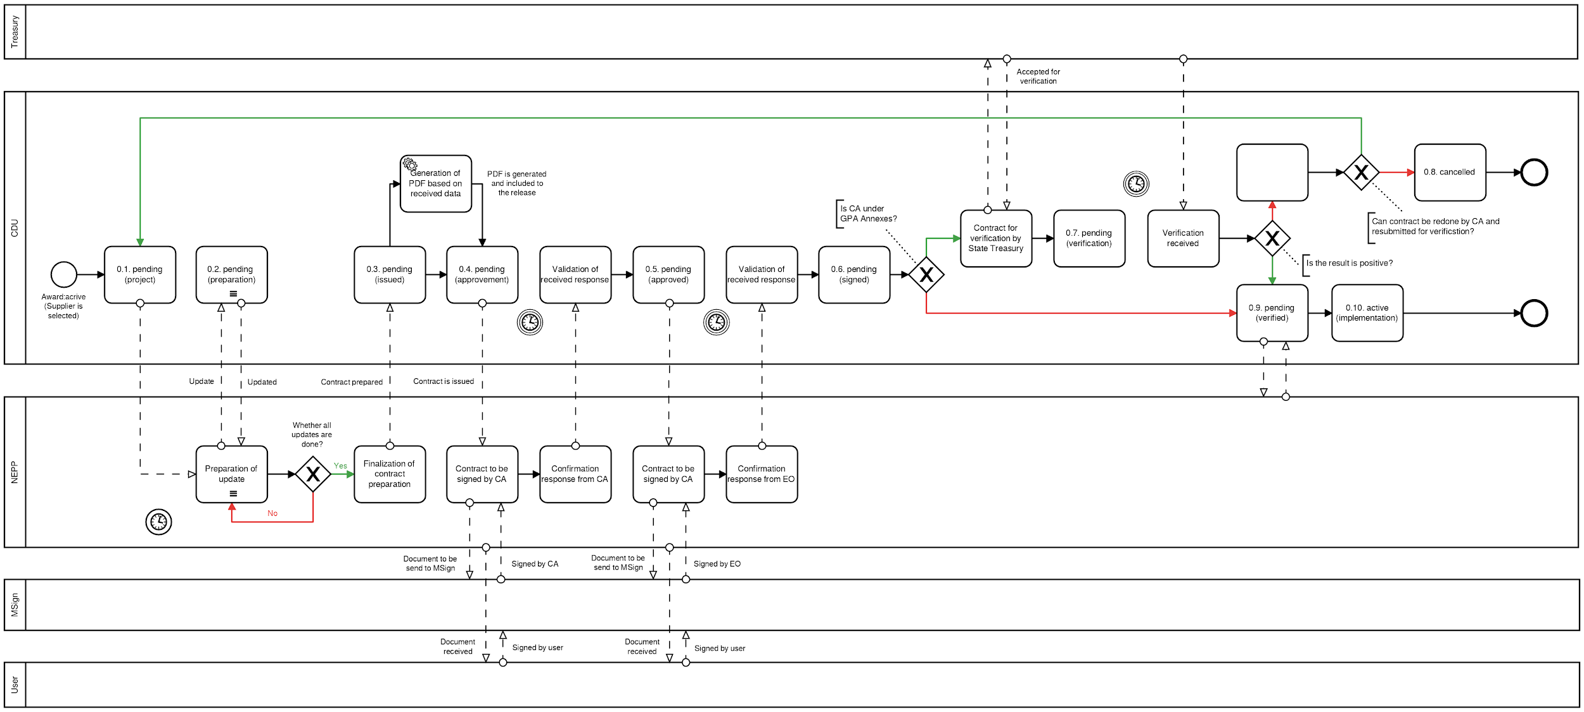Figure 13.1. General contract preparation, signing, verification and activation process (go to <https://goo.gl/jEkWtS> )

**Create a draft of awarded contract**

Once the review period has expired, Awarded Contract against one or several CANs can be created by indication of the CAN(s) using the following scheme of the command mode:

|  |  |  |  |
| --- | --- | --- | --- |
| **Title, description** |  |  | **Obligation** |
| **contract.id** |  |  | required |
| The identifier for CAN | | | |

**Update draft of awarded contract and its preparation for issuing**

Since ‘*contractProject*’ is generated by system, updates can be prepared according to following scheme:

|  |  |
| --- | --- |
| **Title** | **Description** |
| **planning.implementation.transactions** |  |
| **planning.budget.description** |  |
| **planning.budget.budgetSource** |  |
| **planning.budget.budgetAllocation** |  |
| **contract.extendsContractID** |  |
| **contract.title** |  |
| **contract.description** |  |
| **contract.period** |  |
| **contract.agreedMetrics[*].observations[*].measure** |  |
| **contract.documents** |  |
| **contract.milestones** |  |
| **awards[*].id** |  |
| **awards[*].suppliers[*].id** |  |
| **awards[*].suppliers[*].additionalIdentifiers** |  |
| **awards[*].suppliers[*].persones** |  |
| **awards[*].suppliers[*].details.typeOfSupplier** |  |
| **awards[*].suppliers[*].details.mainEconomicActivity** |  |
| **awards[*].suppliers[*].details.scale** |  |
| **awards[*].suppliers[*].details.permits** |  |
| **awards[*].suppliers[*].details.bankAccounts** |  |
| **awards[*].suppliers[*].details.legalForm** |  |
| **awards[*].documents** |  |
| **awards[*].value.amount** |  |
| **awards[*].value.currency** |  |
| **awards[*].value.amountNet** |  |
| **awards[*].value.valueAddedTaxincluded** |  |
| **items[*].id** |  |
| **items[*].quantity** |  |
| **items[*].unit.value.amount** |  |
| **items[*].unit.value.currency** |  |
| **items[*].unit.value.amountNet** |  |
| **items[*].unit.value.valueAddedTaxIncluded** |  |
| **items[*].deliveryAddress** |  |
| **buyer.id** |  |
| **buyer.additionalIdentifiers** |  |
| **buyer.persones** |  |
| **buyer.details.typeOfBuyer** |  |
| **buyer.details.mainGeneralActivity** |  |
| **buyer.details.mainSectoralActivity** |  |
| **buyer.details.bankAccounts** |  |
| **buyer.details.legalForm** |  |

**Termination of issued Contract**

CA can terminate a contract anytime starting from the moment of generation. For this next scheme has to be used:

|  |  |
| --- | --- |
| **Title** | **Description** |
| **amendment.rationale** |  |
| **amendment.description** |  |
| **amendment.documents** |  |

**Signing the Contract**

Since contract is issued and PDF version is generated and added to the contract.documents by the system, contract will go to ‘*statusDetails:approvement*’ and will be ready to signed by Contracting Authority. To confirm that contract signed by CA, next scheme has to be used:

|  |  |
| --- | --- |
| **Title** | **Description** |
| **confirmationResponses[].value.id** |  |
| **confirmationResponses[].value.date** |  |
| **confirmationResponses[].value.relatedPerson.id** |  |
| **confirmationResponses[].value.verification.type** |  |
| **confirmationResponses[].value.verification.value** |  |

#### User Actions

##### Clarification

During ‘enquiryPeriod’ all data describing this period go to public model in real-time. All Entities who participates as ‘enquirer’ will be indicated in initial ‘parties’ right after such information became a public

###### Enquiries

###### Extension of initial query-model

All submitted questions (enquiries) describes as an array ‘enquiries’ in the definition of ‘tender’.

|  |
| --- |
| {  "tender": {  "enquiries": [  {"$ref": "#/definitions/Enquiry"}  ] } |

Also ‘hasEnquiries’ in cnParent will be switched in ‘true’ automatically in case of existing enquiries.

|  |
| --- |
| {  "tender": {  "hasEnquiries": "true" } |

###### Command Model

To create new question standard POST data model should be used for preparation of POST-request.

**Schema**

|  |  |  |  |
| --- | --- | --- | --- |
| **enquiry.author** |  | object | required |
| Question author  See Organization | | | |
| **enquiry.title** |  | string | required |
| The subject line of the question | | | |
| **enquiry.description** | | object | required |
| The body of the question | | | |
| **enquiry.relatedLot** |  | string | required |
| If this question relates to a specific lot, this field contains the lot identifier. | | | |

**Example**

|  |
| --- |
| {  "enquiry": {  "author": {  "$ref": "#/definitions/Organization"  },  "title": "",  "description": "",  "relatedLot": ""  } } |

|  |  |
| --- | --- |
| **See how to submit question in Tutorial** |  |

###### Answers

During ‘enquiryPeriod” CA is able to submit an answer to question received.

###### Extension of initial ‘Enquiry’ data-model

|  |
| --- |
| {  "enquiries": [  {  "answer":"",  "dateAnswered":""  }  ] } |

###### Command Model

To submit an answer to a specific question standard data-model should be used for preparation of POST-request

**Schema**

|  |  |  |  |
| --- | --- | --- | --- |
| **answer** |  | string | required |
| Free text of answer | | | |

**Example**

|  |
| --- |
| {  "enquiry": {  "answer": "Lorem Ipsum"  } } |

|  |  |
| --- | --- |
| **See how to submit question in Tutorial** |  |

|  |
| --- |
| **Future steps** |

### 

##### Submission

‘bids‘ section will be included to initial query-model of the stage and will include all ‘bids‘ that were disclosed Initial status of such ‘bids’ will be ‘pending’. All Entities who submitted ‘bids’ will be indicated in initial ‘parties’ as ‘tenderer’. After ‘tenderPeriod‘ all data describes this period goes to public.

###### Submitted and disclosed bids

###### Extension of initial ‘Process Stage’ query-model

|  |
| --- |
| {  "bids": {  "details": [  {"$ref": "#/definitions/Bid"}  ]  } } |

###### Command Model

To submit a bid standard data-model should be used for preparation of POST-request for BPE.

**Schema**

|  |  |  |  |
| --- | --- | --- | --- |
| **bid.tenderers** | array | object | required |
| The party, or parties, responsible for this bid.  See Organization | | | |
| **bid.value** |  | object | required |
| The total value of the bid  See Value | | | |
| **bid.documents** | array | object | optional |
| All documents and attachments related to the bid  See Document | | | |
| **bid.requirementResponses** | array | object | optional |
| The responses related to the requirements |  |  |  |
| **bid.relatedLots** |  | string | required |
| Provide the lot identifier here. | | | |

**Example**

|  |
| --- |
| {  "bid": {  "tenderers": [  {  "$ref": "#/definitions/Organization"  }  ],  "value": {  "$ref": "#/definitions/Value"  },  "documents": [  {  "$ref": "#/definitions/Document"  }  ],  “requirementResponses”:[{  “$ref”: “#/definitions/requirementResponses”  }  ],  "relatedLots": [  ""  ]  } } |

|  |  |
| --- | --- |
| **Requirement responses**  There is a number of scenarios in which structured information on requirements and other procurement conditions is included in the Contract Notice (see CN publication future steps). The [requirements](https://github.com/open-contracting/ocds_requirements_extension/blob/master/README.md) extension used for communicating criteria on the CN level also includes structures for collecting relevant requirement responses related to described requirements. Thus, command model of ‘*bid*’ will be extended with *‘requirementResponses*’ array cover all the ‘*criteria*’ specified in the Contract Notice  **See how to submit a bid in Tutorial** |  |

###### Update of submitted bid

Anytime during the contracting process before the deadline of submission period, Economic Operator is able to update previously submitted bid. To update existing entity of bid following model should be used for preparation of POST-request for BPE:

###### Command model

**Schema**

|  |  |
| --- | --- |
| **bid.tenderers** | Must be included as it is in initial bid |
| **bid.value.amount** | Can be amended as free figures |
| **bid.documents** | Set of document can be updated with new elements or previously published documents can be updated with new versions |
| **bid.relatedLot** | Must be specified as it is for initial bid |
| **bid.requirementResponses** | Set of responses provided for the requirements |

###### Withdrawal of submitted bid

Anytime during the contracting process before the deadline of submission period, Economic Operator is able to withdraw his previously submitted bid. To withdraw existing entity of bid POST-request according to BPE rules should be used without any extensions for the data model of *bid*

###### Update of bid selected as a winning

Once Contracting Authority has selected particular bid as a winning (relevant *award:status:active*) and before the Awarded Contract is issued, Economic Operator is able to update his previously submitted *bid* with any required *documents*, requested by Contracting Authority (e.g. confirmation of self-declaration, actualized or detailed commercial offer, etc). To update existing entity of *bid* with set of new (or updated) *documents* following model should be used for preparation of POST-request for BPE:

###### Command model

**Schema**

|  |  |
| --- | --- |
| **bid.documents** | Set of document can be updated with new elements or previously published documents can be updated with new versions |

##### Direct Awarding

‘awards‘ section will be included to initial query-model of the stage and will include all ‘awards‘ that were introduced, Initial status of such ‘awards’ will be ‘pending’. All Entities who were sent as 'suppliers' in ‘awards’ will be indicated in initial ‘parties’ as ‘suppliers’.

###### Introduced awards

###### Extension of initial ‘Process Stage’ query-model

|  |
| --- |
| {  "awards": [  {  "$ref": "#/definitions/Award"  }   ] } |

###### Command Model

To introduce an award standard data-model should be used for preparation of POST-request for BPE.

**Schema**

|  |  |  |  |
| --- | --- | --- | --- |
| **award.suppliers** | array | object | required |
| The party, or parties, responsible for this award.  See Organization | | | |
| **award.value** |  | object | required |
| The total value of the award  See Value | | | |
| **award.description** |  | string | optional |
| Description of an award | | | |
| **award.relatedLot** |  | string | required |
| Provide the lot identifier here. | | | |

**Example**

|  |
| --- |
| {  "award": {  “description” : “”,  "suppliers": [  {  "$ref": "#/definitions/Organization"  }  ],  "value": {  "$ref": "#/definitions/Value"  },  "relatedLots": [  ""  ]  } } |

#### 

##### Electronic reverse auction

If electronic auction included into specific contracting process, initial query-model of CN will be extended with the following:

###### On publication level

Subsection ‘procurementMethodModalities’ and ‘electronicAuctions’ of ‘tender’ section will be included to initial query-model.

|  |
| --- |
| {  "tender": {  "auctionPeriod": {  "startDate": ""  },  "procurementMethodModalities": [  "electronicAuction"  ],  "electronicAuctions": {  "details": [  {  "id": "",  "relatedLot": "",  "auctionPeriod": {  "startDate": ""  },  "electronicAuctionModalities": [  {  "eligibleMinimumDifference": {  "amount": "",  "currency": ""  }  }  ]  }  ]  }  } } |

###### On execution level

Unique link for each scheduled electronic auction will be available in Public Point. Depending on access-mode (with or without token) this link might work as:

* individual link of the participant, who accesses his personal page via this link and participates in the auction.
* public link to the auction which can be published anywhere for viewers, who use this link to observe.

|  |
| --- |
| {  "tender": {  "electronicAuctions": {  "details": [  {  "electronicAuctionModalities": [  {  "url": ""  }  ]  }  ]  }  } } |

###### On result level

Once all established under single submission stage electronic auctions end additional data describe final details and statistics will be included into initial query-model:

|  |
| --- |
| {  "tender": {  "auctionPeriod": {  "endDate": ""  },  "electronicAuctions": {  "details": [  {  "auctionPeriod": {  "endDate": ""  },  "electronicAuctionProgress": [  {  "id": "1",  "period": {  "startDate": "",  "endDate": ""  },  "breakdown": [  {  "relatedBid": "",  "status": "",  "dateMet": "",  "value": {  "amount": "",  "currency": ""  }  }  ]  }  ],  "electronicAuctionResult": [  {  "relatedBid": "",  "value": {  "amount": "",  "currency": ""  }  }  ]  }  ],  "statistics": [ ]  }  } } |

|  |  |
| --- | --- |
| **Information disclosure on tenderers occurs once the last auction in this process is completed** |  |

#### 

##### Evaluation and awarding

During ‘awardPeriod’ all data describing this period go to the public model in real-time. All Entities who participate in the submission stage as ‘tenderer’ and become a ‘supplier’ (bidder of bid collects ‘award’ with ‘statusDetails:pending’) will be indicated in initial ‘parties’ right after such information became public.

###### Extension of initial ‘Process Stage’ data-model

|  |
| --- |
| {  "tender": {  "awardPeriod": {  "$ref": "#/definitions/Period"  }  },  "awards": [  {  "$ref": "#/definitions/Award"  }  ] } |

###### Command Model for Declaration of non conflict of interest by evaluation panel

To submit a declaration of non conflict of interest by each separate evaluation panel member a standard data-model to be used for the preparation of the POST-request for BPE. Such POST-request must be based on definition of ‘award’ and include only required and optional data-fields.

**Schema**

|  |  |  |  |
| --- | --- | --- | --- |
| **requirementResponses** | array | object | required |
| The needed statusDetails according  See RequirementResponse | | | |

**Example**

|  |
| --- |
| {  "requirementResponses": [  {  "id": "nonConflictOfInterest-1-1",  "value": true,  "requirement": {  "id":"nonConflictOfInterest-1-1"  },  "responder": {} // specific evaluation panel member to be reflected as   }, // PersonReference or complete Persone object (for replacements)   {  "id": "nonConflictOfInterest-1-2",  "value": true,  "requirement": {  "id":"nonConflictOfInterest-1-2"  },  "responder": {}  }  ] } |

###### 

###### Command Model for Award update

To submit a decision via publication of updates of generated ‘award’ standard data-model should be used for preparation of POST-request for BPE. Such POST-request must be based on definition of ‘award’ and include only required and optional data-fields

**Schema**

|  |  |  |  |
| --- | --- | --- | --- |
| **statusDetails** |  | string | required |
| The needed statusDetails according to Award Status Details codelist | | | |
| **description** |  | string | optional |
| Free-text description of decision made | | | |
| **documents** | array | object | optional |
| All documents and attachments related to the bid  See Document | | | |

**Example**

|  |
| --- |
| {  "award": {  "statusDetails": "",  "description": "",  "documents": [  {  "$ref": "#/definitions/Document"  }  }  ] } |

|  |  |
| --- | --- |
| **See how to submit question in Tutorial** |  |

#### 

##### Working with Contract Award Notices

Since CANs generated as a result of received evaluation protocol, CA is able to run a set of operations

###### CAN update

Once CAN is published and before CAN is confirmed Contracting Authority able to update such CAN with any additionally required document (e.g. report on procedure or signed decision of tender committee)

###### Command Model

**Schema**

|  |  |  |  |
| --- | --- | --- | --- |
| **documents.id** |  | string | required |
| Identifier of document in Document Service | | | |
| **documents.documentType** |  | string | required |
| Type of document specified according to the codelist | | | |
| **documents.title** |  | string | required |
| Free text title of the document | | | |
| **documents.description** |  | string | optional |
| Free text description of the document | | | |

**Example**

|  |
| --- |
| {   "documents":[  {  "documentType": "",  "id": "",  "title": "",  "description": ""   }  ] } |

###### CAN cancellation

In case of a limited list of reasons published Contract Award Notice can be cancelled by CA. Such cancellation can be executed within submitting of separate object - amendment, contains all the information needed to execute and publish such cancellation.

###### Extension of initial ‘CAN’ query-model

Once cancellation for CAN submitted, initial model of CAN will be extended:

|  |
| --- |
| {  "tag": "awardCancellation",  "contracts": [  {  "amendments": [  {  "id": "",  "status":"active",  "statusDetails":"cancellation",  "date": "",  "amendsReleaseID": "",  "releaseID": "",  "rationale": "",  "description": "",  "documents": []  }  ]  }  ] } |

###### Command Model

To submit an amendment for CAN cancellation standard command-model should be used.

**Schema**

|  |  |  |  |
| --- | --- | --- | --- |
| **amendment.rationale** |  | string | required |
| Reason for cancellation (selected from a standardized closed value-list) | | | |
| **amendment.description** |  | string | optional |
| The additional information about cancellation | | | |
| **amendment.documents** | array | object | optional |
| All documents and attachments related to the cancellation  See Document | | | |

**Example**

|  |
| --- |
| {  "сontract": {  "amendment": {  "rationale": "",  "description": "",  "documents": [  {  "documentType": "",  "id": "",  "title": "",  "description": ""  }  ]  }  } } |

#### 

##### Cancellations

Anytime during contracting process before the contract is established, Procuring Entity is able to cancel either separate lot or all the contracting process. The cancellation mechanism technically implemented in a different way for all tender and separate lots.

###### Lot cancellation

Depending on the period and state of contracting process, lot cancellation flow can be executed in different ways:

###### During clarification period

Cancellation of the lot is executed within standart update of Contract Notice: identifier of lot or lots to be excluded needs to be absent in update-payload based on cn command-model.

|  |
| --- |
| **Future steps**  In a next release it is considered to use the same approach as for tender cancellation - separate data-set (payload) through separate end-point. Consequently, to cancel separate lot, platform will be need to use to operate with a payload based on ‘lot cancellation command-model’ (same as tender cancellation) |

###### During tendering period

To be provided

###### During awarding period

To be provided

###### Tender cancellation

Cancellation of the active stage of contracting process is executed within submitting of separate object, contains all the information needed to execute and publish such cancellation.

###### Extension of initial ‘Process Stage’ data-model

If submitted amendment of tender cancellation exists, initial query-model of current stage will be extended with additional object - ‘amendments’:

|  |
| --- |
| {  "tag": "tenderCancelation",  "tender": {  "amendments": [  {  "id": "",  "date": "",  "type": "cancellation",  "relatesTo": "tender",  "amendsReleaseID": "",  "rationale": "",  "description": "",  "documents": [],  "status": "pending"  }  ]  } } |

###### Command Model

To submit an amendment for tender cancellation standard command-model should be used for preparation of POST-request for BPE.

**Schema**

|  |  |  |  |
| --- | --- | --- | --- |
| **rationale** |  | string | required |
| Reason for cancellation (selected from a standardized closed value-list) | | | |
| **description** |  | string | optional |
| The additional information about cancellation | | | |
| **documents** | array | object | optional |
| All documents and attachments related to the decision on cancellation  See Document | | | |

**Example**

|  |
| --- |
| {  "amendments": [  {  "rationale": "",  "description": "",  "documents": [  { "$ref": "#/definitions/Document" }  }  ]  ] } |

Once review period for this decision expired and no claim satisfied, CA is able to switch previously published amendment to the final status and cancel related lots. This will add an additional set of attributes (or amend existing) and switch related lots to the ‘cancelled’ statuses:

|  |
| --- |
| {  "tag": "tenderAmendment",  "tender": {  "amendments": [  {  "id": "",  "date": "",  "amendsReleaseID": "",  "status": "active",  "statusDetails": "cancellation"  }  ]  } } |

|  |
| --- |
| **Future steps**  In a next release it is considered to use the same approach as for tender cancellation - separate data-set (payload) through separate end-point. Consequently, to cancel separate lot, platform will be need to use to operate with a payload based on ‘lot cancellation command-model’ (same as tender cancellation) |

### Data models mind-map

Using data-models described above, procurement process itself as well as ‘collaboration’ of its different part could be shown as a structure of building blocks:

|  |
| --- |
| Figure 14. General scheme of the contracting process described using data-models |

# Components’ management

These Components shall automate entire procurement lifecycle (from planning to payment) for different procurement methods described below (see “Coverage” chapter). The following figure contains a generic distinction for management of the public procurement process and the interaction between the CAs, EOs and the system itself:

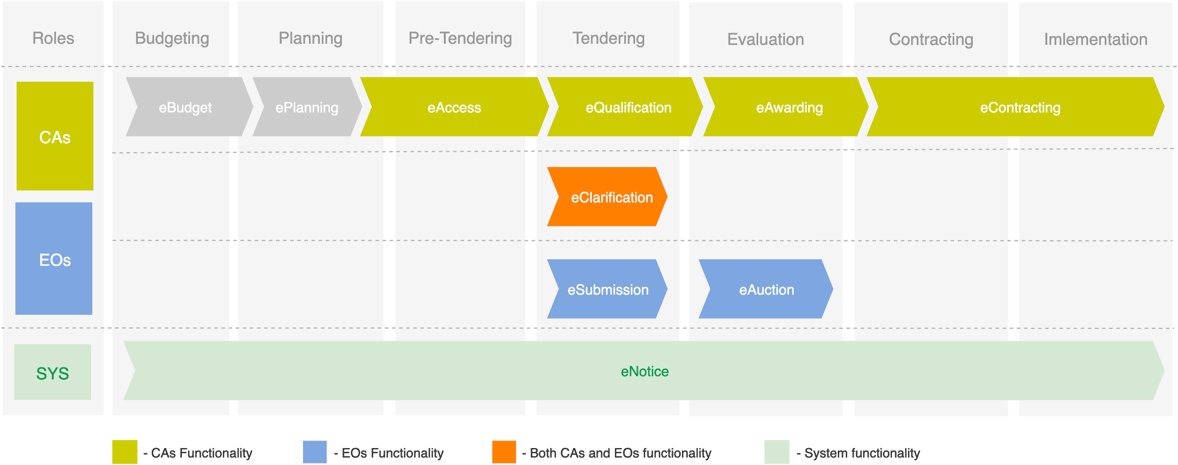Figure 16. BPE Component diagram as a generic distinction for management of the public procurement process

## eBudget

eBudget allows the online definition and preparation of expenditure items, funding sources, periods of budgeting and budgets in structured form.

### Methods

eBudget component provides the following methods which allow to do some actions:

|  |  |  |  |
| --- | --- | --- | --- |
| **Name** | **Method** | **Description** | **Note** |
| **Create.EI()** | POST | create of new ‘Expenditure Item’ |  |
| **Update.EI()** | POST | update of existing ‘Expenditure Item’ |  |
| **Cancel.EI()** | POST | update of existing ‘Expenditure Item’ | TBD |
| **Create.FS()** | POST | create of new ‘Funding source’ |  |
| **Update.FS()** | POST | update of existing ‘Funding source’ |  |
| **Check.FS()** | POST | check on existing ‘Funding source’ |  |
| **Check.BB()** | POST | check budget breakdown for specific OCID | TBD |
| **Cancel.FS()** | POST | update of existing ‘Funding source’ | TBD |
| **Get.Buyer()** | GET | get information about ‘buyer’ for specific OCID | TBD |

##### Create.EI()

|  |  |  |
| --- | --- | --- |
| This method is responsible for:   * validation the obtained data (payload) according to the prescribed rules, * creation a ‘EI’ entity and * generation of a number of related attributes identifiers * subsequent ownership and management of the created entity, its life cycle and possible changes | |  | | --- | |  | |

|  |
| --- |
| **POST** /ei?ownerID=...&country=...&date=...  {} // payload according to internal command model  201 OK Content-Type: application/json; charset=UTF-8  {} // payload according to internal response model |

###### Incomes

|  |  |  |  |
| --- | --- | --- | --- |
| **Name** | **Type** | **Description** | **Obligation** |
| **ownerID** | string | NEPP ID | mandatory |
| **country** | string | Code of country according to countries codelist | mandatory |
| **date** | date-time | Registered date of request | mandatory |
| **data** | object | bpe-payloads/eBudget/createEI-request.json | mandatory |

###### Outcomes

|  |  |  |  |
| --- | --- | --- | --- |
| **Name** | **Type** | **Description** | **Obligation** |
| **success** | boolean | TRUE || FALSE | mandatory |
| **data** | object | bpe-payloads/eBudget/createEI-resopnse.json | mandatory |

##### Update.EI()

|  |  |  |
| --- | --- | --- |
| This method is responsible for:   * validation the obtained data (payload) according to the prescribed rules, * update of existing ‘EI’ entity and * generation of a number of related attributes | |  | | --- | |  | |

|  |
| --- |
| **POST** /ei?ownerID=...&token=...&cpid=...  {} // payload according to internal command model  201 OK Content-Type: application/json; charset=UTF-8  {} // payload according to internal response model |

###### Incomes

|  |  |  |  |
| --- | --- | --- | --- |
| **Name** | **Type** | **Description** | **Obligation** |
| **ownerID** | string | NEPP ID | mandatory |
| **token** | string | EI’s token | mandatory |
| **cpid** | string | EI unique identifier | mandatory |
| **data** | object | bpe-payloads/eBudget/updateEI-request.json | mandatory |

###### Outcomes

|  |  |  |  |
| --- | --- | --- | --- |
| **Name** | **Type** | **Description** | **Obligation** |
| **success** | boolean | TRUE || FALSE | mandatory |
| **data** | object | bpe-payloads/eBudget/createEI-response.json | mandatory |

##### Create.FS()

|  |  |  |
| --- | --- | --- |
| This method is responsible for:   * validation the obtained data (payload) according to the prescribed rules, * creation of the ‘FS’ entity * generation of a number of related attributes and identifiers * subsequent ownership and management of the created entity, its life cycle and possible changes | |  | | --- | |  | |

|  |
| --- |
| **POST** /fs?cpid=...?ownerID=...&date=...  {} // payload according to internal command model  201 OK Content-Type: application/json; charset=UTF-8  {} // payload according to internal response model |

###### Incomes

|  |  |  |  |
| --- | --- | --- | --- |
| **Name** | **Type** | **Description** | **Obligation** |
| **ownerID** | string | NEPP ID | mandatory |
| **cpid** | string | Parent EI unique identifier | mandatory |
| **date** | date-time | Registered date of request | mandatory |
| **data** | object | bpe-payloads/eBudget/createFS-request.json | mandatory |

###### Outcomes

|  |  |  |  |
| --- | --- | --- | --- |
| **Name** | **Type** | **Description** | **Obligation** |
| **success** | boolean | TRUE || FALSE | mandatory |
| **data** | object | bpe-payloads/eBudget/createFS-response.json | mandatory |

##### Update.FS()

|  |  |  |
| --- | --- | --- |
| This method is responsible for:   * validation the obtained data (payload) according to the prescribed rules, * update of the ‘FS’ entity * generation of a number of related attributes | |  | | --- | |  | |

|  |
| --- |
| **POST** /fs?ownerID=...&token=...&cpid=...  {} // payload according to internal command model  201 OK Content-Type: application/json; charset=UTF-8  {} // payload according to internal response model |

###### Incomes

|  |  |  |  |
| --- | --- | --- | --- |
| **Name** | **Type** | **Description** | **Obligation** |
| **ownerID** | string | NEPP ID | mandatory |
| **token** | string | EI’s token | mandatory |
| **cpid** | string | EI unique identifier | mandatory |
| **data** | object | bpe-payloads/eBudget/updateFS-request.json | mandatory |

###### Outcomes

|  |  |  |  |
| --- | --- | --- | --- |
| **Name** | **Type** | **Description** | **Obligation** |
| **success** | boolean | TRUE || FALSE | mandatory |
| **data** | object | bpe-payloads/eBudget/createFS-response.json | mandatory |

##### Check.FS()

|  |  |  |
| --- | --- | --- |
| This method is responsible for:   * check of availability of FS with particular ID or array of such FSs for particular procurement category * extraction of the initial amounts of funds available on specified FSs for specified need | |  | | --- | |  | |

|  |
| --- |
| **POST** /fs/check  {} // payload according to internal command model  201 OK Content-Type: application/json; charset=UTF-8  {} // payload according to internal response model |

###### Incomes

|  |  |  |  |
| --- | --- | --- | --- |
| **Name** | **Type** | **Description** | **Obligation** |
| **data** | object | bpe-payloads/eBudget/checkFS-request.json | mandatory |

###### Outcomes

|  |  |  |  |
| --- | --- | --- | --- |
| **Name** | **Type** | **Description** | **Obligation** |
| **success** | boolean | TRUE || FALSE | mandatory |
| **data** | object | bpe-payloads/eBudget/checkFS-response.json | mandatory |

### Related entities

All entities that are managed by this module are described below.

|  |  |
| --- | --- |
| **Title** | **Description** |
| **Tender** | EI setting |
| **Budget** | Related budget |
| **Address** | EI buyer address and details |
| **Classification** | Budget classification |
| **ContacPoint** | EI buyer contact point |
| **Details** | Buyer details |
| **EuropeanUnionFunding** | Project description |
| **Identifier** | Auxiliar entity to declare identifiers |
| **Period** | Budget or tener period devinition |
| **Person** | Person declaration form buyers |
| **Value** | Auxiliar entity for vaules |
| **_Enums** | Domain values. |
| **EIEntity** |  |
| **FSEntity** |  |

### Functional relationship

This section does not have functional relationship.

## ePlanning

ePlanning component allows CAs to construct their procurement plans by scheduling of procedures during a defined period. The ePlanning functionality grants the possibility of aggregating all Annual Procurement Plans by different criteria such as CPV codes, procurement procedure types, dates, and others to be defined in order to crosscheck the planning between contracting authorities and build an annual aggregated procurement plan, and facilitates the aggregation of procurements. Also ePlanning allows the identification of potential individual procurement plans to be aggregated in order to launch a repetitive procedure (i.e. FA) that achieves gains in terms of efficiency and savings.

### Methods

ePlanning component includes following methods:

|  |  |  |
| --- | --- | --- |
| **Name** | **Method** | **Description** |
| **Create.PN()** | POST | create of new ‘Periodic Notice’ |
| **Update.PN()** | POST | create of new ‘Periodic Notice’ |
| **Check.PN()** | GET | check whether specified entity of PN exists |

##### Create.PN()

|  |  |  |
| --- | --- | --- |
| This method is responsible for:   * validation the obtained data (payload) according to the prescribed rules, * creation of the ‘PN’ entity * generation of a number of related attributes and identifiers * subsequent ownership and management of the created entity, its life cycle and possible changes | |  | | --- | |  | |

|  |
| --- |
| **POST** /pn?stage=PN&country=...&pmd=...&ownerID=...  {} // payload according to internal command model  201 OK Content-Type: application/json; charset=UTF-8  {} // payload according to internal response model |

###### Incomes

|  |  |  |  |
| --- | --- | --- | --- |
| **Name** | **Type** | **Description** | **Obligation** |
| **ownerID** | string | ID of Platform | mandatory |
| **stage** | string | Code of stage | mandatory |
| **country** | string | ISO of Country according to codelist | mandatory |
| **pmd** | string | Procurement Method Details according to codelist | mandatory |
| **date** | date-time | Date of the initiation of the operation | mandatory |
| **data** | object | bpe-payloads/eAccess/createPN-request.json | mandatory |

###### Outcomes

|  |  |  |  |
| --- | --- | --- | --- |
| **Name** | **Type** | **Description** | **Obligation** |
| **success** | boolean | TRUE || FALSE | mandatory |
| **data** | object | bpe-payloads/eAccess/createPN-response.json | mandatory |
|  |  |  |  |

##### Update.PN()

|  |  |  |
| --- | --- | --- |
| This method is responsible for:   * validation the obtained data (payload) according to the prescribed rules, * update of the ‘PN’ entity * generation of a number of related attributes | |  | | --- | |  | |

|  |
| --- |
| **POST** /pn?ownerID=...&token=...&date=...  {} // payload according to internal command model  201 OK Content-Type: application/json; charset=UTF-8  {} // payload according to internal response model |

###### Incomes

|  |  |  |  |
| --- | --- | --- | --- |
| **Name** | **Type** | **Description** | **Obligation** |
| **ownerID** | string | ID of Platform | mandatory |
| **date** | date-time | Date of the initiation of the operation | mandatory |
| **token** | string | PNs’ token | mandatory |
| **data** | object | bpe-payloads/eAccess/updatePN-request.json | mandatory |

###### Outcomes

|  |  |  |  |
| --- | --- | --- | --- |
| **Name** | **Type** | **Description** | **Obligation** |
| **success** | boolean | TRUE || FALSE | mandatory |
| **data** | object | bpe-payloads/eAccess/updatePN-response.json | Mandatory |
| **-** |  |  |  |

### Related entities

Pending content.

### Functional relationship

This component is described in the functional document “EBRD_MTender_Technical Specifications_v16.0.docx”, in section 4.2.

## eAccess

This component is responsible for receiving, validation and saving of core information about the procurement according to selected procurement method, geography, etc (i.e. title, value, CPV code, terms of reference, duration, qualification criteria, award criteria, etc.) and it amendments. Apart from the initiation of a new Contracting Process, the eAccess includes the links to all related processes (such as definition of used budget or conducted prior notices).

### Methods

eAccess component includes following methods:

|  |  |  |
| --- | --- | --- |
| **Name** | **Method** | **Description** |
| **Create.CN()** | POST | Create new ‘Contract Notice’ |
| **Update.CN()** | POST | Update existing ‘Contract Notice’ |
| **Update.Tender()** | POST | Suspension/resumption of the flow |
| **Terminate.Tender()** | POST | Termination of all contracting process |
| **Terminate.Lot()** | POST | Termination of separate lot |
| **Get.Lots()** | GET | Receive a list of lots in ‘active’ status |

##### Create.CN()

|  |  |  |
| --- | --- | --- |
| This method is responsible for:   * validation the obtained data (payload) according to the prescribed rules * creation of the ‘CN’ entity * generation of a number of related attributes and identifiers * subsequent ownership and management of the created entity, its life cycle and possible changes | |  | | --- | |  | |

|  |
| --- |
| **POST** /cnonpn?cpid=...&ownerID=...&token=...&date=...  {} // payload according to internal command model  201 OK Content-Type: application/json; charset=UTF-8  {} // payload according to internal response model |

###### Incomes

|  |  |  |  |
| --- | --- | --- | --- |
| **Name** | **Type** | **Description** | **Obligation** |
| **ownerID** | string | ID of Platform | mandatory |
| **token** | string | PNs’ token | mandatory |
| **cpid** | string | Contracting process ID | mandatory |
| **date** | date-time | Date of the initiation of the operation | mandatory |
| **data** | object | bpe-payloads/eAccess/createCNonPN-request.json | mandatory |

###### Outcomes

|  |  |  |  |
| --- | --- | --- | --- |
| **Name** | **Type** | **Description** | **Obligation** |
| **success** | boolean | TRUE || FALSE | mandatory |
| **data** | object | bpe-payloads/eAccess/createCNonPN-response.json | mandatory |

##### Update.CN()

|  |  |  |
| --- | --- | --- |
| This method is responsible for:   * validation the obtained data (payload) according to the prescribed rules, * update of the ‘CN’ entity * generation of a number of related attributes * generation of separate item for the ‘amendments’ array for each successful update of each particular CN | |  | | --- | |  | |

|  |
| --- |
| **POST** /cn?cpid=...&ownerID=...&token=...  {} // payload according to internal command model  201 OK Content-Type: application/json; charset=UTF-8  {} // payload according to internal response model |

###### Incomes

|  |  |  |  |
| --- | --- | --- | --- |
| **Name** | **Type** | **Description** | **Obligation** |
| **ownerID** | string | ID of Platform | mandatory |
| **token** | string | CN’s token | mandatory |
| **cpid** | string | Contracting process ID | mandatory |
| **data** | object | bpe-payloads/eAccess/updateCN-request.json | mandatory |

###### Outcomes

|  |  |  |  |
| --- | --- | --- | --- |
| **Name** | **Type** | **Description** | **Obligation** |
| **success** | boolean | TRUE || FALSE | mandatory |
| **data** | object | bpe-payloads/eAccess/updateCN-response.json | mandatory |

##### Update.Tender()

|  |  |  |
| --- | --- | --- |
| This method is responsible for:   * Suspension of the contracting process according to the general flow prescriptions * Resumption of the contracting process according to the general flow prescriptions | |  | | --- | |  | |

|  |
| --- |
| **POST** /cn?cpid=...&statusDetails=...&date=...  {} // payload according to internal command model  201 OK Content-Type: application/json; charset=UTF-8  {} // payload according to internal response model |

###### Incomes

|  |  |  |  |
| --- | --- | --- | --- |
| **Name** | **Type** | **Description** | **Obligation** |
| **cpid** | string | Contracting process ID | mandatory |
| **date** | string | Date of the initiation of the operation | mandatory |
| **statusDetails** | string | SUSPEND || NULL | mandatory |

###### Outcomes

|  |  |  |  |
| --- | --- | --- | --- |
| **Name** | **Type** | **Description** | **Obligation** |
| **success** | boolean | TRUE || FALSE | mandatory |
| **data** | object | bpe-payloads/eAccess/updateTender-response.json | mandatory |

##### Terminate.Tender()

|  |  |  |
| --- | --- | --- |
| This method is responsible for management of the *status* attribute of the Contracting Process in case of negative flow   * Set *tender.status:unsuccessful* for for those contracting processes where minimum number of offers not achieved * Set *tender.status.cancelled* for those contracting processes where such process cancelled by CA himself | |  | | --- | |  | |

|  |
| --- |
| **POST** /cn?cpid=...&status=...&date=...  {} // payload according to internal command model  201 OK Content-Type: application/json; charset=UTF-8  {} // payload according to internal response model |

###### Incomes

|  |  |  |  |
| --- | --- | --- | --- |
| **Name** | **Type** | **Description** | **Obligation** |
| **cpid** | string | Contracting process ID | mandatory |
| **date** | string | Date of the initiation of the operation | mandatory |
| **status** | string | CANCELED | UNSUCCESSFUL | mandatory |

###### Outcomes

|  |  |  |  |
| --- | --- | --- | --- |
| **Name** | **Type** | **Description** | **Obligation** |
| **success** | boolean | TRUE || FALSE | mandatory |
| **Data** | object | bpe-payloads/eAccess/terminateTender-response.json | mandatory |

##### Terminate.Lots()

|  |  |  |
| --- | --- | --- |
| This method is responsible for management of the *status* attribute of the separate lots of the Contracting Process in case of negative flow   * Set *tender.lot.status:unsuccessful* for for those lots under contracting process where minimum number of offers not achieved * Set *tender.lot.status.cancelled* for those lots under contracting process where such lot cancelled by CA himself | |  | | --- | |  | |

|  |
| --- |
| **POST** /lots?cpid=...&status=...&date=...  {} // payload according to internal command model  201 OK Content-Type: application/json; charset=UTF-8  {} // payload according to internal response model |

###### Incomes

|  |  |  |  |
| --- | --- | --- | --- |
| **Name** | **Type** | **Description** | **Obligation** |
| **cpid** | string | Contracting process ID | mandatory |
| **date** | string | Date of the initiation of the operation | mandatory |
| **status** | string | UNSUCCESSFUL | CANCELED | mandatory |
| **data** | object | bpe-payloads/eAccess/terminateLots-request.json | mandatory |

###### Outcomes

|  |  |  |  |
| --- | --- | --- | --- |
| **Name** | **Type** | **Description** | **Obligation** |
| **success** | boolean | TRUE || FALSE | mandatory |
| **data** | object | bpe-payloads/eAccess/terminateLots-response.json | mandatory |

##### Get.Lots()

|  |  |  |
| --- | --- | --- |
| This method is responsible for extraction of the set of lots in needed status | |  | | --- | |  | |

|  |
| --- |
| **GET** /lots?cpid=...&status=...  {} // payload according to internal command model  200 OK Content-Type: application/json; charset=UTF-8  {} // payload according to internal response model |

###### Incomes

|  |  |  |  |
| --- | --- | --- | --- |
| **Name** | **Type** | **Description** | **Obligation** |
| **cpid** | string | Contracting process ID | mandatory |
| **status** | string | ACTIVE || UNSUCCESSFUL || CANCELLED | mandatory |

###### Outcomes

|  |  |  |  |
| --- | --- | --- | --- |
| **Name** | **Type** | **Description** | **Obligation** |
| **success** | boolean | TRUE || FALSE | mandatory |
| **data** | object | bpe-payloads/eAccess/getLots-response.json | mandatory |

### Related entities

All entities that are managed by this module are described below:

|  |  |
| --- | --- |
| **Title** | **Description** |
| **AcceleratedProcedure** |  |
| **Address** | Procuring Entity address description |
| **Budget** | Related budget |
| **BudgetBreakdown** |  |
| **Classification** | Budget classification |
| **ContacPoint** | Procuring Entity contact point |
| **ContractPeriod** | Tender initial and ends |
| **DesignContest** |  |
| **Document** | Tender documents declaration |
| **Details** | Buyer details |
| **DynamicPurchasingSystem** |  |
| **ElectronicAuctions** | It includes ElectronicAuctionsDetails and ElectronicAuctionModalities |
| **ElectronicWorkflows** | To declare the type of workflows thar a process has to follow. |
| **EuropeanUnionFunding** | Project description |
| **Framework** | To declare if a process is a Framework |
| **Identifier** | Auxiliar entity to declare identifiers |
| **Item** | A product or service |
| **JointProcurement** | Type of procurement |
| **Lot** | Each or a tender lots |
| **LotGroup** | Group for lots |
| **Period** | Budget or tener period devinition |
| **PlaceOfPerformance** |  |
| **Planning** | Organization plan with the budget |
| **ProcedureOutsourcing** |  |
| **RecurrentProcurement** | Flag for recurrent processes |
| **Renewal** |  |
| **SourceParty** |  |
| **Tender** |  |
| **TenderProcess** | It includes the Amendment |
| **Unit** | Auxiliar entity to describe the items |
| **Value** | Auxiliar entity for economic values |
| **Person** | Person declaration form buyers |
| **Value** | Auxiliar entity for vaules |
| **Variant** |  |

### Functional relationship

This component is described in the functional document “EBRD_MTender_Technical Specifications_v16.0.docx”, in section 4.3.

## eClarification

This component provides the option to ask questions and receive answers regarding the conditions of particular procurement as well as allow CAs to answering questions from EOs.

### Methods

eClarification component includes following methods:

|  |  |  |
| --- | --- | --- |
| **Name** | **Method** | **Description** |
| **Check.Period()** | GET | Validate a validity of the enquiry period for specific landscape |
| **Save.Period()** | POST | Establish clarification period under Contracting Process |
| **Create.Enquiry()** | POST | Create new enquiry |
| **Update.Enquiry()** | POST | Update existing enquiry with an answer |
| **Check.Enquiries()** | GET | Check whether all enquiries complete with an answers |

##### Check.Period()

|  |  |  |
| --- | --- | --- |
| This method is responsible for the validation of requested period for clarifications against prescribed setting for this ‘landscape’ | |  | | --- | |  | |

|  |
| --- |
| **GET** /period?&stage=...&startDate...&endDate=...&pmd=...&country=...  {} // payload according to internal command model  200 OK Content-Type: application/json; charset=UTF-8  {} // payload according to internal response model |

###### Incomes

|  |  |  |  |
| --- | --- | --- | --- |
| **Name** | **Type** | **Description** | **Obligation** |
| **startDate** | date-time | tenderPeriod.startDate | mandatory |
| **endDate** | date-time | tenderPeriod.startDate | mandatory |
| **pmd** | string | Code of applied procurement method | mandatory |
| **country** | string | Code of country of initiation | mandatory |

###### Outcomes

|  |  |  |  |
| --- | --- | --- | --- |
| **Name** | **Type** | **Description** | **Obligation** |
| **success** | boolean | TRUE || FALSE | mandatory |

##### Save.Period()

|  |  |  |
| --- | --- | --- |
| This method is responsible for:   * validation of requested period for clarifications against prescribed data format * establishing clarification period for the retaled contracting process | |  | | --- | |  | |

|  |
| --- |
| **POST** /period?cpid=...&stage=...&startDate...&endDate=...&pmd=...&country=...  {} // payload according to internal command model  201 OK Content-Type: application/json; charset=UTF-8  {} // payload according to internal response model |

###### Incomes

|  |  |  |  |
| --- | --- | --- | --- |
| **Name** | **Type** | **Description** | **Obligation** |
| **cpid** | string | Contracting process ID | mandatory |
| **startDate** | date-time | tenderPeriod.startDate | mandatory |
| **endDate** | date-time | tenderPeriod.startDate | mandatory |
| **pmd** | string | Code of applied procurement method | mandatory |
| **country** | string | Code of country of initiation | mandatory |

###### Outcomes

|  |  |  |  |
| --- | --- | --- | --- |
| **Name** | **Type** | **Description** | **Obligation** |
| **success** | boolean | TRUE || FALSE | mandatory |
| **data** | object | bpe-payloads/eClarification/savePeriodResponse.json | mandatory |

##### Create.Enquiry()

|  |  |  |
| --- | --- | --- |
| This method is responsible for:   * Validation of general ability of the clarifications under required contracting process * Validation of the business rules prescribed for the clarification request under requested contracting process * Save valid request for clarification | |  | | --- | |  | |

|  |
| --- |
| **POST** /enquiry?cpid=...&stage=...&OwnerID...&date=...  {} // payload according to internal command model  201 OK Content-Type: application/json; charset=UTF-8  {} // payload according to internal response model |

###### Incomes

|  |  |  |  |
| --- | --- | --- | --- |
| **Name** | **Type** | **Description** | **Obligation** |
| **cpid** | string | Contracting process ID | mandatory |
| **date** | date-time | Date of initiation of this enquiry | mandatory |
| **ownerID** | string | ID of Platform | mandatory |
| **data** | object | bpe-payloads/eClarification/createEnquiryPayload.json | mandatory |

###### Outcomes

|  |  |  |  |
| --- | --- | --- | --- |
| **Name** | **Type** | **Description** | **Obligation** |
| **success** | boolean | TRUE || FALSE | mandatory |
| **data** | object | bpe-payloads/eClarification/createEnquiryResponse.json | mandatory |

##### Update.Enquiry()

|  |  |  |
| --- | --- | --- |
| This method is responsible for:   * Verification request against prescribed business rules (if requested enquiry is available for update considering current state of the contracting process) * Validation of the rules prescribed for the clarification under requested contracting process * Save valid clarification | |  | | --- | |  | |

|  |
| --- |
| **POST** /enquiry?cpid=...&OwnerID...&date=...&token=...  {} // payload according to internal command model  201 OK Content-Type: application/json; charset=UTF-8  {} // payload according to internal response model |

###### Incomes

|  |  |  |  |
| --- | --- | --- | --- |
| **Name** | **Type** | **Description** | **Obligation** |
| **cpid** | string | Contracting process ID | mandatory |
| **date** | date-time | Date of publication of this answer | mandatory |
| **ownerID** | string | ID of Platform | mandatory |
| **token** | string | Token for this enquiry | mandatory |
| **data** | object | bpe-payloads/eClarification/updateEnquiryPayload.json | mandatory |

###### Outcomes

|  |  |  |  |
| --- | --- | --- | --- |
| **Name** | **Type** | **Description** | **Obligation** |
| **success** | boolean | TRUE || FALSE | mandatory |
| **data** | object | bpe-payloads/eClarification/updateEnquiryResponse.json | mandatory |

##### Check.Enquiries()

|  |  |  |
| --- | --- | --- |
| This method is responsible for check if there is at least one clarification request with no related respond | |  | | --- | |  | |

|  |
| --- |
| **GET** /enquiry?cpid=...&stage=...&OwnerID...&date=...  {} // payload according to internal command model  201 OK Content-Type: application/json; charset=UTF-8  {} // payload according to internal response model |

###### Incomes

|  |  |  |  |
| --- | --- | --- | --- |
| **Name** | **Type** | **Description** | **Obligation** |
| **cpid** | string | Contracting process ID | mandatory |
| **ownerID** | string | ID of Platform | mandatory |

###### Outcomes

|  |  |  |  |
| --- | --- | --- | --- |
| **Name** | **Type** | **Description** | **Obligation** |
| **success** | boolean | TRUE || FALSE | mandatory |

### Related entities

All entities that are managed by this module are described below:

|  |  |
| --- | --- |
| **Title** | **Description** |
| **Address** | Needed to describe the enquiry author details |
| **Tender** | It allows to check the enquiry period |
| **Enquiry** | A new entity is registered in the system for its lot. |
| **ContacPoint** | Needed to describe the enquiry author contact point |
| **Details** | Needed to describe the author details |
| **Identifier** | Needed to describe the author identifies |
| **OrganizationReference** | To describe enquiry author |
| **Period** | Needed to describe the Tender enquiry period |

### Functional relationship

This component is described in the functional document “EBRD_MTender_Technical Specifications_v16.0.docx”, in section 4.5.

## eSubmission

This component allows EOs to respond to Contract Notice by preparing their offers in a structured and secure way, and submit their offers or electronically to a CA, including using templates created by the CA.

On the CAs side, this component generates a standardized schema for bid or proposal in the relevant procurement method, stores received bids or proposal until expiry of tender deadlines and allows secure opening of the received tenders upon expiry of the tender deadlines.

### Methods

eSubmission component includes following methods:

|  |  |  |
| --- | --- | --- |
| **Name** | **Method** | **Description** |
| **Check.Period()** | GET | Check validity of submission period for requested conditions |
| **Save.Period()** | POST | Establish submission period for contracting process |
| **Create.Bid()** | POST | Create new bid |
| **Update.Bid()** | POST | Update existing bid |
| **Update.BidStatusDetails()** | POST | Update *statusDetails* value according to the process flow |
| **Set.BidStatusDetails()** | POST | Set *statusDetails* value according to the process flow |
| **Get.Bids()** | GET | Get list of bids registered under specific contracting process |
| **Finalize.ValidBids()** | POST | Move all valid bids to the final state according to the flow |

##### Check.Period()

|  |  |  |
| --- | --- | --- |
| This method is responsible for the validation of requested period for submission against prescribed setting for this contracting process considering geography and applied legal basic | |  | | --- | | **Sequence diagram** | |

|  |
| --- |
| **GET** /period?country=...&pmd=...&stage=...&startDate...&endDate=...  {} // payload according to internal command model  200 OK Content-Type: application/json; charset=UTF-8  {} // payload according to internal response model |

###### Incomes

|  |  |  |  |
| --- | --- | --- | --- |
| **Name** | **Type** | **Description** | **Obligation** |
| **country** | string |  | mandatory |
| **pmd** | string |  | mandatory |
| **startDate** | date-time |  | mandatory |
| **endDate** | date-time |  | mandatory |

###### Outcomes

|  |  |  |  |
| --- | --- | --- | --- |
| **Name** | **Type** | **Description** | **Obligation** |
| **success** | boolean | TRUE || FALSE | mandatory |

##### Save.Period()

|  |  |  |
| --- | --- | --- |
| This method is responsible for:   * validation of requested period for submission against prescribed data format * establishing submission period for the retaled contracting process | |  | | --- | | **Sequence diagram** | |

|  |
| --- |
| **POST** /period?cpid=...&stage=...&startDate...&endDate=...  {} // payload according to internal command model  201 OK Content-Type: application/json; charset=UTF-8  {} // payload according to internal response model |

###### Incomes

|  |  |  |  |
| --- | --- | --- | --- |
| **Name** | **Type** | **Description** | **Obligation** |
| **cpid** | string | Contracting process ID | mandatory |
| **startData** | date-time |  | mandatory |
| **endDate** | date-time |  | mandatory |

###### Outcomes

|  |  |  |  |
| --- | --- | --- | --- |
| **Name** | **Type** | **Description** | **Obligation** |
| **success** | boolean | TRUE || FALSE | mandatory |
| **data** | object | bpe-payloads/eSubmission/savePeriodResponse.json | mandatory |

##### Create.Bid()

|  |  |  |
| --- | --- | --- |
| This method is responsible for:   * Validation of general ability of the submission under required contracting process * Validation of the business rules prescribed for the bid request under requested contracting process * Save valid bid | |  | | --- | | **Sequence diagram** | |

|  |
| --- |
| **POST** /bid?cpid=...&stage=...&OwnerID=...&date=...  {} // payload according to internal command model  201 OK Content-Type: application/json; charset=UTF-8  {} // payload according to internal response model |

###### Incomes

|  |  |  |  |
| --- | --- | --- | --- |
| **Name** | **Type** | **Description** | **Obligation** |
| **cpid** | string | Contracting process ID | mandatory |
| **ownerID** | date-time |  | mandatory |
| **date** | date-time |  | mandatory |
| **data** | object | bpe-payloads/eSubmission/createBidPayload.json |  |

###### Outcomes

|  |  |  |  |
| --- | --- | --- | --- |
| **Name** | **Type** | **Description** | **Obligation** |
| **success** | boolean | TRUE || FALSE | mandatory |
| **data** | object | bpe-payloads/eSubmission/createBidResponse.json | mandatory |

##### Update.Bid()

|  |  |  |
| --- | --- | --- |
| This method is responsible for:   * Verification request against prescribed business rules (if requested bid is available for update considering current state of the contracting process) * Validation of the rules prescribed for the submission under requested contracting process * Save valid updated bid | |  | | --- | | **Sequence diagram** | |

|  |
| --- |
| **POST** /bid?cpid=...&stage=...&OwnerID=...&date=...&token=...  {} // payload according to internal command model  201 OK Content-Type: application/json; charset=UTF-8  {} // payload according to internal response model |

###### Incomes

|  |  |  |  |
| --- | --- | --- | --- |
| **Name** | **Type** | **Description** | **Obligation** |
| **cpid** | string | Contracting process ID | mandatory |
| **ownerID** | date-time |  | mandatory |
| **date** | date-time |  | mandatory |
| **token** | string |  | mandatory |
| **data** | object | bpe-payloads/eSubmission/updateBidPayload.json | mandatory |

###### Outcomes

|  |  |  |  |
| --- | --- | --- | --- |
| **Name** | **Type** | **Description** | **Obligation** |
| **success** | boolean | TRUE || FALSE | mandatory |
| **data** | object | bpe-payloads/eSubmission/updateBidResponse.json | mandatory |

##### Update.BidStatusDetails()

|  |  |  |
| --- | --- | --- |
| This method is responsible for switching bids collected under specific contracting process where such change requested by BPE according to the current state of the contracting process to the relevant temporary status | |  | | --- | | **Sequence diagram** | |

|  |
| --- |
| **POST** /bid?cpid=...&stage=...&ownerID=...&date=...&token=...  {} // payload according to internal command model  201 OK Content-Type: application/json; charset=UTF-8  {} // payload according to internal response model |

###### Incomes

|  |  |  |  |
| --- | --- | --- | --- |
| **Name** | **Type** | **Description** | **Obligation** |
| **cpid** | string | Contracting process ID | mandatory |
| **date** | date-time |  | mandatory |
| **data** | object | bpe-payloads/eSubmission/updateBidStatusDetailsPayload.json | mandatory |

###### Outcomes

|  |  |  |  |
| --- | --- | --- | --- |
| **Name** | **Type** | **Description** | **Obligation** |
| **success** | boolean | TRUE || FALSE | mandatory |
| **data** | object | bpe-payloads/eSubmission/updateBidStatusDetailsResponse.json | mandatory |
|  |  |  |  |

##### Set.BidStatusDetails()

|  |  |  |
| --- | --- | --- |
| This method is responsible for switching bids collected under specific contracting process where award decision took place against such bids to the relevant temporary status | |  | | --- | | **Sequence diagram** | |

|  |
| --- |
| **POST** /bid?cpid=...&awardStatus=...&token=...  {} // payload according to internal command model  201 OK Content-Type: application/json; charset=UTF-8  {} // payload according to internal response model |

###### Incomes

|  |  |  |  |
| --- | --- | --- | --- |
| **Name** | **Type** | **Description** | **Obligation** |
| **cpid** | string | Contracting process ID | mandatory |
| **bidId** | date-time |  | mandatory |
| **awardStatus** | string | UNSUCCESSFUL | ACTIVE | mandatory |

###### Outcomes

|  |  |  |  |
| --- | --- | --- | --- |
| **Name** | **Type** | **Description** | **Obligation** |
| **success** | boolean | TRUE || FALSE | mandatory |
| **data** | object | bpe-payloads/eSubmission/setBidStatusDetailsResponse.json | mandatory |

##### Get.Bids()

|  |  |  |
| --- | --- | --- |
| This method is responsible for extraction a set of bids collected under specific contracting process and available for disclosure where award period has been started | |  | | --- | | **Sequence diagram** | |

|  |
| --- |
| **GET** /bid?cpid=...&pmd=...&country=...&status=...  {} // payload according to internal command model  200 OK Content-Type: application/json; charset=UTF-8  {} // payload according to internal response model |

###### Incomes

|  |  |  |  |
| --- | --- | --- | --- |
| **Name** | **Type** | **Description** | **Obligation** |
| **cpid** | string | Contracting process ID | mandatory |
| **pmd** | date-time | Code of applied procurement method | mandatory |
| **country** | string | Code of the country of initiation of contracting process | mandatory |
| **status** | string | pending | mandatory |

###### Outcomes

|  |  |  |  |
| --- | --- | --- | --- |
| **Name** | **Type** | **Description** | **Obligation** |
| **success** | boolean | TRUE || FALSE | mandatory |
| **data** | object | bpe-payloads/eSubmission/getBidsResponse.json | mandatory |

##### Finalize.ValidBids()

|  |  |  |
| --- | --- | --- |
| This method is responsible for switching bids collected under specific contracting process where award decision took place against such bids to the relevant permanent status | |  | | --- | | **Sequence diagram** | |

|  |
| --- |
| **POST** /bid?cpid=...&stage=...&date=...  201 OK Content-Type: application/json; charset=UTF-8  {} // payload according to internal response model |

###### Incomes

|  |  |  |  |
| --- | --- | --- | --- |
| **Name** | **Type** | **Description** | **Obligation** |
| **cpid** | string | Contracting process ID | mandatory |
| **date** | string | Date of initiation of finalization | mandatory |

###### Outcomes

|  |  |  |  |
| --- | --- | --- | --- |
| **Name** | **Type** | **Description** | **Obligation** |
| **success** | boolean | TRUE || FALSE | mandatory |
| **data** | object | bpe-payloads/eSubmission/finalizeValidBidsResponse.json | mandatory |

### Related entities

All entities that are managed by this module are described below:

|  |  |
| --- | --- |
| **Title** | **Description** |
| **AccountIdentification** |  |
| **AdditionalAccountIdentifier** |  |
| **Address** | Is completed with AddressDetails, data class CountryDetails, RegionDetails, LocalityDetails |
| **BankAccount** |  |
| **Bid** | A tender bid |
| **Bids** | List of Bid |
| **BusinessFunction** | It is completed with Period and Document |
| **ContactPoint** | It describes the tenderers contact details |
| **Details** | It completes the tenderer description |
| **Document** | It completes the tender documents |
| **Identifier** | It is used for tenderer identifies |
| **IssuedBy** |  |
| **IssuedThought** |  |
| **LegalForm** |  |
| **OrganizationReference** | Describes the tenderers |
| **Period** | The tender star and end date |
| **Permit** |  |
| **PermitDetails** |  |
| **Persone** |  |
| **Requirement** |  |
| **RequirementResponse** |  |
| **ValidityPeriod** | The tender start and end validity period |
| **Value** | Auxiliar entity to describe economic values |
| [**_Enums.kt**](https://bitbucket.org/ustudio-llc/e-submission/src/master/src/main/kotlin/com/procurement/submission/model/dto/ocds/_Enums.kt) | List of values |

### Functional relationship

This component is described in the functional document “EBRD_MTender_Technical Specifications_v16.0.docx”, in section 4.6.

## eQualification

This component handles legal, economic and quality qualification of the tenderers and its proposals. It is responsible for accessing EOs master data. It is also used for shortlist management of procedures that allow shortlisting prior to submission of tenders.

### Methods

eQualification component includes following methods:

|  |  |  |
| --- | --- | --- |
| **Name** | **Method** | **Description** |
| Create.Awards() | POST |  |
| Update.Award() | POST |  |
| End.AwardPeriod() | POST |  |
| Finalize.Awards() | POST |  |

##### Create.Awards()

|  |  |  |
| --- | --- | --- |
| This method is responsible for:   * Analysis of the payload received in order to establish awarding processes for those lots where enough bids were collected and current status of such lots allows to start evaluation * Generation of the ‘awards’ related to the lots under evaluation and related bids * Initial ranking of the generated awards according to applied awarding strategy | |  | | --- | | **Sequence diagram** | |

|  |
| --- |
| **POST** /qualification?stage=...&country=...&pmd=...&OwnerID=...  {} // payload according to internal request model  201 OK Content-Type: application/json; charset=UTF-8  {} // payload according to internal response model |

###### Incomes

|  |  |  |  |
| --- | --- | --- | --- |
| **Name** | **Type** | **Description** | **Obligation** |
| stage | string | Code of stage | mandatory |
| cpid | string |  |  |
| country | string | ISO of Country according to codelist | mandatory |
| pmd | string | Procurement Method Details according to codelist | mandatory |
| startDate | date-time |  | mandatory |
| payload | object | bpe-payloads/eAccess/createAwardsPayload.json | mandatory |

###### Outcomes

|  |  |  |  |
| --- | --- | --- | --- |
| **Name** | **Type** | **Description** | **Obligation** |
| success | boolean | TRUE || FALSE | mandatory |
| responseDetails | array | Description for the code of response (if applicable) | mandatory |
| data | object | bpe-payloads/eAccess/createAwardsResponse.json | mandatory |

##### Update.Awards()

|  |  |  |
| --- | --- | --- |
| This method is responsible for switching ‘awards’ established for the evaluation needs under specific contracting process where award decision was made to the relevant temporary status | |  | | --- | | **Sequence diagram** | |

|  |
| --- |
| **POST** /qualification?cpid=...&stage=...&date=...&OwnerID=...&token=...  {} // payload according to internal request model  201 OK Content-Type: application/json; charset=UTF-8  {} // payload according to internal response model |

###### Incomes

|  |  |  |  |
| --- | --- | --- | --- |
| **Name** | **Type** | **Description** | **Obligation** |
| stage | string | Code of stage | mandatory |
| cpid | string |  |  |
| owner | string | ISO of Country according to codelist | mandatory |
| token | string | Procurement Method Details according to codelist | mandatory |
| date | date-time |  | mandatory |
| payload | object | bpe-payloads/eAccess/updateAwardsPayload.json | mandatory |

###### Outcomes

|  |  |  |  |
| --- | --- | --- | --- |
| **Name** | **Type** | **Description** | **Obligation** |
| success | boolean | TRUE || FALSE | mandatory |
| responseDetails | array | Description for the code of response (if applicable) | mandatory |
| data | object | bpe-payloads/eAccess/createAwardsResponse.json | mandatory |

##### End.AwardPeriod()

|  |  |  |
| --- | --- | --- |
| This method is responsible for completion of the awarding period for specific lot where award decision was made and stand-still period expired | |  | | --- | | **Sequence diagram** | |

|  |
| --- |
| **POST** /qualification?cpid=...&stage=...&OwnerID=...&token=...&endDate=...  {} // payload according to internal request model  201 OK Content-Type: application/json; charset=UTF-8  {} // payload according to internal response model |

###### Incomes

|  |  |  |  |
| --- | --- | --- | --- |
| **Name** | **Type** | **Description** | **Obligation** |
| stage | string | Code of stage | mandatory |
| cpid | string |  |  |
| owner | string | ISO of Country according to codelist | mandatory |
| token | string | Procurement Method Details according to codelist | mandatory |
| endDate | date-time | дата завершения периода | mandatory |

###### Outcomes

|  |  |  |  |
| --- | --- | --- | --- |
| **Name** | **Type** | **Description** | **Obligation** |
| success | boolean | TRUE || FALSE | mandatory |
| responseDetails | array | Description for the code of response (if applicable) | mandatory |
| data | object | bpe-payloads/eAccess/endAwardPeriodResponse.json | mandatory |

##### Finalize.Awards()

|  |  |  |
| --- | --- | --- |
| This method is responsible for switching ‘awards’ where awarding period has been closed to the relevant permanent status | |  | | --- | | **Sequence diagram** | |

|  |
| --- |
| **POST** /qualification?cpid=...&stage=...  {} // payload according to internal request model  201 OK Content-Type: application/json; charset=UTF-8  {} // payload according to internal response model |

###### Incomes

|  |  |  |  |
| --- | --- | --- | --- |
| **Name** | **Type** | **Description** | **Obligation** |
| stage | string | Code of stage | mandatory |
| cpid | string |  |  |

###### Outcomes

|  |  |  |  |
| --- | --- | --- | --- |
| **Name** | **Type** | **Description** | **Obligation** |
| success | boolean | TRUE || FALSE | mandatory |
| responseDetails | array | Description for the code of response (if applicable) | mandatory |
| data | object | bpe-payloads/eAccess/finalizeAwardsResponse.json | mandatory |

### Related entities

All entities that are managed by this module are described below:

|  |  |
| --- | --- |
| **Title** | **Description** |
| **Address** | Incules AddressDetails, CountryDetails, RegionDetails and LocalityDetails |
| **Award** | Tender award |
| **Bid** | Tender bid |
| **Classification** | Tender classification cirteria |
| **ContactPoint** | Award suppliers details |
| **Details** |  |
| **Document** | Tender documents |
| **Identifier** | Auxiliar entitiy to intentify a bider |
| **Item** | A product or service |
| **Lot** |  |
| **OrganizationReference** | Tender procuring entity |
| **Period** | Tender start and end date |
| **Unit** | Item unit |
| **Value** | Auxiliar entity to economic values |
| [**_Enums.kt**](https://bitbucket.org/ustudio-llc/e-submission/src/master/src/main/kotlin/com/procurement/submission/model/dto/ocds/_Enums.kt) | List of values |

### Functional relationship

This component is described in the functional document “EBRD_MTender_Technical Specifications_v16.0.docx”, in section 4.7.

## eAuction

This component facilitates the configuration and management of reverse auction held electronically.

### Methods

eAuction component includes following methods:

|  |  |  |
| --- | --- | --- |
| **Name** | **Method** | **Description** |
| Validate.Auction() | GET |  |
| Schedule.Auction() | POST |  |
| Cancel.Auction() | POST |  |
| Run.Auction | POST |  |

##### Validate.Auction()

|  |  |  |
| --- | --- | --- |
| This method is responsible for validation of the expected start date of eAuction requested within preparation of the Contract Notice of the specific contracting process | |  | | --- | | **Sequence diagram** | |

|  |
| --- |
| **GET** /auction/check  {} // payload according to internal request model  200 OK Content-Type: application/json; charset=UTF-8 |

###### Incomes

|  |  |  |  |
| --- | --- | --- | --- |
| **Name** | **Type** | **Description** | **Obligation** |
| data | object | bpe-payloads/eAuction/validateAuctionPayload.json | mandatory |

###### Outcomes

|  |  |  |  |
| --- | --- | --- | --- |
| **Name** | **Type** | **Description** | **Obligation** |
| success | string |  | mandatory |

##### Schedule.Auction()

|  |  |  |
| --- | --- | --- |
| This method is responsible for scheduling of eAuction for each lot under specific contracting process | |  | | --- | | **Sequence diagram** | |

|  |
| --- |
| **POST** /auction?cpid=...&ocid=...  {} // payload according to internal request model  201 OK Content-Type: application/json; charset=UTF-8  {} // payload according to internal response model |

###### Incomes

|  |  |  |  |
| --- | --- | --- | --- |
| **Name** | **Type** | **Description** | **Obligation** |
| cpid | string |  | mandatory |
| ocid | string |  | mandatory |
| data | object | bpe-payloads/eAuction/scheduleAuctionPayload.json | mandatory |

###### Outcomes

|  |  |  |  |
| --- | --- | --- | --- |
| **Name** | **Type** | **Description** | **Obligation** |
| success | string |  | mandatory |
| data | string | bpe-payloads/eAccess/scheduleAuctionResponse.json | mandatory |

##### Cancel.Auction()

|  |  |  |
| --- | --- | --- |
| This method is responsible for cancellation of the previously scheduled eAuction under specific contracting process | |  | | --- | | **Sequence diagram** | |

|  |
| --- |
| **POST** /auction?cpid=...&ocid=...&lotID=...status=cancelled&token=...  201 OK Content-Type: application/json; charset=UTF-8 |

###### Incomes

|  |  |  |  |
| --- | --- | --- | --- |
| **Name** | **Type** | **Description** | **Obligation** |
| cpid | string |  | mandatory |
| ocid | string |  | mandatory |
| lotID | string |  | mandatory |
| status | string | CANCELLED | mandatory |
| token | string |  | mandatory |

###### Outcomes

|  |  |  |  |
| --- | --- | --- | --- |
| **Name** | **Type** | **Description** | **Obligation** |
| success | string |  | mandatory |

##### Run.Auction()

|  |  |  |
| --- | --- | --- |
| This method is responsible for launch of eAuction for the separate lot under specific contracting process | |  | | --- | | **Sequence diagram** | |

|  |
| --- |
| **POST** /auction?cpid=...&ocid=...&lotID=...  {} // payload according to internal request model  201 OK Content-Type: application/json; charset=UTF-8  {} // payload according to internal response model |

###### Incomes

|  |  |  |  |
| --- | --- | --- | --- |
| **Name** | **Type** | **Description** | **Obligation** |
| cpid | string |  | mandatory |
| ocid | string |  | mandatory |
| data | object | bpe-payloads/eAuction/runAuctionPayload.json | mandatory |

###### Outcomes

|  |  |  |  |
| --- | --- | --- | --- |
| success | string |  | mandatory |
| data | string | bpe-payloads/eAccess/runAuctionResponse.json | mandatory |

When an electronic auction ends due to success execution, eAuction component automatically sends relevant notification to BPE. Such response contents all statistics and results of electronic auctions under all lots in this specific contracting process.

###### Result

|  |  |  |  |
| --- | --- | --- | --- |
| **Name** | **Type** | **Description** | **Obligation** |
| success | string |  | mandatory |
| cpid |  |  | mandatory |
| ocid |  |  | mandatory |
| auctionResults | string | bpe-payloads/eAccess/auctionResult.json | mandatory |

### Related entities

All entities that are managed by this module are described below:

|  |  |
| --- | --- |
| **Title** | **Description** |
| **Amount** |  |
| **Auction** | The auction process |
| **Bid** | A presented bid |
| **Breakdown** |  |
| **Bucket** |  |
| **Command** |  |
| **Country** |  |
| **cpid** |  |
| **Currency** |  |
| **Date** |  |
| **lotId** |  |
| **Modality** |  |
| **Offer** |  |
| **operationId** |  |
| **Period** |  |
| **PlatformId** |  |
| **progressId** |  |
| **result** |  |
| **sign** |  |
| **slots** |  |
| **tender** |  |
| **value** |  |
| **version** |  |

### Functional relationship

This component is described in the functional document “EBRD_MTender_Technical Specifications_v16.0.docx”, in section 4.8.

## eAwarding

This component allows preparation of the Contract Award Notice and Awarded Contract itself in a structured way. It also ensures exchange of documents with the tenderer during the awarding phase. eAwarding is responsible for all actions after evaluation is completed until the contract is executed.

### Methods

eAwarding component includes following methods:

|  |  |  |
| --- | --- | --- |
| **Name** | **Method** | **Description** |
| Create.SuccessfulCAN() | POST |  |
| Create.UnsuccessfullCAN() | POST |  |
| Create.CancelledCAN() | POST |  |
| Update.CAN() | POST |  |
| Confirm.CAN() | POST |  |
| Cancel.CAN() | POST |  |

##### Create.SuccessfulCAN()

|  |  |  |
| --- | --- | --- |
| This method is responsible for generation of the ‘Contract Award Notice’ related to the specified lot where winner was selected | |  | | --- | | **Sequence diagram** | |

|  |
| --- |
| **POST** /can?cpid=...&ocid=...&lotID=...&date=...  {} // payload according to internal request model  201 OK Content-Type: application/json; charset=UTF-8  {} // payload according to internal response model |

###### Incomes

|  |  |  |  |
| --- | --- | --- | --- |
| **Name** | **Type** | **Description** | **Obligation** |
| cpid | string |  | mandatory |
| ocid | string |  | mandatory |
| date | date-lite |  | mandatory |
| lotID | string |  | mandatory |
| data | object | bpe-payloads/eAwarding/successfulCANPayload.json | mandatory |

###### Outcomes

|  |  |  |  |
| --- | --- | --- | --- |
| **Name** | **Type** | **Description** | **Obligation** |
| success | string |  | mandatory |
| data | string | bpe-payloads/eAwarding/successfulCANResponse.json | mandatory |

##### Create.UnsuccessfullCAN()

|  |  |  |
| --- | --- | --- |
| This method is responsible for generation of the ‘Contract Award Notice’ related to the specified lot where winner was not selected | |  | | --- | | **Sequence diagram** | |

|  |
| --- |
| **POST** /can?cpid=...&ocid=...&date=...  {} // payload according to internal request model  201 OK Content-Type: application/json; charset=UTF-8  {} // payload according to internal response model |

###### Incomes

|  |  |  |  |
| --- | --- | --- | --- |
| **Name** | **Type** | **Description** | **Obligation** |
| cpid | string |  | mandatory |
| ocid | string |  | mandatory |
| date | date-lite |  | mandatory |
| data | object | bpe-payloads/eAwarding/unsuccessfulCANPayload.json | mandatory |

###### Outcomes

|  |  |  |  |
| --- | --- | --- | --- |
| **Name** | **Type** | **Description** | **Obligation** |
| success | string |  | mandatory |
| data | string | bpe-payloads/eAwarding/unsuccessfulCANResponse.json | mandatory |

##### Create.CancelledCAN()

|  |  |  |
| --- | --- | --- |
| This method is responsible for generation of the ‘Contract Award Notice’ related to the specified lot where procurement was terminated | |  | | --- | | **Sequence diagram** | |

|  |
| --- |
| **POST** /can?cpid=...&ocid=...&date=...  {} // payload according to internal request model  201 OK Content-Type: application/json; charset=UTF-8  {} // payload according to internal response model |

###### Incomes

|  |  |  |  |
| --- | --- | --- | --- |
| **Name** | **Type** | **Description** | **Obligation** |
| cpid | string |  | mandatory |
| ocid | string |  | mandatory |
| date | date-lite |  | mandatory |
| data | object | bpe-payloads/eAwarding/cancelledCANPayload.json | mandatory |

###### Outcomes

|  |  |  |  |
| --- | --- | --- | --- |
| **Name** | **Type** | **Description** | **Obligation** |
| success | string |  | mandatory |
| data | string | bpe-payloads/eAwarding/cancelledCANResponse.json | mandatory |

##### Update.CAN()

|  |  |  |
| --- | --- | --- |
| This method is responsible for the update of the ‘Contract Award Notice’ generated with additional data or attributes’ values according to the actions taken by parties under post-award stage of the contracting process | |  | | --- | | **Sequence diagram** | |

|  |
| --- |
| **POST** /can?cpid=...&id=...&token=...  {} // payload according to internal request model  201 OK Content-Type: application/json; charset=UTF-8  {} // payload according to internal response model |

###### Incomes

|  |  |  |  |
| --- | --- | --- | --- |
| **Name** | **Type** | **Description** | **Obligation** |
| cpid | string |  | mandatory |
| id | string | Identifier of the specific CAN to be updated | mandatory |
| token | string |  | mandatory |
| data | object | bpe-payloads/eAwarding/updateCANPayload.json | mandatory |

###### Outcomes

|  |  |  |  |
| --- | --- | --- | --- |
| **Name** | **Type** | **Description** | **Obligation** |
| success | string |  | mandatory |
| data | string | bpe-payloads/eAwarding/updateCANResponse.json | mandatory |

##### Confirm.CAN()

|  |  |  |
| --- | --- | --- |
| This method is responsible for switching of the ‘Contract Award Notice’ related to the specified lot where winner was not selected to the final permanent status | |  | | --- | | **Sequence diagram** | |

|  |
| --- |
| **POST** /can?cpid=...&ocid=...&id=...&token=...  201 OK Content-Type: application/json; charset=UTF-8  {} // payload according to internal response model |

###### Incomes

|  |  |  |  |
| --- | --- | --- | --- |
| **Name** | **Type** | **Description** | **Obligation** |
| cpid | string |  | mandatory |
| ocid | string |  | mandatory |
| token | string |  | mandatory |
| id | string | Identifier of the specific CAN to be updated | mandatory |

###### Outcomes

|  |  |  |  |
| --- | --- | --- | --- |
| **Name** | **Type** | **Description** | **Obligation** |
| success | string |  | mandatory |
| data | string | bpe-payloads/eAwarding/confirmCANResponse.json | mandatory |

##### Cancel.CAN()

|  |  |  |
| --- | --- | --- |
| This method is responsible for cancellation of the previously generated ‘Contract Award Notice’ related to the specified lot where winner was or was not selected due to Review Body decision | |  | | --- | | **Sequence diagram** | |

|  |
| --- |
| **POST** /can?cpid=...&ocid=...&id=...&token=...  {} // payload according to internal request model  201 OK Content-Type: application/json; charset=UTF-8  {} // payload according to internal response model |

###### Incomes

|  |  |  |  |
| --- | --- | --- | --- |
| **Name** | **Type** | **Description** | **Obligation** |
| cpid | string |  | mandatory |
| id | string | Identifier of the specific CAN to be updated | mandatory |
| token | string |  | mandatory |
| data | object | bpe-payloads/eAwarding/cancelCANPayload.json | mandatory |

###### Outcomes

|  |  |  |  |
| --- | --- | --- | --- |
| **Name** | **Type** | **Description** | **Obligation** |
| success | string |  | mandatory |
| data | string | bpe-payloads/eAwarding/cancelCANResponse.json | mandatory |

### Related entities

Pending content.

### Functional relationship

This component is described in the functional document “EBRD_MTender_Technical Specifications_v16.0.docx”, in section 4.10.

## eContracting

This component allows preparation Awarded Contracts in a structured way.

### Methods

eAwarding component includes following methods:

|  |  |  |
| --- | --- | --- |
| **Name** | **Method** | **Description** |
| Create.Contract() | POST |  |
| Update.Contract() | POST |  |
| Issue.Contract() | POST |  |
| Verify.Contract() | POST |  |
| Cancel.Contract() | POST |  |
| Activate.Contract() | POST |  |
| Terminate.Contract() | POST |  |

##### Create.Contract()

|  |  |  |
| --- | --- | --- |
| This method is responsible for:   * Aggregation information from Contract Award Notice(s) received in order to generate a *contract* related to awarded lot(s) * Generation of the initial draft of *contract* for awarded lot(s) | |  | | --- | | **Sequence diagram** | |

|  |
| --- |
| **POST** /ac?cpid=...&ocid=...&lang=...  {} // payload according to internal request model  201 OK Content-Type: application/json; charset=UTF-8  {} // payload according to internal response model |

###### Incomes

|  |  |  |  |
| --- | --- | --- | --- |
| **Name** | **Type** | **Description** | **Obligation** |
| cpid | string |  | mandatory |
| ocid | string |  | mandatory |
| lang | string |  | mandatory |
| data | object | bpe-payloads/eAwarding/createContractPayload.json | mandatory |

###### Outcomes

|  |  |  |  |
| --- | --- | --- | --- |
| **Name** | **Type** | **Description** | **Obligation** |
| success | string | TRUE || FALSE | mandatory |
| data | object | bpe-payloads/eAwarding/createContractResponse.json | mandatory |

##### Update.Contract()

|  |  |  |
| --- | --- | --- |
| This method is responsible for update of the initial draft of the contract related to awarded lot(s) with additional required data | |  | | --- | | **Sequence diagram** | |

|  |
| --- |
| **POST** /ac?cpid=...&ocid=...&token=...  {} // payload according to internal request model  201 OK Content-Type: application/json; charset=UTF-8  {} // payload according to internal response model |

###### Incomes

|  |  |  |  |
| --- | --- | --- | --- |
| **Name** | **Type** | **Description** | **Obligation** |
| cpid | string |  | mandatory |
| ocid | string |  | mandatory |
| data | object | bpe-payloads/eAwarding/updateContractPayload.json | mandatory |

###### Outcomes

|  |  |  |  |
| --- | --- | --- | --- |
| **Name** | **Type** | **Description** | **Obligation** |
| success | string | TRUE || FALSE | mandatory |
| data | object | bpe-payloads/eAwarding/updateContractResponse.json | mandatory |

##### Issue.Contract()

|  |  |  |
| --- | --- | --- |
| This method is responsible for issuing of the final version of the contract to be signed once all the prearations made | |  | | --- | | **Sequence diagram** | |

|  |
| --- |
| **POST** /issue?cpid=...&ocid=...&country=...  201 OK Content-Type: application/json; charset=UTF-8  {} // payload according to internal response model |

###### Incomes

|  |  |  |  |
| --- | --- | --- | --- |
| **Name** | **Type** | **Description** | **Obligation** |
| cpid | string |  | mandatory |
| ocid | string | Identifier of the specific CAN to be updated | mandatory |
| country | string |  |  |

###### Outcomes

|  |  |  |  |
| --- | --- | --- | --- |
| **Name** | **Type** | **Description** | **Obligation** |
| success | string | TRUE || FALSE | mandatory |
| data | object | bpe-payloads/eAwarding/issueContractResponse.json | mandatory |

##### Sign.Contract()

|  |  |  |
| --- | --- | --- |
| This method is responsible for signing contracts by Parties | |  | | --- | | **Sequence diagram** | |

|  |
| --- |
| **POST** /confirm?cpid=...&ocid=...&requestId=...&ownerId=...&date=...  {} // payload according to internal request model  201 OK Content-Type: application/json; charset=UTF-8  {} // payload according to internal response model |

###### Incomes

|  |  |  |  |
| --- | --- | --- | --- |
| **Name** | **Type** | **Description** | **Obligation** |
| cpid | string |  | mandatory |
| ocid | string | Identifier of the specific CAN to be updated | mandatory |
| requestID | string |  | mandatory |
| ownerID | string |  | mandatory |
| date | date-time |  | mandatory |
| data | string | bpe-payloads/eAwarding/signContractResponse.json | mandatory |

###### Outcomes

|  |  |  |  |
| --- | --- | --- | --- |
| **Name** | **Type** | **Description** | **Obligation** |
| success | string | TRUE || FALSE | mandatory |
| data | object | bpe-payloads/eAwarding/signContractResponse.json | mandatory |

##### Verify.Contract()

|  |  |  |
| --- | --- | --- |
| This method is responsible for transfer signed contract to the external Body (Treasury) for verification | |  | | --- | | **Sequence diagram** | |

|  |
| --- |
| **POST** /verify?cpid=...&ocid=...  201 OK Content-Type: application/json; charset=UTF-8  {} // payload according to internal response model |

###### Incomes

|  |  |  |  |
| --- | --- | --- | --- |
| **Name** | **Type** | **Description** | **Obligation** |
| cpid | string |  | mandatory |
| ocid | string | Identifier of the specific AC to be updated | mandatory |

###### Outcomes

|  |  |  |  |
| --- | --- | --- | --- |
| **Name** | **Type** | **Description** | **Obligation** |
| success | string | TRUE || FALSE | mandatory |

As a result of success execution, method will switch AC to *statusDetails:verification*

###### Result

As a result of AC verification in Treasury, this AC will be switched to one of values for *statusDetails* described in the state-chart diagram

##### Cancel.Contract()

|  |  |  |
| --- | --- | --- |
| This method is responsible for cancellation of the previously created contract provided that this contract is not yet activated | |  | | --- | | **Sequence diagram** | |

|  |
| --- |
| **POST** /cancel?cpid=...&ocid=...  {} // payload according to internal response model  201 OK Content-Type: application/json; charset=UTF-8  {} // payload according to internal response model |

###### Incomes

|  |  |  |  |
| --- | --- | --- | --- |
| **Name** | **Type** | **Description** | **Obligation** |
| cpid | string | Contracting process ID | mandatory |
| ocid | string | Identifier of the specific AC to be updated | mandatory |
| data | string | bpe-payloads/eAwarding/cancelContractPayload.json | mandatory |

###### Outcomes

|  |  |  |  |
| --- | --- | --- | --- |
| **Name** | **Type** | **Description** | **Obligation** |
| success | string | TRUE || FALSE | mandatory |
| data | object | bpe-payloads/eAwarding/cancelContractResponse.json | mandatory |

As a result of success execution, method will switch AC to *statusDetails:cancellation* and after expiry of reviewPeriod - to *status:cancelled*

##### Activate.Contract()

|  |  |  |
| --- | --- | --- |
| This method is responsible for activation of the contract:   * Signed by Parties * Verified by Treasury (for state funded contracts) | |  | | --- | | **Sequence diagram** | |

|  |
| --- |
| **POST** /activate?cpid=...&ocid=...  {} // payload according to internal request model  201 OK Content-Type: application/json; charset=UTF-8  {} // payload according to internal response model |

###### Incomes

|  |  |  |  |
| --- | --- | --- | --- |
| **Name** | **Type** | **Description** | **Obligation** |
| cpid | string | Contracting process ID | mandatory |
| ocid | string | Identifier of the specific AC to be updated | mandatory |

###### Outcomes

|  |  |  |  |
| --- | --- | --- | --- |
| **Name** | **Type** | **Description** | **Obligation** |
| success | string | TRUE || FALSE | mandatory |
| data | object | bpe-payloads/eAwarding/signContractResponse.json | mandatory |

##### Terminate.Contract()

|  |  |  |
| --- | --- | --- |
| This method is responsible for termination of the active contract due to end of performance or preliminary termination | |  | | --- | | **Sequence diagram** | |

|  |
| --- |
| **POST** /terminate?cpid=...&ocid=...&owner=...&date=...  {} // payload according to internal request model  201 OK Content-Type: application/json; charset=UTF-8  {} // payload according to internal response model |

###### Incomes

|  |  |  |  |
| --- | --- | --- | --- |
| **Name** | **Type** | **Description** | **Obligation** |
| cpid | string | Contracting process ID | mandatory |
| ocid | string | Identifier of the specific AC to be updated | mandatory |
| data | string | bpe-payloads/eAwarding/termanateContractPayload.json | mandatory |

###### Outcomes

|  |  |  |  |
| --- | --- | --- | --- |
| **Name** | **Type** | **Description** | **Obligation** |
| success | string | TRUE || FALSE | mandatory |
| data | object | bpe-payloads/eAwarding/termanateContractResponse.json | mandatory |

### Related entities

All entities that are managed by this module are described below:

|  |  |
| --- | --- |
| **Title** | **Description** |
| **Address** | It includes AddressDetails, CountryDetails, RegionDetails and LocalityDetails |
| **AgreedMetric** | It includes Observation and ObservationUnit |
| **Amendment** | It includes DocumentAmendment |
| **Award** | Tender award |
| **BudgetSource** |  |
| **Can** |  |
| **Classification** | Tender classification |
| **ConfirmationRequest** | It incvludes RequestGroup, Request, RelatedPerson |
| **ConfirmationResponse** | ConfirmationResponseValue, Verification, |
| **ContactPoint** | Tender awarded entity contact point. |
| **Contract** |  |
| **ContractedAward** |  |
| **Details** | It includes DetailsSupplier, DetailsBuyer, Permits, PermitDetails, ValidityPeriod, Issue, BankAccount, AccountIdentifier, LegalForm |
| **DocumentAmedment** | A tender amedment document |
| **DocumentAward** | Tender document award |
| **DocumentContract** |  |
| **Identifier** | Auxiliar entity to identify |
| **Item** | A product or service |
| **Milestone** |  |
| **OrganizationReference** | Details for the awarded entity. |
| **OrganizationReferenceBuyer** |  |
| **OrganizationReferenceSupplier** |  |
| **Period** | Tender start and end dates. |
| **Person** | It includes BusinessFunction and DocumentBF |
| **Planning** | It includes Implementation, Transaction, ExecutionPeriod, Budget, BudgetAllocation and PlanningBudgetSource |
| **RelatedProcess** |  |
| **TreasuryData** |  |
| **Unit** | Units for items |
| **Value** | Auxiliar entity to economic values |
| **ValueTax** | Auxiliar entity for taxes |

### Functional relationship

This component is described in the functional document “EBRD_MTender_Technical Specifications_v16.0.docx”, in section 4.11.

## eNotice

The eNotice is in charge of generating Notices using the data available in the eAccess and other components. The notices will be generated in a structured way available to download or send to third parties. The module will also allow the creation of all other needed types of notices for all types of procedures based on the tender specifications introduced in the eProcurement system.

### Methods

eNotice component includes following methods:

|  |  |  |
| --- | --- | --- |
| **Name** | **Method** | **Description** |
| Release.EI() | POST |  |
| Update.EI() | POST |  |
| Release.FS() | POST |  |
| Update.FS() | POST |  |
| Release.PN() | POST |  |
| Update.PN() | POST |  |
| Release.CN() | POST |  |
| Update.CN() | POST |  |
| Release.CNPN() | POST |  |
| Release.CNPIN() | POST |  |
| Update.Period() | POST |  |
| Cancel.Lot() | POST |  |
| Cancel.Tender() | POST |  |
| Release.Enquiry() | POST |  |
| Update.Enquiry() | POST |  |
| Start.AwardPeriod() | POST |  |
| Update.Tender() | POST |  |
| Update.Award() | POST |  |
| End.AwardPeriod() | POST |  |
| End.StandStillPeriod() | POST |  |

##### Release.EI()

Methods responsible for issuing of the new OCDS-record for EI

|  |
| --- |
| **POST** /release?cpid=...&operation=createEI&releasedate=...  {} // payload according to internal request model  201 OK Content-Type: application/json; charset=UTF-8 |

###### Incomes

|  |  |  |  |
| --- | --- | --- | --- |
| **Name** | **Type** | **Description** | **Obligation** |
| cpid |  | EI ID | mandatory |
| operation |  | createEI | mandatory |
| releaseDate | date-time | Date of release | mandatory |
| data | object | bpe-payloads/eNotice/createEIpayload.json | mandatory |

###### Outcomes

|  |  |  |  |
| --- | --- | --- | --- |
| **Name** | **Type** | **Description** | **Obligation** |
| ocdsRecord | bpe-payloads/eNotice/createEIresponseRecord.json | | |
| ocdsRelease | bpe-payloads/eNotice/createEIresponseRelease.json | | |

##### Update.EI()

Methods responsible for issuing of the new OCDS-release for EI

|  |
| --- |
| **POST** /release?cpid=...&operation=updateEI&releasedate=...&token=...  {} // payload according to internal request model  201 OK Content-Type: application/json; charset=UTF-8 |

###### Incomes

|  |  |  |  |
| --- | --- | --- | --- |
| **Name** | **Type** | **Description** | **Obligation** |
| cpid | string | EI ID | mandatory |
| operation | string | updateEI | mandatory |
| releaseDate | date-time | Date of release | mandatory |
| data | object | bpe-payloads/eNotice/updateEIpayload.json | mandatory |

###### Outcomes

|  |  |  |  |
| --- | --- | --- | --- |
| **Name** | **Type** | **Description** | **Obligation** |
| ocdsRelease | bpe-payloads/eNotice/updateEIresponseRelease.json | | |

##### Release.FS()

Methods responsible for issuing of the new OCDS-record for FS

|  |
| --- |
| **POST** /release?cpid=...&operation=createFS&releasedate=...  {} // payload according to internal request model  201 OK Content-Type: application/json; charset=UTF-8 |

###### Incomes

|  |  |  |  |
| --- | --- | --- | --- |
| **Name** | **Type** | **Description** | **Obligation** |
| cpid |  | EI ID | mandatory |
| operation |  | createFS | mandatory |
| releaseDate | date-time | Date of release | mandatory |
| data | object | bpe-payloads/eNotice/createFSpayload.json | mandatory |

###### Outcomes

|  |  |  |  |
| --- | --- | --- | --- |
| **Name** | **Type** | **Description** | **Obligation** |
| ocdsRecord | bpe-payloads/eNotice/createFSpayloadResponseRecord.json | | |
| ocdsRelease | bpe-payloads/eNotice/createFSpayloadResponseRelease.json | | |
| ocdsRelease | bpe-payloads/eNotice/createEIpayloadResponseRelease.json | | |

##### Update.FS()

Methods responsible for issuing of the new OCDS-release for FS

|  |
| --- |
| **POST** /release?cpid=...&operation=updateFS&releasedate=...  {} // payload according to internal request model  201 OK Content-Type: application/json; charset=UTF-8 |

###### Incomes

|  |  |  |  |
| --- | --- | --- | --- |
| **Name** | **Type** | **Description** | **Obligation** |
| cpid | string | EI ID | mandatory |
| operation | string | updateFS | mandatory |
| releaseDate | date-time | Date of release | mandatory |
| data | object | bpe-payloads/eNotice/updateFSpayload.json | mandatory |

###### Outcomes

|  |  |  |  |
| --- | --- | --- | --- |
| **Name** | **Type** | **Description** | **Obligation** |
| ocdsRecord | bpe-payloads/eNotice/updateFSpayloadResponseRecord.json | | |

##### Release.PN()

Methods responsible for issuing of the new OCDS-record for PN

|  |
| --- |
| **POST** /release?cpid=...&operation=createPN&releasedate=...&stage=  {} // payload according to internal request model  201 OK Content-Type: application/json; charset=UTF-8 |

###### Incomes

|  |  |  |  |
| --- | --- | --- | --- |
| **Name** | **Type** | **Description** | **Obligation** |
| cpid |  | Contracting process ID | mandatory |
| operation |  | createPN | mandatory |
| releaseDate | date-time | Date of release | mandatory |
| stage | string |  | mandatory |
| data | object | bpe-payloads/eNotice/createPNPayload.json |  |

###### Outcomes

|  |  |  |  |
| --- | --- | --- | --- |
| **Name** | **Type** | **Description** | **Obligation** |
| ocdsRecord | bpe-payloads/eNotice/createMSpayloadResponseRecord.json | | |
| ocdsRelease | bpe-payloads/eNotice/createMSpayloadResponseRelease.json | | |
| ocdsRecord | bpe-payloads/eNotice/createStagePayloadResponseRecord.json | | |
| ocdsRelease | bpe-payloads/eNotice/createStagePayloadResponseRelease.json | | |
| ocdsRelease | bpe-payloads/eNotice/udpateEIpayloadResponseRelease.json | | |
| ocdsRelease(s) | bpe-payloads/eNotice/udpateFSpayloadResponseRelease.json | | |

##### Update.PN()

Methods responsible for issuing of the new OCDS-release for PN

|  |
| --- |
| **POST** /release?cpid=...&operation=updatePN&releasedate=...&stage=  {} // payload according to internal request model  201 OK Content-Type: application/json; charset=UTF-8 |

###### Incomes

|  |  |  |  |
| --- | --- | --- | --- |
| **Name** | **Type** | **Description** | **Obligation** |
| cpid |  | Contracting process ID | mandatory |
| operation |  | updatePN | mandatory |
| releaseDate | date-time | Date of release | mandatory |
| stage | string |  | mandatory |

###### Outcomes

|  |  |  |  |
| --- | --- | --- | --- |
| **Name** | **Type** | **Description** | **Obligation** |
| ocdsRecord | bpe-payloads/eNotice/createMSpayloadResponseRecord.json | | |
| ocdsRelease | bpe-payloads/eNotice/createMSpayloadResponseRelease.json | | |
| ocdsRecord | bpe-payloads/eNotice/createStagePayloadResponseRecord.json | | |
| ocdsRelease | bpe-payloads/eNotice/createStagePayloadResponseRelease.json | | |
| ocdsRelease | bpe-payloads/eNotice/udpateEIpayloadResponseRelease.json | | |
| ocdsRelease(s) | bpe-payloads/eNotice/udpateFSpayloadResponseRelease.json | | |

##### Release.CN()

Methods responsible for issuing of the new OCDS-record for CN

|  |
| --- |
| **POST** /release?cpid=...&operation=createCN&releasedate=...&stage=  {} // payload according to internal request model  201 OK Content-Type: application/json; charset=UTF-8 |

###### Incomes

|  |  |  |  |
| --- | --- | --- | --- |
| **Name** | **Type** | **Description** | **Obligation** |
| cpid |  | Contracting process ID | mandatory |
| operation |  | createCN | mandatory |
| releaseDate | date-time | Date of release | mandatory |
| stage | string | PS | PQ | EV | mandatory |
| data | object | bpe-payloads/eNotice/createCNpayload.json |  |

###### Outcomes

|  |  |  |  |
| --- | --- | --- | --- |
| **Name** | **Type** | **Description** | **Obligation** |
| ocdsRecord | bpe-payloads/eNotice/createMSpayloadResponseRecord.json | | |
| ocdsRelease | bpe-payloads/eNotice/createMSpayloadResponseRelease.json | | |
| ocdsRecord | bpe-payloads/eNotice/createStagePayloadResponseRecord.json | | |
| ocdsRelease | bpe-payloads/eNotice/createStagePayloadResponseRelease.json | | |
| ocdsRelease | bpe-payloads/eNotice/udpateEIpayloadResponseRelease.json | | |
| ocdsRelease(s) | bpe-payloads/eNotice/udpateFSpayloadResponseRelease.json | | |

##### Update.CN()

Methods responsible for issuing of the new OCDS-release for CN

|  |
| --- |
| **POST** /release?cpid=...&operation=updateCN&releasedate=...&stage=  {} // payload according to internal request model  201 OK Content-Type: application/json; charset=UTF-8 |

###### Incomes

|  |  |  |  |
| --- | --- | --- | --- |
| **Name** | **Type** | **Description** | **Obligation** |
| cpid |  | Contracting process ID | mandatory |
| operation |  | updateCN | mandatory |
| releaseDate | date-time | Date of release | mandatory |
| stage | string | PS | PQ | EV | mandatory |
| data | object | bpe-payloads/eNotice/updateCNpayload.json |  |

###### Outcomes

|  |  |  |  |
| --- | --- | --- | --- |
| **Name** | **Type** | **Description** | **Obligation** |
| ocdsRelease | bpe-payloads/eNotice/createMSpayloadResponseRelease.json | | |
| ocdsRelease | bpe-payloads/eNotice/createStagePayloadResponseRelease.json | | |
| ocdsRelease | bpe-payloads/eNotice/udpateEIpayloadResponseRelease.json | | |
| ocdsRelease(s) | bpe-payloads/eNotice/udpateFSpayloadResponseRelease.json | | |

##### Release.CNPN()

Methods responsible for issuing of the new OCDS-release for CN based on previous PN

|  |
| --- |
| **POST** /release?cpid=...&operation=createCNPN&releasedate=...&stage=  {} // payload according to internal request model  201 OK Content-Type: application/json; charset=UTF-8 |

###### Incomes

|  |  |  |  |
| --- | --- | --- | --- |
| **Name** | **Type** | **Description** | **Obligation** |
| cpid |  | Contracting process ID | mandatory |
| operation |  | createCNPN | mandatory |
| releaseDate | date-time | Date of release | mandatory |
| stage | string | PS | PQ | EV | mandatory |
| data | object | bpe-payloads/eNotice/updateCNpayload.json |  |

###### Outcomes

|  |  |  |  |
| --- | --- | --- | --- |
| **Name** | **Type** | **Description** | **Obligation** |
| ocdsRelease | bpe-payloads/eNotice/createStagePayloadResponseRecord.json | | |
| ocdsRelease | bpe-payloads/eNotice/createStagePayloadResponseRelease.json | | |
| ocdsRelease | bpe-payloads/eNotice/createMSpayloadResponseRelease.json | | |

##### Release.CNPIN()

Methods responsible for issuing of the new OCDS-release for CN based on previous PIN

|  |
| --- |
| **POST** /release?cpid=...&operation=createCNPIN&releasedate=...&stage=  {} // payload according to internal request model  201 OK Content-Type: application/json; charset=UTF-8 |

###### Incomes

|  |  |  |  |
| --- | --- | --- | --- |
| **Name** | **Type** | **Description** | **Obligation** |
| cpid |  | Contracting process ID | mandatory |
| operation |  | createCNPIN | mandatory |
| releaseDate | date-time | Date of release | mandatory |
| stage | string | PS | PQ | EV | mandatory |
| data | object | bpe-payloads/eNotice/updateCNpayload.json |  |

###### Outcomes

|  |  |  |  |
| --- | --- | --- | --- |
| **Name** | **Type** | **Description** | **Obligation** |
| ocdsRelease | bpe-payloads/eNotice/createStagePayloadResponseRecord.json | | |
| ocdsRelease | bpe-payloads/eNotice/createStagePayloadResponseRelease.json | | |
| ocdsRelease | bpe-payloads/eNotice/createMSpayloadResponseRelease.json | | |

##### Update.Period()

Methods responsible for issuing of the new OCDS-release for CN where one of the periods is automatically updated

|  |
| --- |
| **POST** /release?cpid=...&operation=updateCN&releasedate=...&stage=  {} // payload according to internal request model  201 OK Content-Type: application/json; charset=UTF-8 |

###### Incomes

|  |  |  |  |
| --- | --- | --- | --- |
| **Name** | **Type** | **Description** | **Obligation** |
| cpid |  | Contracting process ID | mandatory |
| operation |  | updateCN | mandatory |
| releaseDate | date-time | Date of release | mandatory |
| stage | string | PS | PQ | EV | mandatory |
| data | object | bpe-payloads/eNotice/updatePeriodPayload.json |  |

###### Outcomes

|  |  |  |  |
| --- | --- | --- | --- |
| **Name** | **Type** | **Description** | **Obligation** |
| ocdsRelease | bpe-payloads/eNotice/createMSpayloadResponseRelease.json | | |
| ocdsRelease | bpe-payloads/eNotice/createStagePayloadResponseRelease.json | | |
| ocdsRelease | bpe-payloads/eNotice/udpateEIpayloadResponseRelease.json | | |
| ocdsRelease(s) | bpe-payloads/eNotice/udpateFSpayloadResponseRelease.json | | |

##### Cancel.Lot()

Methods responsible for issuing of the new OCDS-release for CN where one of the lots is cancelled

|  |
| --- |
| **POST** /release?cpid=...&operation=cancelLot&releasedate=...&stage=  {} // payload according to internal request model  201 OK Content-Type: application/json; charset=UTF-8 |

###### Incomes

|  |  |  |  |
| --- | --- | --- | --- |
| **Name** | **Type** | **Description** | **Obligation** |
| cpid |  | Contracting process ID | mandatory |
| operation |  | cancelLot | mandatory |
| releaseDate | date-time | Date of release | mandatory |
| stage | string | PS | PQ | EV | mandatory |
| data | object | bpe-payloads/eNotice/cancelLotPayload.json |  |

###### Outcomes

|  |  |  |  |
| --- | --- | --- | --- |
| **Name** | **Type** | **Description** | **Obligation** |
| ocdsRelease | bpe-payloads/eNotice/createMSpayloadResponseRelease.json | | |
| ocdsRelease | bpe-payloads/eNotice/createStagePayloadResponseRelease.json | | |
| ocdsRelease | bpe-payloads/eNotice/udpateEIpayloadResponseRelease.json | | |
| ocdsRelease(s) | bpe-payloads/eNotice/udpateFSpayloadResponseRelease.json | | |

##### Cancel.Tender()

Methods responsible for issuing of the new OCDS-release for CN where all tender is cancelled

|  |
| --- |
| **POST** /release?cpid=...&operation=cancelTender&releasedate=...&stage=  {} // payload according to internal request model  201 OK Content-Type: application/json; charset=UTF-8 |

###### Incomes

|  |  |  |  |
| --- | --- | --- | --- |
| **Name** | **Type** | **Description** | **Obligation** |
| cpid |  | Contracting process ID | mandatory |
| operation |  | cancelTender | mandatory |
| releaseDate | date-time | Date of release | mandatory |
| stage | string | PS | PQ | EV | mandatory |
| data | object | bpe-payloads/eNotice/cancelTenderPayload.json |  |

###### Outcomes

|  |  |  |  |
| --- | --- | --- | --- |
| **Name** | **Type** | **Description** | **Obligation** |
| ocdsRelease | bpe-payloads/eNotice/createMSpayloadResponseRelease.json | | |
| ocdsRelease | bpe-payloads/eNotice/createStagePayloadResponseRelease.json | | |
| ocdsRelease | bpe-payloads/eNotice/udpateEIpayloadResponseRelease.json | | |
| ocdsRelease(s) | bpe-payloads/eNotice/udpateFSpayloadResponseRelease.json | | |

##### Release.Enquiry()

Methods responsible for issuing of the new OCDS-release for CN where new clarification request is disclosed

|  |
| --- |
| **POST** /release?cpid=...&operation=createEnquiry&releasedate=...&stage=  {} // payload according to internal request model  201 OK Content-Type: application/json; charset=UTF-8 |

###### Incomes

|  |  |  |  |
| --- | --- | --- | --- |
| **Name** | **Type** | **Description** | **Obligation** |
| cpid |  | Contracting process ID | mandatory |
| operation |  | createEnquiry | mandatory |
| releaseDate | date-time | Date of release | mandatory |
| stage | string | PS | PQ | EV | mandatory |
| data | object | bpe-payloads/eNotice/createEnquiryPayload.json |  |

###### Outcomes

|  |  |  |  |
| --- | --- | --- | --- |
| **Name** | **Type** | **Description** | **Obligation** |
| ocdsRelease | bpe-payloads/eNotice/createStagePayloadResponseRelease.json | | |
| ocdsRelease | bpe-payloads/eNotice/createMSpayloadResponseRelease.json | | |

##### Update.Enquiry()

Methods responsible for issuing of the new OCDS-release for CN where new clarification is received

|  |
| --- |
| **POST** /release?cpid=...&operation=updateEnquiry&releasedate=...&stage=  {} // payload according to internal request model  201 OK Content-Type: application/json; charset=UTF-8 |

###### Incomes

|  |  |  |  |
| --- | --- | --- | --- |
| **Name** | **Type** | **Description** | **Obligation** |
| cpid |  | Contracting process ID | mandatory |
| operation |  | updateEnquiry | mandatory |
| releaseDate | date-time | Date of release | mandatory |
| stage | string | PS | PQ | EV | mandatory |
| data | object | bpe-payloads/eNotice/createEnquiryPayload.json |  |

###### Outcomes

|  |  |  |  |
| --- | --- | --- | --- |
| **Name** | **Type** | **Description** | **Obligation** |
| ocdsRelease | bpe-payloads/eNotice/createStagePayloadResponseRelease.json | | |

##### Start.AwardPeriod()

Methods responsible for issuing of the new OCDS-release for CN where awardPeriod stars

|  |
| --- |
| **POST** /release?cpid=...&operation=startAwarding&releasedate=...&stage=  {} // payload according to internal request model  201 OK Content-Type: application/json; charset=UTF-8 |

###### Incomes

|  |  |  |  |
| --- | --- | --- | --- |
| **Name** | **Type** | **Description** | **Obligation** |
| cpid |  | Contracting process ID | mandatory |
| operation |  | startAwarding | mandatory |
| releaseDate | date-time | Date of release | mandatory |
| stage | string | PS | PQ | EV | mandatory |
| data | object | bpe-payloads/eNotice/startAwardPeriodPayload.json |  |

###### Outcomes

|  |  |  |  |
| --- | --- | --- | --- |
| **Name** | **Type** | **Description** | **Obligation** |
| ocdsRelease | bpe-payloads/eNotice/startAwardPeriodRelease.json | | |

##### Update.Tender()

Methods responsible for issuing of the new OCDS-release for CN where contracting process is suspended/refused

|  |
| --- |
| **POST** /release?cpid=...&operation=...&releasedate=...&stage=  201 OK Content-Type: application/json; charset=UTF-8 |

###### Incomes

|  |  |  |  |
| --- | --- | --- | --- |
| **Name** | **Type** | **Description** | **Obligation** |
| cpid |  | Contracting process ID | mandatory |
| operation |  | suspend | unsuspend | mandatory |
| releaseDate | date-time | Date of release | mandatory |
| stage | string | PS | PQ | EV | mandatory |
| data | object | bpe-payloads/eNotice/startAwardPeriodPayload.json |  |

###### Outcomes

|  |  |  |  |
| --- | --- | --- | --- |
| **Name** | **Type** | **Description** | **Obligation** |
| ocdsRelease | bpe-payloads/eNotice/createStagePayloadResponseRelease.json | | |

##### Update.Award()

Methods responsible for issuing of the new OCDS-release for CN where award decision made

|  |
| --- |
| **POST** /release?cpid=...&operation=...&releasedate=...&stage=  {} // payload according to internal request model  201 OK Content-Type: application/json; charset=UTF-8 |

###### Incomes

|  |  |  |  |
| --- | --- | --- | --- |
| **Name** | **Type** | **Description** | **Obligation** |
| cpid |  | Contracting process ID | mandatory |
| operation |  | updateAward | mandatory |
| releaseDate | date-time | Date of release | mandatory |
| stage | string | PS | PQ | EV | mandatory |
| data | object | bpe-payloads/eNotice/updateAwardpayload.json |  |

###### Outcomes

|  |  |  |  |
| --- | --- | --- | --- |
| **Name** | **Type** | **Description** | **Obligation** |
| ocdsRelease | bpe-payloads/eNotice/startAwardPeriodRelease.json | | |

##### End.AwardPeriod()

Methods responsible for issuing of the new OCDS-release for CN where awardPeriod complete

|  |
| --- |
| **POST** /release?cpid=...&operation=...&releasedate=...&stage=  {} // payload according to internal request model  201 OK Content-Type: application/json; charset=UTF-8 |

###### Incomes

|  |  |  |  |
| --- | --- | --- | --- |
| **Name** | **Type** | **Description** | **Obligation** |
| cpid |  | Contracting process ID | mandatory |
| operation |  | standStilStart | mandatory |
| releaseDate | date-time | Date of release | mandatory |
| stage | string | PS | PQ | EV | mandatory |
| data | object | bpe-payloads/eNotice/endAwardPeriodPayload.json |  |

###### Outcomes

|  |  |  |  |
| --- | --- | --- | --- |
| **Name** | **Type** | **Description** | **Obligation** |
| ocdsRelease | bpe-payloads/eNotice/startAwardPeriodRelease.json | | |
| ocdsRelease | bpe-payloads/eNotice/createMSpayloadResponseRelease.json | | |

##### End.StandStillPeriod()

Methods responsible for issuing of the new OCDS-release for CN where stand-still period under awarding exipred

|  |
| --- |
| **POST** /release?cpid=...&operation=...&releasedate=...&stage=  {} // payload according to internal request model  201 OK Content-Type: application/json; charset=UTF-8 |

###### Incomes

|  |  |  |  |
| --- | --- | --- | --- |
| **Name** | **Type** | **Description** | **Obligation** |
| cpid |  | Contracting process ID | mandatory |
| operation |  | standStillEnd | mandatory |
| releaseDate | date-time | Date of release | mandatory |
| stage | string | PS | PQ | EV | mandatory |
| data | object | bpe-payloads/eNotice/endStandStillPeriodPayload.json |  |

###### Outcomes

|  |  |  |  |
| --- | --- | --- | --- |
| **Name** | **Type** | **Description** | **Obligation** |
| ocdsRelease | bpe-payloads/eNotice/createStagePayloadResponseRelease.json | | |
| ocdsRelease | bpe-payloads/eNotice/createMSpayloadResponseRelease.json | | |

### Related entities

All entities that are managed by this module are described below:

|  |  |
| --- | --- |
| **Title** | **Description** |
| **AcceleratedProcedure** |  |
| **Address** | Procuring Entity address description |
| **Amendment** | Tender amendment |
| **Award** |  |
| **Bid** | Tender bid |
| **Bids** | List of bids |
| **BidsStatistic** |  |
| **Budget** | Related budget |
| **BudgetBreakdown** |  |
| **BudgetSource** |  |
| **Change** |  |
| **Classification** | Budget classification |
| **Coefficient** |  |
| **CoefficientValue** |  |
| **ConfirmationRequest** |  |
| **ConfirmationResponse** |  |
| **ContacPoint** | Procuring Entity contact point |
| **Contract** |  |
| **ContractTerm** |  |
| **Conversion** |  |
| **Criteria** | Tender initial and ends |
| **Criterion** |  |
| **DesignContest** |  |
| **Document** | Document to publish. |
| **Details** | It includes Permits, PermitDetails, BankAccount, AccountIdentifier and LegalForm. |
| **DynamicPurchasingSystem** |  |
| **ElectronicAuctions** | It includes ElectronicAuctionsDetails and ElectronicAuctionModalities |
| **ElectronicWorkflows** | To declare the type of workflows thar a process has to follow. |
| **EuropeanUnionFunding** | Project description |
| **Enquiry** | Tender question. |
| **Framework** | To declare if a process is a Framework |
| **Identifier** | Auxiliar entity to declare identifiers |
| **Item** | A product or service |
| **JointProcurement** | Type of procurement |
| **LegalProceedings** |  |
| **Lot** | Each or a tender lots |
| **LotDetails** |  |
| **LotGroup** | Group for lots |
| **Milestone** |  |
| **Objective** |  |
| **Option** |  |
| **Organization** |  |
| **OrganizationReference** |  |
| **ParticipationFee** |  |
| **Period** | Budget or tener period devinition |
| **Person** |  |
| **PlaceOfPerformance** |  |
| **Planning** | Organization plan with the budget |
| **ProcedureOutsourcing** |  |
| **PurposeOfNotice** |  |
| **RecurrentProcurement** | Flag for recurrent processes |
| **RelatedNotice** |  |
| **RelatedPsocess** |  |
| **Renewal** |  |
| **Requirement** |  |
| **Requirement Group** |  |
| **Requirement Reference** |  |
| **RequirementResponse** |  |
| **ReviewProceedings** |  |
| **Tender** |  |
| **Transaction** |  |
| **TreasuryBudgetSource** |  |
| **Unit** | Auxiliar entity to describe the items |
| **Value** | Auxiliar entity for economic values |
| **Person** | Person declaration form buyers |
| **Value** | Auxiliar entity for vaules |
| **ValueBreakdown** |  |
| **ValueTax** |  |
| **Variant** |  |
| **_Enums** | List of values |

### Functional relationship

This component is described in the functional document “EBRD_MTender_Technical Specifications_v16.0.docx”, in section 4.4.

# Business Process Engine

The business processing engine (BPE) is the logical layer responsible for identifying an event, and then selecting and executing the appropriate reaction. It can also trigger a number of assertions. Processing involves tracking and analyzing streams of data from events to support better insight and decision making. With the recent explosion in data volume and diversity of data sources, this goal can be quite challenging for architects to achieve.

## Architecture

A high-level architecture for building BPE is shown below. Depending on use cases, the components involved may vary.

|  |
| --- |
| Figure 15. General scheme of the Business Process Engine flow |

## Components

The general set of BPE components is as follows:

* *eBudget* - component allows the online definition and preparation of expenditure items, funding sources, periods of budgeting and budgets in structured form.
* *ePlanning* - component allows CAs to construct their procurement plan by scheduling of procedures during defined period as well as identification of potential individual procurement plans to be aggregated in order to launch a repetitive procedure.
* *eAccess* - component is responsible for receiving, validation and saving of core information about the procurement according to selected procurement method, geography, etc and it amendments. Apart from the initiation of a new Contracting Process, the eAccess includes the links to all related processes (such as definition of used budget or conducted prior notices).
* *eClarification* - component provides the option to ask questions and receive answers regarding the conditions of particular procurement as well as allow CAs to answering questions from EOs.
* *eSubmission* - component allows EOs to respond to Contract Notice by submitting their quotations electronically to a CA, including using templates created by the CA. On the CAs side, this component generates a standardized schema for a bid or proposal in the relevant procurement method, stores received bids or proposal until expiry of tender deadlines and allows secure opening of the received tenders upon expiry of the tender deadlines.
* *eQualification* - component handles legal, economic and quality qualification of the tenderers and its proposals. It is responsible for accessing EOs master data. It is also used for shortlist management of procedures that allow shortlisting prior to submission of tenders.
* *eAuction* - component facilitates the configuration and management of reverse auction held electronically.
* *eAwarding* - component allows preparation of the Contract Award Notice in a structured way. It also ensures exchange of documents with the tenderer during the awarding phase. eAwarding is responsible for all actions once evaluation is completed until the contract is created.
* *eContracting* - component allows rearation and creation of the Awarded Contracts in a structured way. It also ensures the interaction with the eGov infrastructure (Treasury, state registers, etc) during Contract preparation phase. eContracting is responsible for all actions once contract is created as a result of evaluation under specific procurement procedure until this contract is implemented.
* *eNotice* - component is in charge of generating Notices using the data available in the eAccess and other components. The notices will be generated in a structured way available to download or to send to third parties. The module will also allow the creation of all other needed types of notices for all types of procedures based on the tender specifications introduced in the eProcurement system.

## Environment

In addition to the BPE and its components, the system also includes several additional logical and functional components:

* Chronograph
* Feed Point
* Master Data Service
* Document Service

### Chronograph

As soon as described architecture considered as an event-driven system, there must be a component responsible for storing and executing of scheduled events that may have any influence in any process executed in the system.

##### Methods

Chronograph component includes a single method responsible for the scheduling of different events under different processed executed in the system:

###### Schedule.Event()

Methods responsible for scheduling an event to be tracked against general systems’ time

|  |
| --- |
| **POST** /schedule?ocid=...&action=...&launchTime=...&phase=  {} // payload according to internal request model  201 OK Content-Type: application/json; charset=UTF-8 |

Incomes

|  |  |  |  |
| --- | --- | --- | --- |
| **Name** | **Type** | **Description** | **Obligation** |
| Ocid | string | OCID of the target phase of the contracting process | mandatory |
| Action | string | schedule | cancel | replace | mandatory |
| launchTime | date-time | Time when this event is requested | mandatory |
| Phase | string | tenderPeriod.end | enquiryPeriod.end | awardPeriod.start | mandatory |

### Feed Point

The component is responsible for arrangement of real-time communication between different internal and external components of the system for transferring a personalized data as a closed feed.

##### Methods

Feed Point component includes following methods:

|  |  |  |
| --- | --- | --- |
| **Title** | **Method** | **Description** |
| Send.Message() | POST | Send a message to specific consumer |

### Master data Service

Master Data Service component provide master data information based on diferent ISO’s. The system provides this data using the following methods:

##### Methods

|  |  |  |
| --- | --- | --- |
| **Title** | **Method** | **Description** |
| Get.Countries() | GET | Method returns list of countries and its codes as in ISO-3166 |
| Get.Regions() | GET | Method returns list of regions and its codes as in ISO-3166 |
| Get.Localities() | GET | Method returns list of localities and its codes as in UN/LOCODE |
| Get.RegistratoinSchemas() | GET | Method returns list of schemes for specified country as in IATI |
| Get.Currencies() | GET | Method returns list of currencies and its codes as in ISO-4217 |
| Get.MeasureUnitsGroups() | GET | Method returns list of measure groups as in UN/CEFACT |
| Get.MeasureUnits() | GET | Method returns list of measure units and its codes as in UN/CEFACT |
| Get.CPV() | GET | Method returns a list of classes specified level of CPV |
| Get.CPVS() | GET | Method returns a list of classes of CPVs |
| Get.PMD() | GET | Method returns a list of codes of supported procurement methods |
| Get.Languages() | GET | Method returns list of languages and its codes as in ISO-639 |

### Document Service

‘Document Service’ is a System Environment Component responsible for registering, uploading, archiving, organising and control of access to all documents (files), enabling long-term preservation of them in digital format and ensuring that they can be easily retrieved without conversions. Service also provides basic document management functionality for receipt, dispatch, storage and retrieval of documents.

#### Requirements

*Supported Document Formats (Media Types)*

According to used Media Types Data standard next formats are supported by Document Service:

*Images: jpg, png, gif, tif*

*Documents: doc, docx, xls, xlsx, pdf, rtf*

*Archives: rar, zip, 7s*

#### Components

As a single part of System environment Document Service consist of several components:

*File Repository Management System - Document Service Gateway*

Gateway managing the access to the file repository: controls access and reads the files from the repository.

*File Repository - Storage*

Storage of the files attached to the tender notices, offers, and complaints.

#### Methods

Document Service component includes following methods:

|  |  |  |
| --- | --- | --- |
| **Title** | **Method** | **Description** |
| Register.Document() | POST | Method for registration of the new document |
| Upload.Document() | POST | Method to load a body of the document |
| Publish.Document() | POST | Method to publish a document |
| Get.Document() | GET | Method to retrieve a document |

### 

##### Registered.Document()

Register a document that will be nested in some information entity and a backup location for uploading the document file to the file repository. To register any document hash of such document should be send to DS. The result of document registration is the permanent link (URL) of such document in the file repository that will be returned within respond of DS as part of success data-package. This link can be put to parent entity an attribute of Document right after success registration. Further, a registered document with an identical hash must be uploaded.

*Flow description*

When document is received to be registered DS performs following actions:

1. The file size is checked - if the value is exceeded (50 Mb), the process is thrown
2. The file format is checked for a valid format
3. In case of a valid format, the file is saved:
   1. description is stored in the database according to the model
   2. Returns file descriptions to the client according to the attribute composition

*Example*

|  |
| --- |
| **POST** /registration HTTP/1.1 Authorization:  Content-Length: 58 Content-Type: application/json Host: HOST  {  "data": {  "hash": "9a0364b9e99bb480dd25e1f0284c8555",  "weight": "1024",  "fileName": "file.txt"  } }  201 Created Content-Type: application/json; charset=UTF-8  {  "data": {  "id": "9a0364b9e99bb480dd25e1f0284c8555",  "url": "https://HOST/get/389684cc28c242b79c97c56be5142e25",  "dateModified": "2017-12-25T17:05:56.044677"  } } |

##### Upload.Document()

Previously registered Document could be uploaded into File Repository (Storage) latter. There is a time-frame setting that limits such “letter” but this setting defines by unique value in every particular implementation of eProcurement.Systems toolkit.

*Flow description*

When document is received to be uploaded DS performs following actions:

1. The owner is checked for compliance with the one to whom the document registration url was issued
2. The hash is calculated using the checksum algorithm
3. Compare the checksum of the received file and stored in the reserve by reference. In case of mismatch, an exception is returned and the process is terminated.
4. It is checked for a valid format
5. In case of a valid format, the file is saved:

*Example*

|  |
| --- |
| **POST** /upload/389684cc28c242b79c97c56be5142e25 HTTP/1.0 Authorization:  Content-Length: 58 Content-Type: multipart/form-data; boundary=----------a_BoUnDaRy572732436472$ Host: storage.eprocurement.systems  ------------a_BoUnDaRy572732436472$ content ------------a_BoUnDaRy572732436472$--  201 Created Content-Type: application/json; charset=UTF-8  {  "data": {  "url": "https://HOST/get/389684cc28c242b79c97c56be5142e25"  } } |

##### Get.Document()

If document is registered and stored in the Document Service it can be retrieved by any user after publication date for specific document is achieved (document is public and relevant link is published via Public Point). To retrieve needed file simple GET-request should be send to the Document Service.

*Example*

|  |
| --- |
| **GET** /get/389684cc28c242b79c97c56be5142e25 HTTP/1.0 Host: storage.eprocurement.systems  200 OK Content-Disposition: attachment; filename=file.txt Content-Type: text/plain; charset=UTF-8 |

## External Environment (integrations)

The MTender system integrates the connections with the following government tools in order to manage the services and information.

* Users’ Authentication
* Notification Service
* Digital signature
* Logging service
* Treasury
* Payment system

## Sequence diagrams

This section describes the technical specifications of each of the processes that are managed through the Business Process Engine functionality, using accurate sequence diagrams.

|  |  |
| --- | --- |
| **Functionality** | **Description** |
| 001. BPE-EI | Management of ‘Expenditure Item’ |
| 002. BPE-FS | Management of ‘Funding Source’ |
| 003. BPE-PN/PIN | Management of ‘Periodic Notice’ or ‘Prior Information Notice’ |
| 004. BPE-CN | Management of ‘Contract Notice’ |
| 005. BPE-ENQUIRY | Management of clarification |
| 006. BPE-PS/PQ-BID | Management of submission (pre-selection/pre-qualification) |
| 007. 007.BPE-PS/PQ-TENDERPERIOD:END | Management of deadline of the submission stage |
| 008.BPE-PS/PQ-AWARDING:STEP | Management of awarding (pre-selection/pre-qualification) |
| 009.BPE-PS/PQ-AWARDING:PROTOCOL | Management of end of awarding process |
| 010.BPE-PS/PQ-AWARDING:END | Management of end of awarding stage and all phase |
| 011.BPE-PS/PQ-START-NEW-STAGE | Management of start of next phase |
| 012.BPE-EVALUATION-TENDERPERIOD:END | Management of end of bidding stage (evaluation) |
| 013.BPE-EVALUATION-AWARDING:STEP | Management of awarding stage (evaluation) |
| 014.BPE-EVALUATION-AWARDING:PROTOCOL | Management of end of awarding process |
| 015.BPE-EVALUATION-AWARDING:END | Management of end of awarding stage and all phase |
| 016.BPE-CONTRACTING-CONTRACT:PREPARATION | Management of contract preparation |
| 017.BPE-CONTRACTING-CONTRACT:ACTIVATION | Management of closing of evaluation |

##### BPE-EI: Management of ‘Expenditure Item’

###### Create new EI

Incomes

|  |  |
| --- | --- |
| payload and params | EI command model according to API documentation |
| api endpoint | /do/ei |

Execution diagram

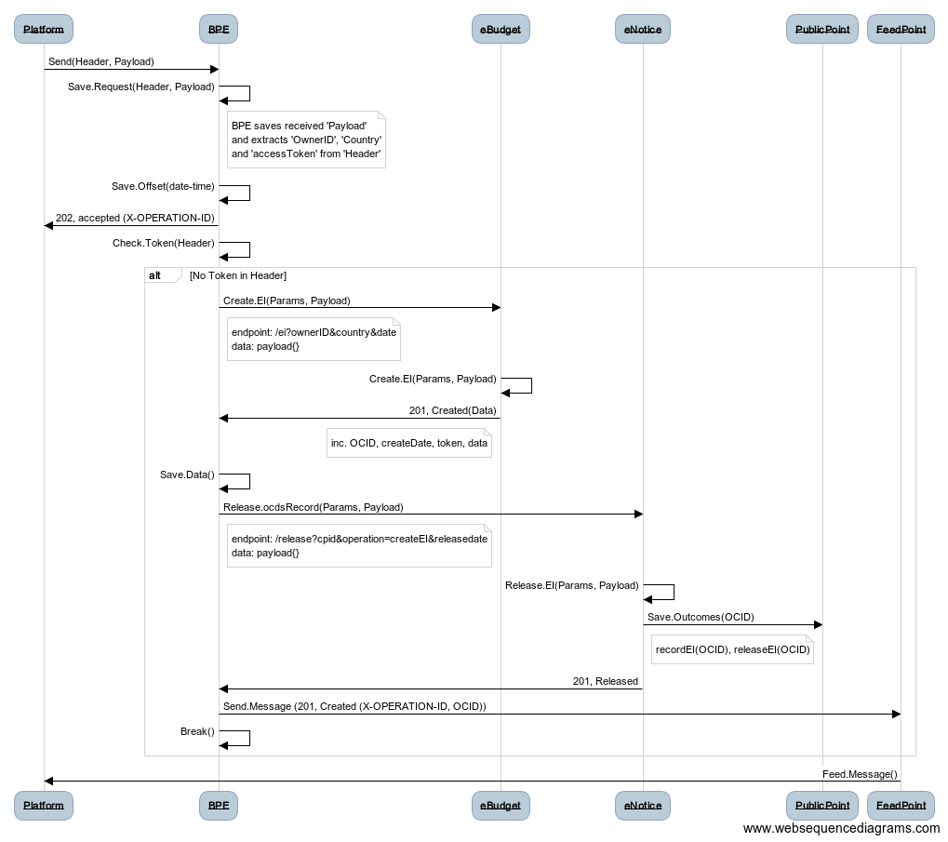

Figure 16. Process sequence diagram (<https://goo.gl/MC13EM>)

###### 

###### 001.1.2. Update existing EI

Incomes

|  |  |
| --- | --- |
| payload and params | EI update model according to API documentation |
| endpoint | /do/ei |

Execution diagram

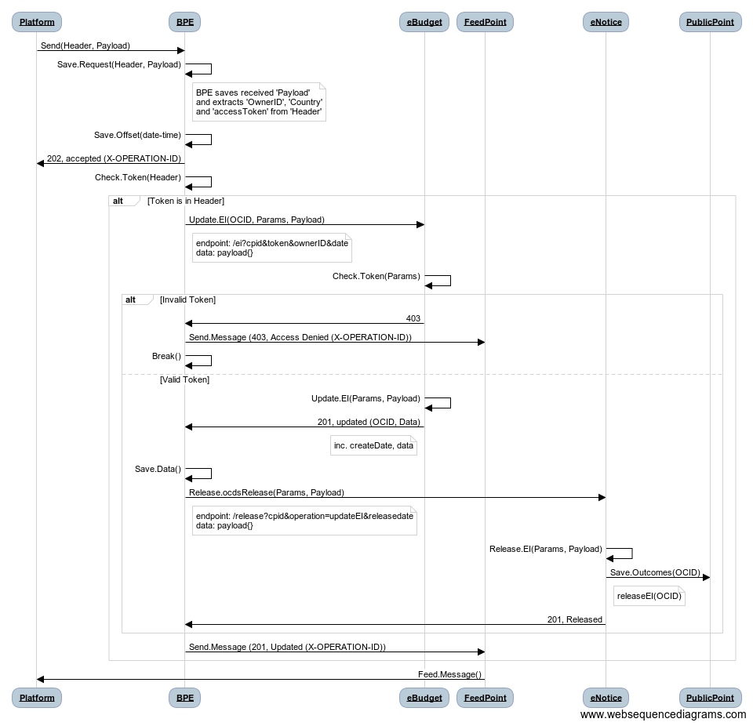

Figure 17. Process sequence diagram (<https://goo.gl/Lntvbs>)

#### 

##### BPE-FS: Management of ‘Funding Source’

###### Create new FS

Incomes

|  |  |
| --- | --- |
| payload and params | FS command model according to API documentation |
| endpoint | /do/fs |

Execution diagram

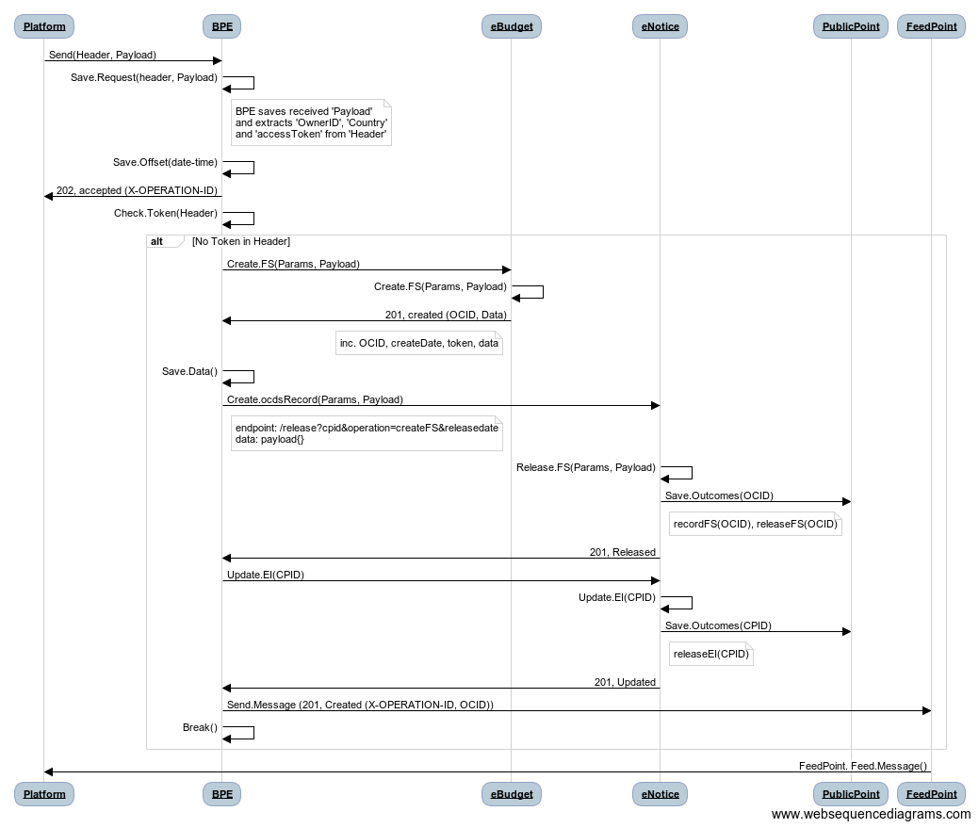Process sequence diagram (<https://goo.gl/Yow9kL>)

###### 

###### Update existing FS

Incomes

|  |  |
| --- | --- |
| payload and params | FS update model according to API documentation |
| endpoint | /do/fs |

Execution diagram

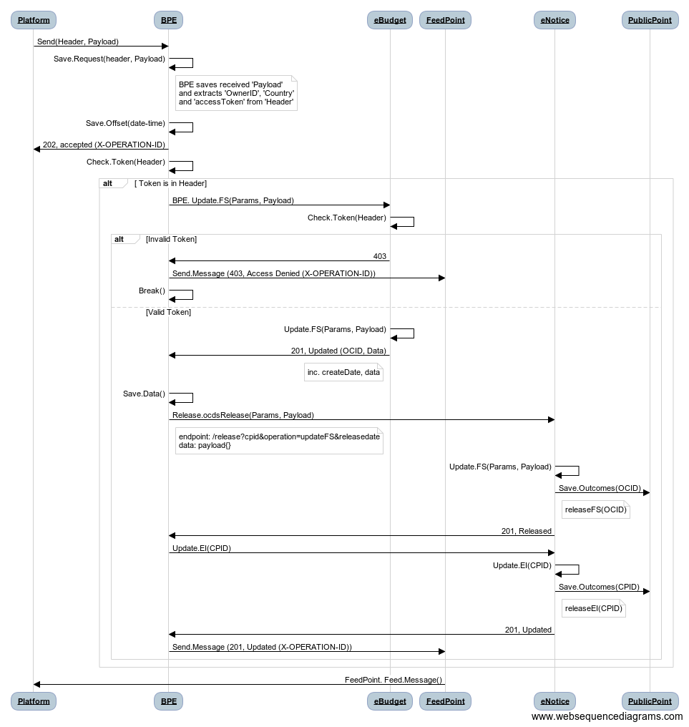

Process sequence diagram (<https://goo.gl/yCYg3L>)

#### 

##### BPE-PN/PIN: creation and management of ‘Periodic Notice’ or ‘Prior Information Notice’

###### Create new PN/PIN

Incomes

|  |  |
| --- | --- |
| payload and params | CN command model according to API documentation |
| endpoint | /do/pn(pin) |

Execution diagram

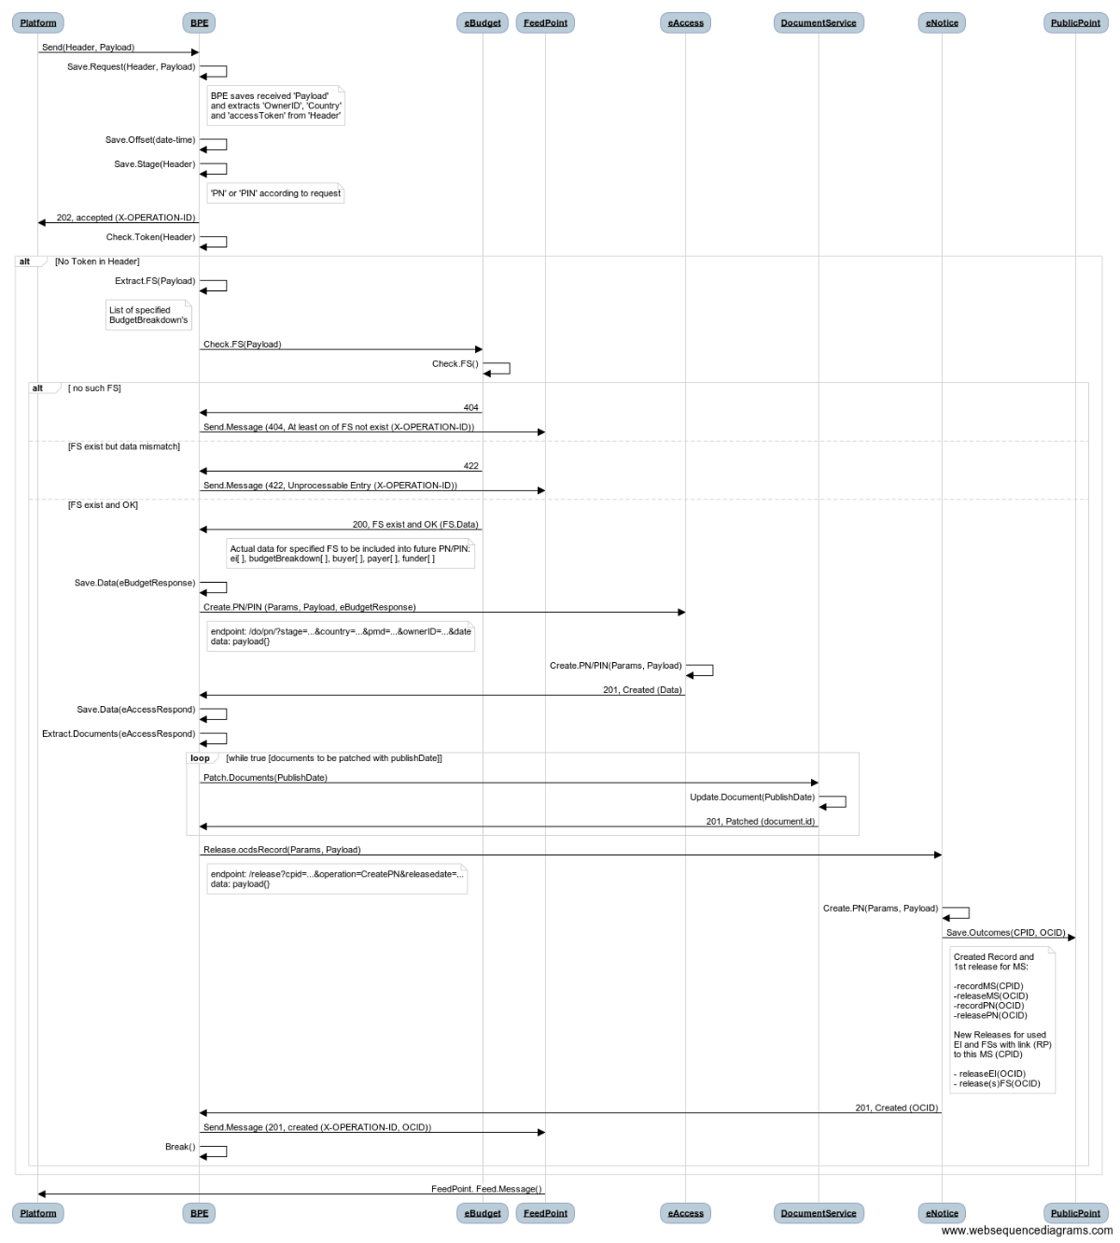

Process sequence diagram (<https://goo.gl/bzqJvR>)

###### Update existing PN/PIN

Incomes

|  |  |
| --- | --- |
| payload and params | CN update model according to API documentation |
| endpoint | /do/pn(pin) |

Execution diagram

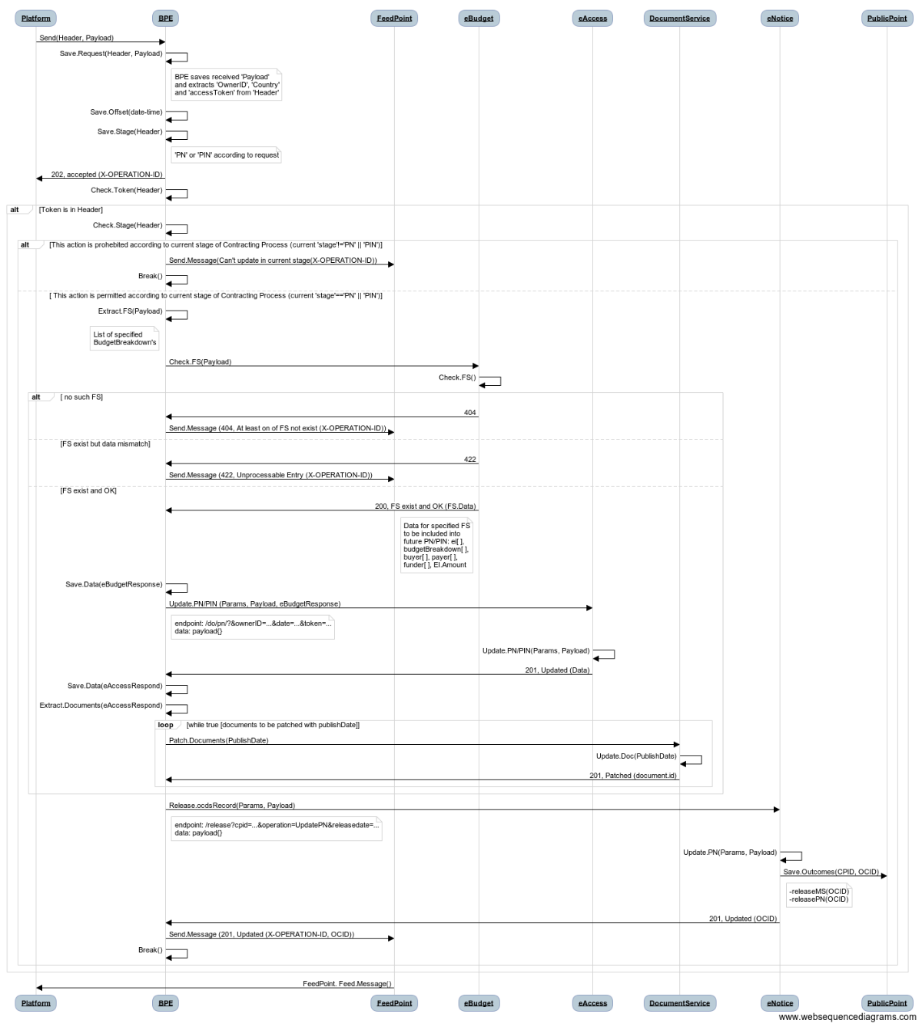

Process sequence diagram (<https://goo.gl/9HLmvB>)

#### 

##### BPE-CN: creation and management of ‘Contract Notice’

###### Create new CN

Incomes

|  |  |
| --- | --- |
| payload and params | CN command model according to API documentation |
| endpoint | /do/cn |

Execution diagram

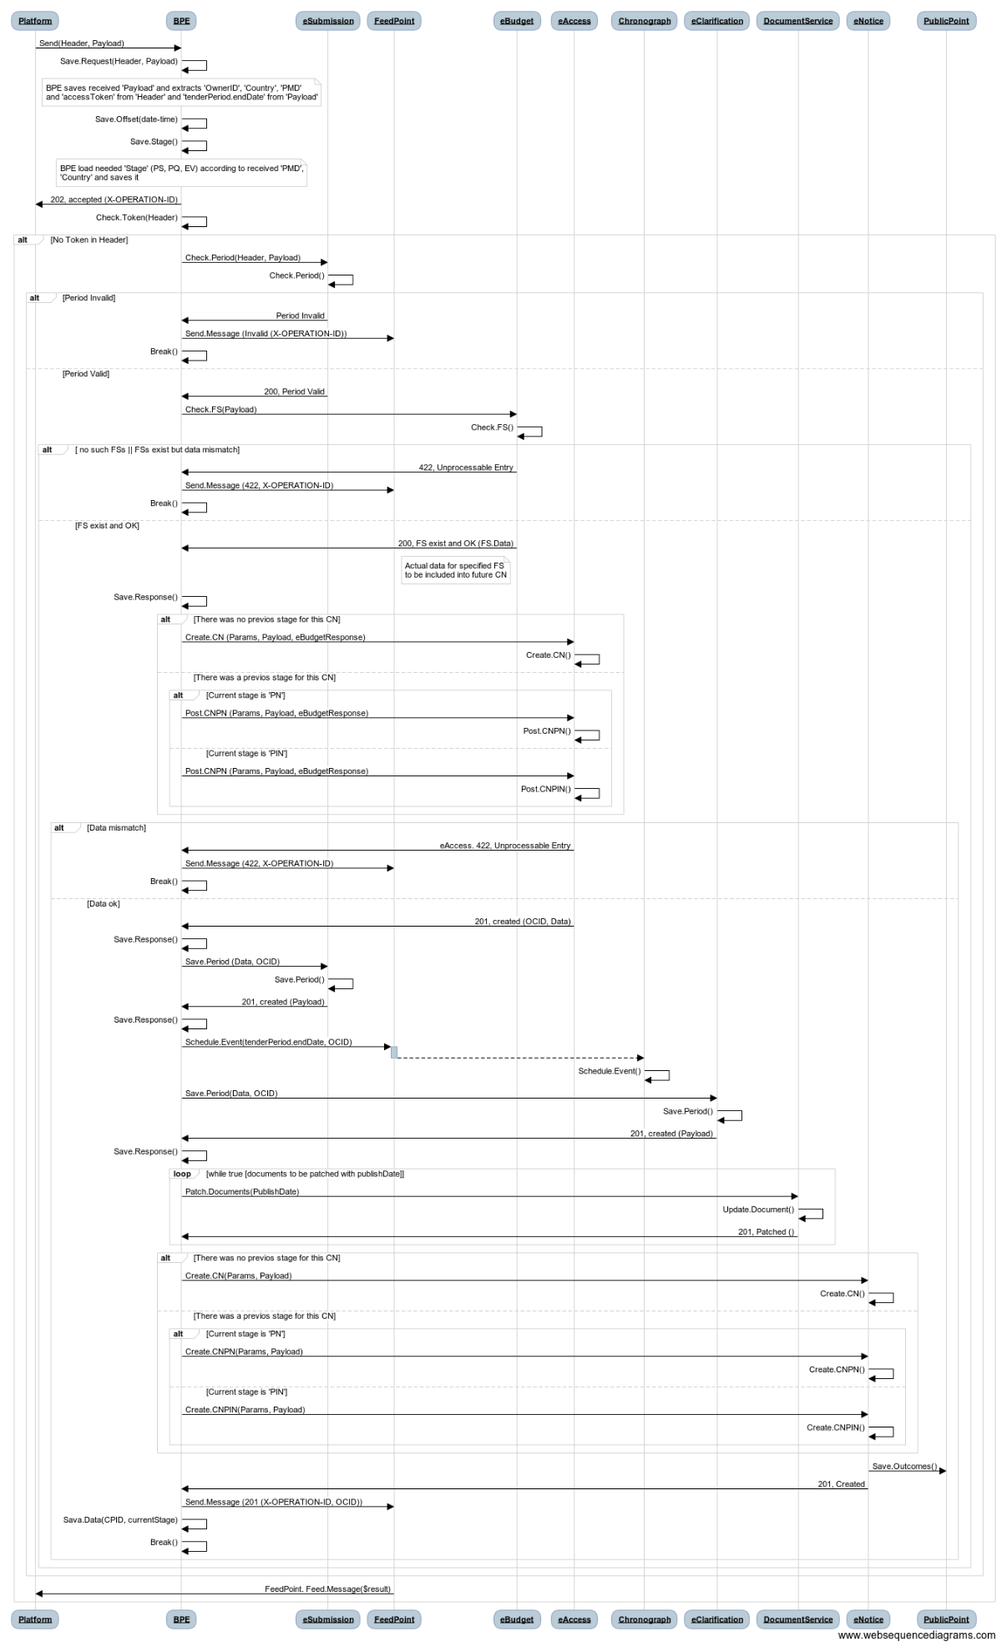

*Depending of current stage of Contracting Process different ways of creation of CN will be used*

*When process will goes forward*

**

*Depending of current stage of Contracting Process different ways of publication will be use*

**

*When process will goes to end*



Process sequence diagram (<https://goo.gl/K9u2qm>)

###### Update existing CN

Incomes

|  |  |
| --- | --- |
| payload and params | CN update model according to API documentation |
| endpoint | /do/pn(pin) |

Execution diagram

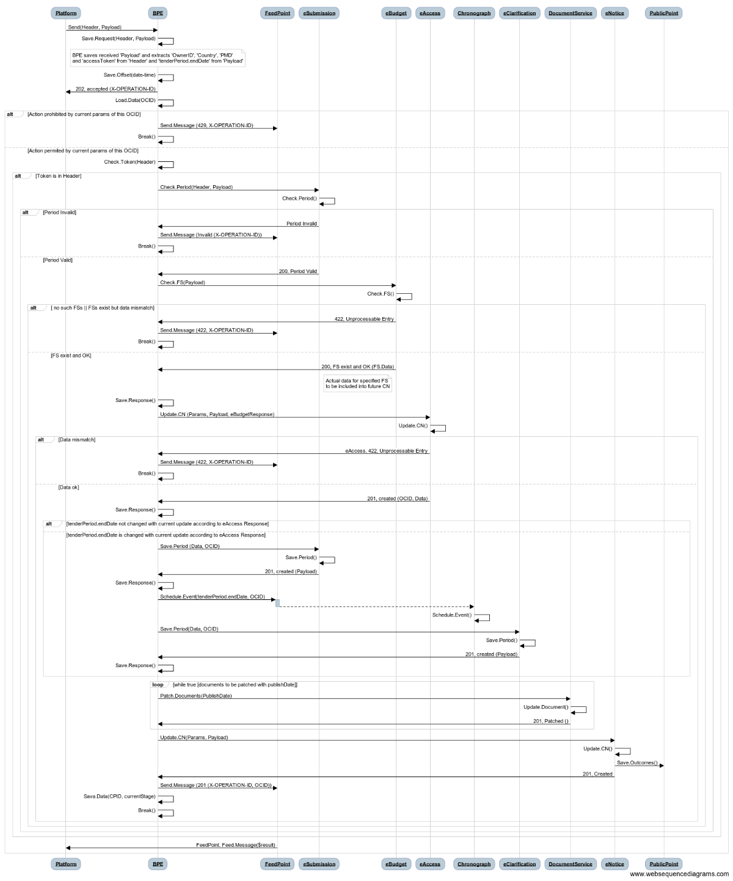

*Depending of current stage of Contracting Process different ways of publication will be used*

**Process sequence diagram (<https://goo.gl/xCBeXh>)

##### BPE-ENQUIRY: execution of flows of clarification

###### Create new Enquiry

Incomes

|  |  |
| --- | --- |
| payload and params | ENQUIRY command model according to API documentation |
| endpoint | /do/enquiry |

Execution diagram

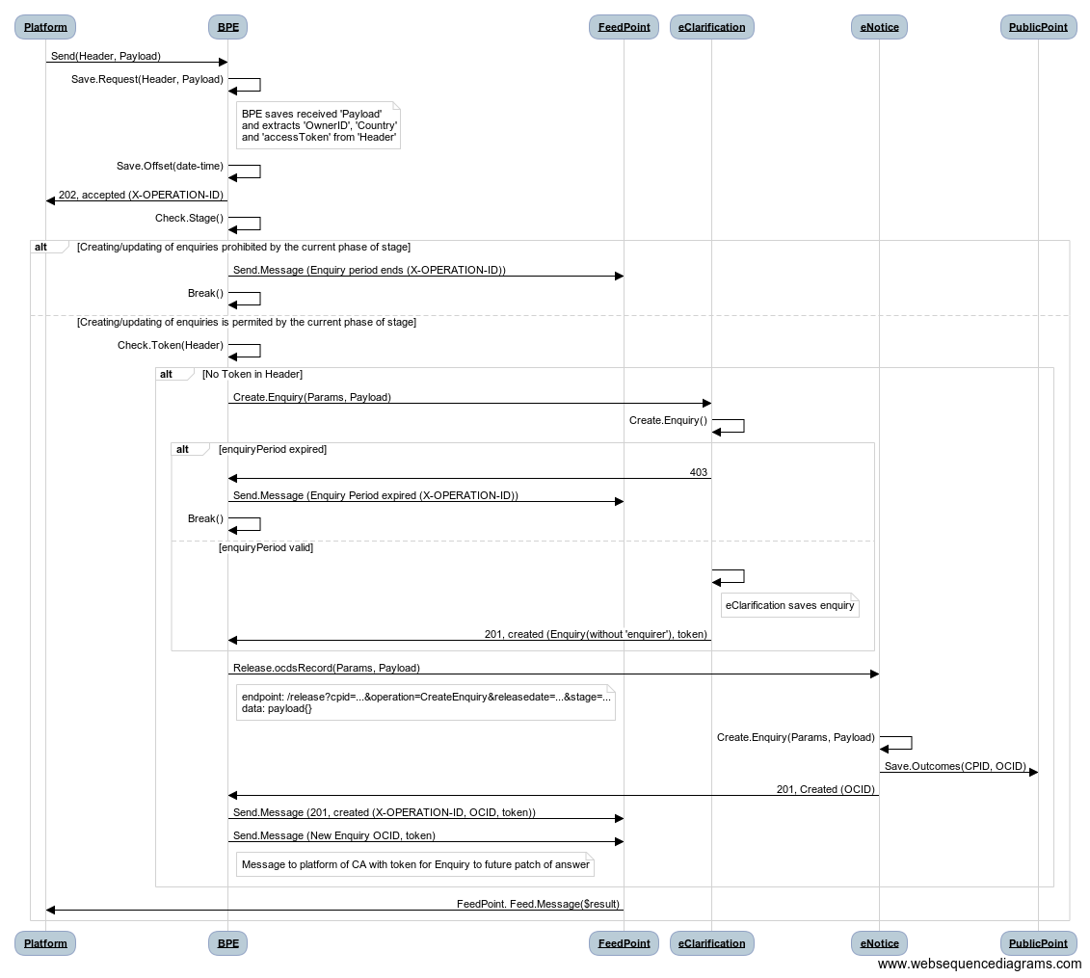

Process sequence diagram (<https://goo.gl/b4d4Nv>)

###### 

###### Answer on existing enquiry

Incomes

|  |  |
| --- | --- |
| payload and params | ANSWER command model according to API documentation |
| endpoint | /do/enquiry |

Execution diagram

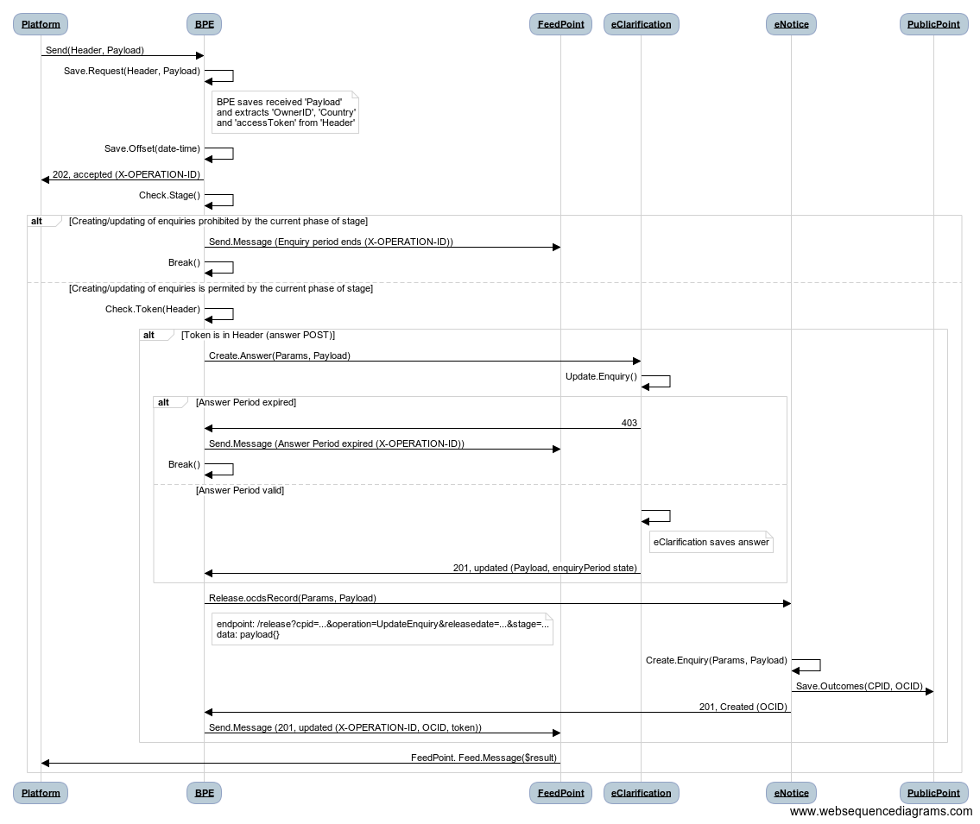

Process sequence diagram (<https://goo.gl/bSh6Lj>)

#### 

##### BPE-PS/PQ-BID: execution of flows of submission stage (pre-selection/pre-qualification phases)

###### Submit new bid

Incomes

|  |  |
| --- | --- |
| payload and params | BID command model according to API documentation |
| endpoint | /do/bid |

Execution diagram

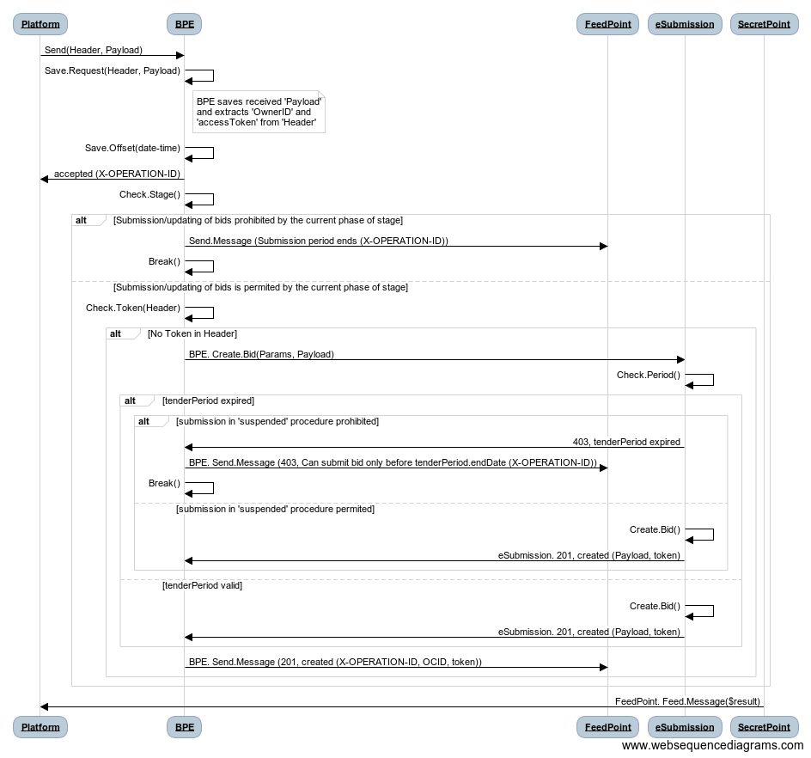

Process sequence diagram (<https://goo.gl/h1XXsM>)

###### 

###### Update existing bid

Incomes

|  |  |
| --- | --- |
| payload and params | BID update model according to API documentation |
| endpoint | /do/bid |

Execution diagram

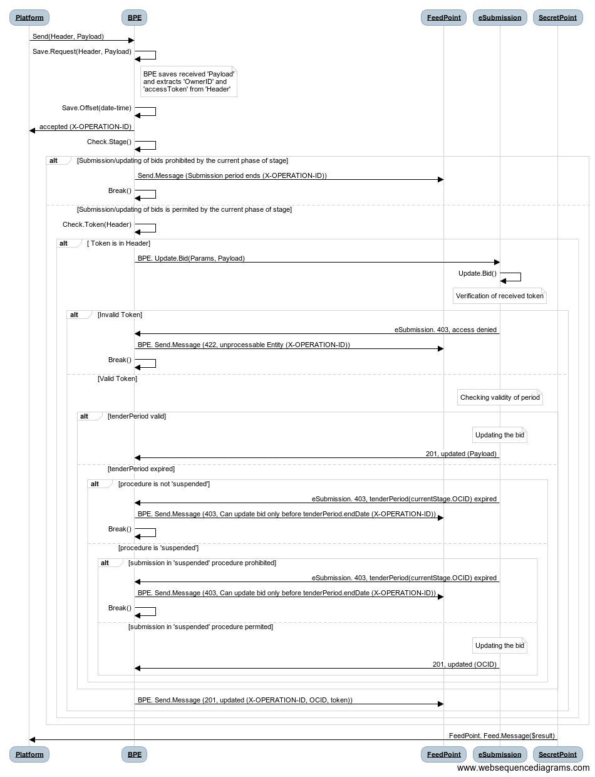

Process sequence diagram (<https://goo.gl/HhgmhD>)

##### BPE-PS/PQ-TENDERPERIOD:END: management of end of submission stage

###### Close of submission period in current phase (automated)

Incomes

|  |  |
| --- | --- |
| payload and params | automated internal process |

Execution diagram

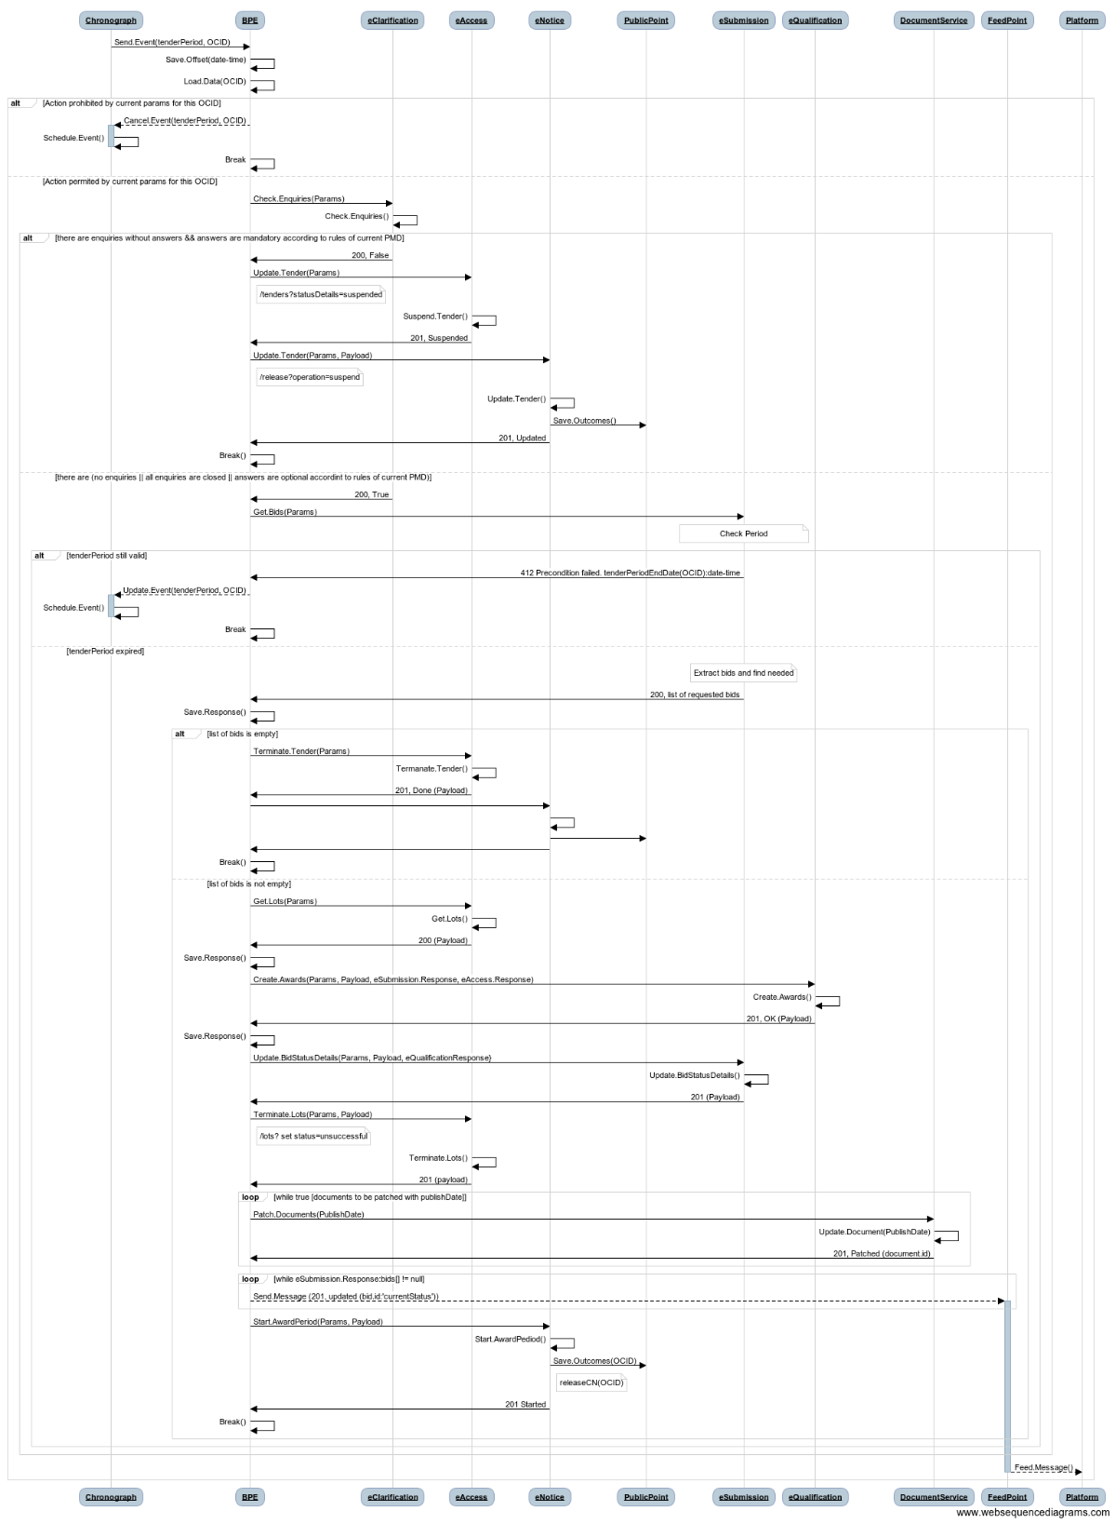

*If there are enquiries without answers and procurement method required such answers mandatory, procedure will be suspended (flow will stops) till all needed answers received*



*If there are no enquiries without answers or such answers are optional according to current procurement method, process will go to next check*



*Depending of consistency of array of extracted bids, process may follow in a two different ways: if an array of extracted bids is empty, all contracting process will go to termination as ‘unsuccessful’*



*If an array of extracted bids is not empty, process will go to next check*



Process sequence diagram (<https://goo.gl/fhyYbW>)

#### 

##### BPE-PS/PQ-AWARDING:STEP: execution of awarding stage (pre-selection/pre-qualification phases)

###### Update auto-generated ‘Award’

Incomes

|  |  |
| --- | --- |
| payload and params | AWARD update model according to API documentation |
| endpoint | /do/award |

Execution diagram

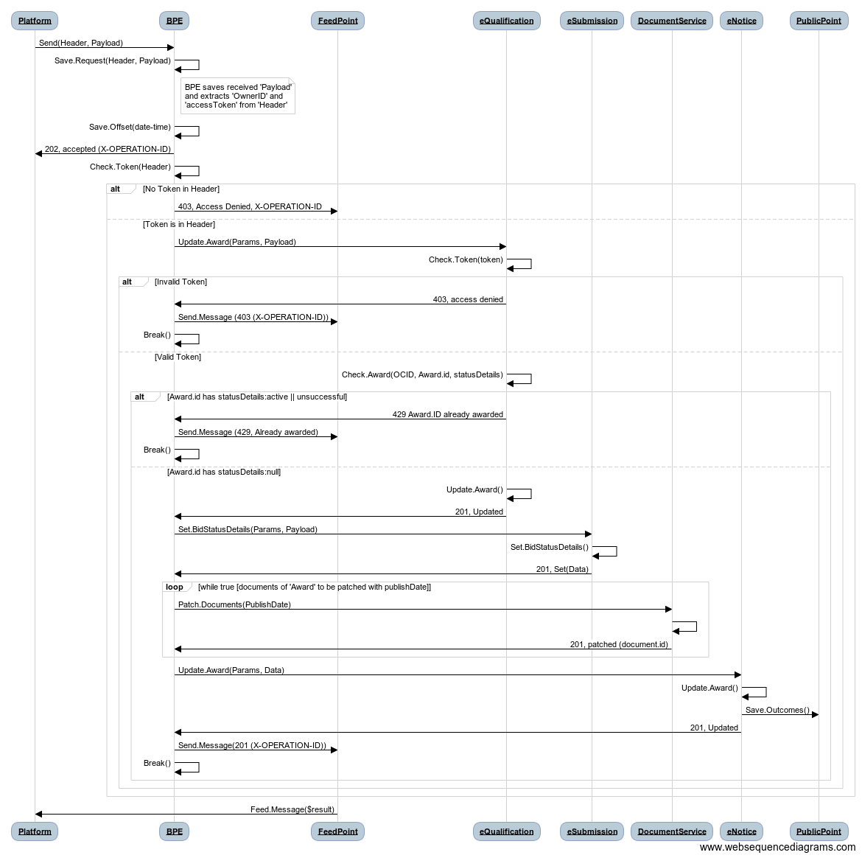

Process sequence diagram (<https://goo.gl/CTBPSD>)

#### 

##### BPE-PS/PQ-AWARDING:PROTOCOL: execution of end of awarding process

###### Submit ‘Awarding Protocol’

Incomes

|  |  |
| --- | --- |
| payload and params | PROTOCOL command model according to API documentation |
| endpoint | /do/protocol |

Execution diagram

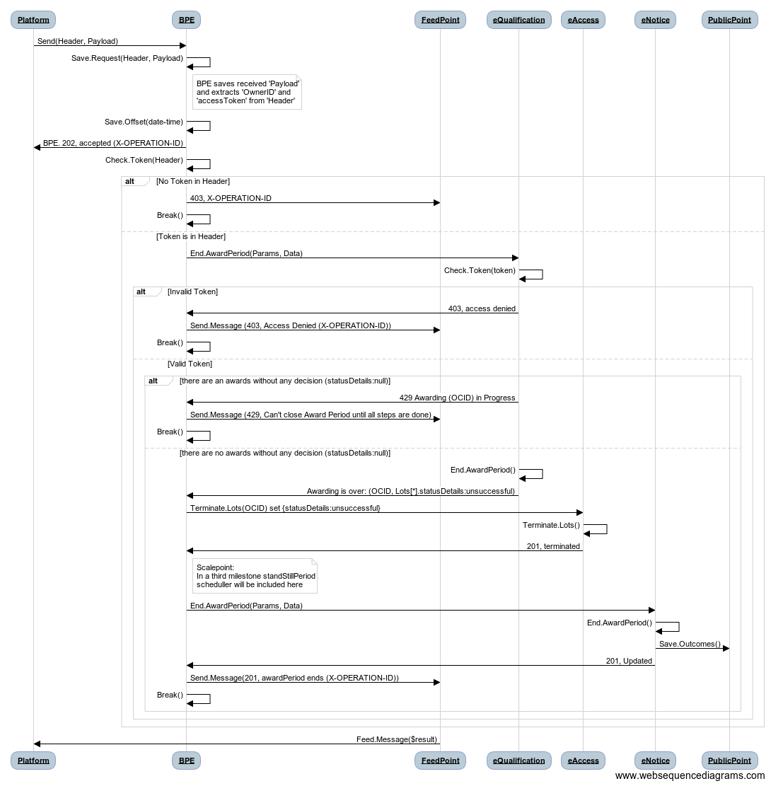

Process sequence diagram (<https://goo.gl/HFxsL9>)

#### 

##### BPE-PS/PQ-AWARDING:END: management of end of awarding stage and all phase

###### Close of awarding period in current phase (automated)

Incomes

|  |  |
| --- | --- |
| payload and params | automated internal process |

Execution diagram

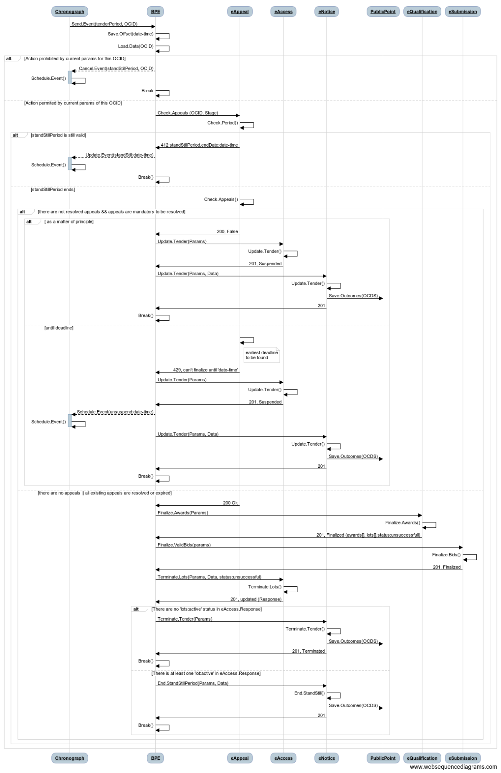

*If there are enquiries without answers and procurement method required such answers mandatory, procedure will be suspended (flow will stops) till all needed answers received*



*If there are enquiries without answers and procurement method required such answers mandatory, procedure will be suspended (flow will stops) till all needed answers received*



*If there are enquiries without answers and procurement method required such answers mandatory, procedure will be suspended (flow will stops) till all needed answers received*



Process sequence diagram (<https://goo.gl/LZJWun>)

##### BPE-PS/PQ-START-NEW-STAGE: management of start of next phase

###### Launch new phase (automated)

Incomes

|  |  |
| --- | --- |
| payload and params | automated internal process |

Execution diagram

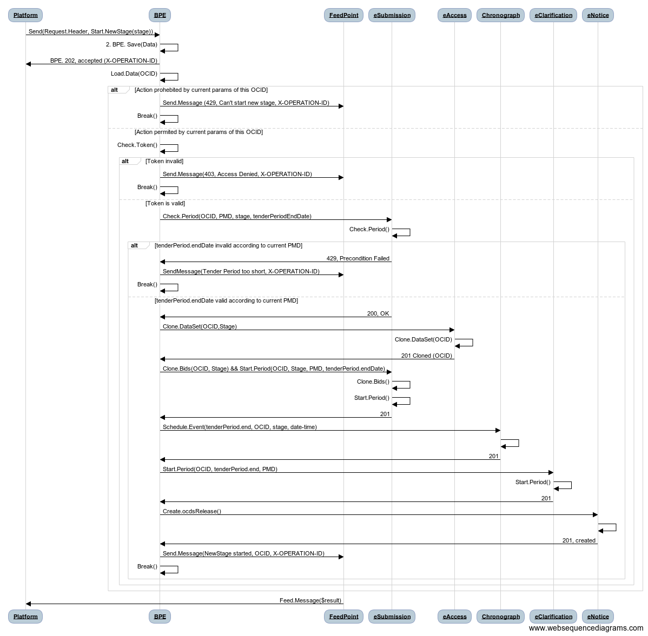

Process sequence diagram (<https://goo.gl/3NFUy4>)

##### BPE-EVALUATION-TENDERPERIOD:END: management of end of bidding stage (evaluation phase)

###### Close of submission period in current phase (automated)

Incomes

|  |  |
| --- | --- |
| payload and params | automated internal process |

Execution diagram

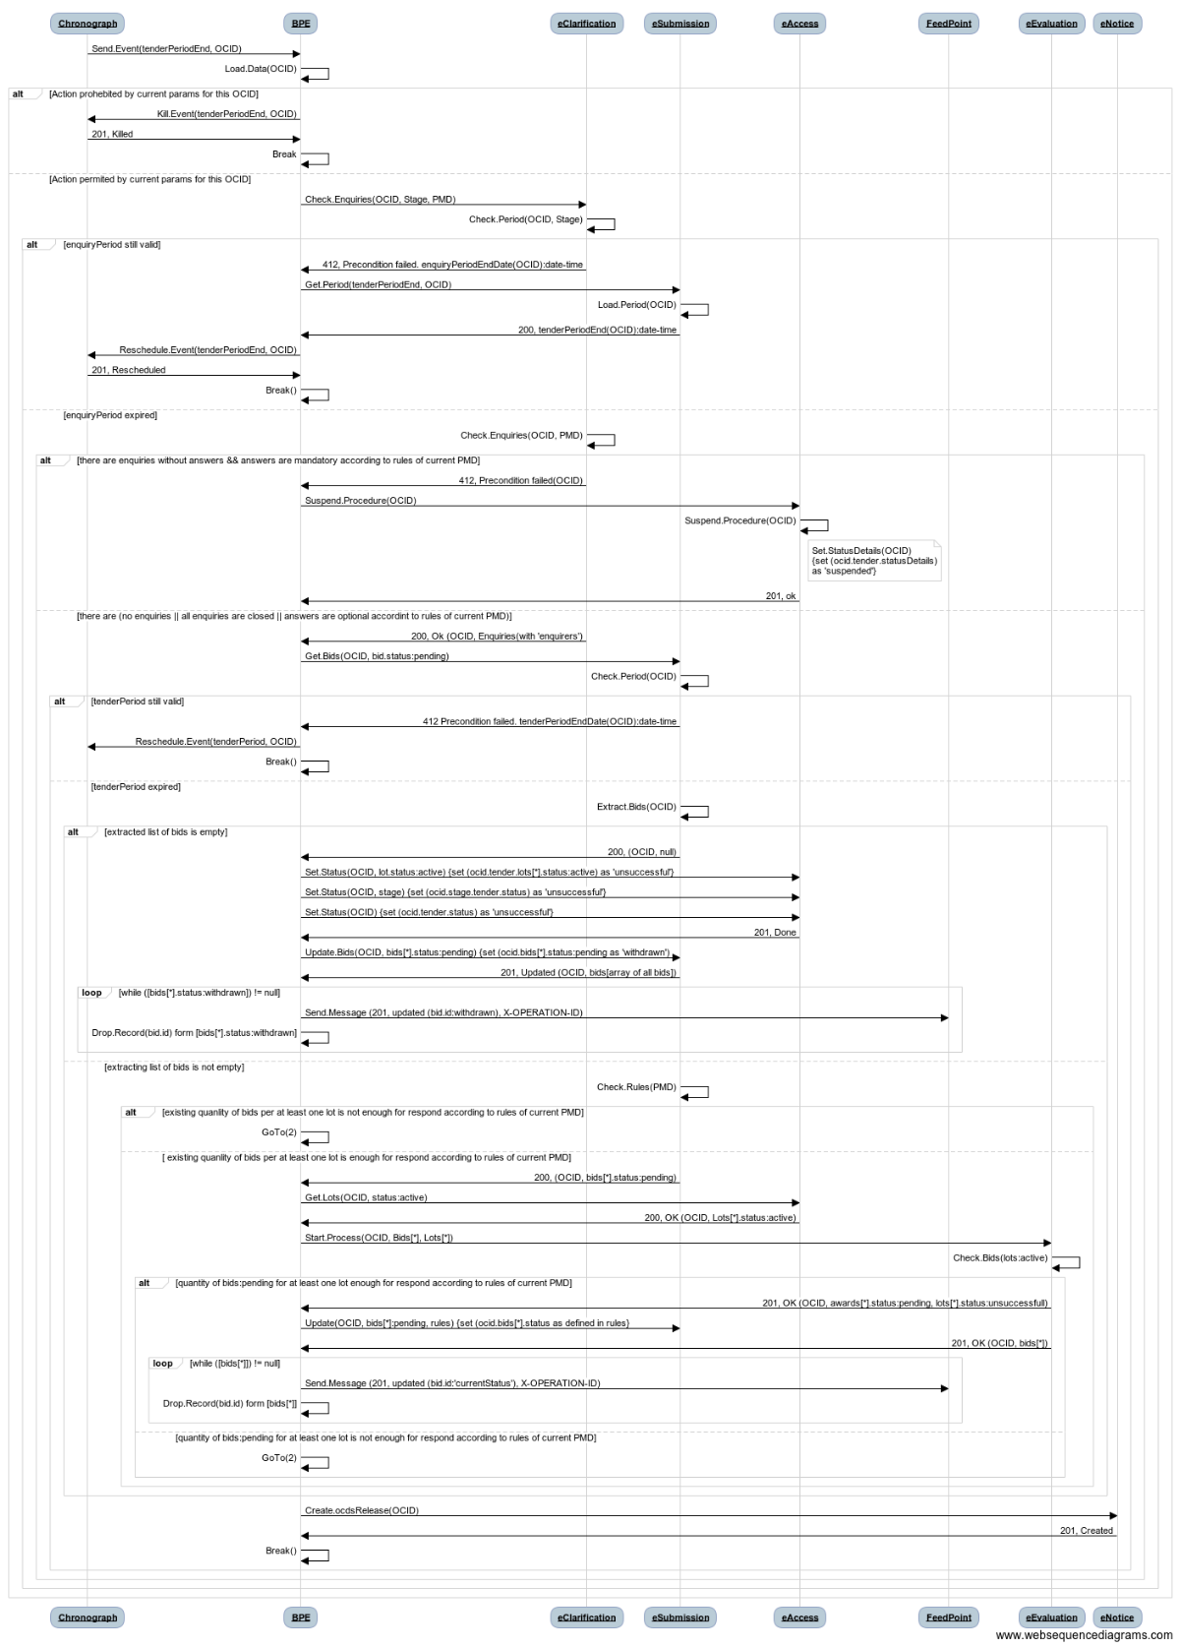

*If there are enquiries without answers and procurement method required such answers mandatory, procedure will be suspended (flow will stops) till all needed answers received*



*Depending of consistency of array of extracted bids, process may follow in a two different ways: if an array of extracted bids is empty, all contracting process will go to termination as ‘unsuccessful’*



*If an array of extracted bids is not empty, process will go to next check*



Process sequence diagram (<https://goo.gl/7gyszq>)

#### 

##### BPE-EVALUATION-AWARDING:STEP: execution of awarding stage (evaluation phase)

###### Update auto-generated ‘Award’

Incomes

|  |  |
| --- | --- |
| payload and params | AWARD update model according to API documentation |
| endpoint | /do/award |

Execution diagram

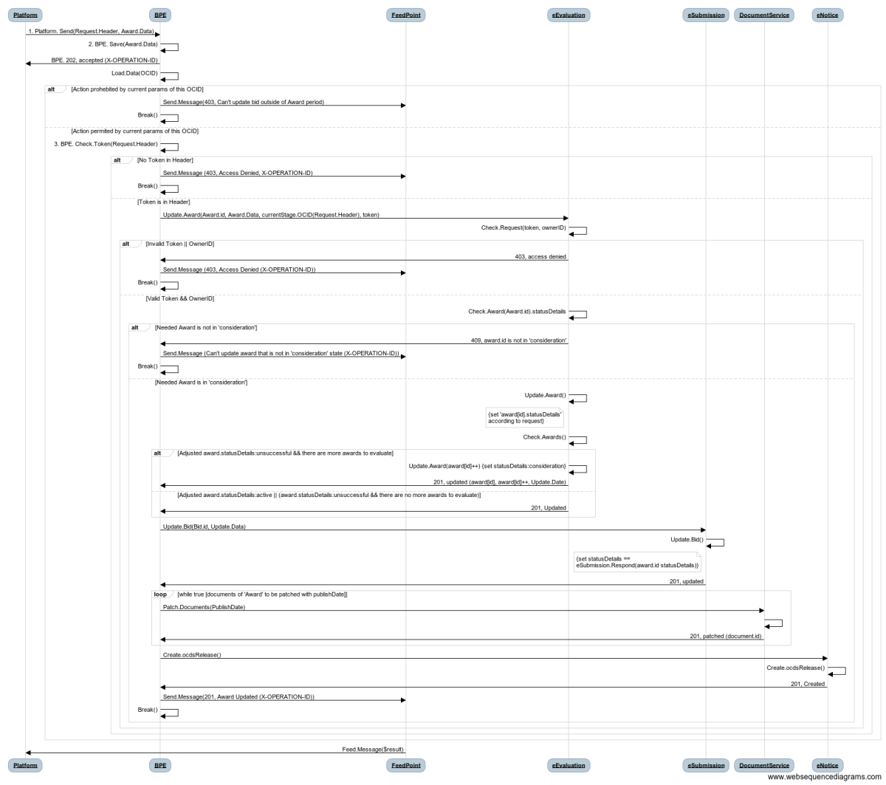

Process sequence diagram (<https://goo.gl/mnuVgu>)

#### 

##### BPE-EVALUATION-AWARDING:PROTOCOL: execution of end of awarding process

###### Update auto-generated ‘Award’

Incomes

|  |  |
| --- | --- |
| payload and params | PROTOCOL patch according to API documentation |
| endpoint | /do/protocol |

Execution diagram

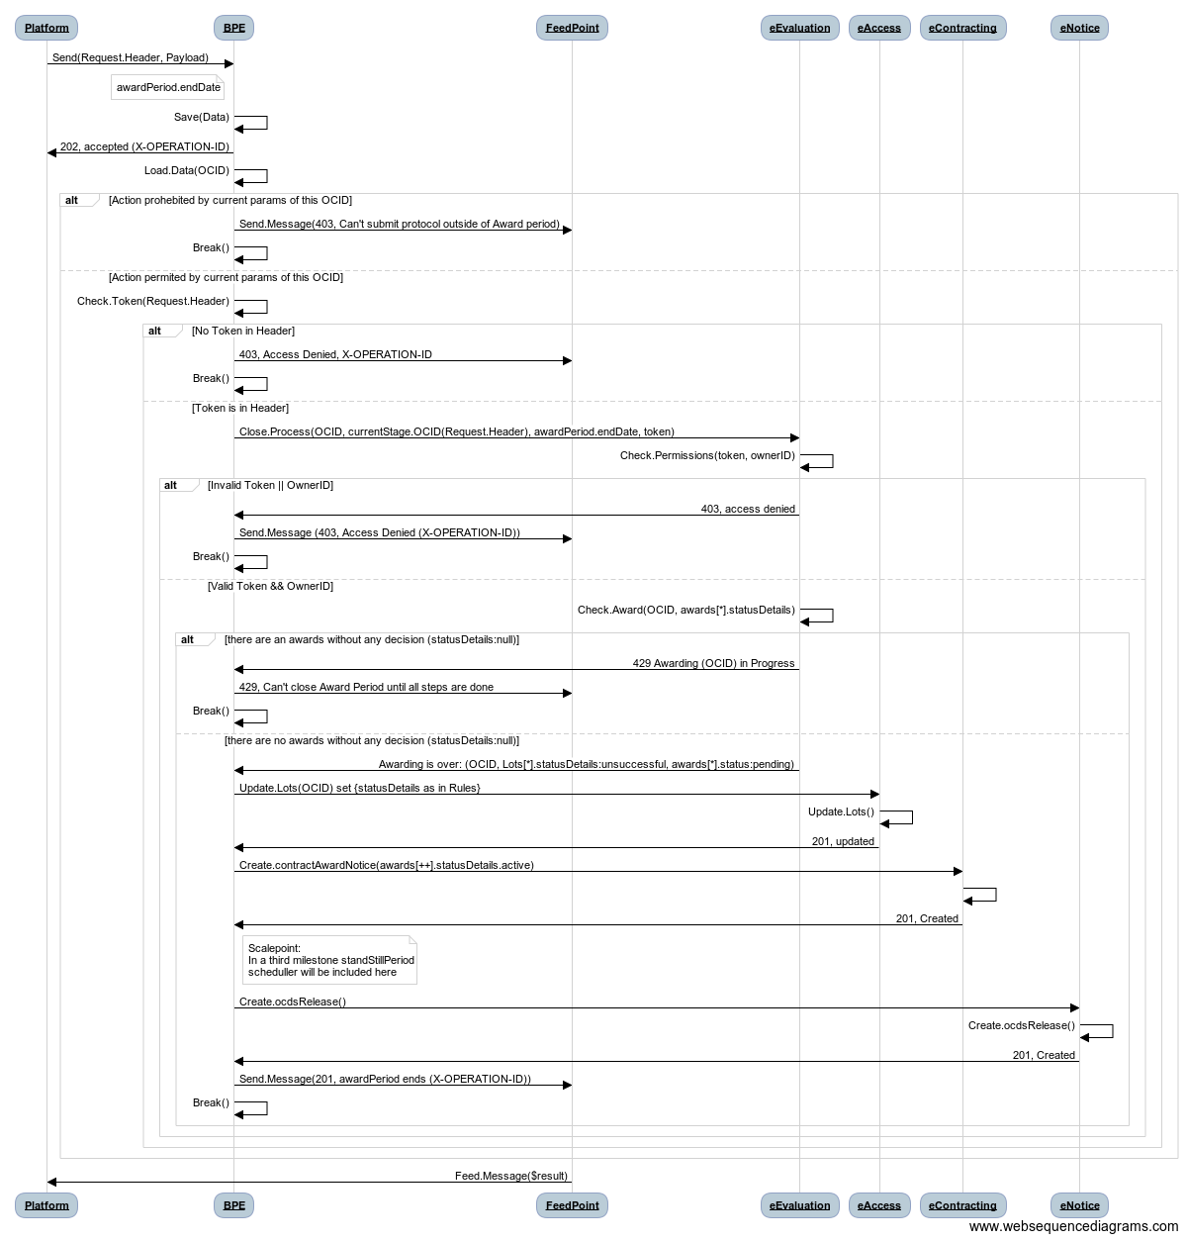Process sequence diagram (<https://goo.gl/XZqu4H>)

##### BPE-EVALUATION-AWARDING:END: Management of end of awarding stage and all phase

###### Close of awarding period in current phase (automated)

Incomes

|  |  |
| --- | --- |
| payload and params | automated internal process |

Execution diagram

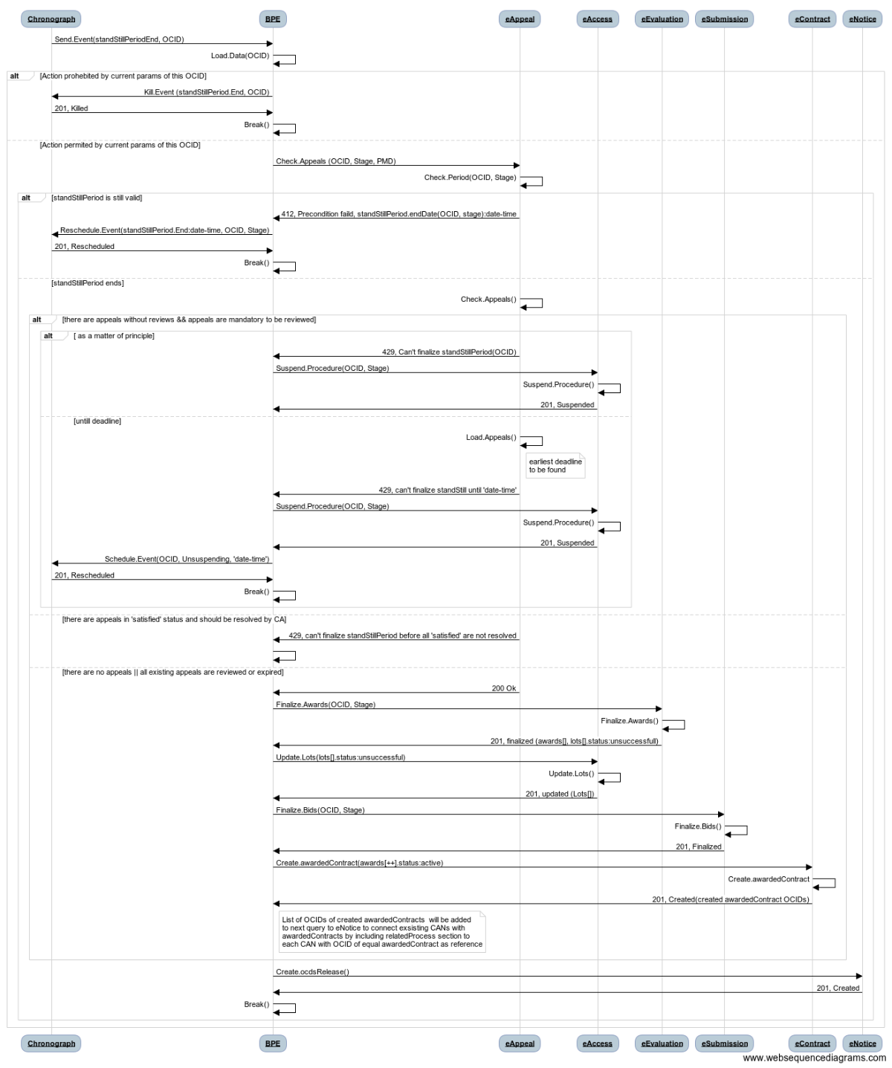Process sequence diagram (<https://goo.gl/aQcDsZ>)

##### BPE-CONTRACTING-CONTRACT:PREPARATION: preparation of contract

###### Close of awarding period in current phase (automated)

Incomes

|  |  |
| --- | --- |
| payload and params | AC update model according to API documentation |
| endpoint | /do/contract |

Execution diagram

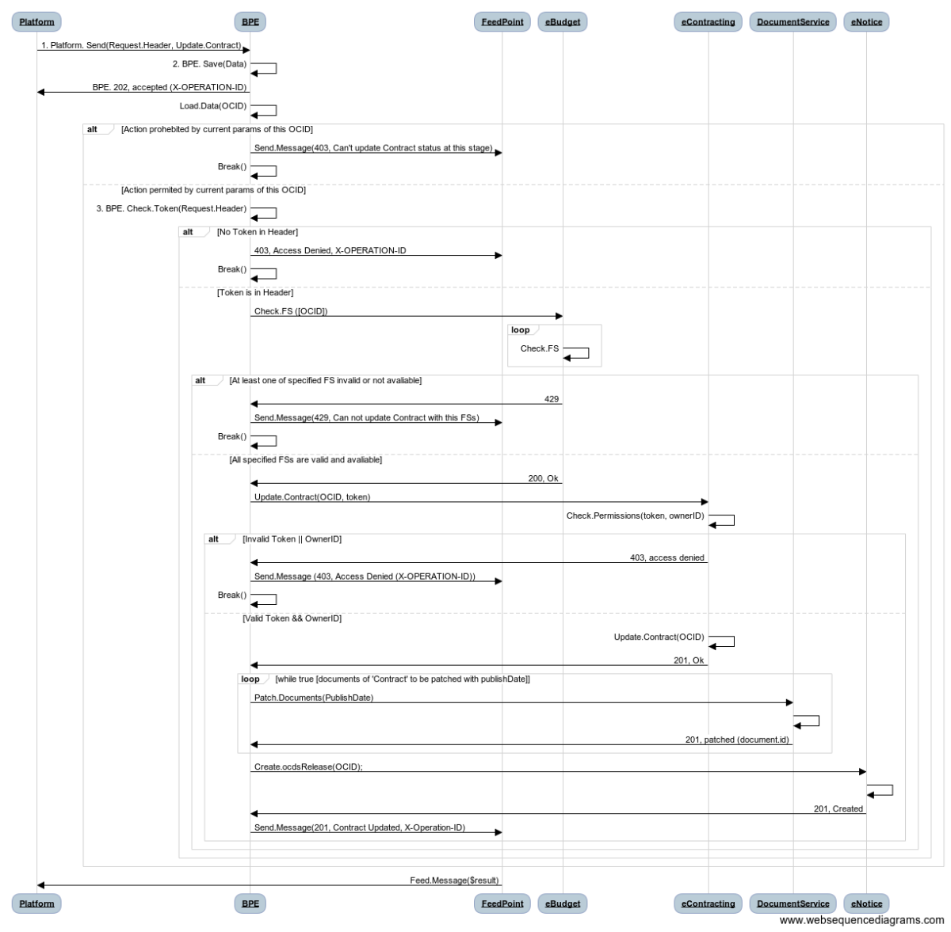

Process sequence diagram (<https://goo.gl/UkMH8W>)

#### 

##### BPE-CONTRACTING-CONTRACT:ACTIVATION: contract activation and closing of evaluation phase

###### Close of awarding period in current phase (automated)

Incomes

|  |  |
| --- | --- |
| payload and params | AC patch according to API documentation |
| endpoint | /issue/contract |

Execution diagram

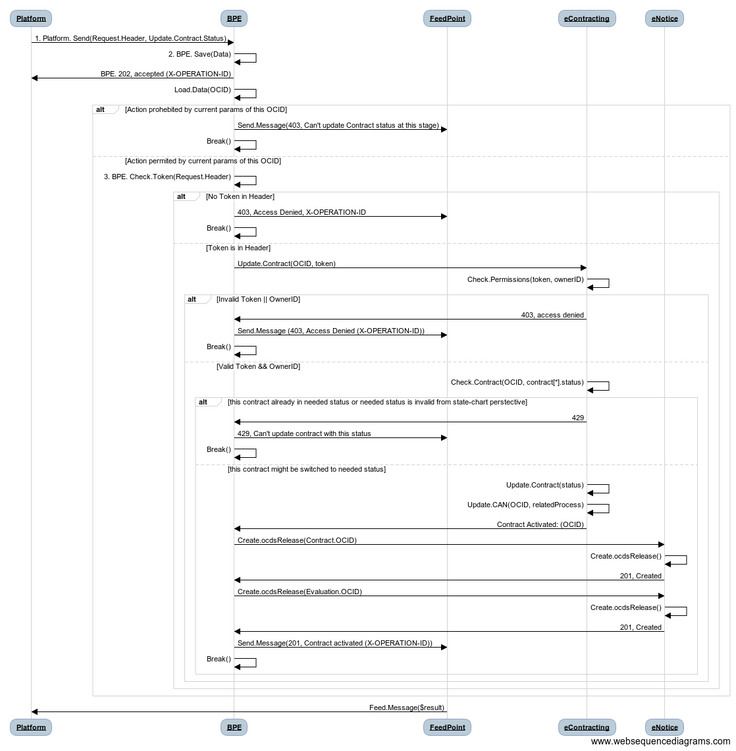

Process sequence diagram (<https://goo.gl/UYbKwG>)

## 

# Public API

The public API is the only interface to use the Central Business Process Engine that is the core unit of infrastructure. The API is a CQRS interface that provides programmatic access to BPE. It provides predictable URLs for accessing resources, and uses built-in HTTP features to receive commands and return responses. This makes it easy to communicate with. The API accepts JSON or form-encoded content in requests. It returns JSON content in all of its responses, including errors.

## CQRS approach

In traditional architectures, the same data model is used to query and update a database. That's simple and works well for basic CRUD operations. In more complex applications, however, this approach can become unwieldy. For example, on the read side, the application may perform many different queries, returning data transfer objects (Data Transfer Objects or DTOs) with different shapes. Object mapping can become complicated. On the write side, the model may implement complex validation and business logic. As a result, you can end up with an overly complex model that does too much. Another potential problem is that read and write workloads are often asymmetrical, with very different performance and scale requirements.

Command and Query Responsibility Segregation (CQRS) - an architecture which addresses these problems by separating reads and writes into separate models, using commands to update data, and queries to read data.

* Commands should be task based, rather than data centric. Commands may be placed on a queue for asynchronous processing, rather than being processed synchronously.
* Queries never modify the database. A query returns a DTO that does not encapsulate any knowledge.

Compared to the single data model used in CRUD-based systems, the use of separate query and update models for the data in CQRS-based systems simplifies design and implementation.

|  |
| --- |
|  |

For greater isolation, the read and the write data could be physically separated. In that case, the read database can use its own data schema that is optimized for queries. For example, it can store a materialized view of the data, in order to avoid complex joins or mappings. It might even use a different type of data store. If separate read and write databases are used, they must be kept in sync. Typically this is accomplished by having the write model publish an event whenever it updates the DB.

## Command API

This section explain how the interfaces to the provided services are called.

|  |
| --- |
| https://bpe.HOST |

### Request example

All requests for Form Service are use POST-method (same as for parent Operation Service)

|  |
| --- |
| **POST** endPoint?specificParams[...] HTTP/1.1 Authorization: Bearer ... X-OPERATION-ID: ... Content-Type: application/json Host: bpe.HOST |

**Specific Params**

Set of specific parameters required in particular case. Described below.

### Response examples

For all valid queries, the response will have a common structure:

|  |
| --- |
| 202 Accepted Content-Type: application/json; charset=UTF-8 |

For all invalid queries, the response will have a common structure:

|  |
| --- |
| 4XX Content-Type: application/json; charset=UTF-8 {  "errors":[  {  "code": "",  "description": ""  }  ] } |

### Activities

This section describes the array of activities that can be performed through the API in each of the processes stages.

#### Budgeting

Budgeting is a stage where CA should assess and define the scope of his needs as well as disclose and describe existing fundings for each defined need. With this description CA will allow system to validate all future contracting processes from assessed needs and available funding perspective as well as control and disclose the progress of execution of this or that expenditure item, analyzing planned and announced procedures, conducted and executed or/and terminated contracts and made transactions.

All needs could be divided into separate expenditure items - groups of needs united under common classification and procuring period for each specific buyer. For example: buyer needs to procure 25 different kinds of furniture (on this stage - doesn't matter which exactly) during next year - all these needs are expenditure item «Furniture» under CPV-code 391. Thus, from technical point of view such groups, expenditure items, are aggregated data-sets, based on common CPV-code and budget period (most often - year). Each defined expenditure item, on a annual financial plans’ level, has available fundings. Thus, next step of budgeting is description of such available fundings. The ‘amount’ available under this expenditure item for this period is the sum of all sources of funding and its amounts, identified for this expenditure item.

##### Expenditure Item (EI)

###### Create ei

|  |
| --- |
| **POST** /do/ei?country=... |

|  |  |
| --- | --- |
| **country** | Identifier of country of jurisdiction according to ‘country’ codelist |

###### Update ei

|  |
| --- |
| **POST** /do/ei/ocid |

|  |  |
| --- | --- |
| **ocid** | OCID of EI to be updated |

##### Funding Source (FS)

###### Create fs

|  |
| --- |
| **POST** /do/fs/ocid |

|  |  |
| --- | --- |
| **ocid** | OCID of parent EI |

###### Update fs

|  |
| --- |
| **POST** /do/fs/ocid/fs-ocid |

|  |  |
| --- | --- |
| **ocid** | OCID of parent EI |
| **fs-ocid** | OCID of FS to be updated |

#### Planning

Once the EI and its FSs defined and described, CA is able to plan and schedule needed procurements - contracting processes for this subject classification - CPV group. Particular EI should be indicated as a ground (meta-parent) of future contracting process. Then, depending of CAs procurement strategy, Periodic Notice or Prior Information Notice could be prepared and published. Within this notice (PN or PIN) allocated by CA himself budget must be specified as a set of identified from the list of available under used EI funding sources together with allocated amounts - separate for each selected FS. The sum of all specified amounts of all indicated funding sources is a budget of future contract that will be conducted under this contracting process.

##### Planning Notice (PN)

###### Create pn

|  |
| --- |
| **POST** /do/pn?country=...&pmd=... |

|  |  |
| --- | --- |
| **country** | Identifier of country of jurisdiction according to ‘country’ codelist |
| **pmd** | Identifier *procurementMethodDetails* according to ‘pmd’ codelist |

###### Update pn

|  |
| --- |
| **POST** /do/pn/ocid/pn-ocid |

|  |  |
| --- | --- |
| **ocid** | OCID of parent Contracting Process |
| **pn-ocid** | OCID of PN to be updated |

#### Announcement

Depending on type of procedure, method of procurement, geography and the legal basis, the attribute composition of the model can be adjusted, but its general logic remains unchanged for all types of procedures. The contracting process based on competitive procedure is commonly carried out in the following sequence:

|  |
| --- |
| *Business Process Diagram* |

Creating a tender, CA determines key fields of the yet-to-be announced procurement, uploads tender documentation, with the requirements to the procurement object indicated as that which determines winner evaluation criteria.

##### Contract Notice (CN)

###### Create cn

|  |
| --- |
| **POST** /do/cn?country=...&pmd=... |

|  |  |
| --- | --- |
| **country** | Identifier of country of jurisdiction according to ‘country’ codelist |
| **pmd** | Identifier procurementMethodDetails according to ‘pmd’ codelist |

###### Create cn based on pn

|  |
| --- |
| **POST** /do/pn/ocid/pn-ocid |

|  |  |
| --- | --- |
| **ocid** | OCID of parent Contracting Process |
| **pn-ocid** | OCID of PN to be updated |

###### Update cn

|  |
| --- |
| **POST** /do/cn/ocid/cn-ocid |

|  |  |
| --- | --- |
| **ocid** | OCID of parent Contracting Process |
| **cn-ocid** | OCID of CN to be updated |

#### Clarification

Clarification period is separately distinguished in the procurement procedure during which participants can ask questions regarding the procurement requirements, demand issue resolution, and submit a claims, while CA can provide answers to questions and introduce changes into the procurement conditions. The duration of the clarification period and offer submission is determined by CA but in any case can not be less than those, prescribed by Law.

##### Create enquiry

|  |
| --- |
| **POST** /do/enquiry/ocid/cn-ocid |

|  |  |
| --- | --- |
| **ocid** | OCID of parent Contracting Process |
| **cn-ocid** | OCID of CN to be updated |

##### Create answer

|  |
| --- |
| **POST** /do/enquiry/ocid/cn-ocid/enquiry-id |

|  |  |
| --- | --- |
| **ocid** | OCID of parent Contracting Process |
| **cn-ocid** | OCID of CN to be updated |
| **enquiry-id** | ID of parent enquiry |

#### Submission

Once the clarification period is over the CA can no longer introduce changes into the Contract Notice. Economic Operators submit offers that are confidential.

##### Create bid

|  |
| --- |
| **POST** /do/bid/ocid/cn-ocid |

|  |  |
| --- | --- |
| **ocid** | OCID of parent Contracting Process |
| **cn-ocid** | OCID of CN to be updated |

##### Update bid

An Economic Operator may modify its electronic bid by submitting online within submission deadlines a new information regarding previously submitted offer in accordance to the electronic submission procedures.

|  |
| --- |
| **POST** /do/bid/ocid/cn-ocid/bid-id |

|  |  |
| --- | --- |
| **ocid** | OCID of parent Contracting Process |
| **cn-ocid** | OCID of CN to be updated |
| **bid-id** | ID of the bid |

###### Update winning bid

|  |
| --- |
| **POST** /do/bidDocs/ocid/cn-ocid/bid-id |

|  |  |
| --- | --- |
| **ocid** | OCID of parent Contracting Process |
| **cn-ocid** | OCID of CN to be updated |
| **bid-id** | ID of the bid |

##### Withdraw bid

An Economic Operator may withdraw his electronic bid by submitting online within submission deadlines a request for cancellation of previously submitted offer.

|  |
| --- |
| **POST** /cancel/bid/ocid/cn-ocid/bid-id |

|  |  |
| --- | --- |
| **ocid** | OCID of parent Contracting Process |
| **cn-ocid** | OCID of CN to be updated |
| **bid-id** | ID of the bid |

#### Awarding

Once the submission period is over and participants can not longer submit or update their bids, system will disclose all submitted bids, generate set of qualification envelopes (awards) and launch the awarding period for this contracting process. System will automatically verify eligibility (based on available via external bus data) of each tenderer whose bid was disclosed according to rules of dispatch under current procurement method.

Those bids that have been passed eligibility check, will go to the technical qualification. All the other that failed go to automatic exclusion. In case if after submission period end there is nothing to disclose (no bids were submitted) or all submitted bids failed, system will automatically change this specific lot of this contracting process to status “unsuccessful”.

##### Create award

|  |
| --- |
| **POST** /do/award/ocid/cn-ocid |

|  |  |
| --- | --- |
| **ocid** | OCID of parent Contracting Process |
| **cn-ocid** | OCID of CN to be updated |

##### Update award

CA sequentially reviews bids that are eligible considering its technical compliance, beginning with first, suggested by the system. Depending on award criteria (priceOnly/costOnly/MEAT) system will rank eligible bids and suggest them in order of admissibility: from the most to the least acceptable by applicable criteria. If the most acceptable bid is in compliance with the CA’s technical requirements, CA determines this offer as a qualified and goes to next step - financial evaluation. If it is not, CA confirms his decision to disqualify the participant, and declines such an offer. Then the system suggests to qualify the next offer from the acceptance perspective.

If qualified offer is in compliance with the CA’s financial requirements, CA determines this offer as a winner. If it is not in compliance, CA confirms his decision to disqualify the offer on this (evaluation) stage, and declines such an offer. Then the systems suggests to qualify the next offer from the acceptance perspective.

If all the offers were declined by CA either on qualification step or on evaluation one and upon the completion of complaining process (review period) this specific lot of this contracting process automatically changes to ‘unsuccessful’.

|  |
| --- |
| **POST** /do/award/ocid/cn-ocid/award-id |

|  |  |
| --- | --- |
| **ocid** | OCID of parent Contracting Process |
| **cn-ocid** | OCID of CN to be updated |
| **award-id** | ID of award to be updated |

##### Submit awarding protocol

Once winner is selected for each lot, CA submits the evaluation protocol which, in its turn, indicates the end of awarding process. As a result of submission of evaluation protocol, system will automatically generate a set of Submission for each awarded lot, change evaluation stage to ‘awarded’ and launch the complaining process - review period.

|  |
| --- |
| **POST** /do/protocol/ocid/cn-ocid/lot-id |

|  |  |
| --- | --- |
| **ocid** | OCID of parent Contracting Process |
| **cn-ocid** | OCID of CN to be updated |
| **lot-id** | ID of the parent lot |

##### Update Contract Award Notice

|  |
| --- |
| **POST** /do/document/ocid/cn-ocid/can-id |

|  |  |
| --- | --- |
| **ocid** | OCID of parent Contracting Process |
| **cn-ocid** | OCID of CN to be updated |
| **can-id** | ID of the CAN to be updated |

##### Confirm Contract Award Notice

|  |
| --- |
| **POST** /do/confirmation/can/ocid/cn-ocid/can-id |

|  |  |
| --- | --- |
| **ocid** | OCID of parent Contracting Process |
| **cn-ocid** | OCID of CN to be updated |
| **can-id** | ID of the CAN to be updated |

##### Cancel Contract Award Notice

|  |
| --- |
| **POST** /cancel/can/ocid/cn-ocid/can-id |

|  |  |
| --- | --- |
| **ocid** | OCID of parent Contracting Process |
| **cn-ocid** | OCID of CN to be updated |
| **can-id** | ID of the CAN to be updated |

#### Contracting

##### Create awarded contract

|  |
| --- |
| **POST** /do/contract/ocid/ac-ocid |

|  |  |
| --- | --- |
| **ocid** | OCID of parent Contracting Process |
| **ac-ocid** | OCID of the *contract* to be updated |

##### Update awarded contract

|  |
| --- |
| **POST** /do/contract/ocid/ac-ocid |

|  |  |
| --- | --- |
| **ocid** | OCID of parent Contracting Process |
| **ac-ocid** | OCID of the *contract* to be updated |

##### Issue contract to be approved

|  |
| --- |
| **POST** /issue/contract/ocid/ac-ocid |

|  |  |
| --- | --- |
| **ocid** | OCID of parent Contracting Process |
| **ac-ocid** | OCID of the *contract* to be issued |

##### Approve contract

|  |
| --- |
| **POST** /do/confirmation/ocid/ac-ocid/request-id |

|  |  |
| --- | --- |
| **ocid** | OCID of parent Contracting Process |
| **ac-ocid** | OCID of the *contract* to be approved |
| **request-id** | ID of initial |

##### Activate approved contract

|  |
| --- |
| **POST** /activate/contract/ocid/ac-ocid |

|  |  |
| --- | --- |
| **ocid** | OCID of parent Contracting Process |
| **ac-ocid** | OCID of the *contract* to be activated |

##### Cancel awarded contract

|  |
| --- |
| **POST** /cancel/contract/ocid/ac-ocid |

|  |  |
| --- | --- |
| **ocid** | OCID of parent Contracting Process |
| **ac-ocid** | OCID of the *contract* to be cancelled |

### Query API

Public Point is a service that displays records and data-sets in read-only mode. Only information allowed for publication by the current legislation is displayed (i.e. it does not show bids of the bidders until the opening session (disclosure) of the bids.

#### AccessPoint

All of the document uploading API endpoints follow the same set of rules and uses single access point.

|  |
| --- |
| http://public.HOST |

#### Flow Description

|  |  |
| --- | --- |
| File to be registered  DS performs following actions:   1. The file size is checked - if the value is exceeded, the process is thrown 2. The file format is checked for a valid format 3. In case of a valid format, the file is saved:    1. description is stored in the database according to the model    2. Returns file descriptions to the client according to the attribute composition | *Process Sequence Diagram* |

##### Retrieving data

To retrieve a list of data or individual entity data-set use GET-request parameterized with one or more options sent to corresponding end-point.

* offset - timestamp of latest updates
* limit - quantity of elements per each package of data
* order - criteria for sorting results

###### Getting list of all data

By default all data returned from public point are sorted by modification time (from oldest to newest).

**Limiting number of Tenders returned**

You can control the number of data entries in the entity feed (batch size) with limit parameter. If not specified, data is being returned in batches of 100 elements.

|  |
| --- |
| GET /get/tenders?offset=...&limit=20&order=asc&mode=history  200 OK Content-Type: application/json; charset=UTF-8  {  "data": [  {  "ocid": "",  "date": ""  }  ],  "offset":"" } |

**Batching**

The response contains ‘offset’ element. This is the parameter you have to add to the original request you made to get next page. If next page request returns no data (i.e. empty array) then there is little sense in fetching further pages.

**Synchronizing**

It is often necessary to be able to synchronize changes of Central Unit with local database. The default sorting “by modification date” together with Batching mechanism allows one to implement synchronization effectively. The synchronization process can go page by page until there is no new data returned. Then the synchronizer has to pause for a while to let Central Unit register some changes and attempt fetching subsequent page.

###### Getting individual entity information

To get a individual entity data set (as Record Package) provide your GET-request with unique ID of particular entity:

|  |
| --- |
| **GET** /get/tenders/ocds-000-00001?offset=... |

# Folder structure

**Kotlin** development:

*module_name*

|- docs

|- src

|- main

|- kotlin/com/procurement/*module_name*

|- application

|- config

|- controller

|- dao

|- databinding

|- domain/model

|- enums

|- exception

|- infrastructure

|- lib

|- model

|- service

|- utils

|- *module_aplication*.kt

|- resources

|- script

|- dockerfile

|- test

|- pom.xml

1. http://standard.open-contracting.org/latest/en/
2. http://standard.open-contracting.org/latest/en/schema/record_package/